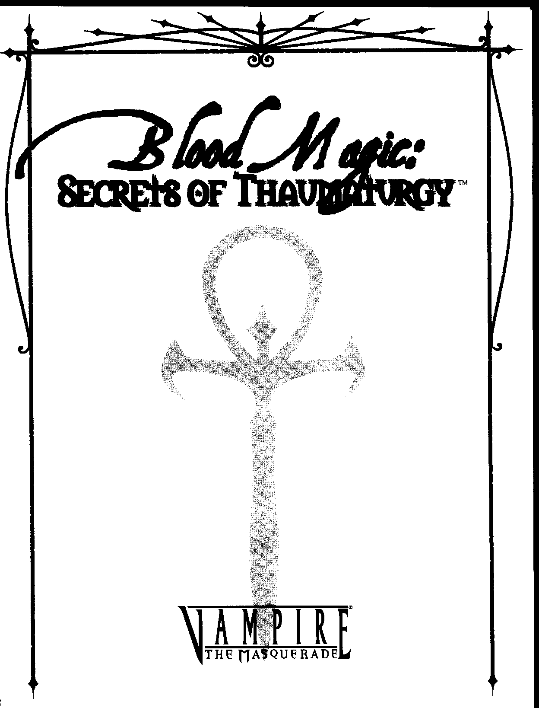

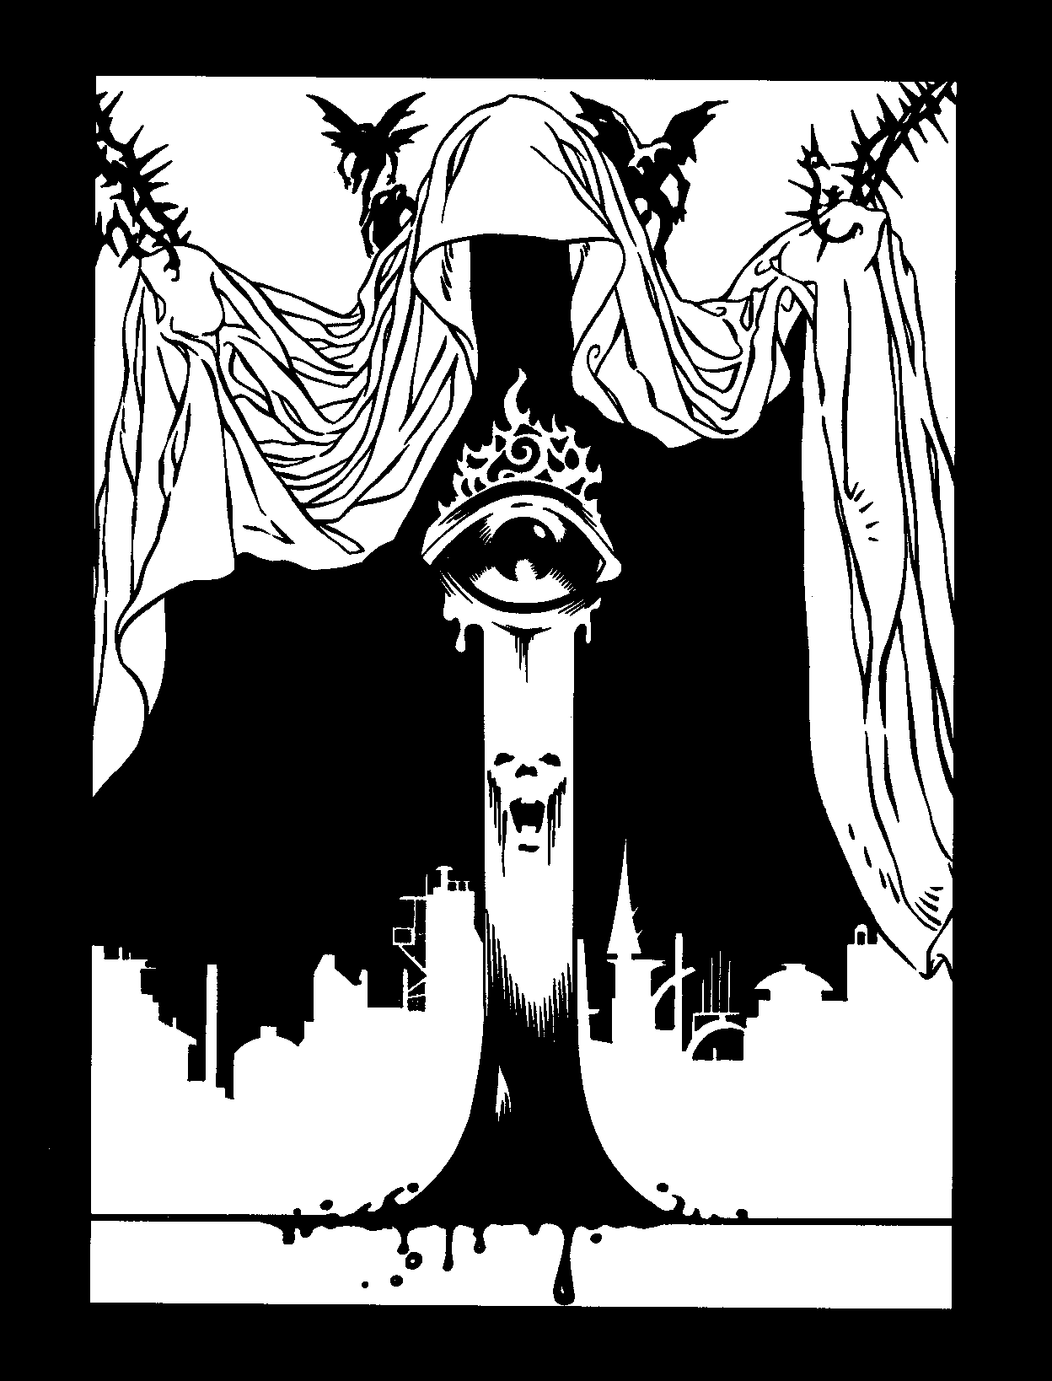

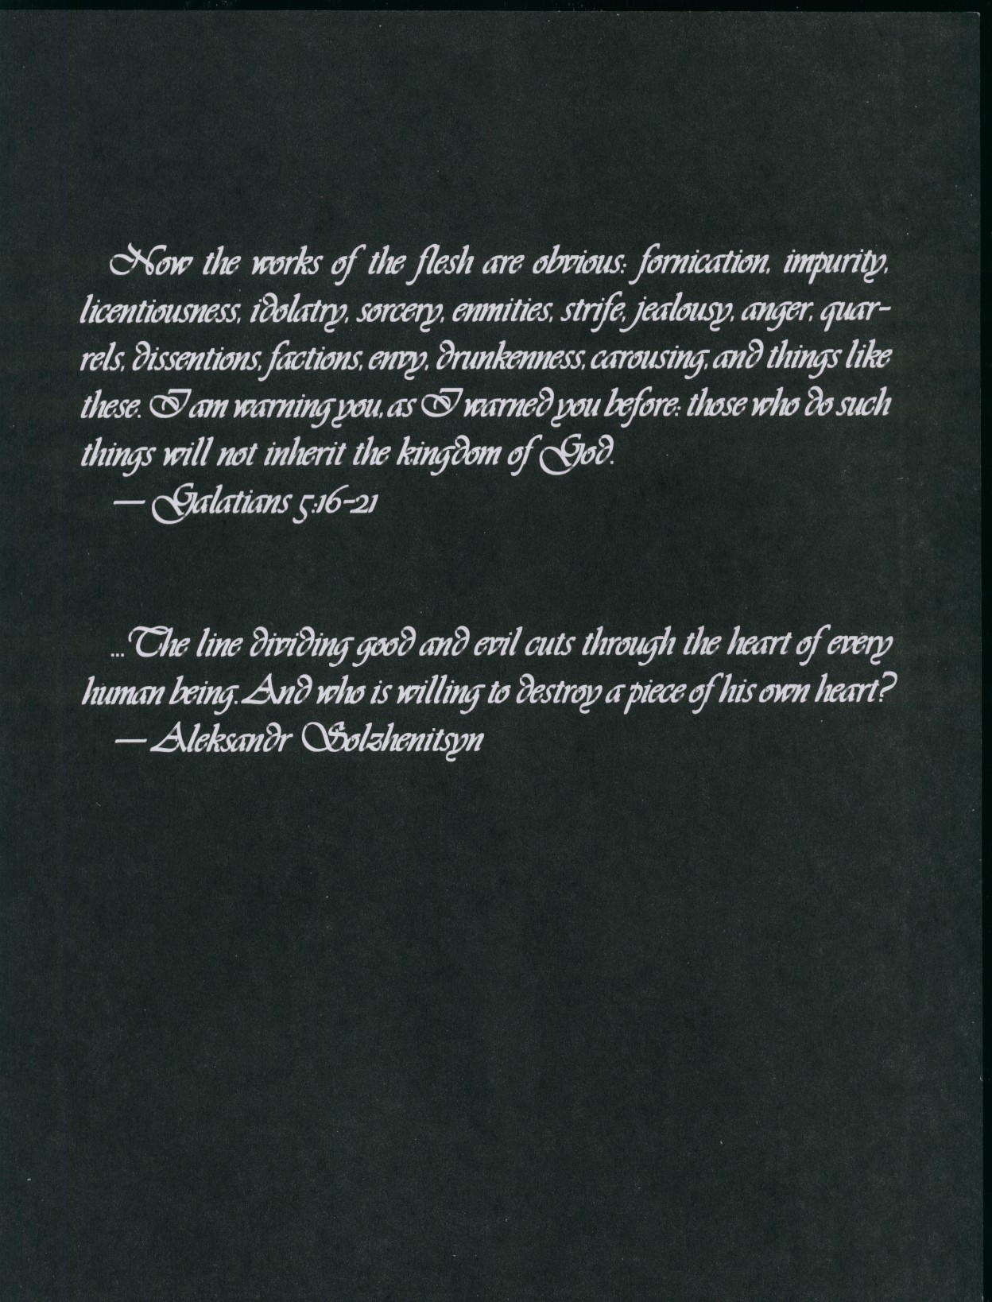



CREDITS
Authors: Bruce Baugh, Chris Bjork, John Goff,
Alan I. Kravit, Robin D. Laws and James Moore Additional Material: Justin Achilli, Fred Garber
and Dana Habecker
Developer: Justin Achilli Editor: Cynthia Summers
Art Director: Richard Thomas
Layout & Typesetting: Becky Jollensten
Interior Art: Leif Jones, Patrick Lambert, Larry MacDougal and Alex Shiekman
Front Cover Art: Patrick Lambert
Front & Back Cover Design: Becky Jollensten
SPECIAL THANHS
Chad "Mycology" Brown, for the deadly salad before the Fatboy Slim show.
Charles "Bishop and Boozehound" Bailey, for keeping the rowdy Sabbat in line with precious drinks. Carl"Handyman" Bowen, forgroping every avail,
able ass at Smellvis.
Tim "You Can Never Leave Home" Avers, for bringing his parents into the office of heathens and infidels.
Rebecca "There'sSomething Wrong WithThese" Schaefer, for having the sense to avoid the cthulhoid candies on the kitchen table.
Diane "Zen Tech" Zamojski, for learning the rigorous martial art of nonviolent copy-machine re­ pair.
DOUBLE-RASPBERRY NO THANHS
TheKnucklehead who stuffed a cardboard box into the kitchen garbage can and let the ants invade.


CIM[ STUDIO
735PWNORTHBLVD.
SUITE128
l'.URKSTON, GA 30021 USA
© 2000 White Wolf Publishing, Inc. All rights reserved. Reproduction without the written permission of the pub­ lisher is expressly forbidden, except for the purposes of reviews, and for blank character sheets, which may be reproduced for personal use only. White Wolf, Vampire the Masquerade, Vampire the Dark Ages, Mage the Ascension, World of Darkness and Aberrant are registered trademarks of White Wolf Publishing, Inc. All rights reserved. Werewolf the Apocalypse, Wraith the Oblivion, Changeling the Dreaming, Hunter the Reckoning, Werewolf the Wild West,

Mage the Sorcerers Crusade, Wraith the Great War, Trinity, Guide to the Camarilla, Guide to the Sabbat and Blood Magic Secrets of Thaumaturgy are trademarks of White Wolf Publishing, Inc. All rights reserved. All characters, names, places and text herein are copyrighted by White Wolf Publishing, Inc.
The mention of or reference to any company or product in these pages is not a challenge to the trademark or copyright concerned.
This book uses the supernatural for settings, characters and themes. All mystical and supernatural elements are fiction and intended for entertainment purposes only. Reader discretion is advised.
For a free White Wolf catalog call 1-800-454-WOLF.
Check out White Wolf online at
http://www.white-wolf.com; alt.games.whitewolf and rec.games.ftp.storyteller PRINTED IN USA.

Bwoo MAcl:, 5"'m ")HAIIM,\lUi(iY



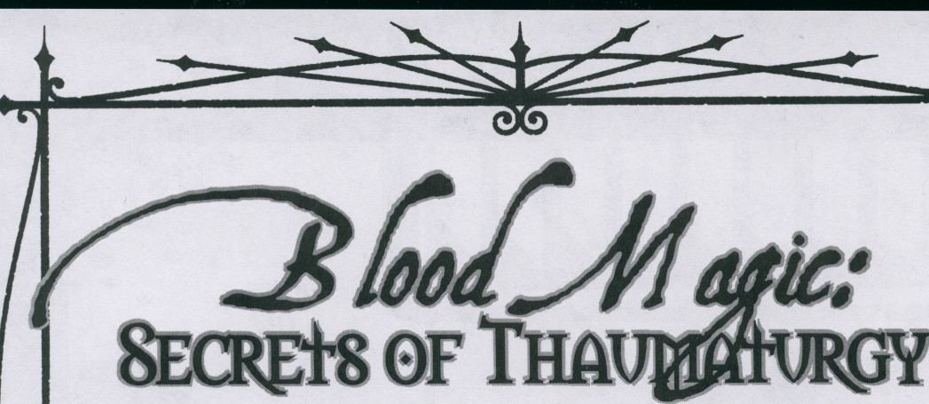




TM
TABLE OFCONTENTS

PRELUDE: TRICHS OFTHETRADE | 6
  INTRODUCTION | 12
CHApTER ONE: THE HISTORY OFBLOOD MAGIC | 18
CHAPTER Two: THERITESOFBLOOD | 30
CHAPTER THREE: THE w AYSOFMAGIC | 66
CHApTER FouR:ELDRITCH SoRCFRIES | 100
AppENDIH: THE FACES OFMAGIC | 134


CoNJINJS


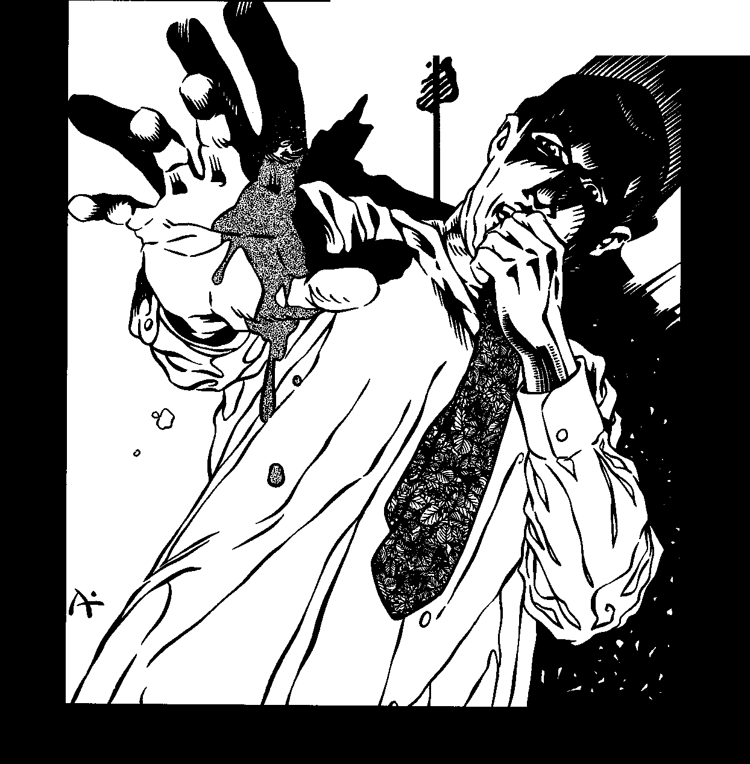


0 • •
0
0

It was four o'clock by the time I made it back to the chantry. Six weeks of stakeouts, shadowing the guy's car, waiting outside the theaters while he watched whatever movie took his fancy that week, and smoking under streetlights like an extra in a gangster movie. Six weeks of giving cops the heavy look and telling them, "There's nothing to see here, officer," and six weeks of minor tension with some snot1nosed Ventrue who leans on the 43rd precinct.
But now it's all paid off.
I pulled off my helmet and heard that damn song Mosely always had playing. It was an awful cover of an old Smiths song, performed by some guy who used to sing with the Psychedelic Furs. Mosely thought it was hilarious at first - the song turned up in some teenage angst movie about witchcraft, and then later as the theme music for a Gen1X television show about three chesty, smiling sorceresses who lived the beauti1 ful life in San Francisco or whatever. He played the song with a sense of irony at first, but then he grew to like it. It drove me up the damn wall.
Mosely was in the living room, as always, and I shook my hair free from the tangle it had be1 come as I tossed the package onto the table. He was reading a messy book that had been bound between the covers of one of those old, three1ringfolders. "What's thi- noN. o, it isn't. It bloody isn't." Mosely always said bloody. He's been dead and in Las Vegas for 20 years, but he's still got the accent
and the idioms. I guess being a vampire makes certain things stick with you. "Oh, Maxie, this is perfect."
The room smelled of burnt sage as Mosely unwrapped the rubber band and unwound the Kleenex. His smooth, dark hands plucked the pink1gray digit from the messy tissue wad. "Oh, yeah, daddy. Yeah. Damn, Max, I swear, I didn't think there were any legitimate prospects anyl where in Vegas."
"And that's where you're wrong, Mose, old boy. Actually, the 13th descendant of a hanged heretic was the easy part," I smiled, showing my sire a bit of fang. "The hard part was finding a real freaking Gypsy in this town. Whatcha readin'?"
"Huh? Oh, an old Daubmannus book. Brock gave it to me on loan. It's not an original, but all the text seems to be there."
"Anything useful?" I wondered aloud. Off with the jacket, off with the gloves. I was going to throw them on the chair, but that was already occupied by a big, gray toad sitting on a pile of what looked to be chickens' feet. I knew better than to mess with a toad in Mosely's sanctum.
The place was a mess, of course, so I just left the jacket on an Ottoman. Mosely was the kind of Tremere who worked in fits of inspiration and left the project "in progress" whenever something else demanded his attention. Cops would have had a heyday with the place: It had parts of murder victims in clear glass jars, an intact hu1

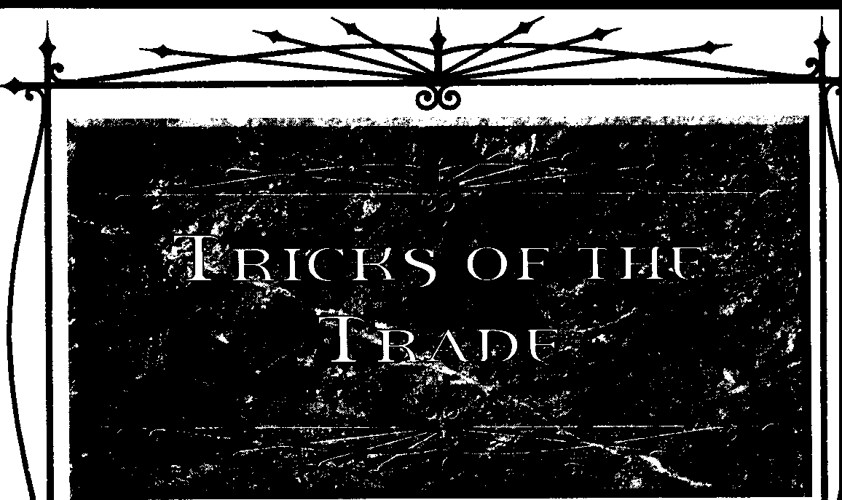
PRr.wDE: TRK:KS OF THET!WlE

man skeleton, at least six grand worth of con­ trolled substances of various types and any number of valuable books that had been reported missing from chantries as far away as Stockholm. Hell, the blue boys at the 43rd would have arrested the both of us just for the look of Mosely's ceremonial daggers. These weren't just drugs and stolen goods, though, which would have gone totally over the cops' heads. These were unique thaumaturgical manuscripts and exceedingly rare ritual components.
• * •
I opened the throttle on the Ducati and roared
up next co Marshall's sedan. He looked at me, and I motioned for him to pull over. He gives me a look that suggests disbelief, but then I show him the envelope.
Never underestimate the power of an un­ marked, legal-sized manila envelope. If someone shows you one, you know you're in trouble. What's inside can't be good.
Marshall followed me off the exit ramp to the parking lot of a Denny's. No one inside cared chat a tall girl on an Italian bike was having words with the guy in the English suit and the sixty-thou­ sand-dollar car. Nothing uncommon; it must happen every night about this time. Just eat your Grand Slam and nobody gets hurt.
"What's this about, then?" asked Marshall. "This had better be important."
"That's for you to decide, Mr. Marshall," I replied.
"Well, then, what do you have there?"
"Just an envelope. I'd like to offer you a trade." Marshall balked. "What's inside?"
"It's a secret. You can find out if you agree to trade."
"Look here, miss, I'll have you know that I'm a very important man, and my time is not idly wasted by-"
"Okay. No deal." I pulled my helmet back on and mounted the bike. The seven-fifty roared as I kicked the starter. Now Marshall decided that maybe I had a something to offer.
"-and I'm sure you understand how strange this all seems," was all I got after killing the engine again.
"Look, Mr. Marshall, the cleat's simple. You want this, and you have something I want. Let's just trade and go on about our business."
TAURANT

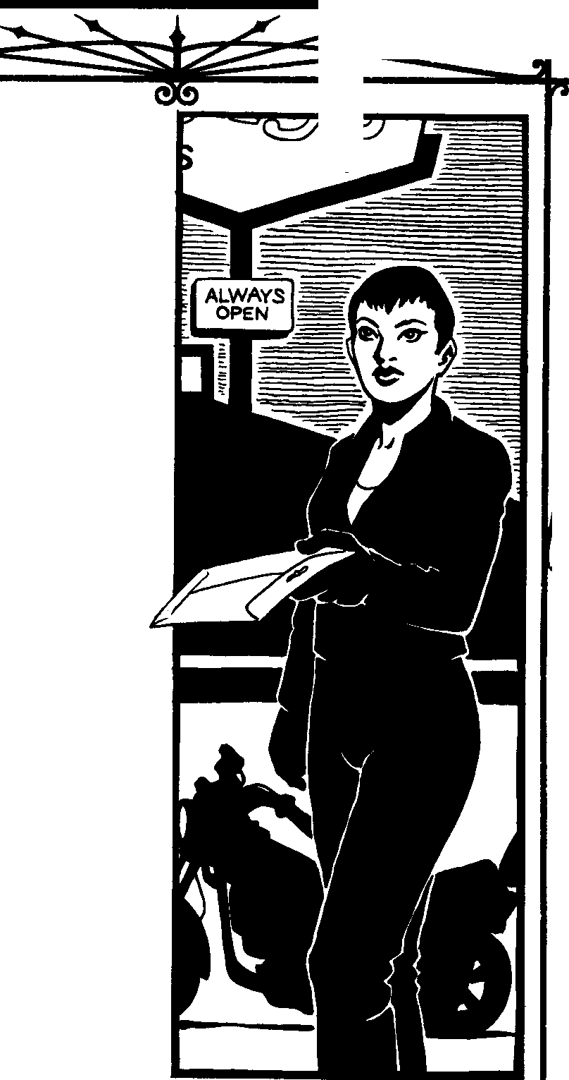

BloooMAac:SECR£JS OFTHAUW.TIJRGY



"Fine. What's your price? You want cash? You want the car?"
"I'm not a thief, Mr. Marshall. I'm a collector. Come with me." I headed inside the Denny's, which had the late-night stink of drunks creeping home from the nightclubs and whores who stunk of stale sweat and old sex. "Come on, I'm not going to bite you." I pulled Marshall into the bathroom, and no one in the dining room contin­ ued to care.
"What's going on here. Is this about drugs? I don't have anythi-"
"Save it, Marshall. I don't give a damn about your money." I grabbed a handful of paper towels and wiped off the countertop. "Let me see your hand."
"What?"
"Your hand, Marshall. Let me see it. You're very busy, and your time isn't to be was-"
"My hand? What do you want with it? What's wrong with you?"
"Give me your hand." I knew it wouldn't work, but l gave it a shot. As it turns out, it did work. Marshall must have a self-esteem problem. He spread his hand, palm down, on the counter.
I took a pocketknife from my jeans, snapped it open, and took off his forefinger at the second knuckle. It wasn't easy - bones are remarkably sturdy. Marshall wrapped his hand in paper tow­ els, and before he finished cursing I was out the door and back on the frontage road.
I wonder what was in the envelope.
* * *
Miranda Werner was not a pleasant woman.
She had to be pushing 300 pounds, and she wore a tent of a dress streaked with rancid stains of unknown origin. She had an amiable enough per• sonality, I suppose, but even that didn't sit well with the subhuman lifestyle she led.
Miranda's home was a trailer perched on cin­ der blocks, and it was as much a pigsty as it was a human dwelling. Half-eaten buckets of chicken grew commendable beards on various surfaces, spilled soft drinks had congealed intosyrupy slicks, and puddles of dog piss - where's the damn dog, anyway? - had become integral parts of the couch and carpet. I was sitting on the sole cushion that hadn't been defiled by pet urine. Miranda talked more at me than to me, preoccupied as she was with the computer in front of her.
"And your maiden name is Tdvetsky, correct?"
"That's right," she wheezed. Even typing tired her out. She was embroiled in an argument with someone named AwitchfyreA in an online chatroom. "Miranda Trfvetsky."
"You're a hard woman to find, Mrs. Werner." "It's Slavic."
"Of course it is. I'm afraid I'm going to have to ask something uncomfortable of you, Mrs. Werner. Are you familiar with the shilmulo of the Old World?"
Miranda stopped typing and turned toward me, her massive head slowly rotating on her obese body. "He's already dead."
The silence became clumsy. "Who is, Mrs. Werner?"
"Peter. That's why you're here isn't it? About Peter's money?"
"No, Mrs. Werner, I'm here about you." "They said it was even. Peter was who owed
them the money, and Peter... no. Now the ac•
count is settled. They said so."
"Mrs. Werner, I'm sure I don't know what you're talking about. I wanted to ask a favor of you."
"What, then?"
"I need you to vex something for me."
"I don't do that anymore. I have to go to bed." Miranda shifted her girth, as if to heave herself from the chair in which she sat.
"Please, Mrs. Werner. Just this once."
Miranda began to cry. "Will you go away and just leave me alone? You and all the shilmulo? Yes, I know you're dead. I'll do it, but only if you go away and tell everyone else never to bother me again." Her words fell apart in the sobs that shook her. A dog outside barked.
"Absolutely." I fished Marshall's finger out of my pocket.
She took it in stride, still crying, but largely unconcerned that she was holding a still-pink severed finger in her hand. With a few words, she handed the finger back to me. Her head fell into her hands as I left.
As I stepped down the stairs, the dog contin­ ued barking. A few lots down, someone was washing their car, and a foot-wide swath of water ran downhill before me. I was surprised to find that I couldn't cross the band of water - I had to walk through the rough flowerbed and onto the dirt road before returning to the part of the lot where I had parked my bike. And my battery was dead.

PRuuOE.:TRICKS or THE TRAD(



With a rolling kickstart, I got the hell out of there.
* • *
"Last step, Max. Just one more night and you'll be good to finish it up."
Mosely meant that he had one more night's worth of ritual casting before we could plant the effigy on the prince. He was all decked out and covered in blood sweat -his thin chest glistened­ with the stuff, which smelled sweet and salty all at­ once. Mosely even had blood and ashes smeared in heavy lines on his cheekbones; if I didn't know better, I might have thought he was a football player trying to keep the sun out of his eyes. Then again, how many linemen know how to invoke 16th-century Greek wards against supernaturally invisible intruders?
One more night. I had one night left before I had to sneak into the prince's haven and plant this shriveled finger somewhere among the prince's personal effects. But, in Mosely's words, "That's what Maxie does - she makes things happen." If you find a six-foot-three, hundred-and-twenty­ pound dreadlocked buffalo souljah in your bedroom, you're probably going to be upset. If you find a five-eight brunette with a biker jacket and a Hollywood smile in your bedroom, you're prob­ ably going to be a bit more forgiving. Believe me, I've slept with the living and pretended to with the dead, and unless they catch you waving a handful of nightshade over a burnt picture of their mother, they all think you've sincerely been watching them and "hoping to get close."
Mosely's plan was to secretly protect the prince's haven from Obfuscated "guests" and later call the prince on the unsuspected boon. Either way, Benedic would look stupid, and better for it to be in the eyes of one Kindred and his childe than every two-bit Lick who staggered into Vegas for hooker blood or to cheat. the casinos. Discre­ tion was apparently the better part of valor among vampire society, but I still had plenty to learn about how things worked in Lost Wages, Nevada. Me, I would have said thank you and killed the guy who did it, but that's probably why I'm not prince.
Mosely drew a circle around the finger with a wax pencil and dropped two handfuls of broken glass inside the ring.
One more night.
* • *
I killed the motor and rolled quietly off the main drag. From the way these neonates and anarchs carry on, you'd thank that princes were like military warlords, with strongholds full of ordinance and private armies, but I've never seen anyone so ostentatious. Maybe it was like that 600 years ago, but it doesn't work like that now. Fence yourself off with a warehouse full of guns and a legion of bodyguards, and the cops'll think you're running some kind of religious cult or drug factory.
No, Benedic's not so stupid as to draw that kind of attention to himself. He's got a nice place
30 minutes from the seedy side of the city - fenced in, patrolled by dogs and a guard at the gatehouse, but it's not like Lifestyles of the Rich & Famous is clamoring for a tour. When you've got as much money as the prince does, you have to spend it wisely or you'll find your name all over the society pages. Benedic's not like that. Good for him.
And good for me. I crept behind a row of hedges, performed a quick ritual to hide my foot­ steps from the grass, and switched my senses into high gear. I could hear two dogs, maybe three, and I saw a security car just leaving the parking lot. Perfect timing,
Hopping the low wall, I got a handful of electrified iron scrollwork. Clever prince. I dropped to the ground inside the grounds and willed blood to my burnt hands, vowing not to be so reckless next time.
I dashed across the yard and onto the patio, where I could see inside through an open set of French doors. Prince Benedic was talking to his aide, Montrose, a twisted freak of a Nosferatu. I smiled to myself- a few of us suspected Montrose was sneakin' and freakin' when the prince didn't know he was there, and Mosely's little trick would put an end to that (for the next month at least). When you're dead, it's the little stuff like that which matters.
In a flash, I was up the masonry. Another brief incantation opened the lock on the window, and I was in the house. I had to do this while Benedic was actually at home, or else the security system would have pegged me. Yeah, I could've crashed it, but that's a bit suspicious. Two minutes later, and Marshall's finger was hidden among a rack of Prada suits. Three minutes later, and I was back on my bike, headed havenward.
• • *


81.ooo MAGK:: Sm[]'S OF THAUMAruRGY

Mosely's ruse worked. Two weeks later, one of Montrose's flunkies was found behind a statue in one of Benedic's sitting rooms. (One of Benedic's sitting rooms. Disgusting.) The prince made a big deal about it, and Mosely stepped forward, put­ ting on a big show about how he had feared this very thing and confounded it with his own tal­ ents. Now we're in good with the prince. We're supposedly in with Montrose, too, but that's be­ cause he can't acknowledge his involvement. I can see the looks he gives Mosely, but we're the ones holding the cards - and he doesn't even know about me.
Still, it makes me nervous. Any knowledge of our magic at all would let the prince know that we had cheated, that we had made him our unwitting subject. I don't think he'd be too happy.
For the time being, though, it works. Mosely has some newfound respect among the young vam­ pires - "Look out for Mosely, 'cause he gots ways to find you no matter where you hide!" - and some weight with Prince Benedic now. As long as we can keep our own secrets, we'll keep calling the shots. But how long can we keep our secrets?




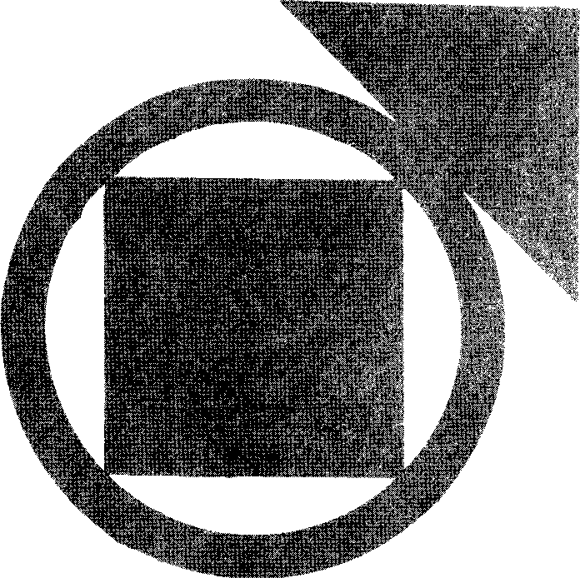

PRELUDE: TIOCKS Cf THET!WlE

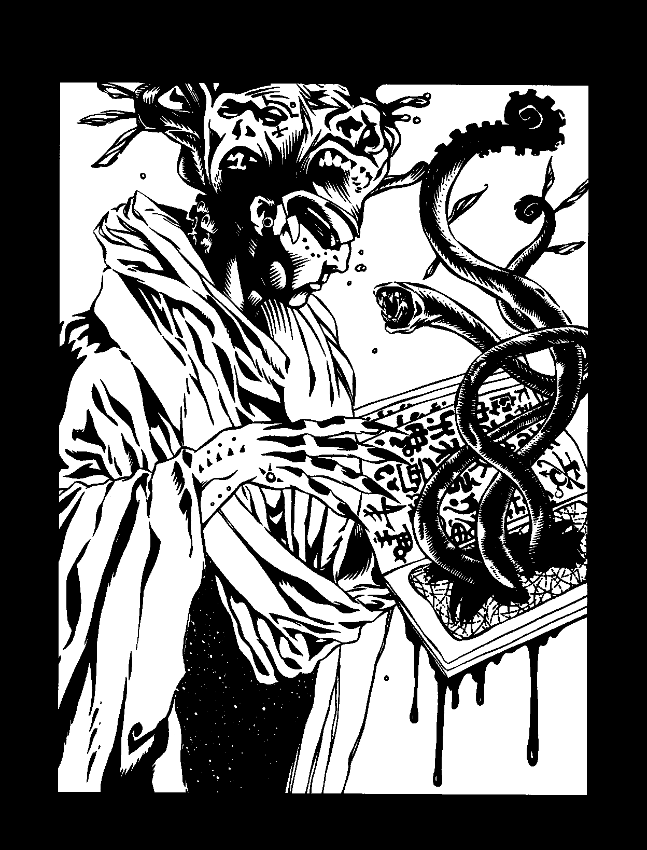

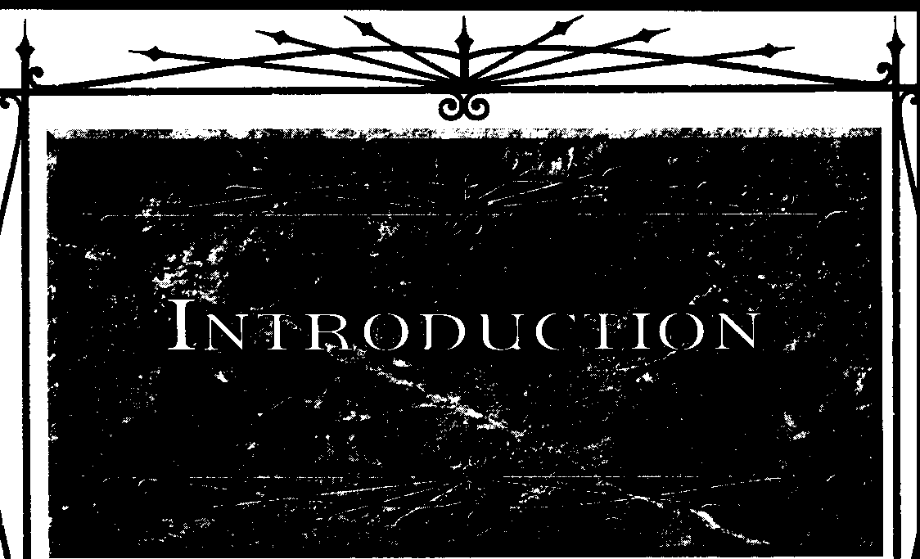

I'll tell you... something of the age-old horrors that even now are festering in out-of the-way comers witha few monstrous priests t:o keep them alive. Some people know things about the universe that nobody ought t:o know, and can do things that nobody ought t:o be able t:o do.
- H.P. Lovecraft, "The Thing on the Doorstep"

This is a book about the magic vampires perform with and through vitae. Most vampiric magicians use the Discipline of Thaumaturgy in some form or another, but it wasn't the first form of blood magic, and even now it's not the only way to exploit the powers innate in vitae. The magic of the blood expresses itself many ways.
Practitioners ofThaumaturgy force their will on the world, changing the behavior of their environment to match their own desires. Living scholars, those few who know anything about undead magicians, generally assume that the magic of the blood is a watered-down version of what the still-living call "hedge magic" or "true magic" or something similar. Thaumaturgy in all its forms is a distinctive art, and while some of its effects echo those of other sorceries, its very essence depends on the vampiric condition. Without vitae there is no Thaumaturgy. It starts with blood.
The roots of blood magic run deep. As long as vampires have prowled the earth, some Kindred have sought to gain powers through the blood that they couldn't create any other way. Almost every generation of vampires active in the mod­ ern nights includes some practitioners of Thaumaturgy in various forms, and the oldest known blood magicians allude to older magi­ cians now destroyed, inactive or disappeared. The Tremere brought organization and visibility to blood magic; they codified it, but didn't in• vent it.
Blood magic isn't pleasant. The thaumaturge bums through his very essence- and that of othervampites
- in an effort to make the wotld into what he wants. This requires enough ego to feel worthy of imposing one's will on the world, enough discipline to master the intricacies of arcane formulae, and enough ruth­ lessness to ignore the moral costs of harvesting so much blood for personal ends. Humanity tends to

INl>OOOCOON

wither in the face of the thaumaturge's willingness to exploit his own kind for the sake of power. Disregard­ ing others as moral concerns makes the blood magic so much easier, after all, and it frees the magician to really explore lines of investigation without troublesome ethical concerns....
Skillful thaumaturges can visit the world with rains of fire, earthquakes, floods, lightning and other impressive displays of power. They can siphon the blood from their victims, curse them with barrenness and give them the fabled "evil eye." But not all blood magic produces such flashy results. Reshaping the world requires more than spectacle; it takes time, effort and transforma­ tions that work deep in the essence of all things. Thaumaturges spend nights, weeks, years and even decades crafting magical effects, most of which won't ever be noticed by anyone else. That's often the point: A ritual that instills a new desire or saps another's willpower should remain secret.
Thaumaturges do not forget that Caine could, or so the stories say, create entire Disciplines by an act of will. He could make himself and his childer into whatever a task required them to be.
Blood magic aims to recreate that state of mastery over self and the night. For the dedicated magi­ cian of the blood, true triumph consists of removing every barrier between will and result. The blood whispers its potential, and however far a student of its secrets goes down the road of insight, the whisper always lies beyond, remind­ ing her of all that she's not.
THEFORMSOFTHEPOWER
Almost every thaumaturge dreams that his will may some night become the will that gov­ erns the world. In the meantime, paths to mastery come in as many varieties as the souls of thaumaturges. Blood magicians often laugh at the aspirations of other vampires, comparing Kindred without Thaumaturgy to mortals stum­ bling across the landscapes of a moonless night. Thaumaturgy provides a bright light. Thaumaturges making this analogy seldom stop to think that the light makes their surroundings clear, but only at the cost of destroying their ability to see what's beyond. Every system of knowledge is also a system of ignorance.
Most vampires associate Thaumaturgy ("the per­ formance of miracles") almost exclusively with the

J l





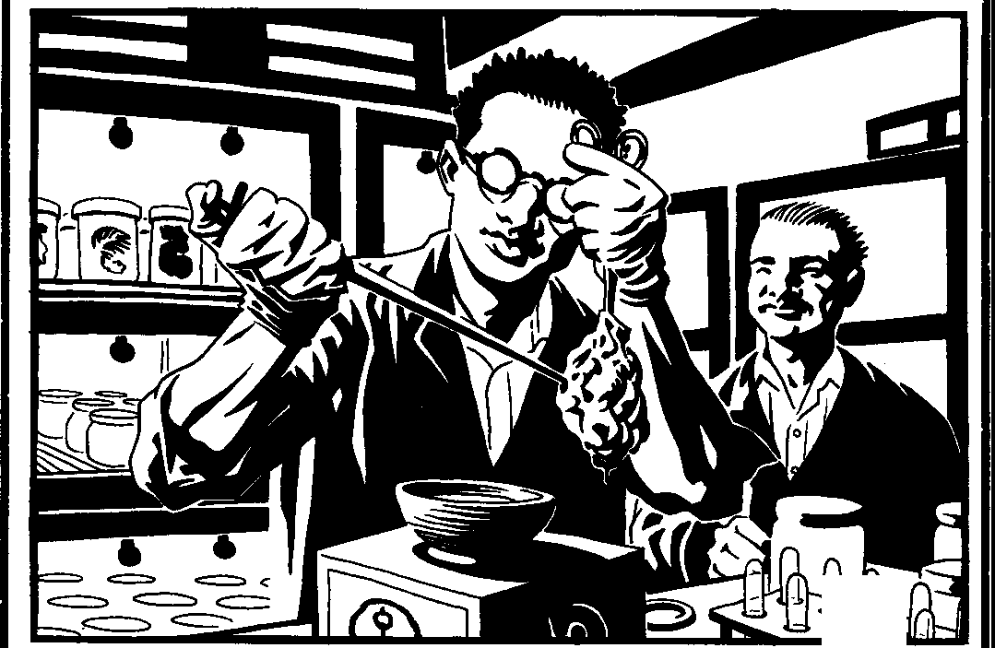
lk.ooo MAGIC: SECRaS OFTHAUMATURGY

T remere.TheTremerecertainlybroughtunprecedented organization and fresh perspective to the search for mastery of the world through blood. The clan's hierar­ chy allows it to systematize research and teaching, producing more competent thaumaturges every cen­ tury than most magical groups have had since the first nights. The clan pays a price, however, in failing to recognize the validity of some paths and the potential in others. Neither do the clan's members realize just how many other thaumaturges Kindred soci­ ety includes. Early Tremere conflicts with other sorcerers built a reputation that lingers long after the clan's leaders recognized the drawbacks of intellectual poaching and gave it up. Still, the Tremere earn their reputations as masters of Thaumaturgy, by sheer force of numbers and coherence in practice.
The vanishing Tzimisce koldun keep their secrets to themselves. Even their own clanmates know little about what power the koldun draw from the spirits in the depths of Eastern Euro­ pean shadows. When it's necessary, the koldun venture forth to bring down death or malefic "justice" on their enemies, then return to their craggy havens. Few threats rouse them, but noth­ ing works so well as hints of Tremere spies or even outsiders only dimly connected to the War­ locks. A few embittered koldun seek constantly for some way to deny the Tremere access to the powers in their stolen blood.
In isolated fortresses, unknown to their own clan as well as the rest of Kindred society, Assamite viziers labor as they have for centuries. They tally the blood harvested by their warrior cousins, and use it to probe the mysteries of the many worlds. They learned long ago how to command spirits and uncover the secret patterns within the world. Now, in the Final Nights, the old fortresses have other gates and the world finds unexpected strongholds, far from Alamut and the deserts, where masters of blood lore stand ready to advance their clan's interests.
Set's children pursue their own studies. Few outsiders learn just what Setites do with their distinctive sorcery; fewer still even know that it exists at all. Setites know a great deal about the harvesting and wielding of secrets in ways that don't attract attention, and enemies of the Ser­ pents fail to grasp just how much blood makes its way through Setite nests.
Other, parallel magics have grown alongside Thaumaturgy. The coarse Giovanni art of Nec­ romancy sprang out of variations on established thaumaturgical practices during the late Middle Ages. Over the years, various contacts and ad­ versaries of the Giovanni have learned or stolen the Giovanni's secrets, turning the death-sor­ cery to their own ends. Like the Tremere, the Giovanni are considered masters of their art, but a few others wield the magic with equal or greater potency.
PLAYING THEMAGICIANS
Thaumaturgy isn't like most Disciplines: It's a framework that can support endless expan­ sions. Further, many of its techniques can't be hastily conjured up in the heat of battle. An effective thaumaturge must be prepared to plan, for not every path is a bellicose display of fiery sorceries.
To creatures driven by whim and impulse, preparation itself seems magical. A good thaumaturge comes ready for all sorts of situa­ tions, and can unleash forces she's gathered together in advance of an emergency. It's not that Thaumaturgy provides greater power than other Disciplines, but that thinking ahead al­ lows the thaumaturge to store up resources. Martial-minded thaumaturges compare it to mak­ ing sure they have extra ammunition. With skillful selection from among a character's avail­ able techniques, a thaumaturge can create the impression of far greater reserves than she actu­ ally wields, if she can produce the right effect for the occasion on a regular basis.
Remember always that a thaumaturge often sees herself as on the way to a position of power most Kindred never dream of. She may take great pride in her achievements, and always feel driven to the next step up. Above all, she must know what she can do, and have plans on how to build on that knowledge. The world might be hers, if she acts just right. Let the other vampires dream of social reform, political connection, wealth and other distractions; the thaumaturge might some night rebuild the world itself so that none of those things count anymore. In the meantime, she knows she's a figure of mystery to others, and exploits that to her advantage.



INl1<lOOCOON



MEANWHILE, BACH IN THEREAL WORLD
This book does not pretend to be a primer for
occultists who would take their game into their real lives. This book is a work of fiction and a supplement to a storytelling game. If you are using this book co cast spells, you are just as big a bonehead as the person who uses it to "prove" how roleplaying games are terrible, evil things that make monsters out of nice children. Get a grip, or find something better to do with your time.
Now that that's out of the way....
SY5Tl!MSAND 'STORIE'')
Although this book explores the secrets of Thaumaturgy, we've made the attempt to move beyond the obvious "book of spells" concept. In fact, of this book's many words, only about half are devoted to game systems and new powers. While this no doubt puts the book into the "that sucks, I wish it had kewl powerz" column for many people, those who are looking for storytelling hooks for their chronicles shouldn't be disappointed.
Additionally, we have left much in the hands of individual Storytellers. The fiendish among Storytellers can derive no end of dramatic glee from sending their troupes' characters after hard­ to-find thaumaturgical components, or by having the rites of blood magic go awry and observing how the characters deal with the situation. Thaumaturgy is much more than just a Disci­ pline; it's a great way to add depth or sub-plots to your stories, it works perfectly when used to create the subtle "creep factor" of Things That Are Not Meant To Be, and it's even an intellec­ tual pursuit for characters who enjoy searching after lost tombs and forgotten libraries in the manner of Lovecraftian horror stories. Make it work for you.
Also, in the interests of helping the Story­ teller, we've left many of the finer details unexplained with regards to ritual and effect. Some Storytellers may prefer to get right to the action, skipping the components and prepara­ tion for blood magic rituals, while others may choose to evince horror from them. Does it make for a better story to assume the action takes precedence, or do you favor the horrific detail of
characters eating spiders and meticulously cast­ ingnumerologiesfor their effects?The choice is yours.

The practice ofThaumaturgy has spawned an enormous body of specialized language. The pur­ pose of this lexicon is to establish a common ground for those terms. Colloquially, words may acquire different meanings, however, and this list should by no means be taken as gospel.
Bokkor: A sorcerer who practices voudoun
for purely personal gain.
Formula: The compilation of the ceremonial steps of a ritual and any ingredients required by it; an "instruction manual" for performing a spe­ cific ritual.
House: A specific sect or faction of magi­ cians. Clan T remere is widely accepted to have been a house of mortal magicians, and since becoming a clan is suspected of having internal houses as well. Examples include House Goratrix, House Etrius, etc. In many cases, chantries refer to themselves as houses, but these are geographic distinctions rather than philosophical. Still, the distinction is just as valid.
Ingredient: A specific item required by a formula to enact magic through a ritual; the ingredient may or may not be consumed during the ritual's performance. Sometimes known as a component.
Necromancy: A tradition of magic that deals with unwholesome death-energies and the dead. When capitalized, it refers specifically to the vampiric Discipline of the same name.
Path: A formal, codified "school" of magic that combines a progression of effects united by a common concept. A path may focus on effect (the Lure of Flam.es), a component (the Path of Blood) or any other ideal.
Rite: The actual ceremonial procedure used to perform non-path blood magic.
Ritual: A set of behaviors that produce a reliable effect, most similar to the fabled "spells" of wizards. A ritual often requires time to cast as well as some sort of physical component that serves to focus the blood magic on the task at hand.
Sending: The end result of a ritual's magic; the effect of a spell, particularly when baneful or focused on an individual.

BLOOD MAGIC: StcRm OFTHAUMATURGY



Subject: The recipient of a benign, benefi­ cial or indirectly problematic thaumaturgical effect. Target: The recipient of an actively hostile thaumaturgical effect, sometimes known as a
victim, as well.
Thaumaturgy: Literally, "working miracles." Loosely defined, any blood magic. Also, the
unique Discipline of Clan Tremere, or any of its
paths or rituals.
Tradition: A system or style of magical prac­ tices. Common examples are Hermeticism, Kabbalah and voudoun.
Working: A less-used variant of sending, most frequently found in reference to necromantic practice.

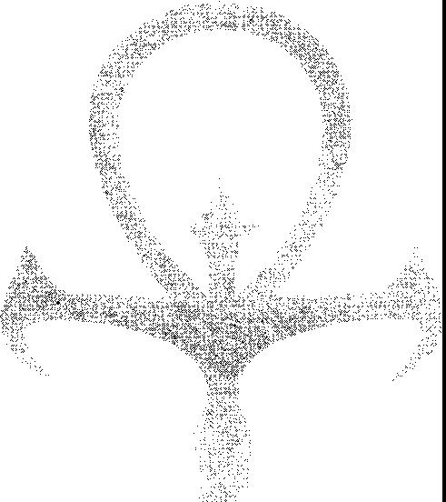



[NIRODUCOON

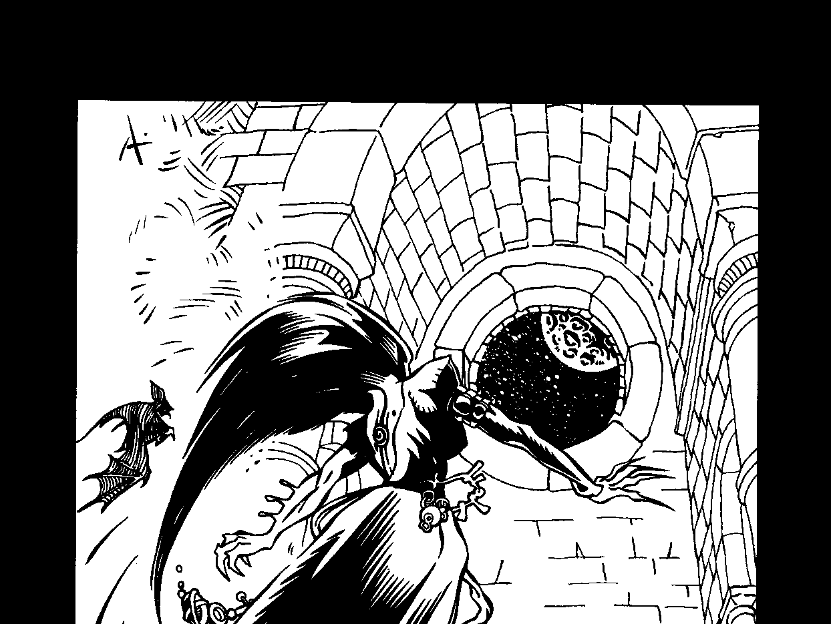
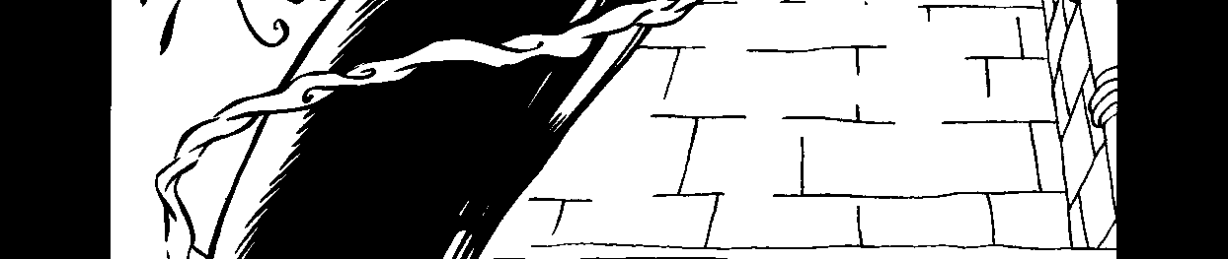
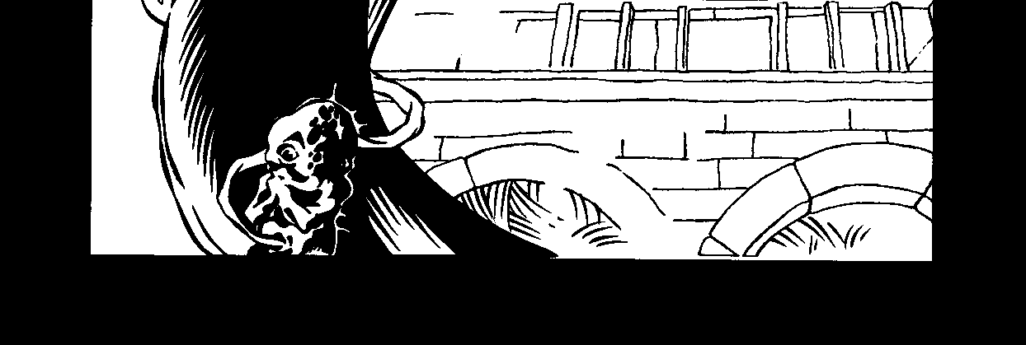

I I

r

"Child of ill-starred fortunes!" he exclaimed in a hollow tone, "dost thou come to pry into the secrets of futurity? Avoid me, for thy life, or, what is dearer still, thine eternal happiness! for I say unto thee ... it is better that thou hadst never been born, than permitted to seal thy ruin in a spot which, in after years, shall be the witness of thy fall."
- Anonymous, "The Astrologer's Prediction"

Thaumaturges fill their havens with records; any­ one who finds the opportunity to read the accumulation must prepare to spend many nights at it. As is typical with the Kindred, almost all thaumaturgical records fall into two categories: the unusable and the unreliable. The really important information either stays in the magician's own memory or it nestles beneath protective layers of cipher and symbolic language. Anything that anyone else can readverylikely contains atrap, whether dangerously incomplete information, misdirection about paths of research or some other form of trouble-making clue. To obtain anything useful from a thaumaturge's records, one must know more than the first, so as to detect the traps (and in which case, why bother?) or practice code-breaking with prodigious expertise or luck.
Curious parties therefore have no way to get the whole story about the magic of the blood. Too much becomes obscured over time, sealed away by destruc­ tion or seclusion. Too much of what remains can't be trusted, in part or whole. I hope this account is true as far as it goes. That's all any chronicler can hope for.
MAGIC INTHE

FIR5TNIGHT5
Some thaumaturges claim Caine as the first magi­ cianof the blood.Ofcourse, every vampire with delusions of pedigree claims Caine as the first whatever-it-is, and you can believe them or not as much as you want. The claim's not quite so ludicrous in this case, though.
The theory of Caine the Magician starts with the obviously true fact that no other Discipline approaches Thaumaturgy's scope and flexibility. It's more like the primal power of Discipline creation legend attributes to Caine than any other power in Kindred blood tonight. The theory goes on to say that Caine sought God's power to make the world ex nihilo, by will alone. Some force - take your pick of Satan, the True God or something else - showed Caine that the route to this power lay in the transformationof himself.Caine killed Abel willingly, wanting God to curse him in response.

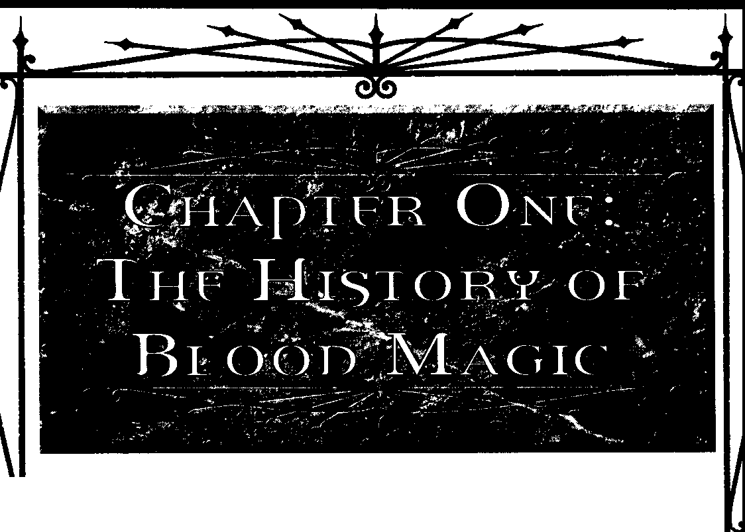

THE HISTORY OF lli.ooo MAGIC

Once gifted with unlife, he took the first step toward stripping away all barriers between his will and power. There may be some truth to the account, or none.
I myself, however, consider it absurd as a matter of
personal faith. For instance, for all the rumors of awak­ ening Antediluvians, Ican find no real proof that Caine ever existed. The story could be an elaborate allegory about the potential ofThaumaturgy and its costs. Per­ haps Caine was real, but this story doesn't get anywhere near his thoughts and motives. I report it here because it provides insight into how my fellow magicians think about their place in the scheme of things. We dream big dreams, bigger than the petty delusions that fill most half-blinded Kindred minds. Whether we retrace the
steps of our Father, or blaze a path toward a possible consummation, we seek to make the world fully and precisely what we want it to be.
THE MAGICIAN'30FTHE5ECOND CITY
If even agrain of truth exists in vampiric lore about the Second City, then blood magic of several kinds flourished there. Please note that nobody then prac­ ticed what we call "Thaumaturgy." The experience of forcing one's will on the world through manipulation of vitae isn't the same for all whoshare it, and they quickly developed different names for it. Even the term "blood magic", as general as it is, wouldn't please some practi­ tioners. At rudest definition, any Discipline involving the use of blood might be considered "Thaumaturgy," and I'm sure you'll see the problem therein. None of the early studies, moreover, had anything like the system­ atic structure that various forms of blood magic use in modem times. A scrap here, a line of investigation there, everything existed only in parts. In retrospect we can see how the early sorcerers' work would converge, but that wasn't obvious to anyone then.
- Assamites: The childer of the Eldest Grandson included students as well as warriors, though we seldom hear about the more peaceful sorts tonight. Some pur­ sued worldly scholarship; some studied the secrets of the blood. The clan's progenitor himself developed new techniques for interrogating the blood for insights use­ ful in his pursuit of justice. For many of his childer as well, power took a second place to insight as a goal. They gained power in the process, because they couldn't help it; past some threshold, knowledge and power are one. Unlike others of the time, however, they focused far more on knowing the world than on changing it.
- The Clan of Death: Whoever existed before the Giovanni - called by turns "Ashurians" or "Cappadocians" - sought answers to the mysteries of death in many ways. Using vitae as the gateway of
examination no doubt occurred to the elder of this line, or some apt childe, early on. For some reason, however, the work foundered, and the clan turned to other paths. What might have become afoundation forThaumaturgy, given the Cainites' reputed dependency on systems, withered in the face of the more obviously useful early Disciplines. Their small stores of lore went to other clans in trades for information the Ashuriansdeemedof higher priority.
- Tzirnisce: Koldunic sorcery wouldn't take shape until much later, in another land, but even in the Second City some Tzimisce sought the power to trans­ form the world as a natural concomitant to their power over themselves.

When I embarked on chronicling the history of Thaumaturgy, moralists among my peers warned me that it was a "study soaked with blood," a"body of knowledge predicated on suffer­ ing." fu it is now, so it was in the beginning. The streets of the Second City must have been filled with blood both human and Kindred, given the feeding needs of the oldest members of our race. Nowhere would the blood have been thicker than in the havens and labo­ ratories of the first magicians of the blood. Experimentation requires many failures for each suc­ cess. Knowing how much effort goes into the slightest
progress Iormy chantry-mates make, Icanonly imagine the torrents of blood and vitae, the chamel mounds of bodies that must have accumulated.
Other Kindred moralists seem tofeel thatsuchcosts in and of themselves make blood magic the province of the Damned. They are fools. If they were to tally honestly the costs of simply maintaining themselves, they would face the equivalent of whole slaughter-





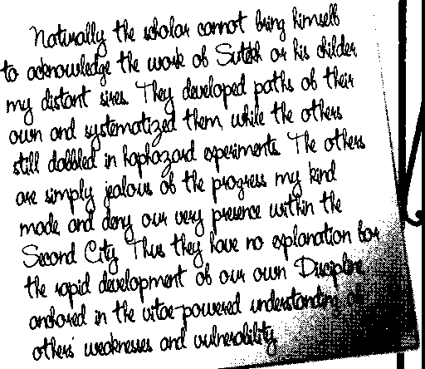
B1000 MAac:: SECRElS orTHAUMA.TUFLY



houses. Where their unlives bring nothing but prolong­ ing the current state of things, mine brings the great consummation that much closer. Every bit of knowl­ edge we gather, everything we learn about how to force our will through vitae to the essence of existence, frees us from dependence on the prison that is the world. How can I regret purposeful expenditure of otherwise useless, stagnant souls?
In time, of course, the Second City fell to fire and violence. Kindred institutions don't last, and won't until we the worthy transform the rest into creatures fit forourends.The survivors of the city sought scapegoats. My predecessors in blood magic provided handy targets, given the very visible costs of their work and the inevitably secret nature of their results. The magicians could have shared their knowledge to persuade the others, but that would have been as foolish as unre­ strained Embrace or arming the mentally defective. So the magicians suffered, and scattered.
ACROSS THE AGES
When you understand what vitae can be, it be­ comesfatuous to rely upon"clan"as the basis of identity. We see all vitae as pieces in a mosaic whose final form eludes us. It makes no sense to glory in the particular fragments of color or texture one possesses, rather than striving earnestly to grasp the whole. Knowledge of vitae's meaning wasn't muchshared in the Second City, but at least some exchanges took place: a line of formula here for a technique of filtering there. After the city fell, even that trickle of exchange dried up. For countless centuries tocome, very nearly every encounter between magicians of the blood would be hostile.
I must here write of a span of time as long as recorded human history in scarcely more space than typical puling neonates might take to list the oh-so­ impressive accomplishments of his sire, and his sire's sire, and soon back intofairy tales. Remember that this work is, like the vitae that rouses you to unlife, a piece, not the whole. I write what I believe it appropriate to tell, but I could take this space again and write equally worthwhile elements of the story without once repeating myself.
THI? INNl?R W ASTl?S
Caine, the stories tell us, went east of Eden. A few coteries of magicians emulated him, heading into what were then still fertile forests and plains deep in the interior of, presumably, Asia. The winds blew differ­ ently in those nights, carrying enough rain to support whole societies of which modern kine sages know nothing. The tribes that wandered those lands were primitive, and readily accepted creatures of the night as one more sort of predator in a world full of dangerous mysteries. The magicians easily moved into the role of semi-divine overseers. In just a few mortal generations, all the energy of belief that the tribes once spread among various sorts of spirits concentrated itself into propitia­ tion of the Lords Like Men, who received as their sacrifice the gift of blood. These primitive echoes of the social order of the Second City developed new patterns of life, and held there while the outside world went on its own way.
A few of the blood magicians cooperated witheach other. Most didn't.The majority understood that there's nosuch thing as a safe exchange of knowledge, and that power must stay in the hands of the fittest. To this insight they added the blind conviction that they were of course the fittest. In a fairly small space, rival magi­ cian-vampires developed very different paths of power. Some used blood manipulation to turn whole family lineages of mortals into mindless extensions of the magician's senses and will. Others crafted exotic crea­ tures by fusing what we'd now call the genetic material of diverse species, together with the spiritual essence we make sure scientists fail to understand. Still others gave up their own bodies, transplanting their vitae into host organisms like the branches of an exotic flower. In at least rudimentary form, innovations in the inner fields foreshadowed many of the breakthroughs other undead sorcerers would make later.
It could only end in violence, andso it did. The less successful blood magicians resented their humiliation and sought to topple the competition, while their more successful competitors each reached to subsume all the blood resources of the area. The conflict lasted a full mortal generation, and included the sacrifice of literally every human being across a thousand-mile expanse. The only survivors were those who managed to flee beyond the summoning of their vampiric masters. Once blood that had flowed in sentient veins could no longer be had, the blood magicians began sacrificing each other and trying to transmute the mindless environ­ ment; I have seen fragments of rituals intended to leach some measure of force from sap and iron pyrite, for instance. The land died. It remains dead tonight. Modern

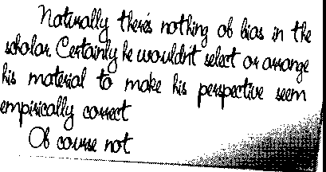
THEHtsroRY orBlooo MAoc



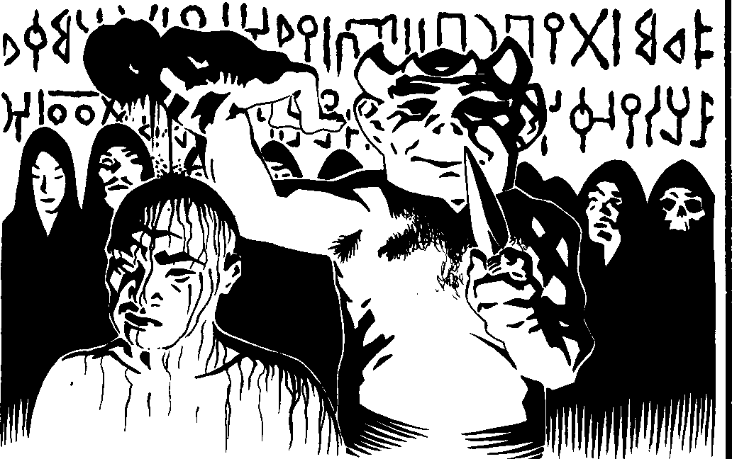
cultures refer to the Altai Mountains and the Tarim Basin as an example of changes caused by the end of an Ice Age. Those of us who know better merely smile, when we do not glide through the shadows in search of havens not yet lost to wind and storm.
There would not be another such gathering of blood magicians until the rise of the T remere clan.
THEPA55INGOFTHEANT{'Dll.UVIAN5
Gradually, the Kindred of the Third Generation fell into ever more frequent torpor. During this change, blood magic made its way (in small quantities) into every clan.Childer oflater generations felt asharpsense of disconnection from their legacy in the vitae, as the opportunity to speak with those who'd known Caine passed. More and more, the Kindred of those nights realized they would have to build their own frames of reference. In that environment, blood magic naturally appealed to vampires with sufficient discipline, for it promised to break down the hardening barriers of clan, lineage and the like.
Few of the new students of the blood made any effective use of their subject, it goes without saying. Most merely irritated elders and eventually slaked their thirsts. Some did manage to at least partially transcend the limits they'd inherited. From time to time in ages to
_come, strange circumstances in the midst of what should
have been routine Kindred affairs turned out to stem from some auto-didactic thaumaturge, one Kindred alone or a small cabal. Most often the circumstance was the not-quite-correct imitation of some other clan's Discipline. Freak displays of auroras, for instance, can stem from botched efforts to make auras visible: The magician's own aura becomes amplified and embla­ zoned across the sky, attracting even observers who normally know nothing of what Auspex can show. A fair number of remote towns died when an effort to produce thaumaturgical mental suggestion succeeded in granting the magician an air of authority so powerful that every mortal who encountered it died of fright immediately. Mistakes were made.
Thaumaturges usually face asmuchsuspicion within their clan as without; they cannot afford to become enmeshed in the big affairs of social and political warfare. Instead, they operate on the small scale and through servants of many kinds. Where one findssocial chaos, it's often the external manifestation of Kindred conflict. Where one finds confusion in the realm of the material, with violations of"natural law," that's thesign of blood magicians in conflict.
All of this stands quite apart from the most usual problem blood magicians face: acquiring and disposing of sufficient vessels to provide them with the blood they need. The demands of research escalate until the final




BLOODMAoc:SECRETScwTHAUMAl\ID'



triumph in a given process. Many ancient and modem accounts of communities wiped out by "disease" cover for the truth of mass exsanguination, with or without accompanying magical manipulation of the blood's carriers. Clever thaumaturges also discovered not only how to exploit mass migrations of people, in which disappearances go unremarked, but how to spread the desire to move. We take no glory in being the secret movers of human affairs. It is nonetheless a fact that tribes from Manchuria to the Yucatan have sometimes moved because we directed them to, and that what seem the random depredations of migration were truly our handiwork.

CLASSICAL ANTIQUITY
At this point, a history of more conventional Kin­ dred activities would drag out the usual claims to fame or infamy. They don't matter to blood magicians. What have we to do with idealistic communities or the destruction thereof, or with the manipulation of this religion or that?
BLOOD INCARTHAGE
For us, the legacy of Persia, Greece, Rome and the all the rest consists not in crumbling edifices but in accumulating scraps oflore and the gradual unification of lines of research. Although the Brujah largely place little value on blood magic, many of the elders of "my kind" still think well of the Carthaginian experiment. Such steady streams of sacrificial blood made our work easy. Oh, the blood magicians working secretly within the Brujah "Utopia" still had to labor as hard as ever to secure Kindred blood, but at least mortal blood came to them with a minimum of effort.
In that era, no Kindred harbored a real sense of Thaumaturgy as a single Discipline. What we now think of as paths of Thaumaturgy existed as separate entities. Sometimes they merged, when a blood magi­ cian realized how a set of separate techniques could be linked conceptually, but only visionaries dreamed of bringing all the paths together into one concept. That vision became more popular as a result of the Carthaginian era, when what had been more than three dozen paths of blood magic coalesced intoa mere dozen. Unity then seems a viable goal.
The Brujah claim to despise Kindred societies founded in blood, though I do not find it written that they resisted the rising Carthaginian prosperity despite itsdependence on sacrifice. Nor did they spurn the help of others in keeping the blood of challengers weak. They objected only when the conflicts among factions of Cainites made them feel uncomfortable. The
Malkavians and Ventrue withdrew, taking their special insights and protections with them, and not long after that their precious city fell. But the enlightened reader has no doubt learned all about fabled Carthage - and likely knows more than the most vociferous young Rabble.
BLOOD ANDSpIRIT
Our kind has always dealt with spirits of various sorts. The natural companion to study of the blood is study of those beings who lack blood or vitae. Blood summons many beings who apparently yearn for more contact with physical existence, and we oblige them gladly. If they remain so bound by ignorance that they do not appreciate the virtues of leaving the world behind, then we do them a favor by binding them through command to serve ones such as ourselves, with wisdom the spirits should acquire. The rise of mystery cults among humanity made our work easier for two reasons. First, the masses became accustomed to the idea that real power might be found only in secret, and second, the bizarre trappings of initiation became well enough known that our own havens could be passed off as just more of the same.
So while some of our kind unified their paths with the unoffered assistance of the Brujah, others refined the paths of dealing with spirits. The very existence of souls without bodies raises all sorts of theological ques­ tions, which I do not propose to address at length here. I don't believe that we have nearly enough evidence to say for sure what sorts of gods or devils there really are, since I know that what we summon depends at least in part on our own expectations.
Something's out there in the interstices of the world, waiting and watching for humans and vampires capable of calling into the empty places. What it may be betweencalls, I cannot say, It could be thatsome human religion actually does provide a true account of the spirits. Perhaps it's all undifferentiated potential, given form purely and only by our wishes. God's truth, Ithink, lies somewhere in between, but I do not know where to strike the balance. All I know is that the practice of summoning brings forth creatures much like what we call but not necessarily identical with our expectations, and that binding gains or loses effectiveness depending on how closely we match the process to the sort of being just summoned. The rituals that bind a Christian or
Jewish devil don't work so well on a Phoenician baa1or nomad's fetish.
The expansion of trade and other contacts between societies made these conflicts of practical as well as theoretical interest. Some Kindred embroiled them­ selves in mortal conflicts, blessing and cursing in

THE Hl510RY OF llwoo MAGIC

exchange for payments of various sorts, and found their work with spirits becoming ever more complex. I've seen Ugaritic records left by blood magicians who decided to try changing mortal society so as to return things to a simpler condition. Their efforts at building new barriers to human movement failed, sometimes very dramatically. The plethora of demons haunting the Palestinian landscape for Jewish (and, later, Chris­ tian) holy men to banish surrounded the unmarked graves of Middle Eastern blood magicians. The fools sought to back their efforts at "social engineering" with supernatural force, only to find that the bindings of millennia past didn't always still apply.
The same sort of calamity happened all around the edges of what Mediterranean rulers liked to think of as the civilized world. Blood magicians acting asshamans, prophets or gods - as well as those independent of humanity - tried to put barriers against Greek and Roman incursion. Sometimes it even worked, with the invaders rationalizing their inability to approach as "bad terrain," or "insufficient reward for the effort," or some other plausible folly. More often something went wrong. Whatever the secrets of command through blood on the large scale may have been, they did not survive the Second City and the ancient Asian war. In the chronicles of those ages you can find plenty of popular madness, sudden religious fervor, overnight transformations of conscience, all fingerprints of our hands within their minds, through the power of the blood. But somehow little of that translated into re­ moval of the ever-approaching threat.
History does not record how the doomed magicians met their end. Did they commit quiet suicide? Fling themselves into fruitless battle against superior num­ bers? Burn themselves out infinal mystic displays?Their havens - at least those later seekers found - provide no clues. The records we can read chronicle rising desperation, followed by silence and blank pages.
BLOOD ANDNAMES
Magic deals with the identity of things. We begin by studying the properties of our targets, what the Platonists would call its"accidents" and what a scientist would call its quantifiable features. At least, that's what we do when we can't begin by getting the subject to tell us itsown True Name. Regrettably, that doesn't happen very often; many targets of our inquiries don't even know their own True Names. So we have to deduce it, breaking apart the tangled components we wish to examine and tracing out inferences. It's a slow process, with many opportunities for failure.
Once we have the True Name, the subject is ours. By changing the name, we change the ideal the name expresses. In doing so, we fight against resistance from all sides, within the organism and apparently from the universe at large, which seems to raise objections to at least some sorts of changes. We must proceed carefully, of course; nothing done through blood can be done without due caution. When we do it right, though, the universe of possibilities opens for us. We reach that much closer to the ultimate essence, setting ourselves
free from the shackles of existence as we know it.
True Names sometimes change over time. Some­ times it's possible to change them, not just through the sort of deliberate effort we make but through the accu­ mulation of actions made with other intents. The centuries-longperiod of tribal wandering across Eastern and Central Europe that began with the Roman Empire at its height changed the Names of the lands those peoples wandered over. War and disease spill blood from many, many veins into the waiting earth, where it seeps in and carries with it fresh hopes, new fears and above all new ideas about what the land is and means. Nowhere is this more evident than in the stunted, sickened lands of the Tzimisce, who have poisoned their own soil with their evil. The more tradition­ bound magicians found their old magic not working so well. Animals, plants and people no longer responded sosubmissively to commands, and even the magicians' havens became gradually unfamiliar places, thanks to their connection to the changed land.
Something unknown caused the premature death of many blood magicians in those years of folk-wander­ ing, which numerous secondary sources identify vaguely as "the Ashrad" and alternately, "the Galli'.l.". The only old-timers to survive were those who adapted as the circumstances required, or who managed to manipulate the changes so as to create a minimum of dislocation. Their less successful rivals also tried to make the migra­ tions intotools,stirring up battle frenzies and tampering with the landscape so as to shove migrating groups in the desired directions. It seldom worked. Yes, theslaugh­ ter spilled much blood, but a magician in suchdesperate circumstances makes more mistakes. At least some myths about the lands of the dead gained fresh power in the era of migrations, when the ground opened to swallow magicians who called on the wrong forces. Rivers and rains of blood marked their passing. Younger, more mentally agile competitors moved into now­ vacant havens and began laying the foundations for the age of magics to come.



BLOOD MACK: SECRITS OFTHAllMATllliGY



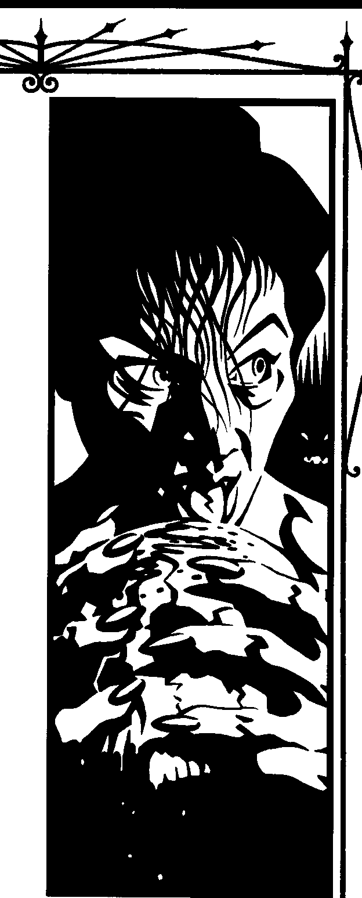

MAGICIAN<, WITH BREATH
I have little to say about those who practice magic while still alive. I wasn't one such in life myself {for the Church condemns such), nor was mysire.What they do bears very little relevance to what we do. By definition they cannot manipulate vitae with anything approach­ ing our skill or control, because they remain bound by the blessing of life. We sometimes cross their paths -
I have myself liberated several useful implements made by self-styled magi who created artifacts better than they knew, and which they'd never put to fullest use. A few times a century, one of our kind and one of theirs actually exchange information that the other can use, and sometimes the information we give them contains some truth along with the decoys.
I know that they classify themselves intoallsorts of factions - Classicists of the now! - but that doesn't interest me. The only person who needs to know the details of a minor blight is the surgeon who removes it. Since I do not truck with the living magicians, merely ignore them, there's no reason for me to pay any attention to them.
The great exception to this rule of rational apathy began in that twilight period between lateantiquity and early medieval times. The one sect name among magi­ cians that weallknow is"Tremere."Their much-vaunted Order of Hermes seems to have the usual accretions of imagined ancient history, and features not at all in our annals until about six centuries after the fall of the western Roman Empire. Then we find our patron Tremere and various of his brood, including the cun­ ning Goratrix, simultaneously trading for information with the Kindred and {when they thought they could get away with it) raiding undead havens.
Blood magicians active at the time recall that many living magicians started complaining about how their ritualsgrew increasingly difficult, subject to some poorly understood interference. In truth, blood magic pcob­ ably worked aswell asever,since blood and vitae remain what they've always been, so the Kindred of that time paid little attention to the problems of self-involved mortal witches. T remete developed a ptofound envyfor the mystical "gift" of Caine, eventually deciding to become one and reap the "benefits" of immortality. Rather than a gift of timelessness that could be used to further one's studies forever, the new group of Kindred found damnation instead.
THE GREAT DARHNE55
FROM MAGE TO8LOODMAGICIAN
What is there to say about the Tremete that others have not already said? We ourselves will recount all our
TH£Hmrn II.cooMAGIC



great glories, all of the real triumphs and many more besides. Any Tzimisce not currently occupied in, say, torturing you to destruction will tell you all the flaws of the Tremere, encompassing the sinsofT remere and his inner circle andstretching back to their remotest mam­ malian ancestors. The Tremere story is no great secret in any except afew aspects, and I cannot waste the space telling you what you should already know, if you have theunderstanding andconnections toread thismanuscript
,7!P.!cek- ft.· .i;

r=+JIIJpk • ,ill/J IdllM. h tn ; ., .1W4ct : j/"H c,·:"#' .!dm, .!
IIIH.(; d.! ;j;f if:l@ttt• /fW .1iid';
£,,,.,,_,;th / ,,,,.,,,,£..1 ,n•t, ••
'.!l;.111tfa .!,JIPin t, d,; {J .
'1;;
"::f'c!,1lld/4,1::ft,fr(d;,C, JJ••
':::?,Jo,,,.;;;,[
4
l101 J
roto!!
-•• That said, there are some interesting and little-known features of the T remere transformationworthy of discussion here, that I mention for the edification of knowledge alone. Goratrix's vigorous search for scraps of relevant lore demonstrates both the strengths and the weaknesses of
the scavenger's approach. Certainly he gained a great deal of actually useful information, without which Etrius' synthesis of a vampire-creation ritual might have taken much longer to complete, or never reached completion at all. He also made a great many enemies of individuals who might have been allies. Such is what I make of the documents (again, unfortunately secondary) that I have seen.
For all our virtues, blood magicians have not yet escaped the baser impulses of the mind. We too often succumb to jealousy and rivalry, especially among the Tremere. It's not a deep secret that a careful manipula­ tor can pit one of us against another and exploit the conflict for her own ends. I have never met Goratrix, but I doubt one who has would describe him as stupid. No doubt it would have taken longer, but I continue to wonder whether he andhisassistants might haveworked their way into Cainite society more gradually, less coercively, and avoided some of the repercussions we faced.
I believe that Kindred at large tend to have a very simplistic viewof the warbetween Tzimisce and Tremere. Yes, it's true that Tremere's transformation depended on vitae extracted from T zimisce vampires, and that this was a remarkably ill-considered choice. Elder Tzimisce probably do not look with favor on novelty, and any challenge (let alone one so direct) would have provoked them to furious response. It's quite wrong to assume that no preexisting conflicts occupied the blood magicians of Eastern Europe, nor that the war against the Tremere consisted only of two easily defined sides.
The era of folk-wandering gave way to an era of religious upheaval, with Christianity spreading from the south. Serious blood magicians know that the beliefs of living men and women offer little guidance and many potential traps, but even the best of us sometimesfalters on the road to purity. Kindred became tangled in the disputes over mortal religion; if recently Embraced, they never really separated themselves from their old social matrices. Some thaumaturgicalconcern about the loss of paganism actually makes sense, as cultures that favor blood sacrifice likely make our work easier. The conflict spread during the same centuries T remere and his house sought some relief from their problems. As with the blood magicians who tried to hold back Mediterranean empires, we must reconstruct much of what happened, since it left few survivors.
Not long after his Embrace, my sire toured with his own, meeting some of the old masters of blood magic. They spent time in obscure comers of Eastern Europe, where a few centuries before, dozens of our kind fought each other directly and through proxies of various sorts. I have seen his sketch of a small grove of trees in a distant Carpathian valley, each one composed of a different body part, all transformed into gnarled wood. The tree of eyes sheds a pungent sap; the tree of hands waves in even the slightest breeze with what seem like sad gestures; the tree of hearts provides neither blood nor vitae, but pulses withan irregular rhythm so that the valley echoes with a sound like drums. My sire said that these were the remains of a village composed entirely of ghouls bound to one blood-witch who went through this transformation at the hands of a rival as a warning to their domitor.
Some of the most interesting havens rendered vacant during the medieval conflicts are hard to reach now. For miles around, the land retains a particular sterility that we who know the blood learn to recognize. The final struggles of a blood magician often include a "death blow" unleashed out of the magician's fears. Sometimes it destroys assailants, sometimes it merely destroys whatever the falling magician believes the

BLOOD MACK: SECRrn OFTHAllMA.nlPGf

assailants sought. Death-struck havens contain noth­ ing except clues to the mental state of their former occupants; on rare occasions there is useful infonna, tion. Generally one sees only how the fallen envisioned barrenness: avast lake of poisonous water surrounded by jagged obsidian cliffs, a mountain where the winds whip around with unusual force and moan in ways chat interfere with mortals' metabolisms, a pleasant valley in which anyone who stays too long becomes violently ill. Regimes of the Industrial Ageoften turnedsuchblighted regions into waste dumps, hiding the old corruption beneath modem, rationally comprehensible garbage.
Keep in mind chat these are the traces left by the wars' losers. The victors' traces cake very different forms, if outsiders can see them at all. My sire located one intact haven by comparing diagrams of historical population growth to maps of the local geology and identifying a minor tributary of one of Poland's great rivers that should have had more settlement than it did. He surrounded himself with the best wards he could muster and walked toward the center of the anomaly. A sudden fit of seizures forced him to stop, or so goes his recounting. His head spasmed wildly for several min­ utes, vitae spewing from hisnose, which dislocated itself from the force of the fit. When he recovered, he discovered that the vitae drops, which he'd thought randomly spattered, spelled out a message in one of the rougher Cyrillic languages of our kind: "Go. My home will never be home to another." Later, in the British Museum, I found in the letters of one of Peter the Great'sgenerals adescription of the same thing happen­ ing to a whole company of Russian soldiers. While he provided an excellent illustration of the blood-soaked
scene, he could not read the message. Still, chat region marked the end of one campaign of expansion.

The wars between blood magicians gradually

Thaumaturgy as a Discipline does not unite all forms of blood magic, of course. It is not given to usurpers to achieve the final consummation; great varia­ tions remain in the forms of blood magic practice. Thaumaturgy, as we Tremere define it, does gather in many of what had been scattered paths. It brings order to what had been chaotic, with knowable patterns of progression and a methodology for building new defini­ tions.Thaumaturgy has no roomfor powers of the blood that require outside factors, either environmental (as in koldunic sorcery) or spiritual (as in Setite sorcery), nor for some styles of blood magic that accompany other cosmologies (as in the magic of the Assamite viziers). This still leaves a great many paths to bring together. Goratrix's scavenging proved more instrumental in the survival of our clan than perhaps even he dreamed of.

The Tremere arranged a few tense cease-fires with rival blood magicians shortly aftercompleting the theo- retical transition to undead Thaumaturgy. Blood magicians who witnessed those early demonstrations describe what a revelation it was. Suddenly many lin- gering mysteries made sense. No, I won't go into the details here; they belong only to the initiated, and in any event require a great deal of space to present adequately. The essence of the vision is verysimple:Key techniques and concepts do in fact tie together a huge number of paths of blood magic. There isn't (yet) any shortcut toward identifying and developing new paths, but once a blood magician identifies a path, the thaumaturgical tools allow much more rapid exploita- tion of its possibilities. New paths multiplied, while students of old paths took them further than ever
before. In those glorious nights of insight, the usual
-
w
rivalries fell dormant for a time.
.,.,
- ,,......,.--~ .--w,ax _.•.--/.
: '11, M#""'s "'..-•I.fui.
'
lilo,II, i.. ,.,....,..."._'';
.,.

find a definite cutoff point. Some conflicts came to an end when all of the participants perished. Others actually had winners. Some stopped when the com, batants found something new to occupy their
capered off, thanks in part to the efforts of the Tremere in their new laboratories. I am at a loss to
attention.
_,_.-"" ,. U.lliti,uJJ ,J - if
" '··. llslbt ""f ''P"' "' '. '
;12.:,".;,,;;.: w,,t ·t,.,.T" ,wk- I
.. 1lfl,M,A..,..,_1"' <.
•·, .;.....: •••• · :u..F,Uru'""'i,11,_,,.

THAUMATURGY
' -;.u..,.,.,,.,:.;..:,r-: .'
tW' '
..",", :"' " ' .• ,,

I've written at several points in this chronicle that early practitioners of blood magic had no sense of an underlying unity to their arts. The T remere changed
that, and this alone makes our continued presence an
,••'.. . u;u - ••"'-- l4u,
: "'" • ¢4,;,J,,,.;.;.......it,itl "'-f nJ. '.
. ·'·t ·;!.-,,11i,;,,,., : " '"''f""""r A4pl"""-i.
;i,iu ,.;t ;..i,..,. t1-'
,uf,., .,,'

asset to Kindred society. Vampires who see chat, and back it up with results demonstrable to others, may yet see something else of value.
•••. - - . ' .•.·
.'f :::s- -'? cs-, <,.- •-



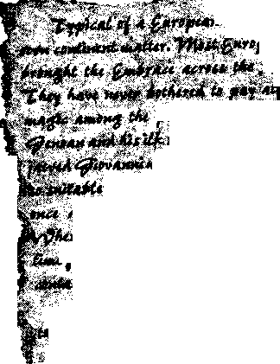
THE lillroRv 01llwooMAoc

FRF5HFIRF'5
Noperiod of peace lasts for very long
among our kind. The Tzimisce gave up their crusade against the Tremere, realizing that they no longer had the support of enough other vampires to prevail, and settled instead for playing with their own newly formed sect within Kindred politics. The blood magicians too closely tied to some specific flavor of paganism perished along with the other believers in the old gods, or went into hiding so deep that they mattered no more than they would if destroyed. Some practitioners of the new Discipline sought places for themselves within clan organizations - some disappeared, others perished, very few found acceptance. These resolutions created a void within the souls of those of us whoseek the essence of things; inevitably we found replacements.
Thaumaturgical insights kindled fresh disputes: competition to be the first to use them against one's rival, hoarding of secrets that might fuel the develop­ ment of fresh paths or rituals, all the usual grudges. Blood magicians particularly impressed with theTremere sought to compete with "the usurpers" for influence among mortals, putting aside the quest to understand the Cainite condition in favor of tawdry rewards like political or economic gain. More enlightened seekers
can scarcely contain their disgust at the spectacle, but the fact remains that many blood magicians now prefer to lord over and influence mortal leaders, rather than remaining on the longer road to real, ultimate power. The betrayers of blood's promise hold no more space in this chronicle than Iabsolutely must give them; you can read of their deeds in annals of larger Kindred society and the front pages of the newspapers, along with the other fools.
THE INQUI",ITION AND THE5ECT'5
For our kind, the Inquisition appeared as one more nuisance among many. Blood magic always attracts some opposition among mortals who think of them­ selves as something more than what they are, fodder for our experiments, Successful practitioners of our arts learn how to hide, or they perish. The subtle witch may continue her hexes, while the obvious witch feeds the Inquisition's fires. While other vampires panicked, we simply pursued our customary courses.
The Camarilla and Sabbat posed more of a prob­ lem. I have no interest in the issues that stir the rapines of the Black Hand, nor in their pathetic efforts to construct a history and theology without the insights that can come only from our studies. Both, however, seek dominion over all Kindred, and therefore they thrust themselves upon us, demanding that we respond to them in the narrow categories they think encompass all of vampiric reality. They don't take "no" as an answer, nor do they listen to even the most patient, simplified explanation of how much they don't know. I do not respect those of my kind who make outward profession ofloyalcy to one sect or the other, but insofar as it gives them a bit of space within which to continue their studies, I can understand it. Obviously, I lend my talents and support to the Camarilla, but only out of support for its purpose. Jingoism is the refuge of the simple.
The only viable alternative to the omnipresence of sects is to retreat into the sort of silence that they attribute to the "Inconnu," whatever that label may refer to. Courage isessential to the blood magician, and might inspire resistance, were it not that judgment is also essential, and inspires a more realistic appraisal of the odds.
The rise of the sects did more damage to the cause of blood magic mastery than any crisis since the fall of the Second City.The would-be lords of vampires forced our kind into channels of activity comprehensible to the new rulers, and wanted all of us to advance their agendas. So many promising linesof inquiry trickled out or simply fellfallow altogether for want of investigators.




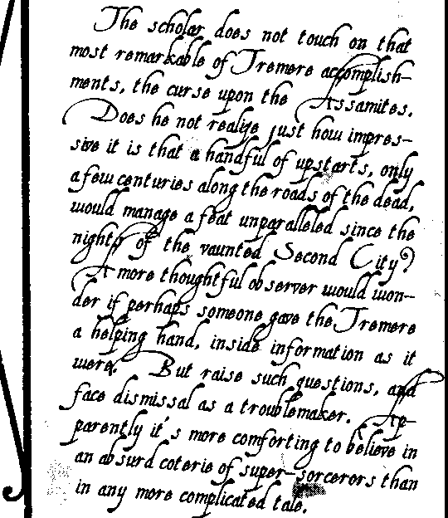
BLOOD Mwc:Socms orTHAUMAruRGv



The great gain of Thaumaturgy scarcely makes up for the inconveniences that persist to this very night.
RECENT DEVELOpMENT5
This is a strange time.
With every passing year, our kind makes unprec­ edented breakthroughs along our respective paths of blood magic. We learnso much that it's hard to believe that we do it all ourselves. Do outside forces manipulate us for their own unknowable ends? Pride makes it difficult to even consider the possibility. If outside forces do operate within us - and surely they do - at least they move us along the roads we're already on. But that thought in turn raises the question as to whether those roads are themselves the best to travel toward the primal essence.
Truth exists in blood magic. It is not all a lie, like the fables we construct to tell mortals. Perhaps some of us have sown lies with the truths; I am not sofoolish as to expect to find no manipulation at all. It still seems more likely to me that if we are being manipulated, that our manipulators seek to use our truths, not simplyour errors.

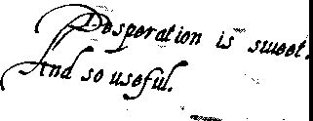
At the
same time we march ahead, old triumphs fail.
The curse on the Assamites seems to have collapsed overnight, without warning, and frantic T remere ef­ forts to resurrect it all fail. Ancient wards crumble,
releasing strange creations into the world. Sealed ha­ vens open, and open havens close, sometimes trapping their creators inside suddenly intensified barriers that noavailable skill can penetrate. The world turns upside down and inside out nightly. Even the familiar night sky no longer welcomes us, as that damnably mysterious red star complicates thaumaturgical analysis of lines of power in the heavens.
The ludicrous Gargoyles gather to demand rights, as though mounds of vitae and gravel were fit for anything but service to their superiors. "Rights" refer to nothing in existence aswesee it through the blood. The creator bears no responsibility to her creation; the creation owes everything to his creator. I like to think that more experienced blood magicians would not have lost control of the Gargoyles so easily. Some of the rhetoric of the "Free Gargoyles" spout makes me won­ der. Perhaps more clueful Tremere have urged their broken toys into claims that the Camarilla cannot honor, and that must lead to conflict in which the Gargoyles must fall.That would bea worthyachievement.
SUMMATION
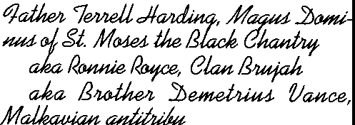
Past events matter only insofar as you put them to use. What matters is the present, and the future. Does this knowledge help you toward mastery? Then retain it. If it doesn't, discard it, and learn something else instead. l have done my part.





THE HISTC4l.Y <J l!t.ooo MAGK:

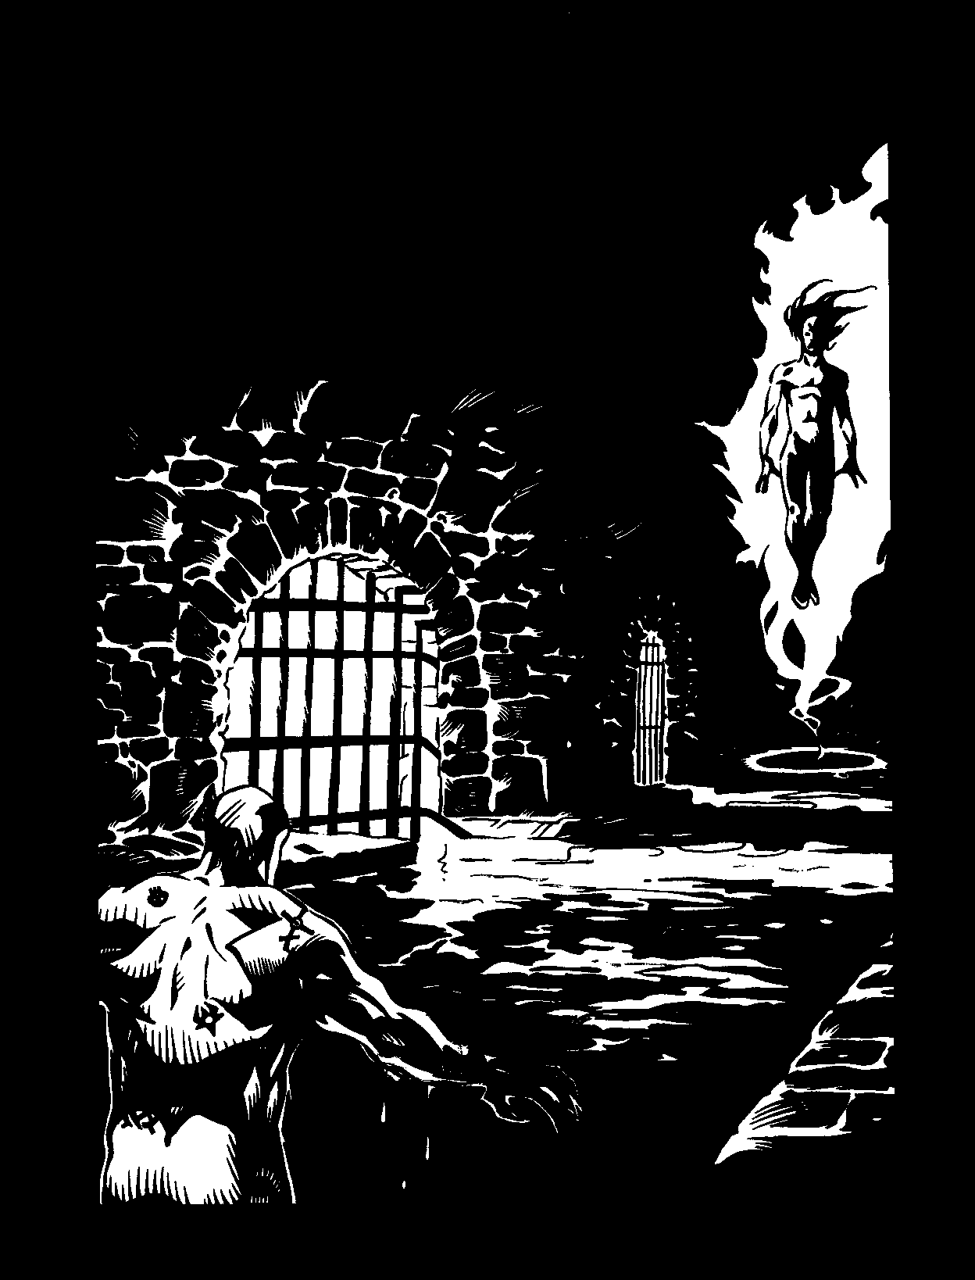

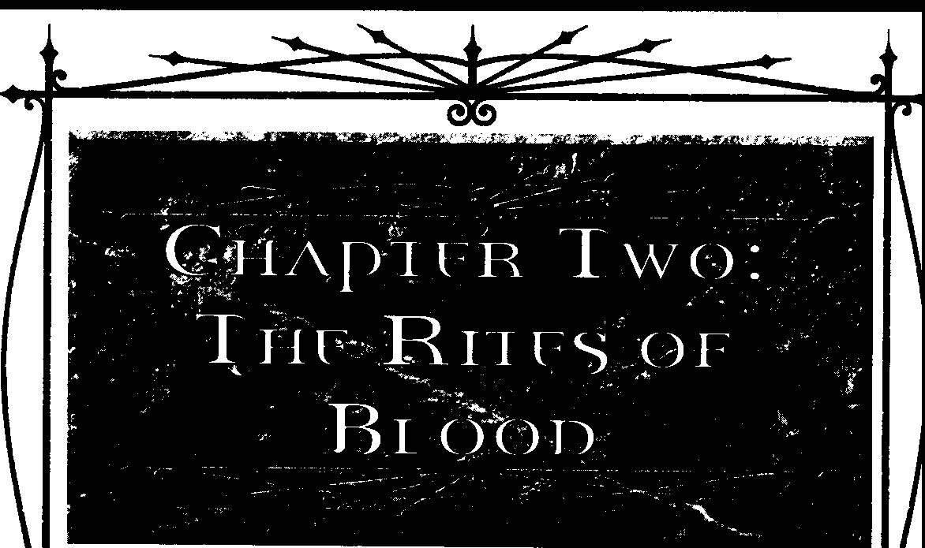

The collection of pages you are holding details the secrets behind the true power of Clan Tremere
- the secrets of Thaumaturgy and blood magic. I spent over a decade in service as an apprentice before finally escaping the stagnant, oppressive sys­ tem that permeates the clan and Camarilla as a whole. Since then, I've plied my fortune as an anarch, free of the influence of my sire and clan elders. I'm not foolish enough to reveal my name here; no doubt, this text will one night find its way into the hands of some clever witch. I have no intention of making it easy for them to identify me - blood magic provides far too many unique and lingering means for exacting revenge.
The Camarilla derives its strength from a sttuc­ ture of centuries of tradition fostered by conservative elder Kindred. By hoarding its knowledge and ma­ nipulating younger Kindred like pawns, that ivory tower is becoming a prison for all but the most ancient among us. With this work, I hope to expose the foundation of one of the pillars of the organiza­ tion, Clan Tremere.
Warlock blood magicians are undeniably one of the cords strangling the growth of Kindred society. Their power rests almost entirely in their sorcerous arts. Without their magic, the grayfaces speak with no special authority. For this reason, they closely guard the secrets of Thaumaturgy. For centuries blood magic protected them against the vengeance ofTzimisce, Nosferatu and Gangrel; now it provides them a chokehold on all Kindred. Even within the
confines of the clan, elders provide bits of knowledge like a Pavlovian reward for correct behavior by younger magi.
For too long anarchs have opposed the clan through trite and trivial methods, like the silly "anti­ rituals," which supposedly heap scorn on the Warlocks, but instead make the creator look child­ ish and immature.
I've decided to take a more direct route. By exposing the secrets of blood magic, I place the first crack in their obsolete fortress.
K,
Mortal retainers recently foud ,, copies of this work in a Chicago warehouse. The warehouse was servin1 as a •halfway haven• of sorts for tr&llsient a.narcha. •icolai managed
to prevent the works from falling into the h&llds of the other clans.
'l'he work appears to have been reproduced ina local I1Dko's. Unfortunately, acoordtns
toa receipt also foud at the site, ,scopies
were made. Therefore, at: least: two, as well as the original, remain at large. Alt:houih the author seems knowledgeable and willini to expose all he knows of our Jlracticea,I believe
we C&ll contain uy d&mace trom this by act:tns quickly &lld decisively.


THERmsorBwoo



THE DEVELOPMENT OFTHAUMATURGY
Magi have spent centuries delving into the mys­
teries ofThaumaturgy. Even in the modern nights, Kindred blood magicians devote vast amounts of time and resources to researching ancient texts and creating new sorceries. Since the Discipline was developed relatively recently in Kindred terms, this obsession may seem odd to an outsider. However, near-blinding ambition and survival motivated the members of Clan Tremere, the primary practitioners of Thaumaturgy, from the beginning to master the intricacies of blood magic.
To5EEHIMMORTALITY
I don't intend to give a full-blown history lesson on the Warlocks, but some knowledge of the clan's past is necessary to understand why Thaumaturgy has developed into its current form.
The legends whispered among neonates are true: Clan Tremere was founded by human mages who voluntarily took on the mantle of the undead. A consuming lust for knowledge and ever-greater power literally devoured the mortal lives of the clan's origi­ nators. Unfortunately, such power can be attained only through long and diligent study - far longer, the mages found, than a mortal's lifespan. The founders gained nearly limitless time with which to continue their research, but, ironically, their pursuit of magic led them to lose it. By sacrificing their mortality, they also inadvertently gave up the arcane abilities they so coveted.
Oddly, the explanation for this loss is a blank spot in the education of a Tremere apprentice. Whatever the cause, it wasn't tied to the original ritual of transfor­ mationitself.Although the grayfaces are closed-mouthed about it, a few years ago I stumbled across anold account of the Tremere's early nights as vampires. The founders Embraced many members of their former House and all, without exception, lost the ability to practice mortal magics. I suspect much about the nature of magic and the Kindred may be bound up in the reason, giving Warlock elders reason to fear its exposure.
Although the loss of their power stung bitterly, of more immediate concern to the fledgling wizards was the fact they had made a number of powerful enemies during their pursuit of immortality. While they were still seeking the secret of undeath, they conducted experiments involving members of the Tzimisce. Those Kindred, including at least one
elder of that clan, did not survive the research. This
act earned the Warlocks the undying enmity of the Fiends. Understandable, really.
The Warlocks, forced by the loss of their original skills, knew they must quickly develop an appre­ ciable edge or be expunged. The former magi adapted an ancient form of mysticism from their mortal grimoires to their new existence. Other clans had already experimented this art, calling it blood magic. It was a form of sorcery drawing on the power inher­ ent in the vital fluid of life - and unlife.
Clan Tremere believed that, with some effort, its rites could be translated into more familiar Hermetic formulae and retain their efficacy. As evidenced by the clan's continued existence and influence, its founders not only succeeded, they excelled in this endeavor. The early Warlocks codified the rituals and practices, creating what became known as the Discipline of Thaumaturgy.
THE '51EOE MENTALITY
Since its origins, the clan has jealously guarded its arcane secrets; knowledge truly is power where Thaumaturgy is concerned. And, even now, the Warlocks have great need of all the power they can muster.
The clan has made many enemies in its short history, and most Tremere believe the clan is still hunted by some of its ancient foes; wronged Kindred have long memories. The Tzimisce still harbor a great hatred for the Tremere, and the Assamite cannibals, once held at bay by thaumaturgical ritu­ als, have somehow broken the bonds of T remere sorcery. There is little doubt upon which clan those diablerists are going to focus their revenge. The Warlocks can rely only on Thaumaturgy to ward off and ultimately defeat their foes.
History and the ongoing threat of extinction have necessitated a tradition of research and experi­ mentation among practitioners ofThaumaturgy, but adherents also have other reasons for continuing to advance the practice of blood magic. Thaumaturgy provides its users with extremely versatile - and potent- abilities. Not only do these serve to protect to the wielder, but also to expand his influence in society. Sorcery provides nearly endless avenues for culling favors with other Kindred.
On the political level, knowledge of the Disci­ pline has built Clan Tremere prestige in the Camarilla. The clan's mastery of blood magic has given that organization a tremendous advantage over its enemies, and as a result, the Camarilla helps

BLOOD MAac: Smi:rn orTHAUMATURGY

defend the Warlocks against their own foes. This protection, in turn, allows the Tremere to devote even more time to study and experimentation, creat­ ing a revolving cycle of increasing strength for the clan and Camarilla.
To protect their secrets, I've even heard they've gone so far as to kill all of the T remere who joined the Sabbat. If genocide is an accepted tactic for them, they've got to be serious.
GEHENNA
While great arcane power has material rewards in and of itself, yet another purpose motivates many students of Thaumaturgy. These magi believe Thaumaturgy may provide a defense for them in the coming Gehenna. They claim the relatively recent development of the Discipline means it is unknown to the Antediluvians - possibly the only such abil­ ity available to existing Kindred.
I question the logic of this assumption, since the Tremere only derived it from older forms of blood magic. Perhaps the clan organized and refined the ancient art, but it's doubtful that the practice was truly unknown to the mythical Antediluvians. The Tremere merely modified existing blood magic into a more reliable form. I've seen several ancient texts in chantry libraries that mention pre-Tremere blood magic practitioners - including early Assamite sor­ cerers. For example, the tome Nominis Inferni is actually a translation from a much older Sanskrit text. Prior to Thaumaturgy, blood magic may have been rare, but I think it's typical Warlock arrogance to claim it was completely unknown.
Nonetheless, many elders among the Warlocks hold such confidence to be nearly doctrinal. I fear they are in for a surprise when the Ancients do return....
HERMETICTHAUMATURGY
Oneof the ways Thaumaturgy differs from the earlier forms of blood magic is in the application of a systematic approach to its practice. The creators of Kindred Thaumaturgy were originally practitioners of Hermetic rituals. The Hermetic tradition takes its name from Hermes T rismegistus, or Hermes the "thrice great," the legendary founder of the practice. Medieval alchemists considered him as the father of alchemical philosophy, and he is mentioned in writ­ ings as early as the seventh century - over time, all alchemical philosophy and practice came to be known simply as Hermetic magic.
Hermetic practice combined the art of ancient mysticism with the analytical approach of ascientist. It
proved the power of magic through reason and logic. Hermeticism pursued mastery over the mundane through application of the will. According to its teachings, all natural elements (gold, lead, water, etc.) and phenomenon (fire, life itself, etc.) were interrelated, and certain ones possessed traits that could be exploited by a Hermetic magician through proper preparation or ritual. A skilled and knowl­ edgeable practitioner, Hermetics claimed, could use these traits and relationships to impose his desires on reality.
Contrary to popular belief, Hermetic alchemy is not concerned solely with the conversion of lead to gold. The magicians merely considered gold as the finest of all metals, and the transmutation of any substance into gold merely represented a mastery of the Hermetic art. Because alchemists claimed the philosophical goal of Hermeticism was the pursuit of a pure spirit or soul, they professed the quest for gold
- the purest metal - was merely allegorical.
Yeah, right, whatever. In reality, those Hermetic magicians were no more spiritually pure than any other. What set them apart from the charlatans and hedge magicians of the time was their understanding of the principles behind the workings of the arcane.
After attaining newfound immortality, the Tremere applied the systematic approach of Her­ metic analysis to their new condition. As I've mentioned before, the condition of unlife somehow blocked their former access to mortal magics. How­ ever, through inquiry and trial, the Warlocks learned that blood magic, an ancient and feared art even among Kindred, would allow them to shape the power inherent in their own vitae and thus regain their lost power. Of course, a more philosophical person might question whether taking a lien against one's soul in exchange for immortality is such a good deal.
BLOOD MAGIC
I have no doubt many mortal religions and soci­ eties have practiced blood magic in some form or another throughout the ages. Evidence of halting and failed attempts is found in cultures ranging from Babylon to ancient Chinese alchemy to the Aztecs in Central America. Some of these enjoyed limited success, but none were very truly reliable.
Blood magicians seek to draw upon the inherent potency of the fluid known as vitae - the mystical essence of blood. What most mortals fail to realize is that blood in and of itself holds no power. In its purest form, blood magic is actually drawing on the




THE RmsOf BlOOD

power of life itself; blood is nothing more than a conduit. Mere blood sacrifices cannot draw forth the life-energy contained within; that feat is quite possi­ bly beyond the practical ability of mortal magicians. On rare occasions, a mortal practitioner may have succeeded in doing so, but such instances are only flukes and almost never reproducible.
Kindred, on the other hand, through their very nature feed on chis power. The Embrace imbues the vitae with mystic energy. Kindred draw upon chis energy to maintain their existence. This same vitae chat makes it possible for us to suspend death opens the door to blood magic. Any Kindred with the proper knowledge and desire can practice blood magic; the Tremere have no special exclusive capac­ ity for Thaumacurgy. The Warlocks' miserliness with their secrets holds back the entire race of Kindred from achieving its full potential, however.
Records on blood magic prior to the rise of the Tremere are sketchy and unreliable at best, but it is interesting to note that the Warlocks weren't the first to realize the arcane potential of vitae. The Assamites, the T zimisce and a few other clans all professed to practice some form of the art. Bue, lacking the reasoned and codified approach of Her­ meticism, blood magic had over a millennium of random tinkering and extraneous ritual tied with it. Many elements of the art were nothing more than gruesome showmanship designed to impress mortals or ignorant Kindred. Accounts of chalices filled with the blood of virgins or carving the heart from a living victim pepper those early histories; good cheater, perhaps, but totally unnecessary as far as blood magic is concerned.
The Tremere fused blood magic with Hermetic practice, trimming both traditions to their bare es­ sentials. To the Tremere, Hermetic Thaumaturgy is nothing more than a tool- no more or less spiritual than any other Kindred Discipline. The Warlocks stripped all references to religion and vestiges of frivolous exhibition. You don't usually find hours of liturgies, beseeching prayers or altars in Tremere rituals. If a procedure doesn't serve a definite thaumaturgical purpose, it's commonly excised from the tradition.
Note that this isn't always the case - as I'll talk about later, some people attach mechanical meaning to nontraditional trappings of blood magic. I know of at least one Catholic priest who depends largely on the Church's ritual to conduct his "miracles." What­ ever floats your boat, father- I'm talking about the ruck and run of the clan in this little treatise.
« TRUE MAGIC" V'5, THAUMATURGY
Tremere often refer to themselves as "magi"; the singular form of this word is "magus." They use the term "mage" - plural "mages" - for mortal practi­ tioners of the arcane. Although both Kindred Thaumaturgy and mortal arcane practices have cer­ tain roots in medieval alchemical science, the Warlocks have good reason to make a distinction between the two- their differences run as deeply as those between Kindred and kine.
Mages practice a form of magic chat differs from the blood rites ofThaumaturgy. Unfortunately, be­ cause clan elders long ago determined it was forever denied to Kindred magi,T remere chantries no longer hold much information on mortal magic - or at least so the grayfaces claim. I can't imagine those survivors of ancient purges not keeping a close watch on any potential foes. What records are available indicate mages rely on some outside element to work their sorceries.
Also, mages seem reluctant to exert much of their power overtly, fearing some form of undefined effect that balances their manipulations of reality. I've never been able to determine from the limited texts I've had the opportunity to peruse what causes these effects. It does seem to have nearly universally unpleasant results - that is, I suppose, if you define old scars gouting blood or joints suddenly bending in the wrong direction as "unpleasant."
While Thaumaturgy traces its roots to a mortal Hermetic tradition, the magic practiced by Kindred is worlds removed from that of their former peers. The blood magic ofThaumaturgy comes from within the magus; he does not rely on any outside source to impose his will upon the world. Only his own deter­ mination and puissance limit a blood magus' power.
Nor is the thaumaturge subject to the strictures of reality in working his magic; no blood magician has ever felt the effects of the mage's mythical and nebulous bane. Why this is so none of my masters ever explained. I think it has to do with the fact that mages draw upon some outside source for their power while we Kindred rely only on our own vitae, but don't quote me on that.Oneschool of thought posits that vampires have long been associated with magic, while mortal sorcerers have always been shunned by their peers. This sort of "consensual acceptance" smacks of artificiality to me, however - legend made fact by mere belief would imply that innumer­ able "other" creatures and magics are out there, and that one could literally cross the street into another world. Such metaphysics are best left unpondered.



BtoooMAac: $(0[JS orTHAUMATU!liY

Magi believe most of the mage's limitations spring from her own mortality. Regardless of her aptitude or training, her existence is like a mayfly's when com­ pared to a Kindred magus; she simply does not have the time to learn her art and hone her skills to the level a magus can. Those mortal restrictions drove Tremere himself to seek the gift of immortality. Also, a magus has the potency of vitae to call upon
- something no mage can reliably tap - allowing him to draw his power entirely from within.
On the whole, thaumaturges view mages as prac­ titioners of a less refined art than their own. However, no blood magus denies the power a mage can wield when pressed. The nature of non-Hermetic, mortal magic allows a mage to call upon terrible forces at her whim. She may pay a terrible price for her imperfect art later, but that is little consolation to those who suffer her sending's immediate effects!
THE PRACTICE OF THAUMATURGY: PATHSANDRITUALS
Thaumaturgy is the most versatile of all Kindred
Disciplines. Through its practice, the Tremere teach that they can duplicate or surpass nearly any other vitae-enhanced ability. Most clan elders claim that the thaumaturge's skill is the only thing that restricts the potential of blood magic. They believe that the possibilities of the tradition are boundless to the true initiate.
Unlike most other Kindred Disciplines, Thaumaturgy has diverged along two lines, rituals and paths. Many non-Tremere find the dual nature of Thaumaturgy perplexing and don't understand why the Warlocks chose to pursue two separate aspects to the same Discipline rather than focus their efforts on one. It would seem, at least to a non• initiate, thaumaturges would be best served by abandoning the lengthy and complex rituals of the past and focusing on the quicker effects of the paths. Yet, the clan still continues to place equal emphasis on each method.
The truth is both rituals and paths have their own individual strengths and weaknesses. Were Thaumaturgy to be limited to only one of the two, the Discipline would not be nearly as versatile as it is. Focus on a single aspect might enhance its effective­ ness, but the loss in universality would more than offset that minor gain.

PATHS:
THepowEROFTHEWILL
Thepaths are the purest forms of blood magic. Simply put, they are the power of vitae channeled by the knowledge and will of the magus, allowing her to instantly affect reality. Such is the case with any Discipline. Unlike complex Hermetic rituals, the effects of paths are available to a magus at any time, and require almost no preparation (aside from learn­ ing them as one does with any skill) and no unique ingredients. Additionally, they have immediate ef­ fects and virtually endless variety. On the surface, the paths appear the more powerful of the two as­ pects ofThaumaturgy.
Because the ritualistic elements are removed, it is easy for the uninitiated to mistake the effects of a path for an innate Kindred ability. The strength and versatility of the paths leads many magi to theorize Thaumaturgy represents the ultimate potential in­ herent in Kindred vitae. They also claim other Kindred Disciplines are actually nothing but pale shadows of Thaumaturgy, little more than special­ ized, stillborn paths that the other clans have developed over several millennia of study and practice.
I should mention that the major proponents of this view tend to be younger Warlocks barely el­ evated from apprentice status,
Tremere elders point out that while paths are capable of reproducing to some degree the effects of other Disciplines, the ends should not be used to compare the means. For example, they say, fire, electricity and acid all are capable of inflicting burns, but do so in a vastly different manner, Other Disci• plines are a function of Kindred nature; in a path, a magus uses vitae as a fuel for blood magic. The difference may seem subtle, but it is very important.
Unlike many other Disciplines, blood magic paths actually consume a portion of vitae to provide power for the magus' will. Whether the magic draws the vitae directly from the magus' body or he actually opens a vein to expose the liquid varies among the Warlocks depending on each practitioner's training. The latter sort are sometimes called "blood-letters" and usually carry a small blade or at least sharpen a thumbnail so they can readily spill their own vitae.
Other Kindred Disciplines are closer to manifes­ tations of the inherent potency contained within Kindred vitae. Only occasionally do they actually expend any of the vital fluid to be effective, A path, and Thaumaturgy as a whole, is not an innate ability




T 11mm BLOOD



like the superhuman physical strength, speed or even
perception that Kindred may exhibit, but, rather, a set of skills allowing trained magi to draw upon their own immortality to shape their surroundings.
This explains the limitations of paths as well. While other Kindred Disciplines are bound by the owner's generation, even the most thin-blooded childer can learn the highest levels of the paths. Oddly enough, however, I have heard of a few potent rituals that only by the most ancient of the grayfaces have mastered - rites that only thaumaturges of the Seventh Generation or lower can perform. One of my masters suggested the explanation for this pecu­ liarity is actually a restriction of thaumaturgical paths themselves, denying elder magi higher achieve• ment. He further postulated that its cause might be the fact Kindred draw their arcane power from a finite source - themselves. Where other Kindred abilities are the result of immortality, Thaumaturgy only exploits an aspect of it.

I•m qll.1fe 1:nterea-ted 1.:n d.isooTering the identUy o;C the whelp's maa"ter. !hat macus
is :Car too careless 1.:n revealing Blloh supposit:io:ns.

Among Warlocks,
the prevalent view is that the paths are the ultimate refinement of blood magic. They combine pure will and pure power without relying on the constructs of Hermetic ritual. As such, they represent a new road for Kindred to follow, one offering possibilities de­ nied by the static progression of Disciplines, one that may eventually lead to another level of Kindred existence.
In spite of this belief, most experienced magi use paths only to a limited extent. While a path may be developed to create nearly any effect, each one is itself fairly restricted in scope. The Pach of Blood, Neptune's Might or even Technomancy are all highly effective within their respective realms, but utterly useless outside of them.
Furthermore, as I mentioned earlier, use of a path requires the blood magician to sacrifice a small portion of her vitae. The amount is small in most cases, generally equivalent to the same amount expended to maintain the Kindred's existence a single night. This may seem trivial, but it does impose a quantifiable limit to chis sorcerous power. No Kindred, especially a blood magician, can afford to frivolously expend her vitae.
Therefore, the majorityofWarlocksemploy Her­ metic rituals to accomplish most of their arcane tasks, relying on path abilities less frequently.
RITUALS:
THE poweR OFTHEFORMULA
Hermetic rituals are tedious and time-consum• ing when compared with other Kindred powers. These archaic rites usually require the caster to obtain obscure items, recite phrases in dead lan• guages and perform complicated movements to be effective. If the thaumaturge neglects to meet a single formulaic stricture, the magic fails and all the effort expended is wasted. Non-initiates often won­ der why blood magicians waste time continuing to study these restrictive forms or even go so far as to develop new ones.
Part of the explanation is found in the history of Thaumaturgy. The blood magic ritual was the first aspect ofThaumaturgy developed by Clan Tremere. The original practitioners were accustomed to intri• cate formulae and complex ritual; Tremere, Goratrix and the other founding members had spent their mortal lives studying these Hermetic applications. It was only natural they would maintain this affinity when they laid the foundation of the Discipline.
As the early Warlocks sought a weapon with which to defend themselves from other hostile Kin• dred, theydelved into previously shunned tomes and writings they had avoided as blasphemous prior to their transformation. They unearthed long-forgot­ ten blood-soaked rites and reworked them according their own skills. It was during this time that the magi developed the first wards against Kindred and ghouls to protect their sanctuaries; Flesh of the Fiery Touch and Wake with Evening's Freshness also appear to trace their origins back to those first nights. Using these first rituals, the Warlocks balked the assaults of their foes until they were able to develop other means to exploit the power of vitae.
However, even after the clan began to experi­ ment with the paths, the Warlocks clung to the ancient forms of rituals. Clan Tremere isn't the type to continue a practice merely because "that's how it's always been"; the speed with which they scrapped their own philosophy and combined it with blood magic attests to that. No, the clan retains the prac­ tice of ritual magic because, quite simply, it works. Blood magic rituals require a great deal more time to enact than a path's effect, but generally place less strain on the caster. Only rarely do they require

111.00DMAoc: SfC:ms orTHAUY.AruRGY

- D • •

the thaumaturge to offer a portion of his own vitae, unlike abilities granted through a path, which always do. Some of the more complex rituals do require the expenditure of vitae, but these almost always pro­ duce a powerful or lasting effect.
Rituals also protect the caster from much of the risk associated with a path. A failure when perform­ ing a ritual seldom has a baneful effect on a magus, whereas some blood magicians have reported a weak­ ening of determination and focus after a botched attempt to summon a path ability. Apparently, be­ cause the magus' will provides not only the impetus but also the focus for a path's effect, she can some­ how actually deplete her own spirit. This loss is, for all intents and purposes, permanent - more than one sorcerer has been left an effete wretch after too many failures. Crafting blood magic requires a strong will, so this potential damage represents a consider­ able risk for magi.
Thaumaturgical magic produced by a ritual is often more potent and has a longer-lasting effect than that created by a path. Clan Tremere's greatest successes are the result of ritual magic. The binding of the Assamites, the creation of the Gargoyles and
the clan founders' very transformation from mortal to Kindred are examples of the power available through Hermetic blood ritual.
New rituals are far easier to develop than new paths, as shown by the earliest practitioners of the Discipline; blood magic rituals were the first form of Thaumaturgy developed by the Warlocks. The clan can quickly and effectively fashion rites to meet its needs. Blood magic formulae allow a magus to quan­ tify and define the effects of her magic by laying out the steps in a pattern. Whereas each step of a path builds on the previous one, through application of Hermetic principles and formulae, a magus can de­ velop a new ritual independently.
Similarly, the only limit to a ritual's power is the blood magician's understanding of the overall prin­ ciples of Thaumaturgy. A magus must learn each path's permutations separately. Rituals have no pre­ requisites beyond the basic understanding of the sorcerous arts of the blood. This allows a magus to pick and choose which effects he wants to develop, rather than advancing through a rather static pro­ gression of a path. As a result, many magi know far more rituals than they do paths.

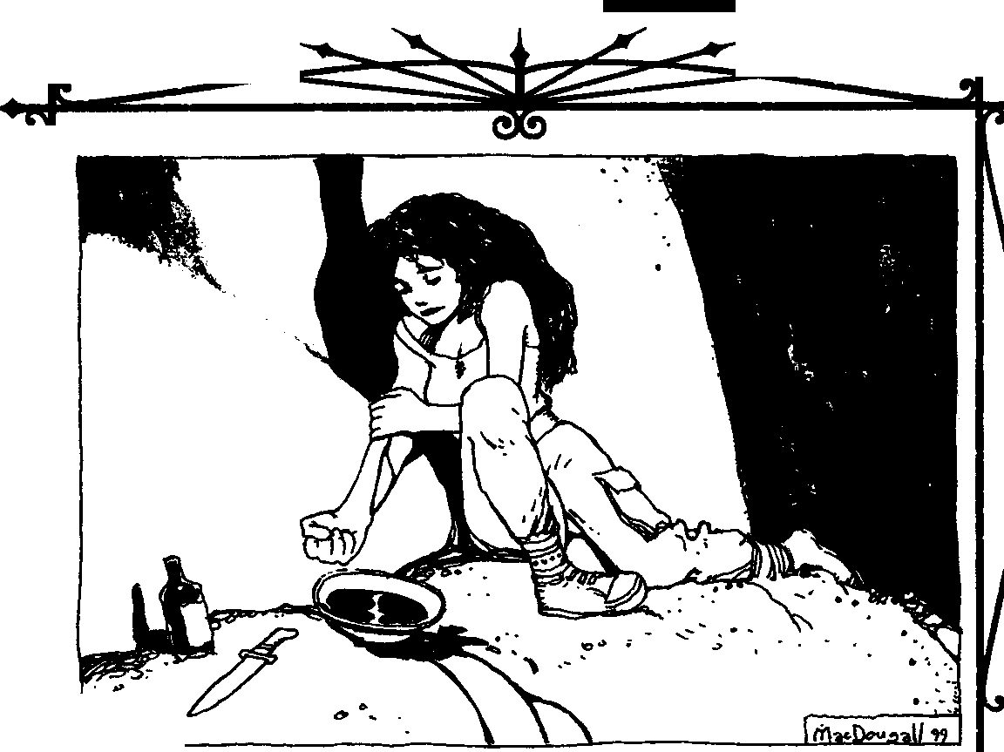

THE RmsOF BLOOD

Although the paths may represent the highest potential of blood magic, rituals are usually more practical to employ. Even the most innovative, non­ traditional practitioners of the art rely on them for a variety of tasks. I expect Hermetic rituals will remain a major part of the Discipline for theforeseeable future.

PRINCIPLES OF
THAUMATURGY
Both paths and rituals are thoroughly docu­ mented and researched by the Tremere, making Thaumaturgy possibly the most studied of any Kin­ dred Discipline. However, in spite of centuries of study, blank spots still remain in Warlock insight about the exact workings of blood magic. The clan has yet to determine any set of formulae consistent enough to be referred to as "magical laws." For chat reason, research and experimentation in the art are often lengthy, trial-and-error affairs requiring years of effort to make even minimal progress.
Of course, the grayfaces are nothing if not me­ thodical, and they have determined seven common elements they've termed the "principles of Thaumaturgy." These tenets are present in the work• ings or effects of the Discipline, whether path or ritual. To a degree, these principles help define and explain how blood magic is performed.

THE MAJOR PRINCIPLES
Tremere theory posits four majorthaumaturgical principles: Blood, Will, Knowledge and Identity. These represent the intent and ability to work magic. They are inherent coevery ritual and path; if an effect can be generated without involving all of the major principles, it's not Thaumaturgy, but rather a differ• ent Kindred Discipline - or similar expression of vitae's potency.
Some Warlocks claim the major principles are too nebulous; they assert chat all Kindred Disciplines involve the first three of these principles - Blood, Will and Knowledge - to one degree or another. This is a specious argument and unworthy of serious consideration by any thaumaturge. While on a basic level this is true, it's equivalent to comparing stand­ ing up from a chair to writing a complex line of computer code; both involve use of the body's motor skills, but the latter is far more complicated in execu­ tion. Thaumaturgy requires a level of sophistication in the involvement of these principles that no other Discipline does.
BLOOD
First and foremost, Thaumaturgy is an art of the blood. Without it, or, more correctly, without vitae, the magus' efforts are for naught. Blood is both the filter and focus for all aspects ofThaumaturgy. Mor­ tal pretenders understood this, they merely lacked the ability to draw forth the power held within their own lifeblood.
Paths require the magus to sacrifice a small por­ tion of his vitae each and every time they are used. Note the magus must expend a portion of his own vitae, not simply any blood. A blood magician can­ not use the vital fluid of another, not even another Kindred; the vitae must come from the magus him­ self. The connection between body and spirit, or perhaps will, is necessary to complete the link be­ tween the magician's intent and reality itself. Note that the Kindred may ingest the blood of others and expend it as his own, as per normal feeding. None of us create our own blood, as I'm sure any reader knows.
As the Tremere understand the principle of Blood, this stricture is what prevents mortals from practicing blood magic to any great effect. Mortal blood lacks the inherent power of Kindred vitae. No mortal can forfeit enough lifeblood to match the potency of even a small amount of vitae, nor can a human mage use another's blood to enact a ritual or path. The few documented instances in which blood magic has been effective for humans all ended in the death of one of the active participants due to self-exsanguination.
Years ago, at the request of one of my former regents, I joined a local mortal cult that was suppos­ edly practicing blood magic. The regent was interested in seeing how far they had progressed and what, if anything, could be learned from their practices. Surprisingly enough, the cult seemed to have gleaned at least the basics of the art; nothing the chantry didn't already know, mind you, but more than I'd have suspected.
The leader of the cult succeeded in actually placing a curse on a rival, giving the target a particu­ larly unpleasant bout of skin cancer - the man eventually recovered, but the scarring was horren­ dous. However, the sorcerer never had a chance to see his success; in order to perform the ritual, he had to open nearly every major vein on his body. Finally, after using a small icepick to puncture his jugular, he collapsed onto the floor and bled out. The other cult members had very little to clean up after the ritual ended. The casting had consumed every drop of



BLoooMAG<::SEClETS OFTHAllMA.TURGY

blood in his body, collapsing his veins. Shortly there­ after, the cult disbanded.
Interestingly enough, a magus can drink from a vessel - or even a blood-filled chalice - and use it to fuel a blood magic ritual or path, but a mortal cannot. A mortal simply doesn't process blood in the same way a Kindred does. A Kindred draws the blood wholly into her essence as soon as she drinks it. The blood must pass through a mortal's digestive tract, a process that takes hours and destroys the power contained within it. All a mortal who attempts this gets out of the process is stained teeth and a stomach full of useless, slowly clotting blood. Thrilling.
Even in rituals ofThaumaturgy that require no expenditure of blood, vitae must be present in the magus - and not just for the obvious reason of avoiding frenzy. In these slower, more deliberate rites, the thaumaturge has time to craft the blood magic carefully. The magus uses his vitae more as a filter than the actual impetus for the magic; in such cases, the other principles are bound into an effec­ tive sending solely by the presence of the vitae.
WILL
Thenext required element is the active intent of the magus to alter the world in some fashion. With• out Will, all other the other principles remain inert. The principle of Blood represents nothing more than potential power for Thaumaturgy; the principle of Will releases that potential.
According to this principle, no magic is sponta• neously performed. It's simply impossible to work Thaumaturgy without the desire to do so. An ap­ prentice can't boil away her eyes or tum her blood to spiders merely by perusing an old tome. If that were the case, thaumaturgical research would be much more delicate than it already is.
Before you get the wrong idea, this principle doesn't protect against the misguided application of blood magic. It's entirely possible to be attempting to generate one effect and, due to an error inexecution, create another. Nothing in the principle of Will prevents a magus from calling forth a demon from the pits of Hell during an inept attempt to create a Sanguine Assistant. Granted, such a mistake is highly unlikely, given the precise nature of Hermetic for­ mulae, but the point I'm making is the principle of Will is a limiting factor, not a failsafe device.
HNOWLEDGE
Desire and ability alone don't enable Kindred to work blood magic. If that were so, the Warlocks wouldn't enjoy the position they do tonight. The
formulae of Hermetic rituals are complex and the paths require intuitive understanding of the interre­ lationships of identities. Sure, it's possible to generate some result through only Will and Blood- an effect of one of the more basic physical Disciplines, per­ haps - but without Knowledge it is not possible to practice Thaumaturgy.
This principle tempers the force created by Blood and Will. Knowledge is the means through which a blood magus shapes a sending. By its very nature, magic seeks the simplest course; that's why invoking takes such an effort. Only with careful manipulation can a thaumaturge force it along the desired route.
The principle of Knowledge includes the learn­ ing necessary to conjure magic through vitae. This isn't limited to the rote formulae and ceremonies of the rituals. The magus must grasp the concepts of Thaumaturgy and how each part of a rite interacts to build a successful sending. For example, to properly shape a sending, he must understand the importance of allowing the candle used in the ritual Heart of Stone to burn completely down as he incants the appropriate invocation; delaying or rushing the reci­ tation rewards the magus with a blistered chest and nothing else. He must also know the characteristics associated with various elements and how these may be exploited through blood magic. Every Warlock apprentice is thoroughly drilled in these concepts before being allowed to attempt even the most basic ritual.
Since I'm on the principle of Knowledge, let me warn you that reading this manuscript does not provide the understanding necessary to work Thaumaturgy. All this text does is expose the basics of blood magic and the Warlocks' society. Thaumaturgy is a dangerous Discipline; invoking it without full understanding is tantamount to asking for the Final Death. Several thaumaturges have es• caped the suffocating confines of Clan Tremere and are willing to exchange arcane secrets for other considerations. I advise any Kindred attracted to the lure of blood magic seek one of these for a tutor.

Such a pity th.at the traitor hadthe sense to include this warning. Without it'
1 suspect th.at cleaning up this mess would have been JllUch, JllUCh easier ••••

IDENTITY
Every creature, every object, every force in the universe has defining aspects and associations. Early




THE RmsorBi.ooo



alchemists spent most of their lives or unlives study­ ing these intertwining characteristics and designing formulae to exploit them. Thaumaturgy has taken that concept and further developed it into the prin• ciple of Identity. In its most basic form, Identity explains that everything has an essence and that this essence is both individual and shared.
One of my earliest masters used colors as an analogy for this principle. In her examples, the closer the relationship between individual essences, the more similar the colors, but no matter how different the shades, all colors are part of the same spectrum. According co this analogy, one Kindred's essence might be represented sea blue whereas another is a darker, indigo-blue; both are the same color, but distinct nonetheless. To take this line of thinking further, a mortal may appear as yellow and a ghoul a green, either yellowish or blue in tint, depending on the amount of Kindred influence. Of course, this is a gross simplification-Identity isn't as clear-cut as a simple color scheme - but I think it's fundamen­ tally valid, at least for instructive purposes. Radio waves might also make a good analogy, by which every association is a unique "frequency."
Thaumaturgy uses Identity to target the effects generated by blood magic. The principle provides clear guidance for a path or ritual after the sending is released by keying the magic to the target's essence. Another of my former masters likened Blood to gunpowder, Will to a bullet, Knowledge coa gun and Identity to the sights on the gun. What the other major principles create, Identity directs. Without it, no control is possible for a sending's effect; undi­ rected magic becomes nothing more than energy released randomly into the world.
One particular facet of Identity, True Names, was, at one time, vital co the very heart of Thaumaturgy. A True Name (or simply Name) is basically a written or verbal shortcut to the nature of whatever it describes. It contains the definition of the essence of the Named item or being; it puts a name to the color, if you want to return to the earlier analogy. AT rue Name binds the Identity - the very essence - of an individual into a word. Thus, with a Name, a magus gains complete understanding of the Named object or entity's essence.
However, over the centuries, the power of Names has become greatly diluted through lack of use. The Warlocks still have lengthy lists of the True Names for common ingredients used in blood magic rituals; these are still used in many rites. Such is not the case for individual Kindred or even mortals though. Ac-
tually, that's a bit misleading. True Names are still vital components of thaumaturgical effects, though they are rarely now invoked as such. Merely seeing a target may satisfy the Identity requirement, as may possessing one of the subject's belongings. I should say that speaking a True Name is not always neces­ sary. As a peculiar side note, the most precious of Kindred humors, vitae, contains a direct link be­ tween that fluid and its parent. Having a quantity of another Kindred's blood is the same as knowing her True Name. Think about that next time a superior offers you a favor "in exchange for a small amount of blood."
First of all, understand that a given name is not a True Name. A magus desiring a victim's Name can't simply open up a phone book and find the True Name listed. At one time, everyone received a Name, but the practice has long been lost to mortals and Kindred alike. Few Kindred - and few mortals - are even aware of their True Names. This is why the use of Names has begun to wane among younger, less patient magi. Attempting to unearth an individual's given True Name is a formidable task in itself; trying to discover one that hasn't even been Named may take years.
Most powerful Kindred magi devote the time necessary to decipher their own Name just to be able co protect it from other blood magicians. If the magus knows his Name, he can take steps to safeguard it by binding the Name in magical ciphers and arcane wards, further complicating an already-difficult pro• cess. On the other hand, if he doesn't, he can only hope no one develops enough of a grudge to invest the years needed to find it.
Less experienced or outright foolhardy thaumaturges sometimes scoff at those more tradi­ tional magi who undertake the years of research. This is a prime example of thaumaturgical Darwin• ism, if you ask me, because once a magus' Name is compromised, he's much more vulnerable to ritual magic. Furthermore, while paths normally have a limited range (usually sight or touch), if a victim's True Name is known, that range becomes virtually infinite.
The ritual Paper Flesh illustrates the potency of knowing a victim's True Name. (This ritual - and a few others I may mention later - is practiced primarily by the few thaumaturges left to the Sabbat, so if it's unfamiliar to any magus perusing this work, that's why. Since their fall, I've had the opportunity to loot a few of their havens for texts and other items of interest.) By inscribing the target vampire's Name




111.oco MAoc:Srom Of THAll'MIUKiV



on a piece of paper and then burning it to ash, the magus temporarily strips away the supernatural tough­ ness of the Kindred's body, in effect leaving it nothing but a dried cinder husk.

So, this whelp has f
4
nest or two Perha ou.n an u.nloote4 time to u.n• earthin ^{PS} we should. dev•o e :more &nd t&Jce ad.TantC the a.ntr.ttr.tbu havens
GoratrU's aet. age of the labors of
!hose •terta" h e Jllentions a
All three minor principles are extrapolations from the major principle of Identity. Sympathy and Contagion designate a subject, and lnherency assists in further focusing a magus' will. Most rituals employ the minor principles to some degree. Because Sym­ pathy and Contagion are similar in function, usually onlyone, orat most two, minor principles are present in a ritual. In my experience, I can recall only a few examples of all three being present in the same rite. The minor principles give rituals versatility and range that paths cannot attain without knowledge of

another reason to hunt thi I'
8
e uy want to oonsid.
re just one down.
a subject's Name. With proper application, they allow a ritual to affect as narrow or as broad a target

our plants uong th er using a few of
so-called. "'1J.abou.n4! _;naroh child.er a.ad the tio.a excursions int Mo ll&ke• few reolaaa-
base as the blood magus desires. By serving as a
surrogate for a True Name, Sympathy and Conta­
gion enable most rituals to ignore the proximity

of 1:hoae :motley banod.8
infiUrate Sabbatt
iami or Mo.atrea 1 • One
uy find 11: easier to
restrictions of a path. Only the simplest or most powerful rites require the subject to be present as

tage of the trait er;11:ory to t&Jce ad.v-an-
ors downfall.

Since common usage of Names has almost com­ pletely faded from the world, at least as far as individuals are concerned, chaumaturges compen­ sate by proximity to the target of when invoking a path. All paths -with exceptions as noted above­ require the magus to be relatively near the subject. Some require line-of-sight to clearly identify the target, but more focused effects may need eye contact between the magus and victim or even a physical touch. These methods allow the magus to direct the magic without employing or even consciously know­ ing the subject's True Name.
The majority of Hermetic rituals also circum­ vent the requirement for Names inguiding asending. A small number still employ a subject's Name to enact their magics, but these are mainly those in­ volving otherworldly entities. And, although some rely on proximity, other methods are also available when working blood magic through a rite. These alternate means comprise the minor principles of Thaumaturgy.
THE MINOR PRINCIPLES
Thaumaturgy's three minor principles are Sym­ pathy, lnherency and Contagion. These describe the particular way in which blood magic is directed. They are more restricted and more clearly defined than the major principles. Blood, Will, Knowledge and Identity lay the foundations of blood magic; the minor principles build the Hermetic framework of the art atop them.
long as Sympathy, Inherency or Contagion is em­ ployed. Unfortunately, these alternates sometimes weaken the effectiveness of the sending and make it easier for a victim to resist a blood curse. However, most magi consider that a small price to pay for the options the minor principles present.
However, not every ritual requires a minor prin­ ciple to focus and deliver its effect. Some are simple enough to work on nothing more than a mental image of the target. Ochers fall back on a sacrifice of the caster's vitae to perform their magics. Hermetic purists see these as the end result of laziness or sloppy shortcuts. A rare few use both vitae and one or more of the principles, and usually accomplish results far greater than other rituals of equivalent complexity.
SYMPATHY
This is the most straightforward of the minor principles. Sympathy uses aspects of Identity to pro­ vide the most powerful substitute fora Name. Building on the premise that the essence of an item or entity is embedded even in its smallest parts, Sympathy allows a magus to focus a sending with a tiny piece or possibly even just a valued possession of a subject. The binding ritual Blood Contract uses the blood of the involved parties to draw on their Identity and link them to the consequences- never pleasant, let me promise you - of violating the agreement. Like­ wise, Incantation of the Shepherd uses the traces of blood remaining in the magus from previous feedings to locate his herd, or at least the vessels from which he has most recently fed.
When a blood magus invokes a ritual using Sym­ pathy, he forms a conduit between the sample item and its original owner. These conduits are strongest

THE RmsOF BLOOD

when the fragment is actually a physical part of the subject: a lock of hair, a drop of blood, a tatter of flesh or evena fingernail clipping. Each part of the victim's body holds the key to her Identity, much like each living cell holds the DNA for an entire organism.
A small piece of the subject's physical body is always the first choice for a thaumaturge's ritual. However, a precious belonging to the subject can sometimes suffice to invoke Sympathy if the formula is properly designed. Prolonged contact can leave traces of Identity; some subtle rituals are crafted to access these faint vestiges of essence. While no commonly known rites employ Sympathy in this fashion, I have heard of sendings crafted in such a manner. The few blood magicians who practice Voo­ doo or Santeria seem to use this facet of Sympathy more than traditional Hermetics.
The rituals Blood Walk and Binding the Accus­ ing Tongue are perfect examples of this aspect of Sympathy. Likewise, the ritual Communicate with Kindred Sire works because of this principle; the Embrace forever imprints the essence of the sire's vitae on that of the childer and the sending draws on this connection.
Assassins and used that to spread the effects of their curse through the entirety of the bloodline. The principle also gave the sending the ability to reach through generations, infecting Assamitechilder Em­ braced long after the original curse was laid.
CONTAGION
Contagion is a variation on the use of proximity in thaumaturgical paths. This principle infuses an item with a sending of blood magic that can then "infect" a subject through contact. Ritual magic directed by Contagion may remain in an inert state until triggered by a physical touch or possession. Unlike the sendings created by paths, Contagion does not always require the subject to be present at the time the ritual is performed. The rite of Devil's Touch is one of the few thaumaturgical rituals using Contagion that requires the preparation of the "in­ fected" item in the presence of its intended subject.
Warlocks often use this principle for creating arcane "traps" or protections. The magus performs a ritual conjuring aneffect, but delays the rite's comple­ tion by linking to an item via Contagion. Physical contact with the item completes the ritual's require­ ments and releases the energies of the sending. The

\he whelp
neglec\ed. '\o
various wards all employ Contagion in their formu­

ironical13, lica\ions of
\hiS
lae, as do the rituals Shaft of Belated Quiescence and

. \he :[Ull imP b.&d. sample& con1u.d.er lf l }lave \he
i le b.i.Jn&e • d \ o mak.e princ P ,oner use \he
d of \he '\ • es in
scrape d assigned appren :i:.1\olink. copies an \o aeaign ar era of
Chicago cb.&n'\r3 all pages wi\h \rac l is i\S effeo\a '\o i'\• ilhen \he ri\ua will
\he \oner on )Usein& 0opieS
Engaging the Vessel of Transference.
Certain rituals employing this principle allow a refining of the trigger conditions, called "attunement," that excludes certain individuals from activating the sending. All wards can be "attuned" to
make a particular being's Identity invisible to the magic. To do so, each individual to be attuned must

comple\ed.,
\he o\her

be consumed• particular oOP3 was made Of course• \his under 1ll3 supervision•
on ano\her pohined several fingerprin:
J..lSO, l 1oca\e e copieS• l'\ shOU
l f\ in we• \oner on't.,h, -..10n am .•..nor curse b a simple ma \ whorls le
e \\er \o ,..as.. f'\ on \he
e d. -to \he fingerprin \ '\o belong \o
}t.eye if none \urn ou ec\s V1ill
::!e;;a ::, 1'moer; ::! ;b!1re0Uon•
n'\ me ..... be b.&PP3 \o po ...
Sympathy uses the small­ est pares to extrapolate the whole, but the converse is also true to an extent. A magus can use the whole to target acomponent. According to Tremere propa­ ganda, the binding of the Assamites showed the true extent of this principle's power. Instead ofrelying on True Names, a group of the most experienced War­ locks determined the common elements among the
be physically present at the time of the ritual's casting.
A small group of Contagion-basedformulae work on the reverse of attunement - they only trigger for a select individual or group. This is an extremely rare practice, though. The only well-known example of this aspect of Contagion is found in the Principal Focus of Vitae Infusion, which may be attuned to function for someone other than the caster.
INHERENCY
Unlike the other two minor principles, Inherency is not a method for directing a blood magic sending. Instead, this principle uses the essence of a ritual's component to describe the qualities that object possesses. Inside the rite's formula, Inherency con­ centrates the magus' will through the desired quality of the ingredient to generate a comparable thaumaturgical effect.



Bt.oooMAG!c:5Ecms Of TKAUMATURGY




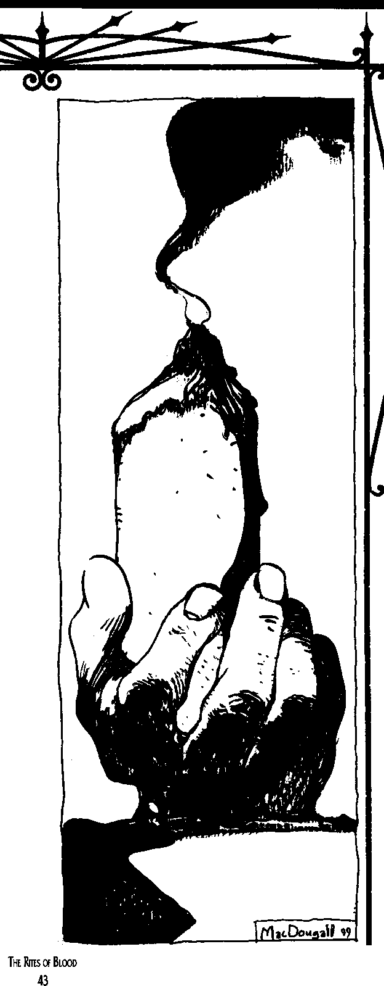

An example of lnherency is found in the ritual Clinging of the Insect (another Sabbat rite I've recently uncovered from thoseantitribu tomes), which requires the blood magician to hold a live spider in her mouth. As unpleasant as it is to have a live spider squirming under your tongue, the rite succeeds in granting the caster the ability to scuttle over vertical surfaces in a manner disturbingly similar to an arach­ nid. Then again, maybe the vampire who created the ritual was just a freak, and it happened to work because of this principle. Stranger things have happened
More experienced magi have suggested this func­ tion of Identity is one of the elements that make many rituals workable without the sacrifice of vitae. The item (or items) replaces vitae as a focus to concentrate the magus' will. This seems plausible. For example, the effects of the ritual Blood Walk are somewhat similar to the most basic ability of the Path of Blood. Other than minor variances in the information gained, the main difference between the two is that the path requires a sacrifice of the thaumaturge's own vitae, while the longer and more complex ritual does not.
The use of lnherency is very prevalent in com­ plex rituals. All wards require an element somehow anathema to the entities they protect against: Lu­ pines and silver, spirits and sale, ghouls and mortal blood, etc. The mirror fragment found in the rite Incorporeal Passage is a particularly integral use of this principle; in this instance, the mirror not only provides the magus with an insubstantial body, it also holds the "image" of his solid form for the duration of the effect.
The magical qualities of an item aren't always apparent. They may be associated with a ritual ingre­ dient only through ancient lore, myth or even common superstition. While the last instance is most common in the less sophisticated rituals found among Sabbat dabblers (Recure of the Homeland, for instance), a few older Tremere rites still include an odd item, such as the "bad" penny in Devil's Touch.
THETRAppINGSOF HERMETIC RITUALS
As I mentioned earlier, the Tremere have cut virtually all unnecessary elements from their rituals. You don't usually hear any prayers or supplications during a blood magic ceremony. A Warlock ritual is trimmed to the bare necessities to get the job done. The bell, book and candle of popular myth are seldom seen in thaumaturgical rites. However, some trappings remain in use even tonight.

All rituals open with some practice to focus the magus' mind. Quiet meditation is sometimes enough, but often the formula incorporates a short, repetitive phrase, often in Latin, to concentrate the practitioner's thoughts. Next, the ritual usually pro, ceeds by building the desired effect. At this point, any necessary ingredients must be present or the rite will fail. Some incantation is often necessary, more to further focus the magus' intent than actually invoke any greater power. Finally, and most impor­ tantly, the craftedsending must beeither immediately targeted (using either Inherency or Sympathy) or delayed (using Contagion). I watched one appren, tice screw up this particular step while performing Flesh of the Fiery Touch and roast himself from the inside out.
The ceremonial circle - most often two con, centric circles with space for various protective inscriptions between them - is commonplace in most magi's havens. (I keep mine hidden underneath a throw,rug to avoid drawing unwanted questions about my choice of floor tiles.) It's not a necessity to every ritual, but invoking any rites involving spirits or demons without one is foolhardy. A permanent circle can be created co protect against either de, mons orspirits, not both at once; additional temporary protections must be added to exclude both sorts of entities. Some magi work their rituals exclusively within a circle, insisting it helps better focus their sendings, while others do so simply because they believe doing otherwise cakes unnecessary risks with demonic attention.
Another common ingredient to many rituals is a special candle of some sort. Usually, the wax con­ tains some unique component that is released as the flame burns down. The "hand of glory" is a good example of this sort of candle. The magus obtains the hand of an executed criminal - preferably by hang, ing - and squeezes every trace of blood from the appendage. Next, he renders the fat from the hand and mixes it with paraffin to make a candle. When the candle is burned between the fingers of the severed hand, the smoke from the candle' flame provides a number of ritual effects through Inherency. The hand of glory is often used in wards, particularly against theft, but also in rituals that deal with subtle manipulation, either physical or mental.
Long, dark red or black robes are also a favorite of some blood magicians, most notably among the "old guard." Not that they serve any ritual function; rather, the dark color conceals bloodstains that might otherwise soil clothing. If you ask me, anyone wearing
a dark robe is asking for trouble - blood also shows very little against the black leather of my field jacket, and I don't look like a weirdo when I wear it. Braziers or other fair,sized fire source are used to burn any ingredients that the ritual requires be consumed by flame; more subtle magi may employ a standard fireplace for this purpose as well.

uSING PRINCipLESIN PLA '/
I
While Will, Blood and Knoweldge are fairly part andparcel to thenormal use9fthClhaumaturgy G Discipline, the principl•es of I4enJi.ty_ -Sympathy 1· and Jnher ncy may add a·_ P: _.dement tog thaumaturg1cal effects. , - , , , ,
•
At the Storyteller's:discreti.Qri,ac er may it ignore any range lfinita.tion On ri (not path) ; e ects, provided the character c aJi.sfy Iden- j uty, Sympathy odnherency.prmc1ple. This may !I make for good mirioi plots, in which the coterie ) must fmd a special component oc arch a rival's ; True Name, or it may get in the way. Storytellers, it's your call, but be-sure to be.fair and consistent when you apply your ruling.
J
, "'" "'-"" l

SpIRITSAND DEMONS
Some thaumaturges prefer to avoid otherworldly beings, whether demonic, spiritual or otherwise. The Tremere have learned that few such entities can be trusted and can be dealt with satisfactorily only from a position of power. Fortunately, vitae holds a terrible attraction - and thus power - over many of these beings and, therefore, a thaumaturge can exert a good deal of control over them through blood magics. But maybe "fortunately" is loaded wording.... Regardless of the ease with which some of these
creatures can be manipulated, a number of purist blood magi refuse to deal with any extra,worldly entities. They claim that compelling such creatures to perform tasks is nothing but a shortcut to avoid crafting a more elaborate sending and indicative of a dangerous laziness. If a magus holds sufficient power to compel a demon or spirit to do her bidding, they say, then she's got more than enough power to accomplish the task without resorting to an unreli, able ally.
The fact that the Necromancers wield so much influence among the dead also gives these Warlocks further concerns about invoking a spirit. And, they add, one need only look at the practitioners of Dark Thaumaturgy, also known as infernalists, to see the



81.ooo MAGIC:SOCRf!SmTHAUMAruRGY



effects of dealing with Hell. These magi are of the opinion that trafficking with the netherworld is best left to idiots or gravediggers.
Although detractors claim otherwise, occasions do arise when it is more expedient to employ a spirit or minor demon than it is to craft an elaborate sending to achieve the same ends. Not the rampant interaction infemalists practice, of course- that's a case of natural (or unnatural) selection waiting to happen. Only a fool thinks he can negotiate favor­ able deals withdemons. Any time a Warlock summons an entity of this sort, she carefully binds it to her will. The principle of Identity - almost always repre­ sented through the being's True Name - is an important part in any ritual involving an otherworldly being.
The Warlocks acknowledge two broad catego­ ries of these entities: spirits and demons. Lacking other evidence, the accepted method used by thaumaturges to identify such a creature is to con­ sider the role of the principle of lnherency in their summoning. Entities requiring items associated with death or the dead are considered spirits, and those drawn by the lure of blood sacrifice or flesh aredemons.
However, not all creatures manipulated through blood pacts are easily classified as a member of one or the other; when in doubt, prepare protection from either sort. Having seen the ruined - and rather incomplete - remains of a magus who'd inscribed protection against a spirit when the entity was actu­ ally demonic, I can promise you that you may make only one guess at the summoned being's nature. You're better off just making the extra effort and guarding against both.
DEMONS
Mortal magicians coerced and bribed demons through rituals long before the creation of Thaumaturgy. A few foolhardy mages relied solely on the control granted by a demon's True Name, while others exchanged blood and life for some diabolic boon. After pure spiritual essence, demons crave nothing more than the essence and fluids of mortality.
After the Tremere successfully combined Her­ metic ritual with blood magic, they gained new power over the denizens of Hell. While simple blood sacrifice is enough to manipulate a demonic entity, vitae provides the magus with the means to compel servitude. When combined with the creature's Name, the control a thaumaturge exerts is nearly absolute. At least for a while at any rate - some ancient
tomes, such as Nominis Infemi, seem to hint that even the control provided by a True Name weakens over the centuries. Even the Warlocks admit demons have abilities they've not yet begun to understand; it wouldn't surprise me to find out the most powerful can alter their Name in some fashion.
It bears mention that these aren't necessarily the Judea-Christian "demons" of Hell popularized by bad music and worse lifestyles. A given demon may simply be the spirit resident in a river, the "guardian spirit" of a sacred site or even something wholly esoteric and unknowable. I have heard that the Tzimisce even number the nature spirits of their ancestral realms as "demons." But remember, I said "necessarily" - sometimes you get a literal Hell demon. I don't know where the demonic hierarchy draws its distinctions. Be careful.
RITUAL'3AND DEMONS
Very few rituals invoke direct demonic involve­ ment. Of these, the legendary Blood Contract is the only one the Clan Tremere acknowledges as truly "demonic" in nature. Demons have long memories and may exist even longer than Kindred; it's not wise to
casually summon them with limired-<luration invocations.
On the other hand, infernalists call upon these creatures on a regular basis for virtually any trivial purpose. Since those shirkers are spoon-fed their knowledge by their dark masters, it's really no sur­ prise they employ their services so frequently.
Still, considering the elements in the Tremere ritual, Sanguine Assistant, I believe that it also summons a form of demonic entity, in spite of clan denials. The formula requires a sizeable portion of the magus' vitae and produces an animate and intel­ ligent servant for the caster. It has much of the magus' knowledge and can even learn, retaining its lessons even once the ritual's effects have expired. This intelligence, attracted by a blood sacrifice, must be some form of imp, lemure or other lesser demon.
DEMONIC BINDINGS
Although the Warlocks wisely seem to shy from too much involvement with demonic entities on a short-term basis, the masters of blood magic do bind these creatures to longer terms of service. An en­ slaved being no doubt despises such servitude, but the binding magus seldom intends to free the crea­ ture to seek vengeance on itsformer master. The two most common types of demonic servants are the homunculi and demon-bound.
Homunculi are tiny creatures, often warped and Boschean in shape and appearance, created by a

THEllmsOf111.0oo

blood magus and inhabited with a very minor dia­ bolic entity. The creator must sacrifice a portion of his own flesh and vitae to craft the body of the homunculus. A weak demon is then enticed to the body by the presence of vitae. Once the being enters the homunculus, the magus uses his own essence, inherent in the flesh and vitae of the construct, to trap it.
The entities captured by such a rite are never of any consequence, and, unlike other dealings with demonic beings, supposedly this one carries little danger to a magus. Due to the physical bond with the creature, a blood magician does suffer some physical damage should the homunculus' corporeal form be destroyed, but there is little fear of immediate de­ monic reprisal from the escaped entity.
Elder magi warn, however, that the creature may be able to decipher the magus' True Name by its association with his flesh and vitae. Although it may not be able to do harm itself, such knowledge could be bartered to more powerful demons or even used by the entity should it grow more powerful later.
The second kind of demonic servant created by the Warlocks is the "demon-bound." A Warlock binds a demonic servant to a human body that has had the soul, but not life, driven from it, usually through horrific torture, blood magic or a combina­ tion of both. The Warlock must know the Names of both the demon and the original owner of the physi­ cal body, carving or tattooing both into the body's skin. This results in a doubly-strong binding chat cannot be broken by the destruction of the physical body, although even then, the demon's True Name prevents it from seeking retribution.
These abominations are rarely made in modern times, and I can't say that I'm saddened to know that. Demon-bound servants may appear to be nothing more than normal humans at a casual glance, but they are physically far stronger than any mere mor­ tal. The power of the entity inside the physical shell leaks out to slowly warp the body. The skin, where not marred by the magical inscriptions, is unnatu­ rally smooth and almost glows with an inner heat. The eyes lack any irises or pupils, and instead are flickering orange orbs without eyelids. The inner heat isn't just an illusion either; I've read accounts of these things spontaneously combusting. Apparently, thebodyofa mortal canonly imprisonademon forsolong.

5pIRIT5
Warlocks scorn most spirits of the dead, believ­ ing them to be the remnants of mortals or Kindred too inept to protect their own existence and thus of
little consequence. The Giovanni, the Tremere say, are therefore incapable of any true magic, otherwise they wouldn't waste their time chasing ghosts. Inter­ estingly enough, while the clan openly derides the Necromancers, they watch their movements with a cautiousness that borders on outright fear.
Nonetheless, spirits do possess a few qualities that make them a worthwhile means to an end. Spirits - often called wraiths, specters or ghosts - are more easily manipulated than demons, and they retain ties to the physical world a magus can exploit. It's much easier to discover the True Name of a ghost than a demon, especially when the magus has access to the physical remains. Finally, a magus can use one of these spirits freely as a pawn without facing the dangers an enslaved demon presents; escaped ghosts usually lack the ability to exact revenge that diabolic entities possess.
5pIRIT5ANDTHAUMATURGY
Atleast two paths deal directly with affecting spirits, testament that spirits are more easily con­ trolled than demons. However, not many rituals invoke these beings; for that amount of effort the magus could probably accomplish the task as easily herself without resorting to afterlife coercion.
Still, the malevolent entity created by Splinter Servant is at least tainted by afterlife emanations. The very fact the wood for the ritual must be taken from a tree that hasdrawn its sustenance from corpses speaks volumes of the nature of the ritual. As to whether or not the spirit bound into the wood enjoys its lot, a Kindred has only to see that fractured humanoid-shaped stake literally tear itself apart in a frenzy to impale its victim to know that whatever it is motivating that thing, it is not happy.
REANIMATION
TheTremere have also found a way to create unliving servants called "corpse minions." The rite requires the magus to recall the departed soul and bind it to its former, now dead, body. The invocation includes only the True Name of the subject, a few esoteric ingredients and the physical body. Thus, corpse minions are easier to make than demon­ bound, avoiding the research necessary to Name a demon. However, corpse minions lack the super­ natural strength of an infernal denizen and are subject to normal rot and decay. I have heard legends of corpse servants created in the earliest nights of the clan that are now nothing more than a pile of bones retaining tortured and enslaved spirits bound to the will of their creator.






BLooD MACK: SECREIS OFTHALIMATURGY



The clan has found ways to compel both demons and spirits through blood magic, but I think a blood magus can safely ignore either practice without any ill effects. Once something's been to the other side of Final Death, I say it's probably best to just leave it there-especially if it wants to come back! You want to fool with ghosts, go be a mortician; you want to meet demons, pick up a pair of sunglasses and watch the sun rise.

OTHER TRADITIONS
I refer to Hermetic formulae and rituals through­ out this text. While most of the Tremere use this conservative tradition to work blood magic, there are a few blood magi who've experimented with other traditions of magic in the clan. Many of these give up after a few years of struggling to convert Hermetic formulae into a different system of incan­ tations or ceremonies. If he'sdeveloping a new ritual, a magus has a chance of gaining some status, but few elders care about a thaumaturge translating an exist­ ing ritual to another tradition.
In spite of the tedium, a small number do have the cultural background and patience to follow other traditions. In most cases, historical, ethnic or re­ gional factors attract the magi traditions other than Hermeticism. A Hebrew T remere mayfind Kabbalah more familiar, or a Creole may be more comfortable with Voodoo. Like Hermeticism, most of these origi­ nated as a part of another philosophy, but have been stripped of any supernal elements. These secondary traditions are now nothing more than vehicles for the practice of blood magic. All the principles of Thaumaturgy, both major and minor, are true for non-Hermetic practices as well.
I've selected only the most widely practiced of these non-Hermetic forms ofThaumaturgy. l've also probably missed one or two, but if so, the numbers following chose traditions don't exceed more than a handful of magi worldwide.
HABBALAH
As you may already know, Kabbalah is a mystical tradition that originated in Judaism as early as the fifth century B.C. Although it didn't receive much attention from non-Hebrew magicians prior to the late 14th or early 15th century A.D., many modem thaumaturges believe the founders of Clan Tremere did at least experiment with Kabbalah during the early stages of their research. However, the first Warlocks, while inquisitive, were steeped in Her­ metic lore and outlook, and soon left the study of
Kabbalah to pursue the more familiar rituals of their former tradition.
Surprisingly, Kabbalah has become more wide­ spread among the Tremere in the last century or so, but the total number practicing the tradition re­ mains less than two dozen Kindred, over two-thirds of whom are ethnically Jewish (at least in ancestry if not current practice) and entirely male (while the traditions of being married and over 40 years old have been tweaked in the name of circumstance, the prohibition against female Kabbalists has not). Only recently has it gained acceptance among the clan mainstream and remains limited to a few geographic regions. Areas where Kabbalah has its strongest fol­ lowing are New York City, Germany, Poland and England.
The tradition teaches that the Torah is actually a book of symbols for secrets of untold power. One of the guiding concepts behind Kabbalah is the belief in the power of the word. More specifically, it posits that words have a numerical value, and through calculations based on these values, not only are hidden truths revealed, but also works of power may be accomplished.
In the Hebrew language, letters are equated with numbers; therefore each word has not only a mean­ ing, but a numerical value as well. The numeric values of the words often show interrelationships. For example, when the values for the Hebrew words for "father" and "mother" are added, the sum equals the value of the word for "child." Through manipu­ lations of these values, Kabbalists work their rituals. Blood magicians have adapted these concepts to their own rites, reducing the tradition to its simplest form - numbers and formulae. A Kabbaliscic ritual
often involves no more than a carefully inscribed mathematical equation. The complexity and length of the formula are directly related to the power of the effect desired. A minor ritual may require only a page or so of calculations, whereas a complex and potent ritual will likely fill several blackboards - or megabytes.
Seldom do many arcane trappings normally asso­ ciated with the other traditions of blood sorcery become involved with Kabbalistic practices. The numerical definition of an item is often sufficient in rituals where more traditional Hermeticism requires the item itself. However, one area Kabbalists haven't been able to synthesize mathematically is the re­ quirement of blood and vitae; no mere formula can replace the power of the blood. In such rituals, the thaumaturge actually uses his vitae to inscribe the necessary equations.



THE RmsOF BLOOD

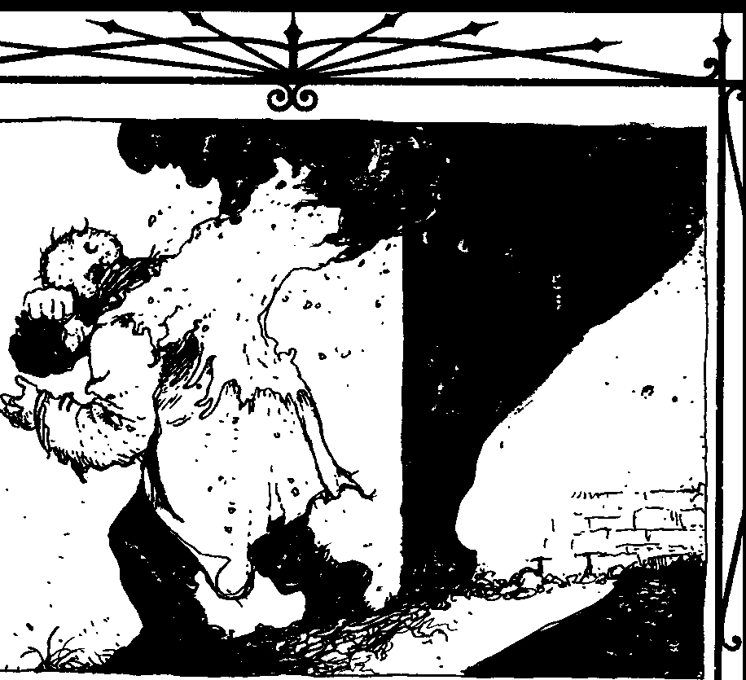

..

Knowledge is a tremendously important part of
Kabbalah. Any thaumaturge studying the tradition must speak Hebrew - the foundations of the practice are built on the language and its alphanumeric nature. He must know not only the values of the words em­ ployed in the rituals, but also the values of its permutations. Additionally, the Kabbalist must to un­ derstand and employ complicated mathematical formulae to exploit the power inherent in the values.
The ocher major principles focus and empower the effect of the magic enacted through the Kabbalist's formulae. The principle of Will ensures that simple schoolhouse calculations don't suddenly peel the flesh from a teacher's bones; without intent, math­ ematical formulae, no matter how complex, are inert and impotent.
Of the minor principles, Kabbalah is concerned primarily with Sympathy and lnherency. Specifi­ cally, Sympathy, in the form of a numeric value, is at the core of all Kabbalistic Thaumaturgy. The value of a word not only defines its essence, but also details its association with the rest of the world. The Kabbalist's manipulation of the relational values between words is almost purely sympathetic magic. The precise brevity of mathematical equations clearly
defines the intent and effect of the rituals in this tradition.
The true difficulty for a Kabbalist lies in cor­ rectly defining a word for a component or focus. Those Named in Hebrew texts are simply exercises in research, but for new inventions or, worse, the Name of a mortal or Kindred, a Hebrew translation must be made. Even if the magus knows the True Name of a target, without a correct translation, only a time-consuming process of trial-and-error can de­ rive the defining word and value. This laborious process usually more than offsets the simplicity of the formulaic ritual.
A corollary of the principle of Sympathy pre­ sents the tradition with its greatest powers. By subtly changing the nature of the defining word, Kabbalistic thaumaturges influence the substance originally de­ fined. For centuries, thaumaturges have experimented with transposition and substitution of letters within words, supposedly to tremendous effect. Practitio­ ners claim that during WWII Syrian Jews relied on Kabbalah to turn Hitler's advance away from the Middle East by rearranging the letters of the Hebrew word for Syria into that for Russia.

BlooD MAGlc:5ocmsOf THAUMAlURGY



Thaumaturges practicing the tradition some­ times employ calculus, physics and other complicated mathematical methods to great effect. Furthermore, Kabbalistic research benefits greatly from advances in computer technology, allowing numerologists to derive permutations and factorials of a given word's value almost instantly. The formulae still must be inscribed to be effective, but no longer are weeks or even years of calculations necessary to determine a value's potential. Scary. If there really was a world­ wide Jewish conspiracy, everyone would be introuble. The readiness with which Kabbalists employ computers in their research has raised eyebrows among conservative elders and regents, who view such as a dangerously small step from the blasphemy
of the path of Technomancy.
V 00D00 ANDSANTERIA
Voodoo and Santeria are both relatively young traditions; neither current form is more than 500 years old. Both developed among slaves in the Car­ ibbean from an eclectic mix of African religions, folk magic and a smattering of Catholicism thrown in to pacify the then dominant European cultures. Al­ though the two traditions differ in terminology, in practice they share the same form and methods. In spite of the potential represented by these recent additions to the practice of magic, neither has re­ ceived much attention from the mainstream chantries.
A few thaumaturges in the southeastern U.S. and Caribbean follow the tradition of Voodoo, and a smattering of Warlocks in New York, Florida, Cuba and Mexico dabble in Santeria. Other than those, almost no other thaumaturges follow either tradi­ tion. This isn't because Voodoo isn't effective. On the contrary, the small group of magi, sometimes called bokkor, who practice it contend it is every bit as potent as Hermeticism - perhaps more so in certain applications. The true reason the grayfaces rarely study Voodoo is they suspect the magical aspects of the practice may have been altered by the influence of other clans (specifically the Serpents of the Light and the Necromancers) among the mortal followers of the belief.
The Serpents of the Light have been involved in many Voodoo congregations since before the belief arrived on the North American mainland. While the other clans tended to ignore the early African slaves and their culture, the Cobras saw them as a fertile and vast network of mortal believers. During the 18th century, the Serpents had a number of Voodoo priestesses, known as queens or mambos,
among their herds. Some were probably Cobras them­
selves. Voodoo congregations held tremendous power among the faithful - usually slaves or free blacks in the antebellum South. The Tremere, ever paranoid, are concerned that the Cobras manipulated not only the population but also the belief itself.
Whether or not that's true, even I can't blame the clan for being a little cautious about the tradition.
Additionally, ample, if somewhat circumstan­ tial, evidence exists that the Necromancers have taken an active hand in the development of the tradition as well. While the Giovanni clan holds its secrets closer than even the Tremere, many War­ locks point to the power ascribed to Baron Samedi, the loa associated with cemeteries and the dead. It's unlikely the Giovanni would ignore a tradition that holds the secret of the creation of zombies, walking dead servants of their sorcerous masters.
Nonetheless, as mentioned earlier, a select few of the clan have chosen to pursue the tradition. Other, non-Tremere thaumaturges may also study these beliefs, but their numbers are unknown, and are, at best, a handful. Blood and animal sacrifices have long been a part of the two traditions, used to curry favor with the loas and other entities. As a result, many of its practitioners find it easy to trans­ late many of its rituals in to blood magic formulae.
Like all variations of Thaumaturgy, the four major principles bind both traditions. Many of the tradition's detractors claim it is a cruder form than Hermeticism because it often employs lesserloas and other spirits as agents to accomplish their goals. Conservative Warlocks see this as a degeneration of Thaumaturgy, slipping toward Dark Thaumaturgy or even Necromancy in method. The practitioners ar­ gue otherwise, but this is another stumbling block the tradition faces ingaining wider acceptance among the Tremere.
Voodoo and Santeria rely heavily all of the lesser principles, perhaps more so than any other tradition. Nearly every ritual employs at least two of these, and a fair number incorporate all three, unlike standard Hermeticism. Practitioners seldom use True Names in their rituals, instead preferring to rely on sympa­ thetic methods for targeting a sending. A lock of hair, a treasured belonging or even a photograph is sufficient for most rituals. This is the mechanic behind the notorious "Voodoo doll"-which strongly resembles the simulacrum-based ritual commonly called Widow's Spite, yet another Sabbat ritual I've managed to get my hands on. In this fashion, these

THE Rm.sOF Bl.00D



beliefs are somewhat more flexible than more con­ servative traditions that require lengthy research to properly Name a target.
Also, in keeping with its folk magic roots, Voo­ doo uses certain herbs and concoctions to focus the magic by Inherency. In some ways, this practice mirrors the early alchemical practices of Hermeti­ cism. Bokkor frequently bind several potent herbs into small packets called gris-gris, which serve as talismans providing arcane protection and a variety of other effects for their owners. With these packets, Contagion becomes a vital part of the magic- if the gris-gris isn't kept with the owner (or at least nearby), it is useless.
For less beneficial rituals, the same principle is also true. Since a victim of a Voodoo curse isn't likely to carry agris-gris voluntarily, the blood magician instead hides it near the target's home or haven. fu long as it remains in place, the ritual's effect will hold. However, care must be taken, for should a rival practitioner discover a baneful talisman of this sort, he can twist the principles of Sympathy and lnherency in the item and tum the curse back on the original magus.
One aspect of the tradition magi shun is the practice of mounting, or !oa-possession. Although Warlock houngans and mambos are not opposed to manipulating minor loas to accomplish their goals, most wisely refuse to relinquish control of them­ selves to an otherworldly demon. Given the involvement of the Setites, Serpents of the Light and Giovanni in the tradition, a thaumaturge could be opening himself to limitless danger by doing so.
While mortal practitioners insist the will of the loas is unconquerable and possession is at the whim of the spirit, Tremere bokkor have managed to resist it - or at least so they claim. Whether this is a function of the Warlocks' will, the power of vitae or their Kindred existence is unknown. Regardless, this is an area of uncertainty, and another reason practitioners are looked on with some suspicion by other thaumaturges.
WICCA
Wicca takes its name from an old Anglo-Saxon word meaning "witch." Confusingly, it's also the title chosen by modem mortal adherents of witchcraft and paganism. Barely a handful of T remere is known to actually practice true Wicca. The majority of these are found in European chantries, where they are better able to research their subject matter. Outside theclan, study of the blood magic tradition is nearly non-existent, so
finding a willing teacher is likely to be difficult for anyone reading this manuscript.
In its modem incarnation, Wicca holds little inter­ est for thaumaturges. The ceremonies and incantations found in commercialized books of franchised book­ stores across the country are, at best, unreliable and all too often completely ineffective. Most are outright fabrications printed solely to profit from the recent surge of interest in various New Age subjects.
Essentially, no trustworthy written work exists on the actual ancient practices - a fact that drives most Tremere away in frustration. What knowledge remains is passed on almost entirely in oral tradition by a few isolated covens in Europe. This presents a number of problems for Warlocks accustomed to methodical and ordered research. Lack of common references, confusing regional dialects, individual biases and questionable veracity all combine to frus­ trate the magi's attempts to codify and adapt ancient practices to modern Thaumaturgy.
Additionally, most conventional blood magi­ cians hold no small disdain for Wicca. The prevalent view among the many Hermetic magi is that the tradition is glorified hedge magic, long outdated by advances made through centuries of studied Her­ metic research. Most conservatives in the clan consider practitioners of the tradition to be fringe members who contribute little to the advancement of Thaumaturgy.
Separation from mortality limits Wiccan Thaumaturgy to a greater degree than many other traditions. The Wiccans admit many of the rituals they've uncovered are related to fertility and life­ oriented magics and, at least for now, unusable by Kindred. Most magics available to Wiccan thaumaturges are baneful curses or an occasional protective ritual. This has caused Wicca to take a more malevolent cast among Kindred practitioners than was the case historically. As a result, Wicca has lost much of its own identity and resembles, in practice, more conventional Thaumaturgy.
In spite of the drawbacks, the tradition does have certain benefits. Based on ancient pagan magic, Wicca is very effective when employed to manipu­ late the natural world. Its researchers claim many of its rituals to be very easy to adapt to Thaumaturgy, as they already possessed a strong element of blood. Wiccan thaumaturges claim responsibiliry for devel­ oping the Green Path and the Path of Weather Control. They provide no documentation to prove

l!i.000MAoc: 5rorrs OFTHAUMATIJPO

this assertion, but, given the tradition's strong el­ emental roots, most of Clan Tremere silently assents on the matter.
The difficulty in gathering truly effective rituals is the major obstacle for Wiccan magi. Due to the Inquisition and witch-hunts of the Middle Ages, Wicca suffered centuries of neglect. The rituals of this tradition usually lack the refinement of more conventional Hermetic magics practiced by main­ stream Tremere. As a result, Wiccan rituals are often the simplest in format and effect of any Tremere Thaumaturgy.
Rather than using True Names, Wiccan "spells" rely on Sympathy or Contagion as their primary method of focusing their effects. Most Wiccan ritu­ als require a more direct link to their targets than that provided by Inherency. In this way, Wicca bears some resemblance to Voodoo and Santeria. The blood magician often employs a valued item or hair clipping to target a sending. "Enchanted" items are also popular, if less discriminate, means of delivering an effect. Interestingly, the ritual Devil's Touch is almost identical in both Wiccan and traditional Hermetic Thaumaturgy.
On the other hand, because the Wiccan tradi­ tion has not received the dedicated study that Hermeticism or even Kabbalah has enjoyed, many Wiccan rituals contain extraneous steps and ingredi­ ents. For example, the pentagram is found in many rites, but its exact purpose is uncertain at best. Many herbs are ascribed a specific potency in one ritual, only to be given another, unrelated power in a different ritual. Filtering these elements is a major part of current Wiccan thaumaturgical research. The Wiccan thaumaturges, denied the extensive libraries available to Hermetic magi, have instead devoted themselves to further study of the few rituals they have translated in order to assist them in devel­ oping original rites using Wiccan methods.
DARH THAUMATURGY
In closing, I must address Dark Thaumaturgy. This is nothing more than standard thaumaturgical practices learned from demons, rather than through the traditional methods. From what I can tell, it is practiced almost solely within the Sabbat, among ignorant or foolish Licks scrabbling for arcane power. Lacking the benefit ofTremere instruction (a condi­ tion exacerbated by the disappearance of that clan's antitribu members), they would otherwise be denied access to such knowledge. Apparently, the Sabbat even has a group of vampires dedicated to fighting
the influence of the infernal. At risk of being branded a traitor (again), good for them.
Sensible Warlocks openly shun and deride Dark Thaumaturgy. With good cause, they deem its prac­ titioners to be imbecilic dabblers who have no understanding of their art and lack the wisdom to avoid dealing with infernal creatures. The tradition not only taints the soul, but its defiling effects even­ tually begin to wear on the infernalist's physical body as well, manifesting in disfigurements such as warts, strange scars, withered limbs or even more diabolic traits. Because of these manifestations, it's impossible to hide skill in Dark Thaumaturgy for long, and any the Warlocks find displaying such marks are immediately censured-or simply destroyed.
The T remere bear their abiding hatted of Dark Thaumaturgy for two reasons. First, the practice is a shortcut to power. By gleaning secrets from demons, the practitioner learns the tradition much quicker than a conventional thaumaturge, but has no true understanding of how rituals or paths work. She knows only how to perform rote steps taught by her Hell-spawned tutor. The infernal thaumaturge is little more than a child reciting a memorized verse, incapable of expanding her knowledge through ex­ perimentation or research. Infernalism, for all its power, is a magical dead-end, advancing only as the otherworldly teacher sees fit.
Second, the dark thaumaturge is beholden to an infernal master. The physical effects are noted above, but the spiritual ones are more significant. The infernalist puts an indelible stain on her soul and ensures damnation. She must heed the demon's beck and call, and will one night pay the ultimate - and eternal - price for her choice.
For the most part, Dark Thaumaturgy functions the same as conventional Thaumaturgy. The prin­ ciples remain the same; Blood, Will, Knowledge, Identity and the minor principles are all evident in Dark Thaumaturgy. If any difference exists between infemalism and other traditions, it lies in simplicity. Magic worked by an infernalist is of a cruder, less sophisticated nature than that of a true Hermetic magus. The Tremere note this is not surprising, since the practitioner has no understanding of the finer points behind the art.
The rituals of Dark Thaumaturgy are similar to those of standard Hermetic practice. An infernalist may perform a few additional (and often demeaning) steps in a procedure or require an extra ingredient or two, but these are more likely due to the capricious



THE Rms OF BLOOD

nature of the sorcerer's demonic tutor. Fresh knucklebones or the congealed fat of an infant are common items in a Dark Thaumaturgical rite, and eating feces has been mentioned in more than one text. The Tremere believe that these are included solely to further the infemalist's descent to damna­ tion through debasement. No, thanks.
Supposedly, infernal thaumaturges have access to a small number of rituals presently unknown to the Tremere. Because other aspects of Dark Thaumaturgy so resemble that of conventional Her­ metic magic, clan elders suggest these rituals were at one time known to blood magicians but lost over time. The Warlocks claim that the infernalists' dia­ bolic masters teach their servants nothing original, only providing access to the labors of others.
If the previous passages didn't make this crystal clear - don't fool with this stuff, no matter how stupid or power-hungry you are. It's dangerous and the rewards are nowhere near the cost. If you want to learn the blood arts, find a Kindred teacher. For all its faults, even the Camarilla is better than cutting a deal with Hell.
Other thall a i ew oversights, the manuscript seems genera!! o;:::::ng the technical aspects. Afrls the work might
in Us
obviously seditious pa n introductory not be inappropriate as
text !or apprentice&•••

THE CHANTRY
The institution of the chantry traces its origins back to the ancient Hermetic order of House Tremere. Now it is the common ground for all Tremere activ­ ity, both magical and political, in a given city as both a place and an organization. The clan makes a big show of requiring its members to participate in the local chantry. If you believe the propaganda, no exceptions are made to this rule. In practice, however, things are very different. After all, it's not like you can be "fired" from the clan for not attending their secret meetings. I haven't reported to asingle chantry in over a decade, and guess what - I'm still a Tremere. Those of you still wearing the frat pin should remember that next time some high-and­ mighty sorcerer tries to bullshit you into doing his dirty work "for the good of the clan."
Politically, the chantry follows the will of the clan. Regents preside over most individual chantries,
but higher-ranking elders with the clan also main­ tain their own chantries. Every action undertaken by the chantry, in theory, furthers the goals of the Warlocks; individuals may pursue their own agen­ das, but the chantry is dedicated only to service of the clan as a whole. In reality, the clan seldom requires much from individual chantries, leaving each to the leadership of the local regent. Of course, without clan support for a decision, the regent can rely only on her own charisma or power to sway support for her decisions; she could run to her elders, but that might lead them to question her own ability to lead. On the other hand, open dissent is frowned upon as well, leaving most chantries in an odd give­ and-take kind of oligarchy governed by the most influential magi in the area.
As a physical location, it serves as a meeting place, research facility and sanctuary to the area's Warlocks. T remere go to great lengths to ensure the safety of a chantry, protecting it against magical and mundane threats. Every so often according to her schedule, the Regent holds a meeting, or convocation, within the confines of the chantry in which all members are expected to participate. The exact agenda varies ac­ cording to eachchantry, but I'veseen convocations run from little more than loosely organized bitch sessions about other clans- and each other - to a candle-lit group ritual crafted to drive a popular local politician over the edge of sanity and into not-so-subtle serial murder. It all depends on the influence of the local regent and her own goals.
Only Clan Tremere has the institution of the chantry; as far as I know, no other blood magicians made use of such an establishment throughout his­ tory.Non-Warlock magi in the Camarilla and among us anarchs tend to lead solitary unlives, and infernalists have only their pocket devils for allies. Although members of a Sabbat pack interact with each other frequently, I can't imagine they are any more a "chantry" than the Manson family was a Senate subcommittee.
SOCIAL ORGANIZATION
Thesocial structure of the Warlocks is an un­ holy union between a secret society, an academic association and some twisted and hateful family like those you used to find in pop Gothic novels during the early '80s. Those on the bottom of the ladder plot and scrape for favors and recognition from above while clan elders callously manipulate the lower ranks to achieve undisclosed goals. The clan recog­ nizes younger magi only after the supplicants have






Bt.oooMAac:SOCR£ISorTHAUMATURGY

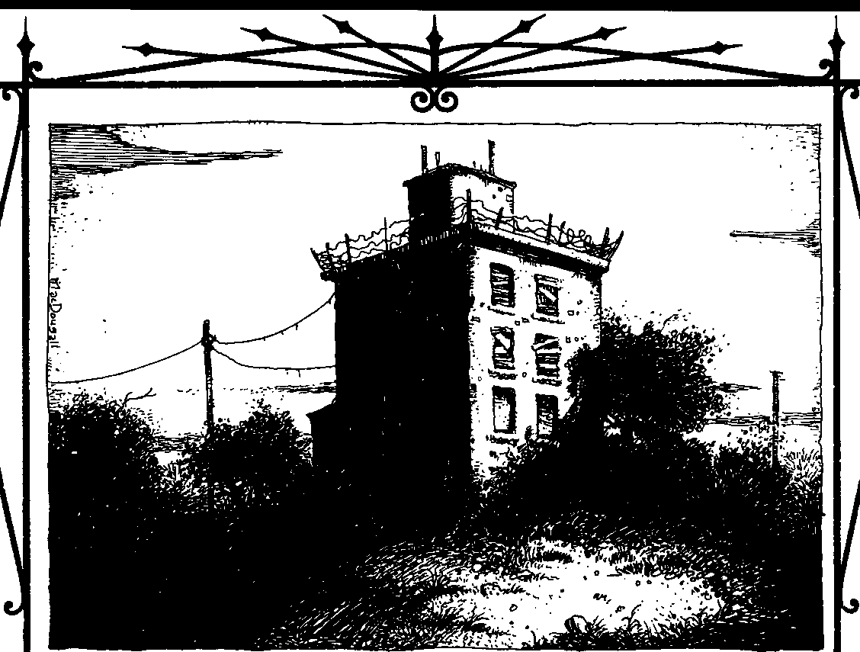

met certain prerequisites, the details of which are often withheld from the very Warlocks trying to fulfill them.
Knowledge of any sort is power to this clan, and those at the highest levels hoard it like gold. Keeping the lower levels blind to the exact details of advance­ ment is one method the Tremere elders use to coerce a form of loyalty. After all, it's difficult to argue with something you're not even aware of.
CLANRANH
I know only the basics of clan ranks above apprentice. Even when I thought such things as clan stature were important, I was unable to glean more than the limited information I'm about to present. This brief description should serve well enough as an overview. If you want more details, go ask a practic­ ing Warlock. But be aware he's probably lying, uninformed or both.
The clan acknowledges five ranks: apprentice, regent, lord, pontifex and councilor. Each rank has seven Circles of Mystery, or sub-ranks, through which a Tremere must advance before promotion to the next level. Apprentices are those Kindred just begin-
ning to walk the paths of blood, although their skill level varies greatly across the Circles of Mystery. The vast majority of the clan is composed of apprentices. The higher ranks are concerned with the politi­
cal engine of the clan. They are only filled when a vacancy exists - or is created, but I'll get into that in a moment. Regents are responsible for local chantries, lords oversee a group of regents (usually seven) and pontifexes supervise the lords. At the apex of the structure are the councilors, who direct vast geographic areas.
Most other clans seem fairly content to work with a much more informal organization, so you're probably wondering why the Tremere have so rigid a hierarchy. Experience leads me to believe the War­ locks maintain their hierarchy as a result of their age-old paranoia; the grayfaces have never forgotten their first nights as hunted usurpers. Individual chantries are a fractious lot, given to petty politics and maneuvering. No doubt the Tremere fear that without the guidance of lords and other elders the chantries would fall prey one by one to the clan's many nemeses. I have never suspected a shortage of individuals waiting for the chance to open a Warlock's

THE RmsOF BLOOD



throat, so there probably is some wisdom to
this approach.
I've always thought it odd that the Tremere seem to have a fascination with the number seven and its permutations. Rumor has it the final goal for War­ lock membership is to fill each rank with seven times the number of the rank above it. The clan counts seven councilors and 49 pontifexes, so, if one accepts the stories that Tremere himself still exists, the claim is true for the first three ranks at least. How­ ever, simple mathematics shows that if that's the case, the end result of this extrapolation is some­ thingon the order of 20,000 Tremere running around
- about an order of magnitude too great. The early clan may have toyed with the idea, but the strictures of reality and the Masquerade put a halt to it centu­ ries before I was Embraced.
Finally, some magi have noted that seven Circles of Mystery exist in each rank, but count only five apparent ranks, seemingly breaking the pattern. From what I learned during my own apprenticeship, the Warlocks never break a pattern without grave rea­ son, so I suspect there's simply more to the clan's hierarchy than has been revealed. Even counting Tremere himself as a "rank," there remains an un­ filled level, an unexplained rank. So watch yourself
- someone's not telling us the full story here.
CHANTRY ORGANIZATION
Unless the chantry is directed by a lord or higher­ ranking magus, the head of the group is a regent. Also, I've heard of a title known as"high regent," but I've no idea how that fits into the scheme of things. I suspect it's a regent who has achieved a certain Circle of Mystery. My experience is limited to smaller, individual chantries headed by regents, so I will focus my discussion on those.
All magi within the chantry, with the exception of the regent, are apprentices. It'simportant to realize that title doesn't necessarily mean the Warlock isa fledgling magus; many apprentices of the Seventh Circle have decades of experience. The highest-rankingapprentice usually acts as the regent's personal assistant and makes his haven on the chantry premises with her. Other members may be assigned positions aswell, but the titles and responsibilities vary according to the locality. I've seen these duties range from archivist (who maintains chantry records), to procurer (who obtains special ritual ingredients, arcane texts or even vessels), to sentinel (who monitors mortal witch-hunting groups or other occult activity in the chantry's locale -thislast isavery rare position).
The optimum sizefor chantry membership isseven, although only those in the largest population centers ever reach that number due the base realities of suste­ nance. Very large cities may support more than one chantry, but this is rare and subject to the approval of the regional lord. Chantries in small cities sometimes have only one or two members or combine the magi from several localities to fill its ranks.
A special note should be made about Wiccan thaumaturges. A "coven" is not a chantry; it is a group assembled purely for conducting large rituals. Thirteen practitioners are required to found a coven, almost twice the desirable chantry membership. Instead, Wiccans usually employ ghouls or other mortal assis­ tants to reach the desired number. These supplemental coven participants don't seem to be considered full chantry members, nor are they allowed much knowl­ edge of chantry proceedings.
ADVANCl:Ml:NT
Other than the progression through apprentice circles - which I'll deal with later - I'm largely unfamiliar with the exact mechanism of promotion above the rank of regent. Advancements in blood magic are tremendously important, but, as I understand it, elders consider other factors in awarding promotion as well, such as increasing Tremere influence in both theCamarilla and mortal world. It'salmost certain chat loyalty of theclan iscarries great weight as well, but this is an unspoken assumption - the elders often seem to expect all apprentices to be almost mindlessly loyal. That "Serve the clan!" attitude might have worked 800 years ago, but it's an idea whose time has long past.
Drivingambition iscommon toall rankingTremere. They compete fiercely witheach otherforclanstatus- not unlike professors at a university struggle for tenure. Of course, with Warlocks the idiom "publish or perish" takes ona whole new meaning. Every magus is expected to contribute to the clan's arcane knowledge. Those who want to rise instature must produce greater results than those satisfied with their lot, but all are required to produce.The generalopinion among theeldest grayfaces seems to be that if a magus doesn't advance the clan, he hinders it. However, most of these stiff-necked magi are too far removed from nightly life, and only Warlocks scrabbling up the social ladder actually pay more than lip service to that idea.
On the other hand, a magus may find her position challenged by another if she falls into disfavor. Such challenges require the approval of the next higher level and, if approved, the two magi fight a ritualized duel called certamen.

BLoooMACK: Srum or THAUMATIJRGY



CERTAM'EN
Certamen is an archaic dueling custom dating to the pre-Kindred days of the clan. It takes place over the course of a single night and is held in a chantry. Lords preside over regent duels, pontifexes over lords, and so on. The Warlocks use it to settle challenges to leader­ ship authority, provided the challenger is of suitable rank to assume the position himself. Rumors circulate among the apprentices of the clan that any advance­ ment above lord is only allowed chroughcertamen. This makes sense if you accept the theory of sevens I men­ tioned earlier; all 49 of the pontifex positions are filled, and an applicant would have to "convince" one of the current pontifexes to step down.

"p ontitexes,• indeed.
Po:t1.ii.fioea.
presence puts the chantry at risk. Many regents invoke this prerogative for no other reason than to avoid "spies" from other chantries. Paranoia knows no bounds, it seems.
Also within the confines of the chantry are typically a meeting area, a sizeable library and an alchemical laboratory or other facility suitable for Hermetic experimentation. Depending on the lo­ cale, other, less common facilities might also be found. In Seatcle, the chantry extended below street level into a walled-off area of the "Seattle Under­ ground" where the magi kept a sub-basement filled with failed attempts at a new type of ghoul they had been developing. I add for posterity that the pitiful creatures, denied further vitae, had resorted to can­ nibalism and the population was quickly dropping.
In the earliest nights of the clan, the Tremere

Would that all his research Blapdash.
was so
relied on the strength of their strongholds to protect chem from the assaults ofTzimisce enemies and their armies - chis was literally back during the Middle

The participants are allowed a maximum of two hours to prepare whatever defensive rituals they desire and enter an area of the chantry prepared as an arena. The arena consists of a bare room with two circles, three feet in diameter and exactly 14 feet apart. For the remainder of the night, the two magi may use any ritual or path to attempt to incapacitate the other. Leaving one's designated circle is consid­ ered forfeiture, a surefire way to end any hope of further status within the clan. Certamen above the level of regent are often fought to Final Death; any T remere in a position of higher leadership incapable of even defending herself poses a danger to the clan as a whole.
I've seen certamen occur once in a New York chantry, when an apprentice of the Seventh Circle deposed her regent. The apprentice claimed the regent had been presenting her discoveries as his own, and the regent's lord approved the challenge. The duel gave credence to the apprentice's claim; she assumed the position of chantry regent, and the former regent was carried away by two ghoul acolytes to feed the rats.
PHYSICAL A 5pecT5
Most chantries include space to serve as a haven ample for the regent and perhaps one or two appren­ tices. Other chantry members must maintain their own havens. Tremere from other localities may re­ quest hospitality from the regent as well, although he is within rights to deny it if he feels the petitioner's
Ages. Those years huddled behind stone must have left quite a mark on the clan elders. Even today, Warlock chantries typically occupy sturdy buildings and are heavily warded against magical and mun­ dane intruders.
Tremere Kindred move cautiously when making a decision to found a new chantry. Often, a regent and her apprentices may observe a city or area for years before making a decision on where to locate a chantry. Once a chantry is in place, the Warlocks are very reluctant to uproot and move it to a different location. A number of ancient chantries in Europe aresaid to have nested inthesame dank hallsforcenturies. A chantry usually occupies a good deal of space,
yet the clan has no desire to call unwanted attention
to its sanctuaries. Chantries located in rural areas are often large estates located far from high-traffic road­ ways and surrounded by fences, walls and security systems. In more urban areas, the Warlocks fre­ quently purchase small apartment buildings to serve their needs. In larger cities, the Tremere usually try to position the chantry near libraries or other reposi­ tories of knowledge. The D.C. chantry is located very near the Library of Congress and linked to it by old, twisting tunnels believed to be bricked up by both buildings' caretakers. Every now and then a janitor who stumbles into the wrong section disappears, dragged into the hidden labyrinth by chantry mem­ bers or their minions. Ocher perennial favorites include buildings on college campuses, appropriated government buildings, old churches and even lim-

THE Rm.s OF BLOOD



ited-access floors of office buildings. I am sure a few harder-to-find variations exist, like the fabled "Londoner's Tunnel" the English Tremere are so secretive about, but I haven't seen any firsthand. This either means I'm as paranoid as the rest and they don't exist, or that they're fulfilling their pur­ pose admirably.
One of the primary duties of the regent's assistant apprentice is maintaining the security of the chantry. The apprentice not only performs frequent checks on all mundane security systems, but she also maintains the wards and other arcane protections upon the chantry. Only in the rare circumstance that the apprentice is of insufficient skill to perform the necessary rituals does the regent himself do so. However, the regent oversees any special servitors the chantry may possess, such as demon-bound or corpse minions; a high-ranking ap­ prentice is too near the regent's position to trust with that kind of power.

RESEARCH
Continuous research and expansion of the art of blood magic is of the highest importance to the Tremere. The clan fears the consequences ofletting Thaumaturgy stagnate; only the power of blood keeps the Warlocks safe from their many nemeses. An important purpose of the chantry is to provide magi with a sanctuary where they may study, experiment and exchange ideas with others of their kind in relative security.
To create a new ritual, a magi usually works backward from the desired effect to develop the necessary formula. The researcher must also deter­ mine which principles will be most effective in the ritual. He weighs the convenience of employing the principle of Inherency against the difficulty in ob­ taining ingredients. He considers whether or not to use a True Name, or rely on Contagion or Sympathy to target the sending. As a rule of thumb, the Tremere prefer rituals using Inherency to those requiring vitae sacrifices and formulae that function without the need fora True Name. Accuracy takes a backseat to convenience; after all, the Tremere have forever to fine-tune.
A new path is much more difficult and time­ consuming. Unlike rituals, paths are seldom defined by formulae. The magus must pursue a much more intuitive route, relying heavily on trial and error. Because of the many obstacles this presents, most magi prefer to research ancient or forgotten ex­ amples of paths from experimentation pre-dating the Tremere and develop those instead.
A sure way to gain stature, promotion and other honors within the Tremere social hierarchy is to push back the boundaries of blood magic. Discover­ ing new or forgotten paths gains more respect than a ritual, but the scions of the clan reward insight and creation of even the simplest formula. Innovation, perhaps ironically, is very much prized among the Warlocks.
However, the Tremere have little tolerance for failure. Many promising thaumaturges have seen their hopes of status dashed due to a miscalculation in a formula during a demonstration.Even achieving results too slowly dulls the clan's interest in an experiment. Ambitious Warlocks - and are there any other kind? - often choose to steal another's ideas or work rather than risk any personal invest­ ment. For those reasons, many magi prefer to conduct their experiments in their own havens, trading the convenience of the chantry facilities for privacy.

AppRENTICES
Among the Warlocks, a neonate is usually re­ ferred to as an apprentice. The institution of apprenticeship is unique to the Warlocks and a cornerstone of clanorder. This practice dates back to the clan's origins as mages, and, in many ways, a new T remere is as much a student of the arcane arts as he is a Kindred. The Warlocks impress this upon their childer, explaining the their undead existence is secondary to their practice of the blood arts.
The title of apprentice is misleading to many outside the Tremere. It's commonly associated with neophytes and beginners, and some apprentices are exactly that. However, in addition to a descriptive term, apprentice is also a rank in the clan structure, one that may require years and even decades to outgrow through achievement. A Warlock may hold the title of apprentice for years, even after she's taken on the responsibility of Embracing and mentoring a new apprentice herself. Remember, the elders of the clan have spent centuries mastering blood magic; even decades of study and research are but the beginnings of a magus' education.
SELECTION
TheTremere take the creation of childer very seriously indeed. The right to make a new apprentice depends not only on the approval of the appropriate prince, but also the local regent. Although regents do have the authority to authorize an addition to their chantry, most seek the advice of the next higher-ranking Tremere before doing so. With this


Blooo MAGIC: 5ocRm OFTHAllMAlURGY



much political involvement in the process, few Warlocks create childer frivolously; all are carefully considered and evaluated prior to the Embrace. A talented student brings prestige for her sire, but a failed apprentice leaves a difficult black mark to erase.
This holds true even during times of open con­ flict; the Warlocks have many methods to bolster their ranks. Better to create a few disposable corpse minions than to foster a failed apprentice.

Obviously, one slipped ihrou&h•••

Contrary to what one might think, the Tremere seldom Embrace prac­ ticing Satanists, New-Age witches or the like. Most of these are nothing more than escapist pretenders who are unable to deal with the harsh reality of their own world and choose to pursue a fantasy life. The Warlocks have no use for such undisciplined miscreants.
Nor does the clan make a habit of choosing mortal mages as neonates. As the early members discovered, the ability to work true magic is stripped away with the mortal coil. At best a former mage might have a psychological advantage over a mun­ dane by accepting the existence of the supernatural, and even this is only a minor edge as being Embraced does wonders for opening the mind to previously unimagined possibilities. Add to this the fact that most T remere - like the rest of the Kindred - have never even met a mortal mage, nor would they likely know one if they did,and the whole point becomes moot. The Tremere favor aggressive, intelligent indi­ viduals, regardless of their prior professions. Astrong mind and inquisitive nature are far more important than anydabbling in mysticism the apprentice might have done as a mortal. However, most apprentices have had some exposure to the occult, even if only one as simple and innocuous as a college anthropol­ ogy course, because those intellectual pursuits are more likely to cause a mortal to cross paths with a
Warlock than other less exotic ones.
The clan seems to be inclined more toward males thanfemales, probably due to a bias carried over from the original Hermetic order. Certainly, nothing in­ trinsic to Hermeticism or blood magic is responsible. As society moves forward, the Ttemere are slowly overcoming this archaic predisposition, but I have heard that the number of male elders greatly out­ numbers those of the females.
Age is also a consideration to the clan, as most apprentices are chosen from the young adult or early middle-aged section of the populace. Children often lack the discipline to be of use to a master, and older apprentices are usually too set in their ways to be able to adapt to the clan's traditional strictures. Given time, both of these drawbacks could be overcome, but most blood magi prefer to spend their time developing their own mastery rather than as nurse­ maids for troublesome apprentices.
Mathematical ability is often considered a desir­ able trait in an apprentice. The logical processes necessary to understand complex mathematics are of tremendous benefit when studying ritual formulae. Understanding of ancient languages is also looked upon favorably as many ancient texts have been recorded in dead tongues. Of course a Kindred magus has eternity to learn a language himself, but time is better spent actively researching texts or jockeying for prestige.
Most notably, however, seldom do the Warlocks consider the desires of the candidate in the decision to Embrace or not. Most apprentices are completely unaware of the existence of the Kindred until the very moment they become one. Once transformed, apprentices must quickly assume their place in the organization'sstructure. Only the strongest wills and most adaptable minds can accomplish this. Since the same traits are required to master Thaumaturgy, the clan treats this adjustment period as a form of natural selection. If the apprentice can't overcome this ini­ tial hurdle, she's not fit for the ranks of the clan - and woe to her sire for choosing such an tmfit apprentice.
Another reason T remere are so cautious about the Embrace is the master is often judged not only by his own acts, but also by those of his apprentice. Among the Warlocks, a sire is not unlike an impo­ tent parental figure. He's responsible for creating and rearing his childe, but all the while authoritarian
- and sometimes just plain malevolent- grandpar­ ents lurk in theshadows, waiting topounce at anymisstep.
TRAINING
An apprentice's training begins almost immedi­ ately and no thaumaturge, Warlock or otherwise, is ever truly done learning the art. Clan Tremere understands its strength flows from the Discipline, and its elders urge all sires to thoroughly school their childer in the ways of blood. Apprentices are the foundation of the great pyramid, and the stronger the foundation, the stronger the clan.


THE RmsorBt.oco

The sire is responsible for the apprentice's initial training and indoctrination to duties, structure and the finer points of being undead. Since most T remere sires focus the early part of an apprentice's education on the practice of blood magic, clan elders grant a short grace period to new apprentices as far as cus­ toms and tradition are concerned. The elders expect the neonate to show proper respect and deference, but they typically excuse failures in the finer points of etiquette. As stratified as the Warlocks' organiza­ tion is, their paranoia dictates that power outweighs courtesy.
An apprentice's training focuses first on the principles of blood magic and how paths and rituals integrate them. During the first weeks after the Embrace, the neonate learns her first path, usually that of Blood, and ritual as an aid to this instruction. Most sires try to select a ritual of some value to the apprentice's nightly existence to provide the student a reason to make frequent use of it. My first ritual was Wake with Evening's Freshness. It was entirely pro­ tective in nature, valuable enough to me as a neonate to insure I'd practice often, and helped demonstrate two of the minor principles ofThaumaturgy, Conta­ gion and Inherency.
During this period, an apprentice seldom has much free time. In order to guarantee the fledgling has a firm understanding of the basics of the arts of the blood, the sire often keeps her occupied from sunset to sunrise reciting rituals or performing other arcane exercises to focus her concentration and will. It's not unheard of for a master to bring his appren­ tice vessels throughout the first weeks to avoid losing valuable time to the neonate's inept attempts at hunting.
After a few weeks of thaumaturgical training, the sire usually shifts the focus from purely arcane studies to a balance between blood magic and clan customs and structure. Each member of the clan must understand her place in the organization and work to fulfill her responsibilities to her fellow Tremere. Those who can't meet these requirements
- or at least appear to do so - are often "removed" from the clan.
Many regents require new apprentices to meet with them at least once a month (some even insist on once a week) following the chantry convocation. At this time, she reviews the apprentice's accomplish­ ments to date, and tests the neonate's skills and understanding of the principles of Thaumaturgy. Simultaneously, the regent usually engages the


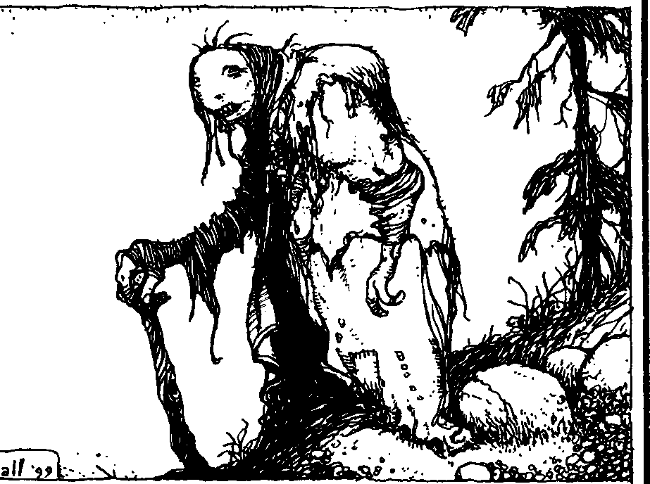
·•

•

!lt.oooMAoc: Smu:rs OfTIW.!MATUF!J\'

apprentice in casual conversation on the course of his training. This way, she also maintains an infor­ mal watch over the sire's activities. All Tremere have spent time as apprentices, and are aware of this practice, so few sires let their childer catch them in any improper activities.
Once the regent is convinced the apprentice has a solid grasp of the basics of Thaumaturgy, the neo­ nate is usually afforded a greater level of freedom. Most apprentices continue to spend at least three or four nights each week with their master in addition to any regent's convocations, but are allowed to pursue their studies on their own at other times. At this point, the apprentice is expected to fulfill her responsibilities to the chantry, hunt for herself and abide by all Camarilla Traditions.
Of course, not all of an apprentice's time is spent mastering blood magic. Most devote at least some of their efforts to honing their other Disciplines, usu­ ally those involving heightened perceptions and mental influence, as well as experimenting with the innate abilities of all Kindred. Many also expand their work to include older languages, like Latin, Enochian, Arabic and Greek, since many archaic texts are not yet translated to modern tongues. Fi­ nally, the Warlocks encourage the fledglings to develop and nurture powerful contacts in mortal society, to further the influence of the Tremere through mundane means.
Over time - usually years - a Warlock appren­ tice advances in both skill and position within her chantry. With each step, she earns more autonomy from her master and more responsibility to the clan. Although she may retain the title of apprentice for a decade or longer, if she conducts herself according to "the rules" and exhibits mastery of the blood arts, she will achieve a level of status nearly equal to that of a full magus within her chantry.
DUTff'5
Only the youngest neonates are unaware of the rumors that the Warlocks force their childer to imbibe an alchemical concoction containing, among other ingredients, the blood of the Tremere Inner Circle, during their Embrace. It's true-all Tremere are already one step along the road to a blood bond with the leadership of the clan. Apprentice obliga­ tion doesn't end there, either; in return for the master's mentoring and instruction, the neonate incurs certain additional obligations and duties.
For most purposes, the apprentice becomes an indentured servant for her sire. According to the
Warlocks, the purpose of this period is to better instruct the apprentice in both the ways of blood magic and clan tradition. In reality, the master is so encumbered by the apprentice's instruction he needs the assistance to accomplish his own work and research. At the beginning of an apprenticeship, the neo­ nate is given the simplest tasks to perform, such as preparing simple ritual ingredients. Often, these are also rather unpleasant, such as pulling fingernails from week-old corpses or plucking maggots from rotted flesh. Sires usually try to incorporate some
aspect of instruction into the assigned labors, even if it is nothing more than teaching the childer patience and discipline. I don't remember having much free time during this part of my training, nor have I seen any evidence to make me believe other apprentices do either.
After the apprentice masters the rudiments of blood magic, the magus begins to gradually expand the scope of her duties. The master may entrust the apprentice with gathering odd components for for­ mulae or assisting in simple rituals. As the neonate's skill level progresses, the master may assign her to perform certain rites for him herself. A sire who has an apprentice with special skills, such as linguistic ability or mathematical affinity, may call upon her to employ these as well.
Over time, most magi reduce the amount of tasks they assign to their apprentices. On average, a neo­ nate at this stage only spends two or three hours a night, or perhaps two nights a week, fulfilling their duties. Combined with the time spent in training and clan duties, an apprentice usually has about two or three nights completely free of obligation.
By the end of the second year or so of apprentice­ ship, a sire begins to reduce the number of requirements he places upon his childe. Truly tal­ ented apprentices may reach this point sooner, but this is a rare occurrence. Seldom does a master require mote than a few hours a week or at most one night a week, from his apprentice. This is balanced, however, by a cutback in the hours spent mentoring the neonate; Warlocks anticipate apprentices at this stage to be able to advance their own studies with minimal supervision. Like most modem "higher education," the apprentice gets out of it what she puts into it.
The magus expects more skilled service from the older apprentice as well. The master may require her to perform basic rituals on a regular basis, assist in research or even acquire vessels for the master to feed on so he may focus on his own work. Strangely




THE lbrEsorBt.oco



enough, few magi abuse the master-apprentice rela­ tionship - probably because the student will soon become a blood magician in her own right and is liable hold a grudge against a repressive mentor. I have no illusions about the good nature of the Warlocks.
Throughout the apprenticeship, all neonates have certain obligations to their masters. Precedent dictates these to instill the proper attitude to younger Kindred and teach the apprentices their place in the clan structure. Outside of training, an apprentice below the Third Circle of Mystery is forbidden to initiate conversation with a higher-ranking magus (exceptions are made in time of emergencies). In chantry convocations, an apprentice is usually ex­ pected to attend her master's request until she reaches the Fourth Circle of Mystery. In any rite requiring the sacrifice of vitae, an apprentice must volunteer her own. This last is seldom more than a formality designed to teach sacrifice for the art; few rituals can be invoked using the vitae of another, though a master may require an advanced apprentice to per­ form the ritual herself. Once an apprentice reaches the Sixth Circle of Mystery, even this final require­ ment becomes a rarity, noted in the breach more than the observance.
PROMOTION
TheTremere have the most regimented organi­ zation of any Camarilla clan, and, arguably, any Kindred group. Perhaps the Giovanni familial ties provide the Necromancers with closer bonds, but when it comes to conformity and order, no other group is as tightly knit as the Tremere. Mess with one Warlock and you mess with them all- atleast that's what they'd like you to think. I'm pretty sure they'd let slide any headhunter who happened to finish me off - hell, they're liable to reward the bastard after this little text hits the streets.
The clan begins building a sense of membership and rank from the first night of an apprentice's existence - remember I already mentioned that whole "drink from the chalice" thing. Even though this is the case, however, Clan Tremere is hardly a universal or monolithic entity. No clan is like a football team, following orders because that's what the captain said to do. Rather, most clans are families of rabble, associated only by their clan blood. When observed in this manner, the Tremere are more like clergy or an academic society. (Or, perhaps, even the Freemasons, if other Kindred are to be believed. Take anything a vampire tells you about the Tremere with a grain of salt. Except me, of course.)
Like other ranks in the Warlocks' clan, the apprentice rank has seven Circles of Mystery. As the apprentice displays arcane skill and dedication to the clan, he advances through these circles and receiving more independence and acknowledgement. The rate of advance is largely dependent on the apprentice's accomplishments, with the truly adept rapidly rising through the ranks. Clan elders watch the "fast-track" apprentices closely because, though talent is important, too rapid an advance may indi­ cate a dangerously ambitious or radical individual.
I know. You're damned if you do and damned if you don't.
The clan ties promotion in through the first two Circles directly to the apprentice's studies. Nor­ mally, no neonate may rise to the Second Circle of Mystery without mastery of at least three basic ritu­ als, and an applicant to the Third Circle must display advancement in his skill with his primary path. These requirements are rigid; only under the most extreme circumstances do elders allow them to be modified.
The strictures covering elevation to circles above the Third are much more flexible than the initial steps. The chantry regent grants promotion through these levels and is often quite subjective in his technique. I've provided the accomplishments the clan most often uses to benchmark an apprentice's advancement. However, the regent may award some outstanding achievement with a promotion to a higher circle even without any of these.
Promotion to the Fourth and Fifth Circles usu­ ally combines service to the chantry with continued improvement in Thaumatucgy. In addition to dem­ onstrating knowledge in several moderately difficult rituals and further advancement in his path, an apprentice rising to the Fourth Circle must accom­ plish some specific task assigned by her master or regent. This may be as simple as performing duties at the chantry convocations (for favored apprentices) to locating a stolen text or item (for a troublesome neonate). The prerequisites for the Fifth Circle are similar to those of the Fourth, though the apprentice must usually learn the beginnings of a second path as well. By the time an apprentice reaches the Fourth Circle, he no longer answers directly to his sire. Instead, he is free to pursue his own studies- as long as they don't interfere with other obligations. It's unusual for a regent to allow an apprentice of the Fourth Circle to Embrace a mortal, but I've heard of

BwooMAa:: SE.ems OF THAUMATIJl(jl'

numerous cases of Fifth Circle and higher-ranking apprentices creating their own childer.
An apprentice achieving the Sixth and Seventh Circles of Mystery has customarily mastered her primary path and is well-versed in her second, and maybe even third. She can perform the most compli­ cated rituals without assistance, and has learned at least a portion of the formulae she knows through her own research. Typically, apprentices seeking the Seventh Circle have successfully created at least one ritual of their own. Additionally, the apprentice must have proven on several occasions her dedica­ tion and value to the structure of the clan.
Only a lord or higher-ranking Warlock can grant promotion to the rank above the Seventh Circle of

..,
oo·: ..
•.
.
.
.,
I?

.'
·

Mystery, which is that of the First Circle of Mystery for regents. The elder bases this decision not only on accomplishment, but also on available chantries. A regent must have a chantry to preside over; if none are open (or at least open to challenge), the appli­ cant must remain an apprentice (in title if not actual
Q • •. .-: b
,., •
, ,,.
.• ,; .

ability) until the opportunity presents itself. For this reason, apprentices of the Sixth Circle are usually
'
considered "journeymen" magi, and those of the D
Seventh Circle are treated as full magi with respect to responsibilities and privileges.
AppRENTICETRAN5FER5
TheWarlocks are notorious for transferring neo­ nates to different chantries. Clan elders often spew the party line that this provides the apprentice the widest possible exposure to various methods and rituals, but only the newest members of the clan swallow this one. Another common tactic is for the regent to declare that the apprentice's continued presence a threat to the local Masquerade. This is also usually a bald-faced lie, but rather than risk the wrath of the prince, most apprentices simply move along when they're told. In reality, the Tremere have been pulling this stunt for centuries just to prevent any particular magus from building a powerful fol­ lowing of former apprentices.
Ironically, this practice has backfired many times. Charismatic and clever masters use this transfer program to seed spies throughout the clan and gather information on other Warlocks. This espionage covers everything from political maneuvering to Hermetic research. Because a newly arrived apprentice may be a security risk, receiving magi often shield much of their activities from their students.
Clan elders hold regents responsible for ensuring transferred apprentices receive instruction appropri-
• ,• ,
- . ,
I? <>
t:t
' • <l" .
:
••
••
.j - ,,
••
"

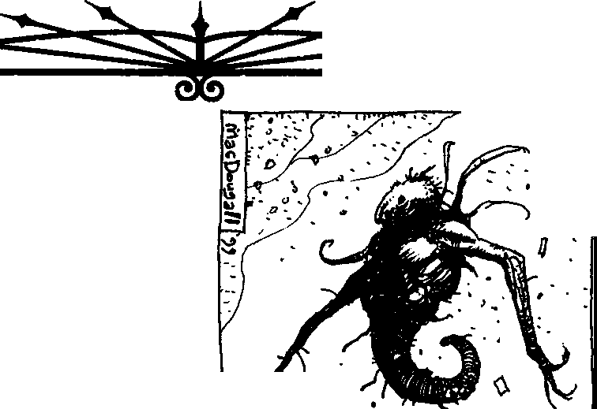

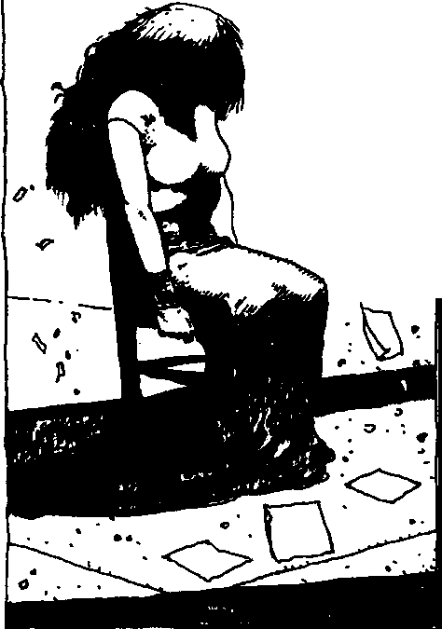
THE Rmsor&.ooo

ate for their level and censure masters who are too stingy with their knowledge. This leads most magi to a complicated game of give-and-take, where the master provides the apprentice enough training and insight to allow advancement, but not enough to reveal her strengths and weaknesses to hercompetitors.
In theory, a master tries to instill a sense of trust in her apprentices that will allow her to later call on this good will to spy on her own rivals. At the same time, she mustn't develop any reciprocal sense of duty to the apprentice, lest she expose herself to a former master who's already secured the student's loyalty. In the end, most magi end up teaching their apprentices from a core of "safe" (i.e., commonly known) topics and formulae. As a consequence of this conservative maneuvering and scheming, an apprentice must accomplish any truly advanced re­ search or experimentation on his own - which the master invariably finds a way to take credit for, I might add.

!!'he IID&roh has
d.esenes 1l1vest1 • a J'IOint here that
chantry at a later date, so the master can use the student's abilities strengthen her own power base, not only through arcane assistance, but also with boons and information. As long as the apprentice's studies remain secret, the master has no formal at­ tachment associated with the student; she doesn't suffer any negative social or political repercussions for her protege's actions. This gives the blood magus much greater freedom in the tasks she can assign her student as well.
Finally, the greatest attraction to teaching the blood arts to a non-Warlock is prestation. Many Kindred recognize the potential of blood magic, but Thaumaturgy is so closely guarded by the clan that few non-members have ready access to it. A shrewd magus can negotiate very favorable conditions for his services as an instructor - which she must then reconcile with the displeasure of the clan as a whole, if she's ever found out.
The bottom line: If you're not a Tremere and you want to learn the secrets ofThaumaturgy, lotsa luck. It's possible but not very probable.

- eJD d.oee lead to
ga ion. th
&i e
current sye-
GOING IT ALONE

hohniquee by mast&inaUon in instructive loaa as to how t:rs However, I am at a
keei,ing the '"ca • dd.ress this while
rro -a.ttd.-sti .,
use to i,ro•ote newd ck method. we
!!'hi eveloi,ment in the an
Not all Kindred desiring to learn the rites of blood have enough influence or power to tempt a Warlock to betray his clan. While those with any sense bide their time until they can convince a
magus to tutor them, some decide they're capable of

s WOUld. •»Jlear t O •

wiser JDi.ttds tha
n lD3 own.
be a ioi,ic ror
learning Thaumaturgy on their own. Even assuming the Kindred can garner the resources necessary, this is a difficult and lengthy process, and takes far longer

N ON-TREMERE AppRENTICE5
Thus far, I've dealt only with apprentices of the blood art who are Warlocks themselves. I have ob­ served no shortage of Kindred seeking an instructor in the secrets of blood magic. However, rare is the T remere who considers non-clan apprentices worth the bother to train. The outsider can't bring her master any clan status for her achievements. In fact, the elders are likely to expel a Warlock for divulging the clan's pet Discipline to a non-member, assuming the prospective teacher can get past the selfishness that prevents her from teaching unique secrets in the first place. Therefore, to avoid censure, any magus who decides to accept an outsider as an apprentice does so secretly.
I hypothesize a few advantages in a non-Tremere student. The chantry regent doesn't monitor the apprentice's training and treatment, giving the mas­ ter much greater freedom in her methods. The apprentice won't be forcibly transferred to another
than studying under another blood magus.
Few survive their experiments long enough to expose any great secrets, so unless the dabbler trans­ gresses against the clan by stealing arcane texts or interfering with Tremere activities, the Warlocks ignore them. Other clans watch for such self-taught blood magicians with great interest, however - not only the Tremere, but also the Serpents, Giovanni and power-hungry Sabbat packs.
A few self-taught rogues often end up making some of the most startling discoveries. Unfettered by the highly restrictive training schedules of the War­ locks, these magi often stumble onto new paths or formulae by leaps of illogic or taking risks few "sane" Tremere would ever dare. The Warlocks aren't blind to the potential such independents represent, and may offer such magi special favors in return for details of these unorthodox discoveries. Assuming, of course, the magus in question is capable of defend­ ing his achievements from a more "direct" approach.



ll!.oco MAo::: 5EIJI1S OFTHAUMAillRGY

BoOHSOF BLOOD MAGIC
Chantry libraries contain a staggering amount of
scientific and occult works, most of which contain only snippets of useful information. Others, like the works of mortal Hermetics such as Albertus Magnus, Michael Scot and Thomas Norton, are respected for their insights into fundamental alchemical practice. Some of the most prized texts of this sort include The Difference of Soul and Spirit (Alkindi), Particularis (Scot), On Alchemy (Magnus) and Opus Mljus (Bacon).
Few books are dedicated solely to the practice of blood arts, and the Warlocks scurry to snatch these up as soon as they surface. However, the T remere magi only trust those they can attribute to authors from their own clan; to do otherwise would expose them to fraudulent texts planted by cagey foes. In spite of the clan's best efforts, some of these works - or at least reliable copies - remain outside their grasp.
Clever magi keep their own magical tomes, en­ crypting them in either complex codes or heinously difficult allegories. I'll admit to being confounded here, which is probably A Good Thing from the point of view of the clan. Since the Warlocks so viciously guard their knowledge, even their notes become exercises in critical thought. Most young apprentices keep little more than journals or "scrap­ book" grimoires, but anyone who has truly studied Thaumaturgy for any length of time has a collection of rituals and resources worth a king's ransom if not more. Just be sure they're not warded to set you on fire if you haven't spoken a protective phrase - remember chat someof the principles work in theobverse.
Below, I've detailed those works I'm most famil­ iar with, either through firsthand knowledge or reliable secondhand information. No doubt many more exist, but, like the infamous Al-Azif, one can never becertain if the book is realor merely an urban legend
VENEFICORUMARTUM 5ANGUI5
Inner Councilor Etrius penned this work, called the Veneficorum by most magi, probably the oldest text in existence written by a Tremere magus. This book chronicles many of the early experiments of the Tremere and their efforts to combine blood magic and Hermetic rituals. The work is thorough and explicit in its explanations of the procedures, elabo­ rating in great detail the principles ofThaumaturgy. The Tremere guard all copies of the Venefteorum
jealously, because they feel it may enable any Kin­ dred in possession of this work to learn Thaumaturgy. The original come, written in Latin, is reportedly
kept in Vienna, and most of the copies were also
scribed in the same tongue. A few English transla­ tions, made in the early 18th century and entitled simply The Sorcerous Art, are scattered among North American chantries. All told, a total of 11 Latin copies and five English translations exist.
NoMINI'SlNFERNI
Using excerpts from an ancient Sanskrit frag­ ment titled Naaman'h raakShasa, a 13th-century Warlock composed this short work on demonology. The translator's name is unknown, and no record exists of hisfate after completing this text. The small book, actually a hardbound pamphlet, reportedly contains not only the True Names of several moder­ ately powerful diabolic entities, but also one of a being of least archdemon status.
Only the original and a single copy were made while the book was in Tremere possession. At some point during the 15th century, the clan lost both copies to agents of the Arcanum or Inquisition. The Warlocks believed the Inquisitors destroyed the works until recently, when rumors began to arise that at least one copy still existed and was in the hands of an infernalist somewhere in Central Europe.
DAS TIFFE 0EHEIMNI5
This book is probably the most common work on the subject of blood magic Hermeticism. Johann Kloepfer, a member of the Cologne chantry, wrote the book in the 15th century. Although originally in German, the work has been translated into most European languages, including English, French, Ital­ ian and Russian. A translated copy of the text, usually titled The Dark Secret, or at least a portion, can be found in nearly every major chantry, and virtually every Tremere has perused its pages at one time or another.
The book contains not only many of the most common rituals and paths (including Blood and the Lure of the Flames), but also lays the foundations for the basic principles ofThaumacurgy. Unfortunately, glaring errors in Kloepfer's explanations, such as omitting vital steps in common rituals, make the work useful only in a supplemental capacity. Many magi believe Kloepfer placed these fallacies deliber­ ately to safeguard the art from non-initiates. Most chantry copies are littered with copious hand-writ­ ten notes and corrections added by respective members over the centuries.




THE RmsOF BLOOD



THEjOURNAL50FTHOMA5BREMOND
The only historical written work detailing Tremere research into Voodoo is a set of two leather­ bound journals dating to the mid-19th century. They detail the research of one Thomas Bremond, owner of a Louisiana sugar-cane plantation. Bremond dis­ appeared shortly after the end of the Civil War, and clan historians believe his former slaves put him to the Final Death.
A recluse, his chantry was composed only of himself and his single childe, but he drew heavily on the Voodoo folklore of his large slave population to augment his Hermetic knowledge. Isolation and a ready source of subjects for experimentation led Bremond to some startling variations in blood magic rituals. His writings also allude to some experimen­ tation along the Path of Corruption, although whether he learned the practice from his sire or developed it independently is unclear.
According to rumors, the New Orleans chantry holds the original copies of Bremond's journals, though none of the members of that group are known to practice or pursue Voodoo. However, a number of copies, many of questionable accuracy, are known to be in circulation.
THE EIGHT DI5H5
Also known as The Blasphemous Text. First re­ corded on eight black 3.5" floppy disks, this ASCII text document contains the secrets of the Path of Technomancy and is rumored to contain a number of rituals involving computers and other technological devices. Both the explanation of the path and the descriptions of the rituals are said to be highly math­ ematical in nature - possibly even Kabbalistic. When in paper form, the text is several thousand pages in length.
Conservative Warlock elders seized the original disks, but numerous copies exist throughout Europe and North America. On occasion, excerpts from the
These last two sections are particu­ larly damaging. He reveals far too mu.ch of our efforts in the mortal world and hints at our greatest weakness. The only good part of this commentary is that the whelp appears somewhat dated in his information. He is unaware of the true force behind the fall Of the Sabbat betrayers, which indi­
cates he no longer has close ties within the clan.
While I regret that means fewer targets
!or vengeance, it also means should he release any !u.rther documents, they are
text appear on the Internet (mainly ITP-only sites), thanks to the efforts of certain anarch thaumaturges.
BLOOD MAGIC IN THEREAL WORLD
Throughout this manuscript, I've focused on the
practice of blood magic and how the Tremere have integrated it into their clan hierarchy. The elder magi have built an intricate and secretive culture around the blood arts and they try to keep the secrets of its power to themselves. But that doesn't mean the rest of us are free from its influence.
The Warlocks use blood magic freely to spread their dominion throughout the Camarilla and mor­ tal world. Their designs are subtle and concealed from view by their sorcerous arts. The clan's seem­ ingly endemic paranoia drives its members' decisions, and nothing less than complete control will ever ease these fears - which the sensible deem impos­ sible, but for one truth. The Warlocks are the Illuminati; the man behind the curtain is a Tremere.
Through blood magic, Warlocks have the power to slowly shape the world into their own vision, and they're not the sort to balk at an opportunity like that. Ritual magic provides the Tremere with the ability to strike unseen anytime and anywhere.
Political figures conveniently turn up ill at cru­ cial times and favorable legislation passes. The numbers of the stock market are manipulated nightly by Kabbalists, sometimes to benefit the clan, some­ times just to see what happens. An associate drug lord's rival is stricken mute by a Voodoogris-gris just before important negotiations, leaving him unable to argue. A single bullet fired from an assassin's rifle defies the laws of physics, leading the entire popula­ tion of a major country to suspect a multi-level conspiracy and vast cover-up.
Even the mundane isn't safe from their interfer­ ence. A nightclub owner enhances the flavor of a drink through alchemy, literally addicting his clien­ tele and driving his competition out of business. A brand of over-the-counter medication is changed to arsenic through the application of Sympathy, caus­ ing mass hysteria and causing a shift in consumer buying patterns.
And so on, ad infinitum.
Blood magic is a powerful tool of the vitae, one to which all Kindred have a right. However, the Tremere have chosen to deny it to others through secrecy and political maneuvering. The Camarilla

likely to be less damaging than this one.
iOCRETS OFl HAllMATURGY

serves the Warlocks neatly in this function, protect­ ing them from threats as they slowly craft the world as they see fit.

THE MAGIC FALTERS
In closing, recent events have shaken the very core of Thaumaturgy. All practitioners feel the ef­ fects, but none stand to lose as much from these occurrences as Clan Tremere. Blood magic seems to be losing its potency, and the Warlocks scramble about like cockroaches trying to discover the cause. Not long ago, the Sabbat Tremere antitribu van• ished without a trace. Initially, the Warlocks greeted this as a great triumph, a righteous retribution on the rebel magi for betraying their own. However, no explanation is forthcoming, and whispers hint at the rise of some ancient foe. Some suspect the Tzimisce have begun a dreaded purge or maybe another, for­ gotten nemesis has resurfaced to seek vengeance. Other, more loyal clan members claim the Tremere themselves were responsible for the downfall of their Sabbat counterparts, but these mouthpieces can pro­ vide no proof - or even a plausible explanation.
Even preposterous whispers of unthinkable things - Salubri antitribu, walking Methuselahs and the like
- have made it to the rumor mill.
The very fabric of blood magic seems to be weakening. Rituals, previously foolproof, now have an element of uncertainty. The Assamites somehow escaped the centuries-old binding the Tremere placed on them - a feat chat has no precedent. The War• locks have made several moves to reinstate the sorcery, but none have beensuccessful, leading many to suggest they have either lost the knowledge to do so or the ritual itself no longer works. Others even hint chat the original sending was too powerful an accomplishment for even blood magic and that some­ thing else was behind the actual binding.
No one knows these incidents mean. The Tremere have retreated to their chantries to comb their libraries for an answer. The Warlocks jump at shadows. A rumor has started to ripple through the darkened halls of their sanctuaries. It's never uttered louder than a hushed whisper and consists of a single word:
"Gehenna."




THE Rmsor BLOOD

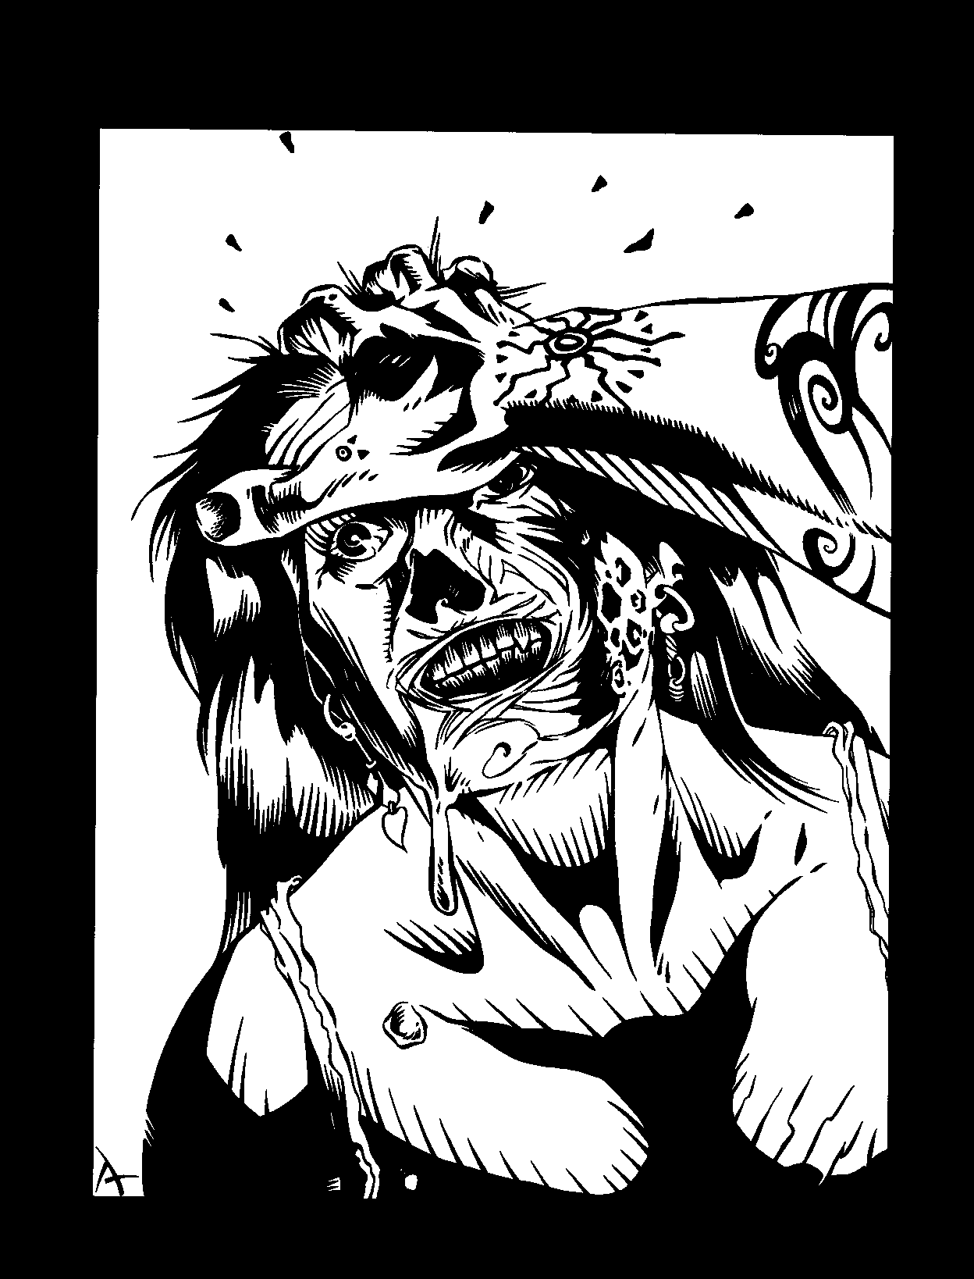

This chapter explores several lesser-known (but nonetheless reliably reported) paths and rituals of Thaumaturgy. These new thaumaturgical powers are appropriate for any story, whether in the hands of the players' characters or the Storyteller's supporting cast. All powers printed hereafter use the basic thaumaturgical systems as presented on pages 178 and
182,183 of Vampire: The Masquerade. A few of these powers have been updated from previous editions of Vampire supplements, but most are new. This is by no means a complete collection of Thaumaturgy's capa­ bilities, but rather astarting point for players who would have their characters learn the sanguinary secrets of T remere magic and for Storytellers who would have new and eldritch fears with which to highlight their stories. In theory, Thaumaturgy's powers have no lim­ its, and a character's efficiency is governed solely by his own understanding of the art.
PATHSOF

THAUMATURGY
LE'ARNING THAUMATURGICAL PATHS
After mastering their primary path, many thaumaturges continue to learn more of the arcane powers of the universe. Choosing a secondary path is a mixture of personal preference and the availability of the preferred magic. Within Clan Tremere, the desire to study thaumaturgical paths and rituals increases as clan prestige and honor becomes increasingly depen-
dent upon magical power. Even so, thaumaturges re­ quire dedication and perseverance in the pursuit of their blood magic.
Leaming secondary paths in Thaumaturgy requires either a mentor who possesses the path knowledge desired or occult materials that hold lore essential to deciphering the magic. Without access to one of these requisite sources, a character is unable to learn the fundamentals of a path, although the thaumaturge can create the path from scratch. This option takes an extremely long amount of time (see below).
The road to the discovery of the rumors of possible mentors and lost arcana should be interesting and exciting for the thaumaturge. The search for specific and rare information can be a long and arduous task, and perhaps spawn its own story.
As always, the Storyteller has the final word on whether a character is able to learn - or even find - the knowledge she seeks.
CREATING NE'W THAUMATURGY PA TH5
Creating a new path is much more difficult than performing any other aspect of magic, even creating new rituals. To create a new path, the thaumaturge is required to have a minimum Occult 5 and Thaumaturgy of Level Five.The thaumaturge must alsohave access to a haven with alaboratory while pursuing this study into the unknown.
The player creates the path as he wishes to see it (including what effects it has, durations, etc.) and submits it to the Storyteller. To be sensible, all the

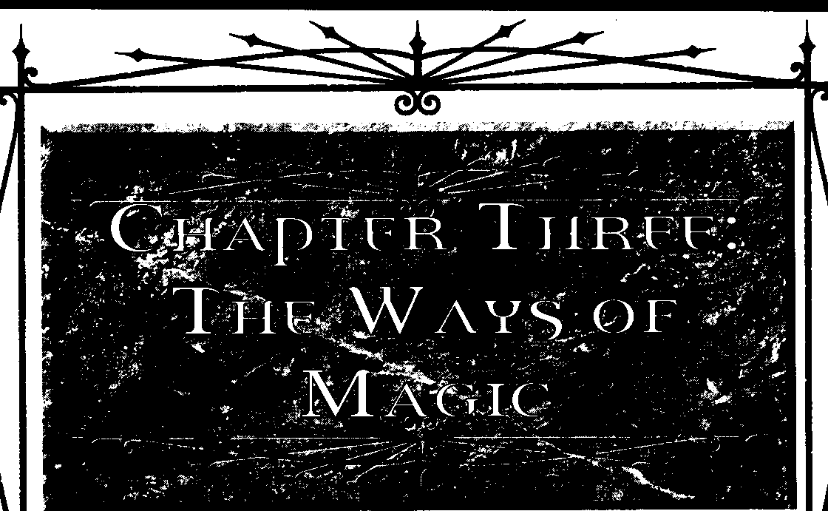
THEWmmMAGIC

powers of the path should follow a common theme. It should not be a compilation of random and unrelated powers the player wants access to. A good rule of thumb for power levels is to compare them toother path powers at the same level. The Storyteller determines whether or not the new path is acceptable. If not, she makes any modifications she deems appropriate or scraps it en, tirely (after a few months of research by the character).
The thaumaturge then begins an extended action, rolling Intelligence + Occult (difficulty 5 + the level she's researching) and requiring five successes. Every time a player makes this roll, she must also spend five blood points per every level of the power she's researching. These blood points need not necessarily come from her
immediately, but she must have them readily available (it's assumed that she consumes them and spends them as necessary during the research). Each roll represent.s one year of research and experimentation,with success allowing the character to develop a single level of the path. Each levelof the new path repeat.s this process and levels are researched sequentially. A character may not learn the next level of a new path without researching and creating it first. A botch on anygiven roll resets the successes garnered for the creation of a path's level to zero. Generally, it takes years to develop a new path from beginning to end, but the path to knowledge and power is not an easy one.
For example: Vit.!ienne has decided to research and create a new path based upon the principle of emulating "faitli h£aling." The Storyteller apt,roves the patli, and
Vivienne's player, Mark, makes the Intelligence+ Occult roll and spends five blood points. Vivienne's Intelligence is 3 and her Occult Ability is 5, so Mark rolls 8 dice. The difficulty tounlock the secrets of the first level is 6-aLevel One power plus the base difficulty of 5. Mark ral 9, 8, 6,
6, 6, 4, 3, and 3: five successes. In just one year, Vit.!ienne codifies the first level of her "faitli healing" patli, and Mark spends the experience points to let her learn it. Later, Mark tries to see if Vivienne can uncooer further secrets of thaumaturgical healing. He rolls eight dice againand spends IO blood points, this time yielding three successes ( against a difficulty of 7, as this is the Level Two power), whichmeans thatVivienne is gettingcloser,but hasn't quite completed the fcmn.ula. The next year, Mark rolls again, spending 10 more blood points, but botches. Vivienne's three successes vanish - she must have made some error or overlooked some property of vitae. !{Mark wants Vit.!ienne tocontinue learning this path, he must start again at Level Two.
The new path requires the expenditure of seven experience point.s for the first level and four times the current level for all other levels. After the thawnaturge researches and successfully develops each level, the
magus can teach it to others at the nonnal cost for a Thaumaturgy path.
THAUMATURGICAL

PATHS
These are a few paths known to the T remere, though not as universally as those in the core rulebook or the Camarilla and Sabbat guides. Storytellers should make these as common or as rare in their chronicles as they like, though almost all of these (unless mentioned otherwise) are probably known by or available to some T remere in any city of appreciable size.

ALCHEMY
Thaumaturgy has some of its roots in the early practices of Hermetic alchemy, which concerned it.self with changing the properties of given ideals. Indeed, much of Thaumaturgy's codified structure and basic principles are very similar to those of alchemy.
In the near-millennium that has passed since the Tremere's earliest efforts with blood magic, alchemy has fallen by the wayside, however. Modem technology makes possible almost anything thi.s path cando and far more - it is easier and more reliable to mine for gold, for example, than it is to create it by transmuting other materials. Still, old habit.s die hard among vampires, and the T remere are no exception. A few elders still practice this path, and of these, some still teach it to their childer to illustrate the basic tenets of modem blood magic.
System: The number of successes on the activation roll determines how radically a thaumaturge may alter a given compound's form. He need not use all his successes - a thaumaturge wishing to effect only a simple change of form need not tum lead intogold if he accumulates five successes. The thaumaturge must, however, acquire at least the minimum number of successes suggested by the table below to generate the effect he seeks.
Changing one element intoanother requires famil­ iarity with both element.s. One cannot suddenly decide he wants to change a balloon's worth of helium into a sphere of solid titanium ifhe has never dealt with either of those element.s before. Simply knowing an atomic number is not enough to warp the laws of nature so radically. It is worthwhile to note, however, that Al­ chemy makes no distinction between naturallyoccurring and man,made elements - it affects Einsteinium as readily as it affects carbon.




Btro, MIOC 5"'m <>lHAMA'"""


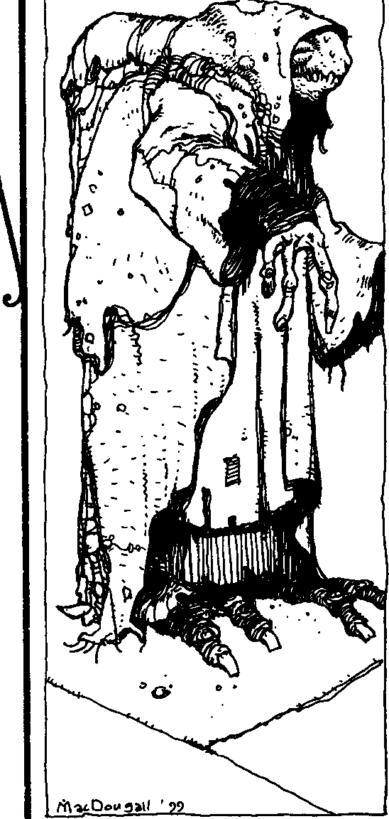


Note also that this path has fallen out of practice because it is less useful in modem nights than it was in the past.Transmutationscreate Hermetic"ideals" rather than perfect real-world resources which cannot be broken down into lesser constructs. A hunk of gold is a hunk of gold - an attempt to cast coins with it will reduce the hunk to a pile of inert sludge. Before you ask
-yes, this means your T remere anarch will not be able to create nuclear bombs by turning the prince's shoes into uranium. There's nothing wrong with converting lead into gold and selling that hunk of gold to someone else, however - caveat emptor!
Note: Storytellers are encouraged to apply this principle to the use of the Path of Conjuring as well. Characters who try to conjure "antimatter" or create weapons of mass destruction magically should be subtly but reasonably discouraged.
Also, use of this path assumes the thaumaturge works with the elements ina laboratory-style (orat least controlled) environment. No vampire will be able to walk down the street and tum the iron in people's blood to helium with a simple touch.
A vampire's knowledge of Alchemy determines how greatly she may change a given element.
- Simple changes in form - solid to liquid, liquid to gas, etc.
- • Complex changes to form - liquid to a specific shape of solid, water to separate hydrogen and oxygen gas clouds, etc.
- • • Complicated changes to form-water to breathable 0i and loose Hz, compounds into sepa­
rate elements, etc.
- • • • Minor shifts in composition, such as adjusting an element's atomic number up to five greater or less than its original designation.
- • • • • Miraculousshifts in composition, such as turning lead into gold or nitrogen into radium.

BIOTHAUMATURGY
This bizarre pathreputedly has its roots in the secret tomes of the inscrutable Black Hand. Over the past few years, its esoteric secrets have spread among certain cabals ofT remere, who regard it as a curious mixture of Hermetic science and genetics. Biothaumaturgy con­ cerns itself with the manipulation oflife energies. In the laboratories of inspired biothaumaturges may be found strange creatures almost out of myth, veritable Frankenstein's monsters and less wholesome creations. Although it is not considered a "taboo" path, Biothaumaturgy is nonetheless strange and unsettling to those who observe its results.

THE WAYS Cf Mia
(fJ

Biothaumaturgy does not require the expenditure of blood points to create its magic. Rather, the powers of this path take one week per level to complete at Levels One and Two, and one month per level to complete at Levels Three through Five. For example, the Level One power takes one week to work, while the Level Three power takes three months for the biothaumaturge's experiments to come to fruition.
Biothaumaturgy also requires the thaumaturge to have a laboratory where he may conduct his experi­ ments. This need be nothing more complex than a doctor's table and a few sharp knives, but it may be as
complex as the "mad scientist" affairs of pulp fiction, with steaming alembics and crackling generators. The Storyteller should feel free to modify a character's Biothaumaturgy difficulties ifhe has an excellent labo­ ratory resources or his facilities are utterly lacking. Working with a crude lab may add two to the difficulty while a high-grade facility may lower his difficulties by two.
- THAUMATURGICAL FORENSICS
Thethaumaturge may take a tissue sample from a living, dead or undead creature and ascertain its distin­ guishing characteristics. A wealth of information may be gleaned from thissample, including information that "normal" forensics and genetics would not yield,such as age, generation, clan, etc.
System: Each success on the activation roll yields one piece of simple information about the subject, which may beanyIiving, undead or dead entity (but not an inanimate object), including plants. This informa­ tion is limited to physical characteristics of the subject
- Thaumaturgical Forensics can be used to determine gender, dan, traces of diablerie and the like, but it will not reveal if a given subject killed an individual or where she kept her trove of personal belongings.
- • THAUMATUROICAL 5UR0ERY
Thethaumaturge uses his knowledge of magic and physiology to aid a body in its regenerative capacity. Even the most grievous wounds may heal more quickly if aided by this sorcerous art.
System: Each success on the player's roll allows the thaumaturge to "convert" one health level of damage to a lesser type. Aggravated damage becomes lethal, lethal damage becomes bashing and bashing damage becomes easily slept-off fatigue (and vanishes completely). Note that the actual surgery does not take the above-men­ tioned two weeks to finish, but recuperation times account for that period.
•••LESSER ANIMATION
Thethaumaturge mystically endows adead lifeform with magical energy and imparts to it a rudimentary set of instructions. The resultant creations carry out their orders to the letter; biothaumaturges use this power to populate their havens with deathless guard dogs and other, quirkier "pets."
System: This power affects plants and simple ani· mals - nothing more than a single tree or dog per use. If the effect is successful, the animated creation may he given a one-sentence command, which it will fulfill until destroyed. Minor variations on the subject may even be made - a thorn thicket could be animated to move slowly toward intruders to entangle them, or an animate cat could be given a set of larger, permanently extended claws that do additional damage. Specifics should be worked out with the Storyteller.
Creatures animated in this manner have their origi­ nal Strength and Stamina Traits, while their Dexterity drops by one (but never below 1). Social and Mental Attributes are considered to be at zero. Each creation has a number of health levels equal to half of those it had in life (round up).
Creatures animated in this fashion immediately crumble to dust if stricken bysunlight, and suffer double damage from fire.
•••• GREATER ANIMATION
Ac this level, the thaumaturge has refined her knowledge to allow her to animate more complex creatures. Even human corpses and large animals may be given the "spark of life" with this power - one biothaumaturge in Egypt is rumored to have a pair of animated elephants with which he terrorizes his en­ emies.
System: This power works the same way as Lesser Animation, but allows the vampire to animate more complex creatures. Certain lifeforms are probably be yond the capacity of this power- zombie whales sound fairly foolish-but theonly limit is what the Storyteller chooses to allow. This power also allows minor changes to be made to the subjects, or allows major changes to be made to lesser subjects. For example, an animate human corpse maywield a bone-hook instead of a hand,
or a rat might be able to fly with a pair of leathery
gargoyle-wings made from the bones and skin of birds and infants.
A human animated in this manner retains none of his original "self." This power merely animates the corpse; it does not reunite the spirit with the body.






&.ooo MAoc: 5ECRm Cf TIWMTUF.GY



- • • • • COONIZANTCON'5TRUCTION
The pinnacle of Biothaumaturgy, this power be­ stows adead creature animated through one of the lesser powers of this path with a semblance of the intelligence it had in life. Animated animals possess a malicious cunning while higher lifeforms gain a shrewd ability to reason deductively rather than satisfy rote commands.
System: Although this power gives an animation a base intelligence, the creature nonetheless still serves the orders it isgiven by its creator. A creature animated via Cognizant Creation has Mental Attributes of one less than it possessed in life (but never below 1). This won't be creating any undead geniuses, but the story effect is that it creates an animated monster capable of reasoning. A Cognizant Construction won't mindlessly fight to its second death if it sees a better or cleverer way of routing foes, and it will be capable of other deductive tasks as well.
THEFocu5eo MIND
Developed by a Tremere Kabbalah scholar, this little-known path ofThaumaturgy has been around for a few centuries and remains in practice by a select few. Practitioners of the Focused Mind greatlyenhance their mental alacrity and readiness, allowing better
comprehension of problems and situations. Thaumaturges, already disciplined of mind, become frightfully powerful in the realm of the cerebral when mastering this path.
Unlike most Thaumaturgy, the powers of this path do not require an action to invoke, although they still require the normal blood expenditure and Willpower activation roll. Each of these powers is usable only once per tum.
- READINE'5'5
Using Readiness makes the caster able to gain a quicker understanding on a predicament. Enhanced lucidity enlightens the caster, allowing better reactions to changing situations and increased cleverness.
System: This power is only usable on the thaumaturge himself. Every success on the activation roll adds one die to a special dice pool for the remainder of the tum.These dice may be used on any Wits-related rolls or actions that themagus performs during this tum. Alternatively, each die removed from the dice pool adds one to the caster's initiative rating.
••CeNTERING
By invoking this power, the thaumaturge causes a sudden, intense calmness in the subject by whispering




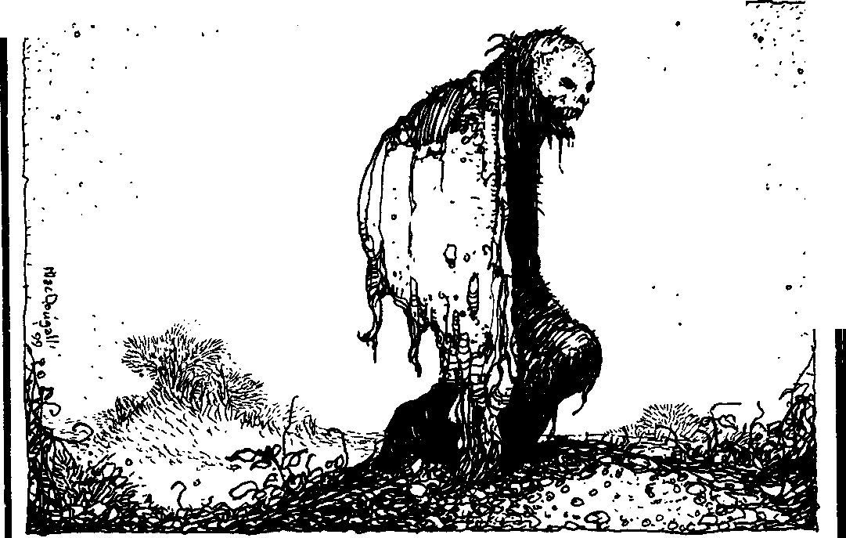
' ·... •'

THEWAYSorMACK

soothing words to her. While under this serenity, the target is able to better focus on casks at hand, ignoring distractions andannoyances, including grave bodilyharm.
Magi in fear of frenzy often use this power on themselves to achieve a state of tranquility, asemotions are stifled.
System: This power is usable on any subject within earshot of the thaumaturge and lasts for one tum per success on the activation roll. During this period the target is unaffected by any effect that reduces his dice pools.This includes wound penalties, situational modi­ fiersand Disciplines. Modifications to difficulty numbers still apply during this time, however.
In addition, due to the unnatural serenity that this power bestows, the target receives two additional dice in all attempts to avoid or break frenzy. Lupines may even be calmed from their murderous rampages iffive or more successes are scored on the activation roll.
••• ONe-TRAcHeoMINo
By extending his powers to other individuals, the thaumaturge is able to fixate the subject on one action. This single-mindedness of the target is such that they ignore everything else that occurs around them.Guards are easily distracted with this power, as their attention becomes fixated elsewhere, and research becomes a dedicated, focused cask. Use of this power is sometimes colloquially referred to as "railroading someone."
System: This power may affect anyone who can hear the thaumaturge. Successful invocation makes the target unable to split any dice poolsfor extraactions and unable to change tactics after actions have been de­ clared. As a side benefit, reduce the difficulty of the action by one. Additional actions that the victim takes (from Celerity, for example) during the duration of this
powet muse follow their initial action, as they concen­ trate wholly upon chis one idea. The duration of One-Tracked Mind is one scene if used outside of combat, otherwise it is reduced to one tum per success on the activation roll.
••••DUAL THOUGHT
With the rigors of concentration required to learn Thaumaturgy, many Tremere are able to take quickand complete control of a situation. With this power, the thaumaturge is able to divide his attention to two completely separate tasks without problems. As One­ Tracked Mind forces the subject's attention into a single objective, Dual Thought expands the thaumaturge's concentration to the point that focus upon two goals is possible.
System: Successful use of Dual Thought allows the caster to cake an extra action during his tum. Thi.s is
restricted to mental actions, be it the use of Disciplines such as the use of Auspex or Thaumaturgy, or the contemplation of some problem. If the character is using both actions to solve a problem, he has two separate dice pools to draw from. These two actions happen at the same time, asdetermined by the initiative rating of the character.
••••• PERFECT CLARITY
Perfect Clarity brings about a Zenlike moment of unimpeded insight for the thaumaturge. Pure focus is achieved, thought and action become one, and com­ plete serenity of mind descends upon the Kindred magus. This lucidity protects the thaumaturge from influences both internal and external; even the Beast within i.s unable to rage forth.
Some practitioners have likened use of this power with the state of Golconda (theoretically, of course), but the upper T remere hierarchy denies chis rumor as much as they deride the existence Golconda itself.
System: This power lasts for the duration of one scene. For this period the thaumaturge has the difficul­ ties of all actions reduced by two. The Kindred is immune cofrenzy and ROtschreck from allsources, even by supernatural means. Finally, any means to control or influence the thaumaturge suffer a+ 2 difficulty, includ­ ing the powers of Presence and Dominate.

THE HEARTH PATH
For those T remere who maintain private havens, secrecy is paramount. The Hearth Path seems to have evolved from a collection of rituals designed to protect the integrity of a vampire's sanctum sanctorum. Havens protected by these powers often acquire reputations as "haunted" houses and the like. The T remere are quick to point out, however, that these reputations help to strengthen the Masquerade rather than jeopardize it. When people find out that the house is just a house with a spooky atmosphere, they chastise themselves for be­ ing so foolish as to believe in ghosts.
1
•
Gue5T 5HeRALD
This power, when used on a door or other ponal, creates an audible or visual effect that notifies the Tremere that someone has crossed it. In this way, the vampire knows when someone has entered her haven and can deal with the interloper as she sees fit.
System: This power lasts for 24 hours. The signal may be anything of the thaumaturge's choosing - a particularly noisy creak, a tendency to stay ajar or even something wholly unconnected, like the rotation of a decanter in another room. In all cases, the effect isstatic
- it looks or sounds exactly the same every time it



8!.ooo MAGC:SID11SorTHAMATURGf



happens. Any point at which someone other than the thaumaturge crosses a warded area, the effect takes place. Whether or not the vampire is present to observe it is a different matter.
Note that complex chains of events are outside the purview of this power. The ritual will not trigger an elaborate Rube Goldberg-style"trap" (though it may set off the first part ofone), nor will it aim andfire ashotgun at the door. These are simple, subtle, brief effects.
•• MA5TER'50RDER
Inhis own haven, the thaumaturge knows where every last article lies. He knows where he placed an important book, he knows the drawer that the keys to his safe occupy, and he knows where his ensorcelled
wooden stake rests. He even knows these things when he doesn't....
System: fu long as this ritual is successful, for the duration of the scene, the thaumaturge knows exactly where any given object has been placed, as long as it is in his haven. This knowledge applies only to inanimate objects - he may not locate his childe in this manner. Also, the object must belong to the Tremere himself; an assassin's knife will not be found by this power, nor will the objectson another's person.Something the Tremere has swlen will tum up without difficulty, however.
This power works only in the Tremere's haven, where he has spent at least one day's rest prior to invoking the power.
eee RHYM'EOFDI<;CORD
Thevampire may create a miasma of confusion in her haven. This power plays upon intruders' minds, causing them to become lost in the vampire's haven, to lose their direction and misremember specific details such as objects in rooms and their location.
System: Characters other than the thaumaturge find themselves hopelessly lost in her haven, no matter how small it is. Additionally, they are unable to remem­ ber any but the smallest details regarding the place once inside. Even if an intruder attempts to follow or chase the Kindred through the haven, she will lose track of direction, make wrong turns, etc. This effect lasts for one full 24-hour period, but the confused memories an intruder takes with her last until she visits the haven when it is not under this protective ensorcellment.
••••TEMpORTAL
As master of her haven, a vampire may briefly reshape it so that doorways lead to rooms other than those to which they are connected. For example, the door to the bedroom may suddenly open into the study,
while the deepest catacomb of a Transylvanian dun­ geon might lead to a tower elsewhere in the castle. Thaumaturges find this useful both as a convenience - how better to retrieve a book from the basement when one is on the third floor? - and as an escape route.
System: This power works until sunrise. At the thaumaturge's whim, he maywalk through any doorway in his haven and be immediately transported to any roomof hischoice that isalso in hishaven. Anyone who follows him through the door will find themselves in the room the doorway naturally connects to.
1
••••• THECAULDRON 5RED'E
This power bestows a primitive awareness upon the magus' haven. While her haven is under this sending, the thaumaturge may ask any of the items in her haven about specific events taking place therein. A bedroom mirror may whisper of guests conspiring in the foyer, a divan may disclose bedchamber indiscretions, and the lowliest kitchen rug may reveal high treachery taking place in a salon. Anything occurring within the haven (or within eyeshot of the outside, as the windows can "see" as well) can be relayed to an inquisitive magus by the common items inside.
System: This power lasts until the sunrise after the vampire invokes it. The vampire must verbally ask questions of her haven's accouterments, should she desire information from them. Only in case of extreme danger, such as a pending attack or a haven set ablaze will the voices of the haven call out to the Kindred.

MASTERY OF THE MORTAL SHELL
A thaumaturge practicing Mastery of the Mortal Shell explores the fundamental functions of the body, granting control over the physical workings of asubject. Lesser powers of this path are clumsy in their control of the body, but become increasingly precise and com­ plete.
In the early nights, Mastery of the Mortal Shell was created to assist in the hunting the Tzimisce and Gangrel enemies of the Tremere, but its uses were expanded to enforce subservience among enslaved Gargoyles after their first revolt. The powers of this path form the foundation for many tales of witches' curses and posses­ sion in folklore.
Unless otherwise stated, the powers of Mastery of the Mortal Shell last a number of turns equal to the number of successes a thaumaturge scores on his activation roll.

THE WAY£ OF MAGIC

•VeRTIGO
Thethaumaturge induces minor disorientationand dizziness through subtle manipulations in the subject's body. Although the physical discomfort is temporary and minor, Tremere have beenknown to use it on social rivals at the most inopportune times, causing them to lose their aplomb.
System: A touch from the thaumaturge (possibly requiring a Brawl attack, with Storyteller discretion) invokes disorientationin her victim. All of the subject's physical actions are at +I difficulty for the duration of Vertigo. Further uses of this path may extend the duration, though the difficulty will not increase beyond
+I. The Storyteller may impose any other desirable effects, such as acrophobia or agoraphobia.
- • CONTORTION
With but a touch, the thaumaturge causes her opponent's muscles to contract involuntarily, reducing her to twitchingfits.This effect isextremely disconcert ing to the subject, rendering the affected limb unusable.
System: By making physical contact with one of the limbs of the target, the thaumaturge renders it useless for the duration of Contortion. Targeting rules (see Vampire: The Masquerade, page 209) apply for selecting a specific extremity, should contact not be guaranteed. A leg rendered useless may make it difficult to remain standing. A contorted arm hangs lifeless at the subject's side. A useless head causes loss of speech and increases the difficulty of all Social rolls by three as the facial muscles spasm out of control.
The thaumaturge can affect himself, causing his muscles tighten like a vise. Each success increases the difficulty by one to break his grasp or hold. This is very useful during a bite or choke attack, making futile any attempt to flee, and may also be used on others in this "beneficial" manner.
••• 5EIZURE
Like a nervous disorder, this power causes the body to "lock up" in a fi.t of convulsions. All the muscles throughout the body tighten uncontrollably, the victim foams at the mouth and spasms rack him with agony. A mortal may even choke to death as her tongue cuts off her air supply.
System: A light touch visits upon any target the very unpleasant effects of this power. For the duration of the seizure, a target's body writhes, tormenting him to the point of incapacitation. Victims suffer a four dice penalty to all actions. The victim also suffers one level of bashing damage every tum, though this damage is soakable, as her bodyhelplessly twists itself unnaturally.
••••BODY FAILURE
Thaumaturges wielding this frightful power gain devastating insights into the workings of the body, allowing a complete shutdown of its systems. This sudden biological overload often proves fatal to mortals and damaging to other supernatural beings. Body Fail ure has been used throughout the ages to afflict victims in "natural" and inconspicuous ways. Many cases of "fatal palsy" and natural death may indeed be the result of a skilled thaumaturge.
System: This power can affect any target the thaumaturge can see. A successful activation of this power grants effects similar to Seizure, except that damage is lethal (and thus not soakable by mortals) due to complete otgan failure. Additionally, the victim suffers a five dice penalty to all actions. Kindred are likewise affected by Body Failure, as their muscles spasm and brain activity becomes erratic. As Kindred, they may soak the damage this power inflicts on them.
- • • • • MARIONETTE
The thaumaturge invoking Marionette gains such mastery over the body that he can magically seize control of another being and manipulate her actions to suit his own whims. Although this control is not as fine as the direct and personal command of the Dominate power of Possession, the thaumaturge's true body is not as vulnerable during the manipulation. Once estab lished, the Marionette victim is under the complete sway of the thaumaturge, forced to perform as the thaumaturge's macabre pawn. As Gepetto once moved Pinocchio's strings, so the thaumaturge bends his target to his will.
System: The thaumaturge may affect any target within his line of sight and he must keep visual contact with the victim at all times to maintain this effect. A subject may resist the effectsof Marionette on a Stamina
+ Fortitude roll (difficulty equal to the thaumaturge's Willpower) when the thaumaturge attempts to take control. Each success he gains on this roll reduces the duration of Marionette by one tum. Victims lacking Fortitude do not have the physical resistance to defy this effect.
For the duration of this power, the thaumaturge can cause the victim to perform any physical action. How, ever, due to the nature of this control, the difficulties of all the actions of the victim increase by two. The concentration this power requires also increases the thaumaturge's own difficulties by two for all actions undertaken while manipulating the victim. Another application of this power extends the duration of this arcane control.





81.0ooMAOc Srum crlHAMAru"'

Marionette does not rob the victim of his cogni­ zance, only his physical control over his body. During this time of thaumaturge's mastery, the target remains aware that some outside force is manipulating his ac­ tions, conscious that they are not his own.
0NEIROMANCY
Although the corrupt dream-magic of the Path of Morpheus had been used by the Sabbat for decades, the original augury that it was based upon has been a long­ held secret by the Tremere. Oneiromancy, divination rooted in the somnolent state of consciousness, is actu­ ally based upon ancient Greek philosophies of prophecy. The T remere, adopting these ancient sortileges, devel­ oped them into the thaumaturgical pathofOneiromancy shortly after their transformation to vampiric magi.
With the recent loss of the Sabbat's Tremere antitribu, the Path of Morpheus has since fallen from common knowledge, and Oneiromancy no longer car­ ries the stigma once associated with its practitioners. With the approaching of Gehenna, the elders of Clan Tremere have again rethought their disdain of Oneiromancy in the clan in an effort to gain more information on unfolding events.
Use of any of these powers requires at least five minutes of reading the signs during which the Warlock goes into a trance similar to sleep. Awareness of his surroundings is limited, and he can "awaken" from the trance at any time but will suffer the same penalties as if awakening during the day for three turns (maximum dice pool equals his Humanity score). Oneiromancy powers can also be used while the thaumaturge is in torpor.
  - poRTENT5
From the ephemeral fragments of his own dreams, the magus may attempt a personal reading of the near future. While asleep, the oneiromancer draws upon the dream imagery flittering in the unconscious. Upon waking from the divination, the Cainite may scrutinize the meaning of the visions. Although these visions of the present and future are invariably hazy, they often provide important glimpses into significant events.
System: This power of Oneiromancy must be used immediately after awakeningand takes the thaumaturge 10 minutes to read the signs. With a successful activa­ tion roll, the Storyteller relates disjoined dream images allegorically (or sometimes literally) concerning one forthcoming personal event to the oneiromancer. This event is completely up to the Storyteller's discretion, and multiple uses of Portents may well result in the same
vision occurring over and over again. The Portent should always be fragmented and cryptic, although the more successes scored on this activation roll, the more information the Storyteller should relay to the player.
•• FoRE5FE
Foresee lets the Warlock look into the mind of a sleeping individual, interpreting her dreams as clues to future events involving that individual. Used by thaumaturges in soothsaying, oneiromancers sometimes gain the trust of people while gleaming unconscious secrets from the targets.
System: This power behaves similar to Portents, but the imagery comes from the dreams of the target and the divination concerns an event for that person. The subject must be within the presence of the oneiromancer and asleep for Foresee to work, though Psychic Projec­ tion also works if the thaumaturge is not physically present. Additionally, if a Kindred is the subject of this power, the thaumaturge must spend a Willpower point to successfully see and understand the prognostication.
- • • DREAM5pEAH
Theoneiromancer can now send messages toothers in dream form. Although these messages appear while the target is asleep, the subject remembers them clearly after waking. Since these messages are dreams, those unfamiliar with this power may discount them as such. More nefarious uses have included sending nightmares and threats to a victim.
System: Dreamspeak sends a static dream message, determined at the time of sending, to anyone the oneiromancer has previously met. If the subject is not asleep at the time this power is used, the Dream.speak has no effect. While using this power, magi drop into a trance as with the other divinations of Oneiromancy. One tum's worth of dreams can besent per success of the activation roll - this won't allow the thaumaturge to haunt her victim for a full night, but it will allow her to leave messages, impart warnings, etc.
••••AuGURY
Refining the power of somnolent divination, the oneiromancer is able to seek answers to questions and problems. While specific information can be sought by the oneiromancer, the dream images providing that knowledge have the same disjoined and confusing qual­ ity. Augury is helpful in seeking answers to problems, possibly providing the required breakthrough with a dilemma.
Since fortune-telling and prophesy is convoluting and bewildering, Augury may not provide any answer






THE WAYS Of MAGIC

chat is useful to the thaumaturge, and has been known to be completely misleading, as is often the case with dream-symbols. Let the diviner beware.
System: Where broken and unguided imagery is the hallmark of Portents, Augury provides more direc­ tion and continuity. The augury comes to the Warlock in the same dreamlike imageries but the events are better understood. Thaumaturges who achieve this level of skill in the Path of Oneiromancy often have little use for lesser powers.
Note that thesubject must have the knowledge the thaumaturge seeks, or the power is useless. The Story­ teller has the final say on whether an Augury provides
any beneficial information, and should not provide any revelations that will ruin a chron,icle or plot.
•••••REVEAL THEHEART '5 DREAMS
This power of divination works on a much more immediate means, the thaumaturge gaining an immedi­ ate insight into the dreams and desires of a person just byobserving them directly. The innermost desire of the target becomes instantly apparent to the magus. With this information, a rnagus is able to approach a person with offers that are next to impossible to deny. It is hard to say no to the thing chat you desire most. According to legend, even the hero-king Gilgamesh left his people in his desire for immortality.
This revelation of the soul occasionally reveals even more information about the target - that of his greatest of fears. It is this aspect of revelation that some say is the power the Followers of Set use to destroy the souls and virtue of their victims.
System: This power requires the expenditure of a point of Willpower (two, in the case of Kindred sub­ jects) in addition to the normal blood point to activate and thesubject must be withinsight of the thaumaturge. If any successes are scored on the activation roll, the innermost desire of the target is reveled to the oneirornancer.Additionally, if moresuccesses aregained on the activation roll than the subject has Willpower, the oneiromancer gains an even deeper understanding of the target's soul and learns the victim's innermost fear. The subject's reaction to being confronted with this information is up to the Storyteller (or the player), but remember that it is their ultimate driving passion.
When confronted with her inner horror, the sub­ ject may be completely paralyzed with fear, or she may frenzy in the tradition ofROtschreck. Again, the exact results are up to the Storyteller, but they should be consistent with confronting one's worst fears.
,
pATHOFTHEBLooo sCuRsE
Elder vampires have forever flaunted their powers over their lessers, the ancillae and neonates. With the approaching threat of Gehenna, young Kindred ac­ tively pursue ways to circumvent the stranglehold these powerful elders possess in the Jyhad. With this desire driving their ambitions, a few rogue Pander and Caitiff thaumaturges gathered together and developed this thaumaturgical pathasameansofousting those above them. These rebels resorted to a very basic concept for this path of thaumaturgy by exposing the inherent disad­ vantages that accompany the vampiric Embrace. The elders' paranoia hasonly increased exponentially due to this movement toward a new method of usurping their power and vitae. These new thaumaturges give rise to the whisperings of the Day of Reckoning soon at hand
in the courts of Elysium.
  - RAVAGES OF THEBEAST
From the moment a Kindred is Embraced, he suffers the rage and instincts of a primal Beast; it is the first bane to accompany the Change. If provoked, the Beast Within sends a vampire into a mindless, berserk frenzy. Some Kindred struggle to keep their Beasts in check, while others enjoy riding the waves of this violent rage. A thaumaturge invoking this power coaxes the Beast to surface within his target, unleashing a rampant killer.
System: The subject of this power must make a frenzy roll (Self-Control, difficulty 7), as per page 228of Vampire: The Masquerade. If the victim cannot resist the Beast, he immediately enters afrenzy the Storyteller deems appropriate to the situation, whether rage, ROtschreck, hunger, etc. A thaumaturge may affect any target within her line of sight.
- • WEIGHTOFTHE5UN
Aconcomitant curse of the Embrace is an inability to remain awake during the daytime. Forced to main­ tain a surreptitious existence at night, a Kindred loses the opportunity to ever again see the sun. As that fiery­ white globe rises in the east, Kindred feel its pressing weight as it drives them down into slumber. This power allows a thaumaturge to invoke the same type of leth­ argy that the sun imposes during the long hours of the day.
System: This power lasts for one scene per success on the thaumaturge's Willpower roll. Suffering the same penalty as if awake during the daytime, a Kindred reduces his maximum dice pool to equal his humanity (or Path of Enlightenment). Characters who have achieved Golconda are immune to this power.






111.oooMAOC: Stam OfTHA1Mru11a

' • ,
- ·;-·-r="-­--
·-t-

"

6

..

••• ABAT'EDTOOTH
Allvampires require blood to survive; they depend on mortal vessels for sustenance and the Kiss to main­ tain their unlives. When Kindred do feed, they usually extend their fangs, to more easily pierce their victim's flesh. By invoking this power, a thaumaturge mystically dulls a subject's fangs, robbing him of the ability to use them effectively. His fangs become so severely blunted that it becomes nearly impossible to effectively pierce flesh, causing affected Kindred to search for alternate methods of feeding.
System: Each success the thaumaturge scores dulls the fangs of his subject for a night. Victims may make a Stamina (plus Fortitude, if any) roll (difficulty 8) to subtract successes from the thaumaturge. While af. fected by this power, a Kindred may not use the Bite close combat maneuver, and her Kiss ceases to cause ecstasy, instead becoming a "normal" bite.
Storytellers may decide to throw as many obstacles as deemed necessary at the victim in this sticky situa­ tion. The police do not lookkindlyon psychopaths who bite others in the middle of the Rack, and anyone who feeds carelessly is almost sure to arouse the ire of Kin­ dred interested in maintaining the Masquerade.
••••TREACHEROUSBONDS
Oneof the most potent properties of Kindred vitae is the ability to create a blood bond. A regnant offering his blood to a victim on three separate nights floods a thrall with a powerful attraction and devotion to him. Under a blood bond, the thrall becomes a most loyal and subservient tool of the regnant and will do anything to appease him.
Traditionally when the connection of a bond be­ comes unstable or weak, emotions of hate may cloud the mind of the thrall, though it may possibly span lifetimes before thesefeelings become evident. The thaumaturge invoking this power incites an instantaneous, hate­ induced emotional statewithina regnant's thrall;where once there was love, now only loathing drives his emotions. This power creates a backlash in the target's blood, temporarily twisting any bonds he is under, from the newest to ones built over years' time.
System: The vampire must touch his intended subject for this power to ta.lee effect. For the duration of one night per success a thaumaturge scores on his Willpower roll, and depending on whether the magus chooses to affect a regnant or his thrall, a blood bond becomes comipt and unstable. Should a thaumaturge



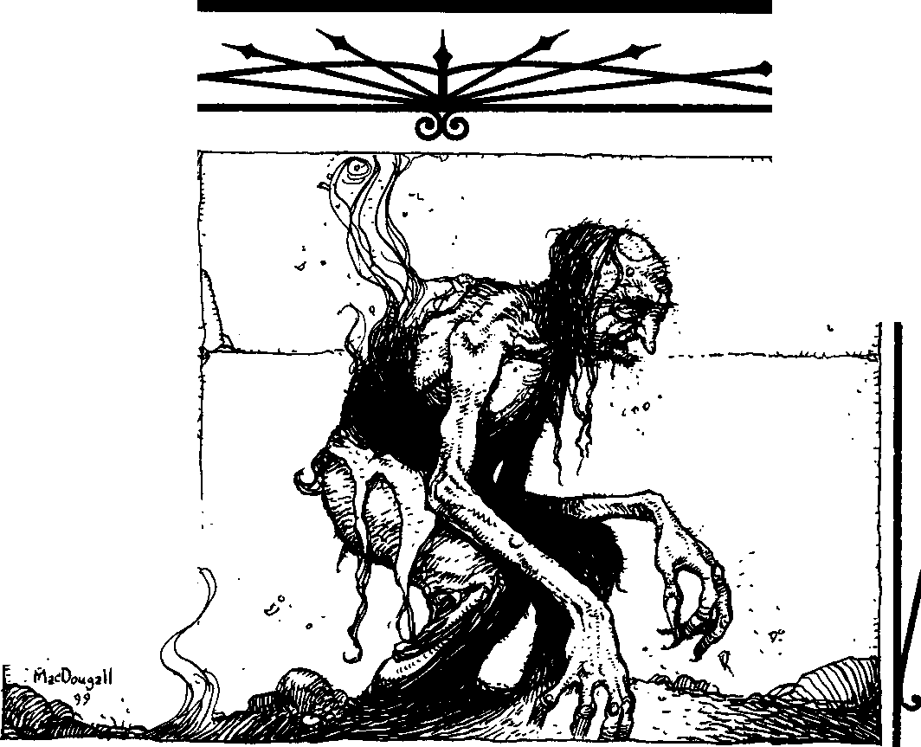

THE WAYS or MAac

n



direct this power at a thrall, only the thrall's bond is
corrupt, consumed by hate for as many nights as suc­ cesses. However, if the thaumaturge chooses to invoke chis power in a regnant, one of the regnant's thralls is affected per success. Should a regnant also be in thrall to someone else while under chis effect, she too will feel only malignity for her regnant.
This power is mistrusted widely by vampiresof Clan Tremere, and had the Ventrue and Lasombra any real knowledge of it, they would likely balk at it, too (when they weren't inflicting it upon their enemies). More thanone regent has levied extreme censure on vampires learning this power, and an apocryphal story tells of a European prince putting a T remere to Final Death after learning that he had used this power to tum her ghouls against her.
For example: Clifton Andrews wants w settle a score
with Josephine the SeamstTess of Flesh, a Tzimisce, by reversing the blood bonds of those in her thrall. Clifwn's player spends a blood point and rolls against a difficulty of 7 (as this is a Level Four power). He gains three successes on the roll, and Clifton warps the blood bcmd in all five of Josephine's childer. For the next three nights, three of Josephine's blood bound thralls will not only loathe Josephine but may plot w harm their "tyrannical" mistTess. Clifwn's revenge is sweeter still, as for the span of these three nights Josephine is racked by fiery harred for her own sire, whohad blood bound her decades before. Clifwn knows how tTeach­ erous the SeamstTess of Flesh is, and rejoices in the knowl­ edge that there is a chance his enemy will suffer a slow Final Death at the hands of her sire.
•••••THE WITHERING OFAGE5
This devastating power warps the blood within vampires, temporarily suspending the properties sus­ taining their immortality. A thaumaturge making physical contact with a victim may strip her of her agelessness and render her briefly decrepit. Within moments, the body of the target will reveal the truth of her true age, shriveling and shrinking to reflect the weight of her years. Additionally, the fangs of the victim become elongated, and other facial features accentuate his vampiric nature. Ancient vampires be­ come crippled, as their bodies become their own worst enemies.
System: After the thaumaturge makes physical contact with her victim, the player engages in a con­ tested Willpower roll (difficulty 8). Should he accumulate more successes than his target, the victim begins to grow physically older until he fully resembles his true age.
A character will lose one Physical Attribute point per 10 years of age he physically gains, to a minimum of
0. VampireswhosinktoscoresofOin Physical Traits are soenfeebled chat they must have help moving, feeding, etc. and can barely be heard or understood. This effect lasts for one night, after which time the victim rapidly sheds his physical years and is restored to the full potency of his vampiric blood. The affected Kindred can also restore himself by spending five blood points and one Willpower point, though this blood must be spent on the same tum he becomes afflicted. Once the duration of this power has expired, the victim will appear as youthful or as old as he was the night of his Embrace.
PATHOFCUR5E5
Mankind learned early in history to hate, envy, lust and wish malice upon itself. In such spitefulness curses were born. Most were just plain words and gestures, but some, spoken with such vehemence and spite, became tangible and formed true curses. In the dark depths of passionate hate, curses gained more weight, more sub­ stance, until people could use the evil eye or a spoken word to afflict such banes upon their fellow men.
Early in the history of Thaumaturgy, the Path of Curses was developed and refined. It isstill known by its early names in certain circles: Maleficium, Hexen-Kraft, the Evil Eye. Victims of chis path, often called accursed, are subject to extreme treatment and psychological feelings of inadequacy, often to the point of becoming social outcasts. When accursed are afflicted, friends and society tend to distance themselves from the victim, creating asocial schism and driving the accursed toward alienation.
When cursing a victim, the thaumaturge is obvious
- curses must be spoken aloud and directly toward the target of their ill effects, although the curse itself isoften comprised of dead languages and sounds like gibberish. In modem, industrialized countries, many tend to dis­ count the verbal telltales of being cursed, while some areas of the world might see a witchwho actsso brazenly outright assaulted. Additionally, the thaumaturge re­ quires some essence of the victim to curse him. This essence can be hair, blood, flesh or any other part of the victim. (See Chapter Two, "Principles of Thaumaturgy".) This link binds the mystic energies bringing the malison to the accursed.
Because of the severe psychological effects on a victim, the target may attempt to resist all the powers of this path with a Willpower roll (difficulty 7, unless



Bt.oooMACK: SmiITS OFTHAMAruRGv




stated otherwise). This is the victim asserting his own strength of will and personality to throw off the yoke of anathema. The thaumaturge can lift the curses that she brings down at any time she wishes, which makes and excellent bargaining chip.
•STIGMA
Themost basic of curses, the victim isstricken with an invisible stigma that manifests only in the eyes of those around them. Few can describe its actual form. People shy away from interacting with the marked victim, and will have a hard time taking him seriously. Social interaction becomes difficult, and frustration quickly follows for the accursed.
System: The stigma lasts until the next sunset, during which time the victim is doomed to frustration when performing any Social actions. All of the victim's Manipulation, Charisma and Appearance rolls are at
+1 difficulty (maximum 10) during this curse. Unlike the Ritual Devil's Touch, this powe,- also worlcs on Kindred.
••MALADY
Thethaumaturge causes the victim to suffer intense illness and discomfort, not unlike the plagues and pestilences of history. During the Dark Ages, this power
was used to strike down rivals and force them into subservience to the thaumaturge. Cainites likewise feel the pain and suffering from the sickness instilled by this curse. For elder Kindred, this is one of the worst curses
- to bestricken downwith illness asifa common mortal!
System: If this power is successfully invoked, the accursed suffers the effects of severe illness for a number of nights equal to the thaumaturge's Willpower. This intensity of this sickness equals the successes the thaumaturge scores on the activation roll. Each success reduces the victim's Strength, Dexterity and Stamina dice pools by one (with a maximum reduction of three dice). The afflicted character may also attempt to see if she breaks the curse nightly - as soon as she succeeds in resisting, the malady will not afflict her unless in­ voked again.
•••pARIAH
This curse touches upon one of the most feared elements of society, that of becoming an outcast. This power goes beyond cursing the victim withsimple social ostracism - while under the effects of Pariah, the accursed appears to be the most hated of enemies to everyone they encounter. This alteration of perception is only in body and form, the victim still acts and speaks

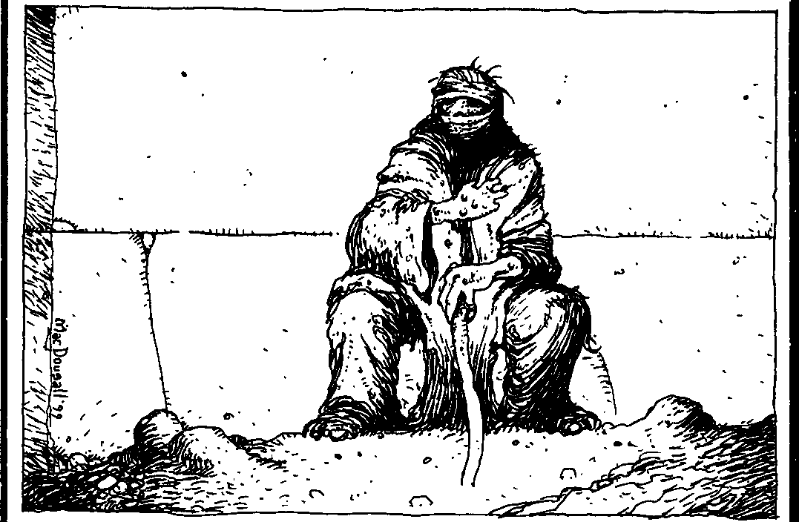

THt WAYS or MAac

as normal. But thenagain, few are willing to listento the ranting and ravings of a despised foe.
System: This nasty curse sustains its baneful effects upon the subject for a period of one night per success. Similar to the power Mask of a Thousand Faces, this power influences the perceptions of those around the accursed, leading observers to believe that the subject is a dire rival. This will not necessarily result in attack­ indeed, in most cases, it shouldn't - but will cause antagonism in whatever way is most appropriate to the onlooker. Most people will just leave the vampire's presence with a look of disdain, but some may snubher, insult her or even throw the first punch. Unlike the Obfuscate power, Auspex cannot see through this in­ voluntary disguise for the duration.
- • • • CoRRUpT Bonv
This powerful curse is invoked by the thaumaturge, who approaches the victim and denounces his physical form. Over the course of seconds, the victim's body distorts and perverts into a parody of itself. During this transformation, the victim suffers extreme pain that wracks his body. This defilement leaves behind a victim scarred both physically and mentally. Recently, Camarilla princes have had this power used upon vio­ lators of the Traditions to enforce their will; a graceful Kindred dancer reduced to an uncoordinated oaf is not likely to forget his mistakes.
System: During the three turns that the physical change occurs, the target suffers a three-dice penalty to dice pools. For the duration of the Corrupt Body, the accursed suffers a one-die penalty to all dice pools, as if she were wounded. This iscumulative withother wounds.
The thaumaturge chooses Strength, Dexterity, Stamina or Appearance to warp. This drops the appro­ priate Attribute to 1 for the duration. The Storyteller should add any additional effects to aid in how nasty this
withWillpower and scores only one success. This yields two successes, which means that the curse will la.st one week, during which Elizabeth has a Dexterity score of 1 . The Storyteller also determines that she suffers from a severe limp during this time and cannot dance. Needless to say, Elizabeth is less than happy with this tum of events, and suspects the strange incant:ations and gestures made by Danica.
••••• FALL FROM GRACE
Themagus is now able to curse his victim with supreme ineptitude, causing a loss in confidence and failings in any and all tasks. Striking a combination of mystical dread and self-loathing in the victim, failure becomes almost acertainty. Fate and circumstance now conspire to prevent prosperity. Victims of this power often retire from the normal activities of their lives as nothing goes right; relationships fall apart, jobs crumble around them, and accidents seem to become commonplace.
System: The victim can contest the effects of this power with a Willpower roll against a difficulty of 8.So severe is this curse that if the victim botches this Willpower roll, the effects of this power may become permanent.
While under this curse, the victim cannot auto­ matically succeed in even the most trivial of tasks. All actions have one automatic botch die that must be overcome to accomplish anything ( treat this as a phan­ tom die that came up asa "1").Additionally,even when the victim successfully performs an action, it will be mediocre at best. At most, any action can have a maximum of two successes; drop additional successes
beyond two, including any from expenditure of Willpower.
Unless the subject botches the contested Will­ power roll, the number of successes determines the duration of this penultimate failure, as follows:
One success One night
Two successes One week

power is. Only one Corrupt Body can affect a victim at any one time. The number of successes determines the duration of Corrupt Body, as follows:
One success One night
Three successes Four successes Five successes
One month One season One year

Two successes One week Three successes One month Four successes One season
Five successes One year
For example: Elizabeth, a Toreador known for her acrobatic prowess, is the subject of a Corrupt Body curse cast by Danica, a regent of Clan Tremere. Danica curses Elizabeth with the loss of her grace and Dexterity. Spending ablood pointand rolling herWillpower activation, Danica's player gains three successes. Elizabeth's player tries to resist
PATH OFTRANSMUTATION
Thaumaturges practicing the art of Alchemy can manipulate the forms of solids, liquids and gases. Guns and knives melt into pools of metal, wood petrifies and becomes brittle, and common boundaries such as walls and doors transmute to vapor. The laws of chemistry do not bind Warlocks employing the powers of transmuta­ tion, as materials shift their state regardless of their temperature. Effects similar to those achieved by true alchemy can beachieved by using the Path ofTransmu­ tation. This path is looked upon somewhat unfavorably




BLOOD MAc!c: SE.CRtlS OFTHAMATURGY

among the Tremere, as it reflects a "quick and dirty"
effect rather than true mastery of alchemical rransmutation.
e FORTIFYTHE5OLIDFORM
By fortifying a solid object, a magus increases the strength and integrity of an item. A thaumaturge mys­ tically transmutes a feather to become a crude blunt object, pencils become makeshift stakes, and a car becomes as tough as a tank.
System: This power increases the offensive and defensive capabilities of an object. For each success the player scores, an object will absorb one health level of damage. Similarly, a thaumaturge wielding the same object offensively will inflict one extra die of damage per cwo successes the player scores on the activation roll. In either case, an object may absorb or inflict a maximum of five health levels or dice of damage, respectively. The effects of fortifying an object last for one scene, and must either be offensive or defensive - the Platonic ideal of attack is not the same as for defense.
Note: This power cannot be used to increase the structure of a living creature. However, a thaumaturge may use Fortify the Solid Form in conjunction with the Level Two power Crystallize the Liquid Form to make a very solid piece of ice, molten metal, etc.
- • CRY5TALLIZETHE LIQUID FORM
Tremere designed this power to prevent other Kin­ dred from taking vitae. This can also be used to solidify water and molten metal. Liquids within living bodies may not be altered, though blood exiting the body may besolidified. Kindred may not consume solidified blood. System: For every success the player scores on the Willpower roll, the vampire may transform one blood
point (or about two pines of a liquid) into solid form for ascene. This substance will not change in temperature; solidified molten steel still bums and melts other mate­
rial.The liquid must bewithinthe thaumaturge's lineofsight.
•••LIQUEFY THESOLID FORM
A thaumaturge may "melt" solid objects and leave them in a liquidlike state. By employing this power, attackers could find their weapons in small pools at their feet. Stakes rot away at a rapid pace, and blades corrode into soft, nondescript puddles. Some wily thaumaturges might even transmute bullets before they impact an intended target.
System: The thaumaturge may transform an object within his line of sight. When the object reforms from a liquid, it will likely assume a deformed state and be rendered useless. A transformed object remains in a liquid state for one scene, after which it resumes its original shape (which many thaumaturges claim is a
recent improvement over an older, more dated version of this power). The size of the object that may be changed depends upon the success of the player's roll.
One success A lighter Two successes A telephone lbree successes A computer
Four successes An automobile
Five successes A railroad car
As much as many Tremere would like it, Liquefy the Solid Form may not be used on living (or unliving) beings.
••••GAOL
When a Warlock invokes this power, he solidifies the air into an opaque, indestructible object. A crude shimmering prism forms around a victim's body, encas­ inghim within unbreakable material. Doorways become impenetrable boundaries as the air between adoorjamb condenses to a resilient barrier.
System: A Warlock may solidify the air within 50 yards of his person. One success on a Willpower roll solidifies an amount of air equivalent to a brick where five successes will form a solid block of air that can encompass a telephone booth. Once the air condenses, it becomes completely indestructible; this effect lasts for one scene. Victims trapped within the solid air will not be able to break through this barrier (not even with Potence), though mortals will not suffocate.
The oxygen within the block is breathable, though liquidlike. These victims will experience an uncomfort­ able sensation in their lungs from the aliendependency on the oxygenated fluid, and they may reject it alto­ gether. When the effect of Gaol expires, the barrier around the subject dissipates into its original gaseous state. The oxygen within the target's lungs, however, will remain a fluid and, though breathable, must be purged from the body - coughed out - before it can transmute back into a gas. Subjects suffer one level of bashing damage from this overexertion.
For example: Clifton Andrews notices Rebecca, a ghoul spy, attempting to sneak into his haven. His player gains five successes, solidifying enough air to completely capture Rebecca iruide anindestructible block. Immediately after, Rebecca panics as she breathes the liquullike oxygen within the ,olid block of afr. She gulp, in mouthful, of the fluid whik he, body adjus to the fareign method of breath­ ing, causing her to retch until she accepts the oxygen. After the solid block dissipates, Rebecca drops to the ground and throws up all the liquid she took in while trapped, suffering a level of bashing damage from the amount of retching she must do befare the liquid pu,g,, from he, lung,.







THEWAYSOFMAGK:

••••• GHOST WALL
After attaining this level of mastery, a thaumaturge finds herself no longer hindered by common barriers such as walls and rock formations. With but a thought, solid objects shift to a vaporous state and may be traversed with little difficulty. The Warlock passes beyond walls, as they are insubstantial and will not obstruct his movement. Targets fall through a gaseous floor, and vaporous parachutes are useless in slowing the travel speed of a skydiver.
System: A thaumaturge may make vaporous any nonliving bodywithin hisline of sight. Foreverysuccess he scores on his Willpower roll, a larger amount of material transmutes in this manner. It takes a single success to transmute a laptop computer into vapor, while it takes five successes to transmute a city bus. A transmuted object loses its shape and becomes transpar• ent. This effect lasts for one scene, after which the object in question reforms as if nothing had ever hap­ pened. Needless to say, this is an outrageous breach of the Masquerade if any inappropriate eyes observe it.
Should a victim occupy the same space as the object after thispowerexpires, hesuffers a numberof unsoakable health levels of aggravated damage the Storyteller de­ termines appropriate to the circumstance. Forexample, a rock reforming within a body might inflict a single level of damage, where a person trapped within a tree trunk should suffer at least five levels of damage. Ob­ jects that reform partially within another object will remain this way until physically removed, or invoked to be vaporous again.

THE VINE OFDIONYSUS
Years before the rise of the mighty Roman Empire, pagansectsdedicated to theGreek god Dionysus thrived. Small cults of vampires worshipped the lord of rebirth as a release from the burdens of undeath. Symbolized in oinos, or wine, and orgy, the cults of Dionysus spread their intoxicating practices throughout Eastern Europe. In practice, members of the cult of Dionysus would gather at night and debauch themselves with oinos, orgies and other euphoric activities. When the ecstasy rose to fever-pitch, the rites might culminate in castra­ tion or even cannibalism.
Any practitioner of the Vine of Dionysus often refers to himself/herself as a thyrsus (females are occa• sionally called "Maenads", preferably from a safe distance). These Warlocks sometimes wear jewelry or other accouterments with ivy and/orpinecone motifs as symbols of their dedication.
- METHYSHEIN
By making physical contact with a subject, the thyrsus causes him to act as if he were drunk. While intoxicated, the subject falls into a slight euphoric episode, including slurred speech and clouded judge­ ment.
System: A victim suffers a one-die penalty to all Dexterity and Intelligence dice pools for one scene per success the thaumaturge scores. However, a victim may make a Stamina roll (difficulty 6) to subtract successes scored by the Warlock. Failure on the part of the thyrsus
will nor alert her victim to this attempt at intoxication, though a slight "buzz" may momentarily cause a target to become disoriented.
Note: A mortal, if affected with Merhyskein for three consecutive nights, lose the ability to willingly resist this euphoria. Only with the expenditure of a Willpower point can he initiate a Stamina roll (diffi­ culty6). Kindred reactdifferently should they beexposed to this influence for an equal amount of time. For every three consecutive nights of intoxication under Methyskein, a Kindred'sdifficulty to resist on aStamina roll (difficulty 6) raises by one, to a maximum of 9.
••OMOpHAOY
According to myth, Dionysus had the ability to incite animal urges within anyone he pleased. The thyrsus invoking Omophagy creates a ravenous hunger in a target, overwhelming allsense of reason and reality. To the victim, the only thing that matters is devouring raw flesh and hot blood, and he is not choosy about his potential targets.
System: Once the thaumaturge makes eye contact with a subject, and successfully invokes this power, a target gains the derangement Gluttony (page 162 in the Guide to the Sabbat). Whenever consuming food, the subject will gorge himself until physically unable to eat more. Kindred affected by Omophagy not only drain a vessel completely of blood, but may also attempt to devour the victim's body. Vampires will also frenzy when confronted with the sight, smell or taste of blood when hungry (blood pool of three or less). This effect lasts for the remainder of the night. A victim may resist this effect by spending a point of Willpower to ignore Omophagy for a scene. Nore that this power does not impan vampires with the ability to digest food - any flesh or food they eat will be immediately vomited forth unless other circumstances prevail.
•••HAMARTIA
Far less subtle than Methyskein, Hamartia grants the thyrsus the power to cause an extremely dangerous





8toooMio::SlamIll THAMA100


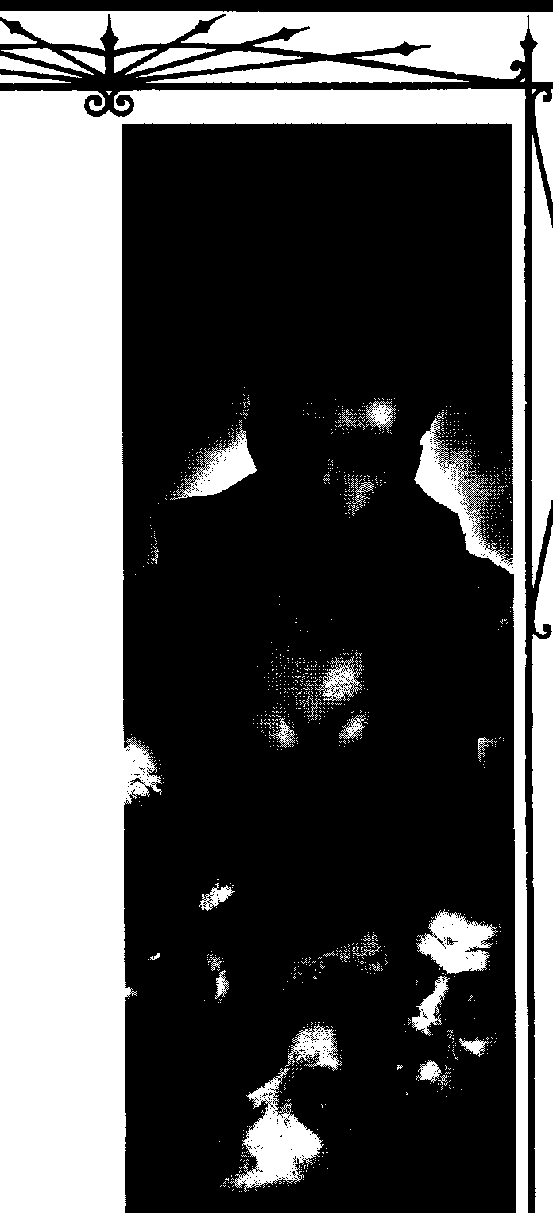

euphoric episode within a target, to the point of delirium, perversity and possibly torpid stupor. Cultists of Dionysus claim to gain superhuman vigor while in a similar state of intoxication on oinos.
System: For each success on the activation roll, a subject remains under the effects of Hamartia for a scene. Victims affected lower all dice pools by two, though they gain two dice to Strength-related pools. Targets can resist this effect by scoring more successes on a Stamina roll (difficulty 7). The Storyteller should decide how a character reacts to this type of intoxica­ tion, as a character's Nature may dictate actions. Some might stand very still and glassy-eyed, while others might choose to engage in conjugal relations with the people around them (gender notwithstanding). This power lasts for one scene.
  - • • • ENTHOUSlASM6S
A thyrsus may exude a pheromone into the air all about her person. Those affected fall into a druglike stupor as the empathogenic toxin induces visions of all sorts of ephemeral creatures: fauns chasing nymphs, angels in flight, sprites dancing in the comers of one's eyes, and the like. The pheromone induces a happiness within the affected targets, who are likely to dance around in glee to fictitious music with make­ believe creatures.
System: A thaumaturge successfully invoking this affects any target within a 10-foot radius of herself. Victims suffer a two-dice penalty to all Dexterity and Intelligence dice pools for one scene. Furthermore, victims under the effects of Enthousiasm6s are passive, content to while away their time in the euphoric haze. Anyone wishing to take any action must spend a point of Willpower to shrug off its effects for a tum.
    - • • • • OrnosAIMATOS
Many thaumaturges suspect that this power is not the original apex of this path, but rather a variation suited to a Dionysian cult headed by a vampire passing himself off as an incarnation of the god. When the thyrsus invokes this power, her blood cakes on the properties of potentoinos. Whether this was intended as a deterrent to diablerists or to drive feeding ghouls into euphoric ecstasy is unknown.
System: For the duration of one scene, anyone drinking even the tiniest drop of the thyrsus' blood is affected as perEnthousiasm6s.The thaumaturge's player need only spend a point of blood and make a Willpower roll when the character first invokes this power - thereafter, anyone who drinks the blood suffers the effects without any further expenditure on the part of the vampire.

THE WAYS OF MAGic


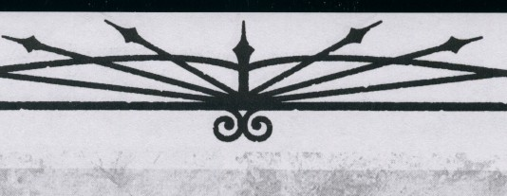

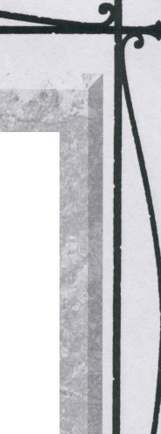
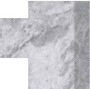

THEFAUHPATH
From the Diaries of Constantin Addams, Regent of ateSixth Circle.
We walk the nights of a new age, brothers and sisters of the Pyramid. Since Gutenberg, our tomes are no longer handwritten, and hence much less rare. With the rise of public libraries, many "secret works" are JlOW vailable for public consumption. Since the rise of the personal computer, any apprentice with a scanner, printer and the "Internet" can acquire a minimal occult library in weeks, ratp.er than the years spent in ages past.
Oncedigitized,acompletesetoftheBooksofal-AztheElderwillfituponacollectionofCD-ROM approximately the size of a sandwich, rather than the 29 volumes withwhich most of us arefamiliar. And no longer do younger Kindred guard the "secrets of the clans." An understanding of the limitations, effects, and abilities of most common Disciplines is available to anyone who asks, and even those rare Disciplines, such as those of the Samedi, are often rec izable toatleast one person in a domain. Only Thaumaturgy is treated as precious knowledge, and the other clans hold it against us. New means must be used to guide our fellow Kindred into heeding our superior advice.


For this purpose, I have developed what I humbly call the Faux Path. It commands little actual power. Few rituals that will affect another are contained within. However, the clever thaumaturge may use the Faux Path to great effect by playing on the fears and preconceived notions of his or her fellow Kindred. At the highest levels, the lines betweenfalsityand reality blur, but wiseTremere take heed: most Kindred do not take well to being openly deceived.
Enough talk. Step with me onto the False Path.
      - HELLO, GOODBYE
Thethaumaturge has a basic understanding of the m ic of falsity. She may cause any one true statement she makes to be perceived as a lie for the duration of the evening. At dawn, all Kindred affected will beable to make their own judgements about the statement.She cannot make lies appear to be true, however.
System: With successful invocation, this power causes anylistenerswhohear the truestatement immediately disbelieve it. This magicdoesnot affect Aura readings, a Boneof Liesor other Discipline usage of greater power than this Discipline.
      - • OISCipLINARY IDENTIFICATION
Oneof the primary skills of the deceiver is the ability to recognize when she is being deceived. Withsufficient training, the thaumaturge can identifywhich Disciplines arebeing used in frontofher, and, with a sufficient explanation or by looking at the results (such as a ghoul's arm affected by Vicissitude), can even identify Disciplines not directly witnessed.
System:The thaumaturge can identify the Discipline used in anysituation. Only Disciplines may be identified directly, whereas the powers of other supernatural creatures (but not hedge magic) are identified only as "powers belonging to something else." A Storyteller may allow a bonus to Kindred possessing one or more of the skills of Kindred, Camarilla or Sabbat Lore (where appropriate). A Kindred cannot concentrate longenough to identify Disciplines used on her while she isengaged in combat, though she may remember the effects and identify them later. Regardless of specifics, at this level all "thaumaturgical"effects, whether hedge magic,True Faith, Dark Thaumaturgy or evenother uses of the Faux Path register as "Thaumaturgy."
Note that a character may not identify a Discipline with which she is not at least somewhat familiar. Forexample, a character isunlikely to knowof the moreesoteric Disciplines ofcertain minor bloodlines, while Dominate should be fairly obvious. Also, this is not a "catalogue" of Disciplines, as the information is gained mystically. A Camarilla Kindred may never have seen another Kindred using Telepathy, but would be able to identify it using this power through familiarity with Auspex.

Btooo MAac:SECRETS Of TIWMlURGY


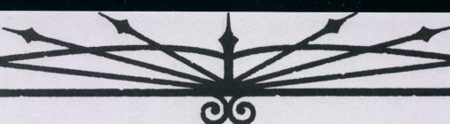

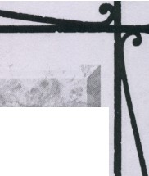

- • • THAUMATURGICALNOMENCLATURE
Once the chaff has been separated from the wheat, so to speak, identification of the most versatile Discipline of Thaumaturgy remains. Despite the frustrated thoughts of some young T remere, no limitexists to the number of paths a thaumaturge may learn.However, someof the more common elements of Thaumaturgy can be identified.
System: A power described as "Thaumaturgy" by Discipline Identification can be further identified as to the path, power or ritual, or even as true magic, if this is the case. In case of a truly obtuse, unique or unknown path, a result of "unquantified" is not uncommon. Note that if an effect is incorrectly assumed to be Thaumaturgy (without using the Level Two power), the results of this Discipline will be incorrect as well. For example, a Kindred who has caught his hand on fire and is using Fortitude to resist the damage may be incorrectly identified as using the Lure of Rames.
  - • • • RITUAL MADNESS
By now, many Kindred are aware that most powers and rituals have a limited range. With the public and private transportation options available to most Kindred, even the dreaded Splinter Servant holds little terror if the victim can stave off his attacker for a mere minute. A clever thaumaturge can use this knowledge against her enemies.
System: Using this power, any thaumaturgicaleffect a vampire extemporizes can be "modjfied" to supply only a physical sensation, but no actual effect. For example, a Warlock may cause Kindred approaching him to feel"vague discomfort and uneasiness" withno explanation, though a successful Aura Perception might discover sparkles indicative of any other magical effect.Likewise, a vampire may "Engage the Vessel of Non-Transference," which causes another Kindred to feel a cold shiver if she touches a certain object. The much-vaunted "Ward Versus Fools" causes an individual to feel as though he is approaching a ward designed against his "creature type," whether Lupine, ghoul, mortal, ghost, Kindred. A cagey Kindred can evenclaim"next time,it'll be the real thing," regardless ofhis or her true powers. This isan uncommonly versatile path power, but itseffectsare always mental (and psychosomatic) in nature.
  - • • • • 5ANGUINAR YAFFECTATION

Once a careful study has been made of various Disciplines, the thaumaturge can then seek to duplicate the outward effects upon his own self. For example, a Tremere's hands may seem to grow claws, he can make other seem to bow to his whim, or his hands may crackle with the lambent fires of an unmastered but familiar path. Of course, his nails are merely longand cause no damage beyond normal, the patsy was going to do what the vampire said anyway, and his hands couldn't light a cigarette.
System: After a successful roll, the player spends a Willpower, and can then successfully duplicate the outward effect of almost any Discipline, path or ritual of Level Five or below upon his or her own person, by fulfilling the normal prerequisites of the Discipline (bloodexpenditure, Willpower costs, etc.), for one tum. Note that a Kindred duplicating Celerity, for example, could not actually move faster than a normal Kindred, but she could perform parlor tricks with Faux Celerity, such as "snatching the pebblefrom the hand of the Master" and the like.Ofcourse, to snatch the pebble from the hand of someone withCelerity may well require her to spend the extra blood, and even then she would likely have to win a contested roll. But convincing a convocation of other Kindred chat she has thisspeed might be worth the cost,even though she could never evenoutrun Kindred with only one dot in Celerity using this path's powers.


THI WAYS Of MAGIC

OpTIONAL Ruu : BLOOD L0'55
Thaumaturges have ways of draining the pre­ cious vitae from their victims, causing extreme debility. Whether the blood is taken with Theft of Vitae or destroyed by Blood to Water, the effect is the same - blood loss. In addition to any normal effectsfrom the power causing by the blood loss, the following may apply at the Storyteller's discretion. Mortals suffer one health level of unsoakable bashing damage for each blood point lost. Blood
loss merely causes Kindred to lose blood points from their blood pool. Kindred do not suffer any other effects, though blood loss may indirectly lead to frenzy, should a Kindred lose enough to make her ravenously hungry....

RITUALSOF THAUMATURGY
The most awesome aspect of Thaumaturgy is its
versatility. Given enough time co research a new ritual, a thaumaturge can surmount almost any obstacle - or create nearlyanyeffect. Indeed, should the thaumaturge sowish, she would theoretically be able to duplicate the effects of any other Discipline, or devise some ritual manner of countering chem. And that's just a start, as Thaumaturgy can generate an infinite number of other effects as well....
Although such versatility gives the Tremere a great advantage over the other clans, these powers are lim• ited. The main differences between the powers of a chaumacurgical path (or any ocher Discipline power) and ritual magic are the times of preparation and execution between the powers. While Discipline pow• ersare generally invoked instantaneously, the powers of rituals are hindered by constraints of time, energy and materials.
LEARNING EHISTINGRITUALS
Leaming rituals also requires time and energy. Learning a new ritual requires knowledge of Thaumaturgy greater than or equal to the level of the ritual, access to the knowledge, and time. (Storytellers can also opt to have players spend experience points to learn rituals to compensate for the power -see below.) Access to the knowledge of the ritual requires either a mentor who knows the ritual or a document completely outlining the ritual's details and mecha-
nisms. Although Tremere characters have an easier time with these requirements due to their sorcerous connections and expansive libraries, other characters who are devoted to learning the ancient blood magic can slowly progress in power.
The time to learn new rituals estimated in the sidebar allows for other activities by the thaumaturge. If the thaumaturge devotes his entire time and effort into learning a ritual-Storytellers, beware - this time can be reduced by half with other factors influencing the time as the Storyteller sees fit. The Storyteller should modify the time to learn any ritual as required to allow for game balance and to prevent characters from abus­ ing downtime.
'TIME l.,1;1A JinuALs I
Whena thaumatuig additionaTlevel P
in Thaumaturgy, hetatj1eai,:i a· eq tio
I
thelevel o/Thjl,\lllllltutgy,gained/Fhisfreeritual is ! does not cost any additional.:t ;Oteffort beyond thatrequiredforgainingthe -malllrgy. Othcr than thoae"ftce"ric..;ii,'f.;;r.;.-;.ilj.4!rudy <
I

reflects.the<ompl ,i>frl)o .• .•_ •···.. _
. • Note.-tbai1• applies only to leammg j n"tuals, .not.creating them (see below). , ;; Ritual Level f f.,tlp,atedt'imetoLeam i One· ,, .'t,J)ne week ;,
0
Two • ;

Three Qpe (thn,emonths) \
Four . Twa§e"SOns j

, five • 0-yeac. !
CREATING NEW RITUALS
Creating a new ritual is more difficult than re• searching an existing one. Most undead thaumacurges lack the necessary requirements - dedication and imagination - to develop their own rituals. Members of Clan Tremere pride themselves on creating personal rituals, striving long and hard to perfect one that they can claim as their own. This not only brings them more power, but also the prestige in having a unique and personal magic.
To create her own new ritual, the thaumaturge must have anOccult Trait of 5 and aThaumaturgy Trait one level higher than that of the ritual level she seeks to create. A thaumaturgical laboratory and library, while not required, makes the goingeasier.The playersubmits a draft of the ritual (including its effects, duration, etc.) to the Storyteller. The Storyteller then makes any modifications that are required to its power. The char,





BwooMAoc 5"'tts <>ltWMruOJ/

acter must then research the ritual, assuming all the criteria have been met.
The level of the new ritualdetermines the base time to develop it. Research takes the same amount of time as it would to learn the ritual, from the sidebar above. The actual time to create a ritual varies by the character's ability. The player makes an extended action roll of Intelligence+ Occult (difficulty 5 + the ritual's level, to a maximum of 10). Every time a player makes this roll, she must also spend two blood points per level of the power she's researching. This extended action requires three times the ritual's level in successes to complete. Each roll indicates one season of development time. If the thaumaturge botches any of these rolls, total failure results and the research must start fresh.
Often a magus knows a ritual that works similar to what he wants, but hassome fundamental difference. By working with the original ritual, the magus can con­ struct a modified version asa new ritual much easier and with much less time than making a completely new ritual. In cases like these, the research roll has a diffi­ culty of 3 + the ritual's level.
Note chat these creation times are simply guide­ lines. If the Storyteller deems a certain ritual to take more or less than the normal creation time, so be it.
For example: Ramsa is developing a new Level Three ritual he calls Sight of the Damned. Ramsa has Intelligence 3 and Occult 5. Devoting one season roresearch (based on the Level Three ritual), Ramsa is ready to put his theories to the test. His player spends sixblood pointsand rolls eight dice against adifficulty of eight. Ramsa' s playeraccumulates five successes after a season of Ramsa's work. However, he neech nine successes ro develop this ritual, so Ramsa spends another season (and another six blood points) working out the finer details. This time the player rolls three successes, foratotal of eight.Tryingwfinishthisritual, Ramsaspends a third season in the laboratory. In the third month of experimentation(after sixmore blood points are spent), the player rolls three successes, which signifies that Ramsa has finally pe,fected the ritual after ane full year.
THAUMATURGYRITUALS LEVEL ONE RITUALS
BRAND OFTHEPARAMOUR
Thaumaturges cast this ritual to maintain an active awareness of their ghoul's physical condition. The thaumaturge must first perform this ritual over the blood of mortal twins, then share the vitae with his ghoul. After imbibing the blood, the vampire remains aware of any physical harm befalling hisghoul byfeeling
a phantom pain. Hence, should the "paramour" ghoul sustain a bullet wound to the chest, the caster is immediately alert to this danger. This alertness also triggers should the paramour trip and fall, bruising his knee. The extent of danger is unknown to the thaumaturge, simply the fact that his ghoul has been harmed somewhere on his body.
System: Both the caster and his ghoul he desires to create as a paramour must each drink one of the two blood points of the mortal twin. Afterward, should any physical peril befall the ghoul, the caster feels a sympa­ thetic pain in the same part of the body. Hence, if the vampire's ghoul is hit in the shoulder by a stray bullet, the caster feels an acute pain in his shoulder.
This pain, however, does not translate asdamage to the vampire should his ghoul sustain extreme bodily harm. If the ghoul sustains any health levels of damage, the thaumaturge will still only feel pain centered on the location where his ghoul suffers his damage.
Bcand of the Paramour remains active so long as the ghoul is alive and remains a ghoul; the Embrace will negate this bond, as thaumaturges cannot create a pacamouc of another vampire.
E°NCRYpT MISSIVE
To insure that messages remain secure against pry­ ing eyes, the T remere sometimes use this ritual to encode documents magically. Created during nights long past to send messages across battle lines or hostile borders, this citual is not used as often in the age of electronic communications, but is occasionally used to communicate between chantries. Also, this is a fairly common ritual - many anarchs of the Anarch Free State seem to have learned it, and use it to encrypt graffiti messages to others of their kind.
System: The thaumaturge writes the message in blood over the course of a night and speaks the name of the person he wishes to read it. Only the writer and the person to whom the letter is addressed can read the document, but numecous "counter-rituals" exist that can be used to confound the magic of this ritual. To any others who observe the letter, the writing simply ap­ pears as gibberish.
E'HpEDIENT PAPERWORH
This beneficial ritual expedites paperwork through the bureaucratic systems of governments or other hier­ archies. By preventing the ensorcelled documents from being misplaced, the paperwork goes through the swift­ est channels, even bypassing normal daytime agencies that would hinder the Kindred's nocturnal lifestyle. Although extremely useful in modem society, this




THE WAYS OF MAGIC


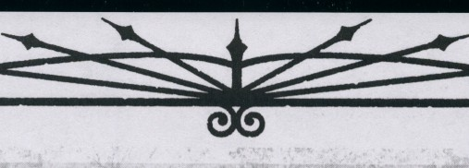
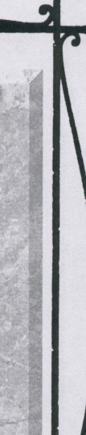


STORYTELLER OpTIONS
Notevery Storyteller wants to have thaumaturgical powerso easyor difficult to come by as thisbook posits.The basic rules take thaumaturges effectively"outof the picture" while theyare busycreating new powers, which is done for the sake of balance. A Storyteller has other options at her disposal as well, which may be used to make thaumaturgical rituals harder or easier to come by.
OpnoNAL Expt:RIENCe CosT FORRITUALS
Because rituals add an element of power thatcanemulate literallyanyeffect in the storyStorytellers must carefully monitor and exercise control in letting characters research or learn a desired ritual. In addition to limiting a character's accessible rituals, Storytellers may also choose to have players spend experience points to learn new rituals.One method isto havean experience point cost equal to the ritual level to add it the character's ritual repertoire, but thisshould not reduce the story to merely"getting the ritual." This helps keep the power of Tremere characters in check, but isn't always necessary, so it is presented as the Storyteller's choice.

For example: Sarah wishes to learn the ritual Ward versus Lupines. The Storyteller decides that this is a commonenough ritual and wishes to"lead" the story in pursuit of a panicular story line. After a few sessions in search of an arcane reference, Sarah finds the recorded ritual material in an arcane tome. Since Sarah has the requirement of Thaumaturgy Level Three and has gained the necessary reference materials, the Storyteller thenallows Sarah's player tospend the three experience points, and Sarah gains the necessary understanding to use the ritual. Sarah then spends a few months learning it.
UNCOMMON CoMp0NeNTS
TheStoryteller may determine that a player's ritual requires a certain hard-to-come-by ingredient to take effect, or that the research required to developa given path or demands "research material." This may spawn a story in and of itself, or it may simply add to the time suggested to complete the research and development.
HNOWLEDGE VER80TE:'N
Quite simply, the Storyteller may choose to adjust the time necessary to create paths and rituals by making magic "harder to create." Feel free to adjust the times in the systems to reflect the difficulty of magic research. Perhaps even the secrets of Level One rituals require one full year to codify, while Level Five rituals may well takecenturies.Thisworks best ifthe Storyteller wantsmagictrulydifficult to acquire, but doesn't want to deny the players' characters outright.
DIVERSIONS
Theabove rules assume that a character conducting thaumaturgical research is doing little else - arcane studies demand much from theirscholars. Assuch,a character researchinglost or new magic may havedifficulty justifying her continued relations with the coterie, at least whilestudying. Rigorousstudy doesn't allowfor the scheming politicsof Elysium or confounding the nightly pressures ofSabbat scouts. Storytellers should haveno qualmsabout extending research timesfor characterswho interrupt theirstudies.
COLU:CTIVE RESEARCH
If multiple magi workon a project to study a path or a ritual, every thaumaturge involved must meet the endeavor's requirements. When rolling for successes, the largest dice pool is used as a base and an additional dice is added for every other contributing magus. While this doesn't save any of the initial research time, it may well contribute to shortening the time spent developing the path or ritual itself.
OpTIONAL BACHGROUND
This new Background is particularly appropriate for characters with a bent toward the arcane.
Storytellers should allow it or restrict it at their discretion.




Bi.ooo MAGIC:SECRrn orTHAMAruRGY

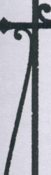
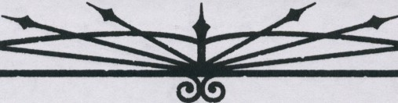
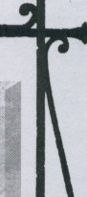

OCCULT LIBRARY
Stephan rubbed his blood.shot eyes. Hehad finally tracked down a copy of Browning'sJournals of Rite and Rigor, but set1eral of the key points therein alluded to yet another book. It seemed that the process of just finding the resources, let alone learning the secrets of magic, was net1erending.
His sire crept quietly behind him, laying her hand on his shoulder. "Looking for something?" she asked.
"Thirteen Hermetic Mandalas," Stephan replied. "It takes nine months to find one book, and then that one tells me I need to find another."
"The secret is knowingwhere tolook," his sire said, takingherown copy of theoounted text fromher shoulder bag and placing in on the table before him.
Some Kindred have accumulated vast stores of mystical knowledge over their many years. Such resources may have been inherited from a character's sire, treasures gleaned from previous journeys, gifts from a mentor or evenstolen from rivals. In fact, a library need not even be printed- books contained on CD-ROM or even a contact who knows occult lore may be considered a library for the purposes of this Background.

Whatever form it takes, an Occult Library aids the character in certain cases involving knowledge of the mystical or magical. Whenever the player needs to make a roll involving the Occult Knowledge and the character has the opportunity to consult the books, she may call upon this Background to help her. While this won't be of much aid if the character is held prisoner by another Kindred or visiting a foreign city, if the character is in her own library or laboratory, the information may prove invaluable.
- A few books: +1 die to Occult dice pools
- • A modest collection: +1 die to Occult dice pools, -1 to Occult difficulties
- • • Many noteworthy titles: +2 dice to Occult dice pools, -1 to Occult difficulties
- • • • A wide variety of lore: +2 dice to Occult dice pools, -2 to Occult difficulties
- • • • • A veritable magical encyclopedia:+3 dice to Occult dice pools, -2 to Occult difficulties

ritual was developed to handle the Church bureaucra­ cies of earlier nights and allay anysuspicion toward the caster.The ritual requires the hairs of a dog, known for protection and loyalty, to protect and guide the paper­ work.
System: This ritual enchants the expedited paper­ work, which shows up as an aura to anyone who looks for such. Normal handling time of a given document is reduced to roughlyone-thirdand it willnot getlost.The ritual ends when the material is finished being pro­ cessed.
IMPRESSIVE'VISAGE
A thaumaturge may enhance hissexual appeal and charm when interacting with other individuals after casting this ritual. When this ritual is cast, the thaumaturge gains a degree of animal attractiveness; he's simply more desirable than everyone else and commands attention as ifhe were a top model. For this ritual to take effect, the caster places a sprig of dried mint in a pocket or in his shoe.
System: The caster gains two dice on all Appear­ ance-related rolls for the duration of this ritual. This
power lasts for a number of hours equal to the successes scored on the activation roll. Storytellers may opt to narrow the use of this ritual by having a player dedicate one of the character's characteristics as being more appealingaboveand beyond hisotherattributes. Hence, the character might gain a bonus when staring into a person's eyes, speaking in a deep baritone voice, flash­ ing a pearl-white smile, etc.
Tue lMp'sAFFLICTION
Adisgusting ritual, the Imp's Affliction curses the
subject by aggravating his ears, throat and nose. Mucus membranes inflame, ears fill with liquid, the throat becomes raspy and dry,and the subject's eyes brim with tears. This ritual requires merely that the thaumaturge write her victim's name on a scrap of paper.
System: The Imp's Affliction lasts for one scene, during which the victim becomes winded after five minus Stamina turns. Subjects so exhausted suffer a temporary level of unsoakable bashing damage, which vanishes at the end of the scene as the symptoms disperse. This ritual is most often used to torment people in social situations, as their unpleasant maladies

TH[ Wf,.YS OF MAGIC

make them odious, to say the least - the difficulties of Social rolls for a character stricken with the Imp's Affliction increase by one. This ritual has no effect on Kindred.
LEARNING THE MIND ENSLUMBERED
This ritual is used to determine the cause of torpor in a vampiric body or the cause of destruction in a Kindred's ashen remains. To conduct this ritual, the vampire places a penny or other small coin over the eye of the torpid Kindred, and she hears in the vampire's voice the cause of hercold rest. If the Kindred is ash, the thaumaturge need only lay the penny in the ashes.
System: This ritual requires one half-hour, at the end of which the thaumaturge hears the message. This power has no effect on creatures other than Kindred.
puRGETHEINNER DEMON
All Kindred have a raging monster within their souls. A thaumaturge invoking this ritual can silence the Beast in a vampire for a time, even removing the vampire from the Beast's control. The caster must push a sturdy pin through his own hand to begin the ritual. This causes the subject to become strangely submissive, even pulling her out of frenzy. In actuality, her bestial nature has been temporarily separated from her psyche. According to legend, some Kindred have willingly starved themselves into torpor after having been sub­ jected to this ritual.
System: This ritual lasts for a number of nights equal to the number of successes the caster scores on a Manipulation+ Empathy roll (difficulty 10 minus the subject's Humanity, but never less than 1). During this time, the subject cannot frenzy. The thaumaturge may not use this ritual on himself.
REBIRTH OF MORTAL VANITY
This ritual allows a vampire to grow her hair again. For every inch of hair the thaumaturge wishes to grow, she must pluck one hair from the head of a human child. She places them on a mirror and looks down into the mirror while mutely gesturing over it, inscribing glyphs into the air. As her hair begins to grow, the mirror absorbs the hairs on its surface. Once the ritual is complete, the vampire's hair follicles die again, but the hair remains at the new length until cut. This ritual may be cast on another Kindred, but the recipient must pluck the hairs himself, and both caster and recipient must stand over the mirror during the ceremony.
System: The number of successes determines how rapidly the vampire's hair grows. With one success, it takes 10 minutes for each inch of hair, whereas at five successes, the hair seems to pour forthfrom the subject's
scalp, growing up to a foot in under a minute. If the hair is ever cut shorter than it was at the time of the vampire's Embrace, it will return to its original length the next night. A vampire who was bald in life will remain so in undeath; his hair simply does not grow, though some speculate a more powerful version of this ritual existsfor the trulyvainamong the undead touched by baldness.
RITE OFINTRODUCTION
TheTremete use this ritual as the formal method of presentation for arrivals in a new city. However, it is an old ritual and not as widely used as it once was. Many young members of the clan are not even aware of its existence. Still, some traditional regents insist on its use and tolerate no excuses for a breach of courtesy. It isalso possible to use this ritual to request aid. The caster boils a handful of ground tamarisk root in a pot of rainwater and recites a short incantation into the vapors thatform over the water, then adds a drop of galangal oil. He then speaks a brief message, which is telepathically commu­ nicated first to the regent and then to the other clan members in the city according to their place in the hierarchy. The ritual allows the regent to reply tele­ pathically, thoughshe isbound todosoonly by tradition.
System: The caster may make a 30-second "intro­ duction speech" in which he presents himself to the other members of the city. The ritual also enables telepathic communication with the regent for five minutes.
5ANGUINEOUS PHIAL
This ritual allows a vampire to enchant a vessel so that it may hold a quantity of blood and keep it from spoiling. It is useful for Kindred who do not have the medical knowledge or technology required to preserve blood in a more mundane fashion. The caster takes a covered earthenware jar and buries it in the earth for two nights, then digs it up the following evening. He crumbles a dried ash leaf into the empty canister and pours the blood in, closing the container andsealing the lid with tallow melted from a candle. The blood will remain fresh until the seal is broken. Though common during the Middle Ages, this ritual disappeared from grimoires after the formation of the Sabbat. It is be­ lieved to be the same ritual, reclaimed from theantitribu, but reworked slightly, owing to some superstitious el­ ders who fear that anything from the Sabbat traitors could be tainted by the infernal.
System: After the container is opened, the blood begins to spoil at a normal rate. If the vessel is broken, the blood immediately deteriorates to the state it would have attained had it not been preserved at all. The




Bwoo MAoc:SECRETSOFTHAMATURGY

canister may be used more thanonce, but the ritual must be recast or the blood will go bad.
Tm,5CRIBE
This ritual creates a written document from the spoken words of the caster. The thaumaturge simply speaks, and her words mystically appear on paper before her. Some thaumaturges have observed variants of this ritual that involve moving feather-pens writing the words as they speak them, but the most common form of this ritual makes no such overt display. Further, some young thaumaturges have developed a variant that records their words directly to computer files -which their elders almost universally decry as vulgar. This ritual requires the beak of a bird or the tongue of a lizard to be crushed between the caster's thumb and forefinger.
System: For the duration of the scene, any words spoken by the thaumaturge are transcribed to whatever surface she wishes. This is most commonly paper (whether loose or bound into a book), but may also be a wall, the head of a pin, anything. The Scribe auto­ maticallyfits the thaumaturge's ideas on agivensurface, but it makes no provisions for legibility; transcribing all 400pagesofThe Seventh Sigilonto a note card isn't going
to make it readable without a microscope. Additionally, the Scribe does not improve a speaker's eloquence- in matters where clarity or quality is crucial, the speaker's Expression Trait may come into play. The Scribe may be cast on someone other than the thaumaturge, should the latter so wish. Also, she may voluntarily end the effects of the power before the end of the scene.
5ERENADlNGTHE HAMI
Through invocations and smudging with incense, the ritualist gains the temporary support ofspiritsknown as kami, "highly placed beings" that are found in all things. Developed by a traditional Japanese Kindred to aid in a duel, this ritual is used prior to a major feat of strength. The thaumaturge must bum a stick of incense to invoke this ritual.
System: This half-hour ritual allows the thaumatutge to reduce the difficulty of any single physi­ cal action by two immediately following the completion of the ritual. This may be an extended action such as digging aditch, or it may beas brief asguiding a deadly blow.
5EN5E THEMY5TICAL
This ritual provides the ability to sense the "mysti­ cal residue" left by magical objects and effects. This ritual was originallydeveloped to seek out non-Tremere who use Thaumaturgy and magical artifacts, and is common among the younger T remere seeking a name for themselves. While this power is in effect, the
thaumaturge carries a lit candle, whose light causes the stuff of magic to glitter.
System: After chanting for five minutes, the thaumaturge is able to sense magical effects. Sense the Mystical can detect Thaumaturgy, Necromancy and similar blood-related vampiric magic if used within several yards of the object or person in question. This power does not distinguish between the different types of blood magic, nordoes it pickup"normal" Disciplines. This ability lasts for one scene.
LEVEL TwoRITUAL',
BLOOD MEAD
It was thought by the cults of Dionysus that super­ natural powers could procured while under the effects of oinos, or any intoxication for that matter. During the Dionysian rites, a special drink combining vitae and mead (a fermented honey drink) might be prepared for favored supplicants. The drink was thought to pass on a powerful resilience, though only under intoxication. Similarly, a thaumaturge casting this ritual will be able to withstand a greater amount of damage than he would normally tolerate.
System:The thaumaturge must ingest this concoc­ tion to trigger its effect. By mingling two points of his own vitae with ahoney brew, the magus creates a potent anesthetic and intoxicant. While under this effect, the caster gains an extra Bruised health level. However, he suffers the effects of intoxication and, as such, loses one die to all Dexterity and Intelligence dice pools. The effects from Blood Mead last a number of hours equal to the successes scored after the blood mead is imbibed. At night's end, the vitae within the Blood Mead dilutes and loses its mystical properties and, as a result, cannot refill a vampire's blood pool. The mead may, however, continue to act as an intoxicant, depending on how much the vampire consumed.
BuREAUCRATICCONDEMNATION
Developed as the antithesis of Expedient Paper­ work, thisritual causesforms, letters or other paperwork tendered by the target to become lost in red cape. Use of this ritual hascreated many apocryphal tales among the Tremere, who boast of rivals' havens foreclosed upon, cars repossessed and building permits revoked. The earliest recorded use of this rituals seems to have been during the Renaissance, whenaT remere hadaLasombra rival excommunicated for failing to submit a writ to the
Inquisition. A thaumaturge must sketch an effigy (how­ evercrude) o/hersubject msquid inkwhencasting thisritual.
System: The time any single bureauCratic action cakes to complete is tripled, including mailing docu-




THE WAYS CJ MAoc

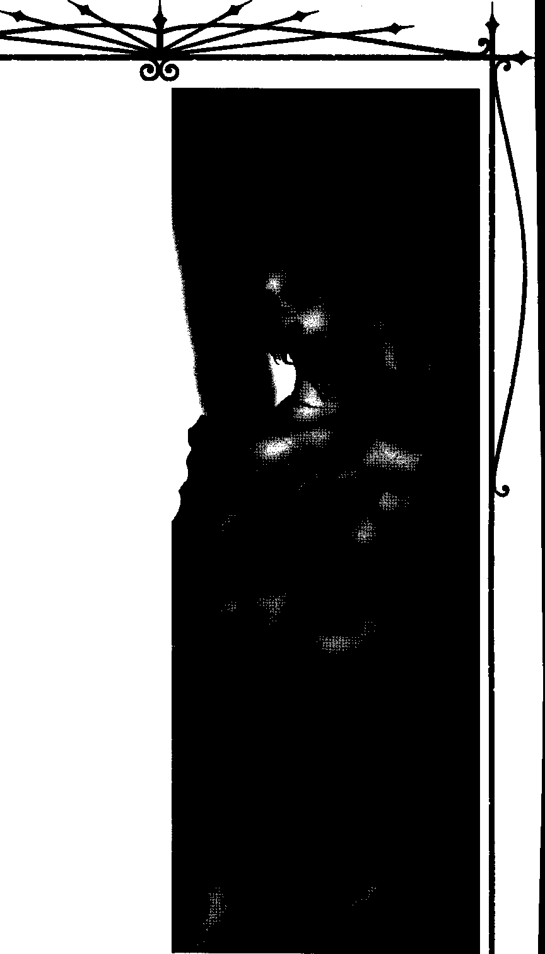
ments, applying for licenses, etc. Characters with suffi­ cient Influence or the like should still be able to "push things through," however, though they are likely to experience additional difficulty.
CRAFT BLOODSTONE
This ritual creates a small stone used as a tracking device. The caster must place a small pebble into a vial filled with three points of blood from any source. This blood need not be human. Every night for three nights, the thaumaturge recites an invocation over the vial. The bloodstone absorbs a single point of blood each night, and the liquid becomes slightly clearer, until on the third night it becomes as transparent as water. The vampire then has a mystical connection to the stone, and knows its relative position at all times.
System: A thaumaturge who creates a bloodstone instinctively knows where it is at all times. This is not so much knowledge of its precise location as it is an unden;tanding of itsdirection and distance from the caste,.
ENHANCINGTHECUR'5E
Ghouls can survive almost indefinitely, with the stipulation that they have vampiric blood within their bodies. A thaumaturge casting this ritual on a ghoul enhances the strength of the vampiric vitae in his body but causes him to suffer similar adverse effects to sun­ light exposure as vampires would suffer. Every moment the subject spends exposed to daylight will generate third-degree bums over the ghoul's body. This proves fatal if the ghoul is unable to find shelter from the sun's rays. The vampire must scratch the subject and draw blood, though some variants of this ritual require the thaumaturge to strike the ghoul. Obviously, this is not a pleasant ritual, and is used by thaumaturges to disci­ pline or test their ghouls.
System: This ritual requires physical contact be­ tween thaumaturge and ghoul for it to take effect. So long as the victim retains vampiric blood in his body, he will suffer one health level of aggravated damage per two turns while indirect exposure to sunlight. Once the vampiric blood is spent from his system, the victim will cease to suffer damage from sunlight. For the next month, anytime the ghoul ingests and retains vampiric blood in his body, he will suffer damage in direct sunlight.
EHTINGUJ'5H
This ritual eliminates the threat that fire poses to Kindred. The caster is able to douse dangerous flames, leaving vampire hunters quite surprised when their torches and brands are no longer effective tools. To enact chis ritual, the caster pinches out a candle's flame while spitting on the floor.

Bl.ooo MACK:SECREJS orTHMMM:GY



System: The ritual is set up in advance, but for the entire night the vampire has but to speak a single magical syllable to extinguish one fire up to the size of a bonfire. For the durationofone night, the thaumaturge can use this power a number of times equal to the number of successes on the initial ritual roll. Pinching a candle's flame in preparation is likely to require a
ROtschreck check, as well.
1MpA5'5ABLETRAIL
The vampire can travel through even the densest woods without leaving any sign of his passing. He will still leave a trail for creatures with powerful olfactory senses, but that will be all. The thaumaturge must carry an owl's feather steeped in Kindred vitae or bum the legs of a dead toad and carry the ashes with him while this ritual is in effect.
System: The vampire will leave no evidence be­ hind, save for a faint odor that takes three successes on a Perception + Alertness roll (difficulty 8) to detect. The ritual lasts for one night.
_JINH
This ritual concerns itself with using the blood of other Kindred to afflict them with various minor banes at the thaumaturge's whim. Relying largely on the Principle of Identity (see Chapter Two), this ritual consumes the blood of the subject instead of the blood of the caster.The thaumaturge must have in his possession one point of his victim's blood, which vanishes once a sending is attempted. The horrors visited upon subjects as a result of this path have given the Tremere quite a reputation. Indeed, many Kindred have reasonable fears of allowing the Warlocks to harvest any of their precious vitae, as the powers of this ritual can attest. Most fearsome of all, a thaumaturge need not even be in her victim's company, so strong is the connection of Identity. All the thaumaturge needs to do issacrifice the subject's blood....
Thethaumaturge briefly vexes his victim with bad luck, causing her to fail in a mundane task. This can cause everything from minor typographical errors to automobile accidents and everything in between, de­ pending upon how the magus jinxes his mark.
System: The next roll a jinxed character makes automatically fails, regardless of the outcome. This does not cause a botch, just a simple failure. If applied to a contested or extended action, the roll simply yields no successes for the current tum- thevictim may gamer other successes on subsequent turns (provided the fail­ ure doesn't make the all the difference... ).
MOURNINOLIFECUR5E
Although this ritual causes no physical damage to its subject, it can be psychologically traumatizing. It allows the caster to coax blood from a mortal without injuring her. The Tremere must drink a dram of thrice­ distilled crocodile blood and make a paste from copal oil, ground eyebright and dates. He carries this paste until he finds a suitable victim. He then dabs the paste onto her eyes and whispers a two-line invocation into the morcal's ear. The mortal then begins weeping un­ controllably, and bloody tears slowly ooze down her cheeks. The effect continues until the caster stops staring at the victim. The only after-effect is a slight swelling of the capillaries around the subject's eyes, along with the normal effects of blood loss.
System:The victim will bleed slowly. It takes aOOut five minutes to collect a single blood point. There is no active defense against this ritual, but the mortal must be able to hear the invocation that the caster whispers. Some thaumaturges use this power on sleeping victims, to spare them the unpleasantness of seeing the act.
5TEp'5OFTHETERRIFIED
This power lets the caster put the brake on afleeing enemy. The harder the subject tries to run, the slower he becomes. Eventually, he slows co the point that he can barely move at all. The vampire is often able to cake her time and still catch up with her target. The vampire must cast a handful of poplar buds at the target and then
douse her hands in oil while repeating a short incanta­ tionseven times. She then wrings the oilfrom her hands before following the target.
System: The first tum after the ritual is completed, the subject moves at half his normal speed. If he tries to speed up, he slows to one-quarter his normal speed.
Each time he tries to go faster, his speed is halved. The ritual lasts until the following sunrise.
TRIMA
This type of oinos is made with spices and herbs, serving to heat up the blood in a body and, therefore, cause drowsiness in a victim. A m.agus will sometimes serve this drink to many mortals, possibly at a party or other social gathering. This serves to better protect the Masquerade before Kindred guests drink their share fromdrowsy mortals. Kindred caking vitae from mortals under the effects of trima feel a slight buzz of the after­ effects, though not strong enough to be considered intoxicated.
System: The caster mixes at least one point of his vitae with the desired wine andspices. Once completed, the trima must be ingested to take effect. After imbibing

THEWAYSorMACK



trima, a victim must make a successful Willpower roll
(difficulty 8) to take any action, as he is overcome by an artificially induced lethargy. This effect lasts a number of hours equal to the number of blood points the caster uses to create the ritual. Subjects may resist this effect by scoring at least three successes on a Stamina roll (diffi­ culty 8). Cainites and other supernatural creatures are unaffected by trima as their blood is too potent to be overpowered by this concoction.
WHI5PER50FTHE' OH0'5T
Using this strange ritual, the vampire may commu­ nicate from his Psychic Projection form into the material world. While employing this ritual, the Kindred can speak with anyone he encounters, but his words come as ghostly whisperings. People who hear these whisperings often mistake them for the words of ghosts or spirits. When this ritual is performed, the thaumaturge must have the ear of a still-living creature in his left hand.
System: This ritual applies only to vampires using the Auspex power of Psychic Projection. After weaving the spell, the Cainite can speak for one scene or until sunrise, whichever comes first. The thaumaturge may only speak to the physical world; he may not be seen, touched, etc.

LEVEL THREE RITUALS
BLOOD ALLERGY
Reminded of their lost mortality, of illness and unhappiness, Kindred suffering from an allergy of the blood cannot keep vitae within their bodies. Attempts to hold down any blood after ingesting this unlife­ sustaining fluid will result in moments of severe nausea followed by episodes of vomit-induced heaves that only abate when all of the blood is expelled from the system. After spilling his blood onto the dead petals of a red rose, a magus may infect a target with this allergy.
System: This ritual requires only 10 minutes of preparation before casting, duringwhich a thaumaturge must spend a blood point and mingle it with dead rose petals. A target suffering a blood allergy is affected for one night per success scored by the caster. Victims are unable to keep blood within their bodies, and, therefore, unable todomuch that concerns their vampiric powers. Vampires will not expunge blood if they have three or less blood points remaining, and this power does not work on Kindred older than the caster. While the loss of blood is not enough to cause a Kindred to enter torpor, he will be on the threshold of hunger, and may need to roll for frenzy if he encounters blood.
CLEAN51NGOFTHE FLE5H
Vampires must drink the blood of mortals in order to survive and, accompanying this bane is the risk of becoming addicted to mortal vices: illegal narcotics and alcohol. In some cases, Kindred lead their unlives as hosts to a number of sexually transmitted diseases, such as AIDS. The Warlock casting this ritual must spend one full night in a bathtub filled with purified water. Throughout the night, the thaumaturge must expunge all but the smallest drop of his blood from his body, a little at a time over the course of one night. As the blood is released from the body, all addictions and diseases the vampire formerly housed will no longer burden him.
System: The caster lies in a vessel of purified water and bleeds out all but one of his blood points, roughly two points an hour. All addictions to drugs and all diseases that are not supernatural in nature will no longer hinder the thaumaturge beginning at night's end, though he will likely be quite ravenous after performing the ritual. This ritual may be performed on another, who must open his own veins, with the War­ lock chanting beside the tub.
CRAFT DREAM CATCHER
By combining the knowledge of the Spirit Lands and this ritual magic, the caster is able to create a minor artifact that helps protect a sleeping person. Used mainly in Native American culture, the Dream Catcher has a powerful talisman to ward against hostile spirits. A Dream Catcher is a personal item, crafted for an indi­ vidual and only working for that person. The caster takes bits of hair, blood and spittle from the owner, mixing them into the creation of the Dream Catcher.
System: The Dream Catcher provides two protec­ tions to the owner. First, spirits trying to affect the character have an increased difficulty of two. Second, any of the Thaumaturgy powers of Oneiromancy may either add one or subtract one from the difficulty, based upon the desire of the owner. These benefits apply only when the character is in possession of the Dream Catcher.
MAJOR CREATION
Normally the Path of Conjuring is restricted to items the size of the thaumaturge, both in size and weight. However, by the application of this ritual, the conjurer is able to create items that exceed this normal limit. Tremere magi can surprise enemies by creating a motorcycle "out of thin air" for an escape or anything else they can think up. This ritual requires the caster to sever his own thumb, which disappears during any conjuration. Many thaumaturges suspect that the thumb

blood MACK:secre15 oftiwmjurgy



provides the additional mass for large conjured objects, even though the object may beseveral times the caster's size. System: After preparing this ritual, the number of
successes on the activation roll determines the multi­ plier that the conjurer can exceed his normal weight and sire limit. Example, if the conjurer's player earned three successes on the ritual roll, he could create some­ thing that was three times hissize.Useof this ritual costs an additional three blood points, in addition to the normal costs ofconjuring an item.What thethaumaturge creates is still limited by the Path of Conjuring power beingactivated. Additionally,severing one'sown thumb requires a successful Willpower roll or the expenditure of a Willpower point.
TE'L'E'COMMUNICATION
This modem magic allows the caster to influence what is displayed on a television set. The caster can create a picture to communicate with people near the set or create fictional stories for broadcast: ''We inter­ rupt our regularly scheduled program...." Since the thaumaturge can view images from the set itself, this ritual also serves as an effective surveillance device.
System: Any television the thaumaturge has touched within the last week is subject to the effects of this ritual. Each success allows the caster to view and communicate through the television for five minutes, during which time the thaumaturge drops into a medi­ tative state. He can observe everything from the television and can regulate everything that appears on the set, whether he chooses to use broadcast signals or the fruits of his own imagination.
A TOUCH OF NIGHTSHADE
This ritual allows the thaumaturge to poison a single victim by her slightest touch. The caster must anoint his hands with the bitter extract of nightshade before conducting this ritual.
System: The victim rolls Stamina + Fortitude (difficulty 8). With three or more successes, the target is unaffected. With two successes, the victim feels nauseous and queasy for three nights and increases his difficulties by one.
TRACH TRANSGRESSOR
Following the recent destruction of the Tremere antitribu, a subsect of Clan Tremere has undertaken hunting what they call transgressors, non-clan Kindred whowield the secrets ofThaumaturgy.This crackdown on those violating the most sacred ofTremere laws has not been widespread, but this is expected to change soon with the recent addition of this ritual. This ritual finds and tracks down these transgressors, presumably to be dealt with at the Tremere's discretion. The
thaumaturge spills her own blood on the ground, which briefly reveals the footprints of the transgressor.
System: The thaumaturge must conduct this ritual at a site where Thaumaturgy has been used within the past 24 hours. After casting this ritual, the T remere is able to flawlessly trackdown the other magus for the rest of the night. This tracking follows the exact path that the magus took after leaving the area where the magic wasused.This ritual may track downonly Thaumaturgy and not Necromancy or other typesof magic. The caster must spend at least one blood point to activate the ritual.
WARoVeRsusFAe
During the nights of ages long past, peasants and nobles took superstitious precautions to avoid an un­ timely visit from the Fair Folk. The T remere created this ward to protect themselves and their mortal and ghoul thrallsfrom any interactions with the Wild Ones. fu the Middle Ages came to a close and the Industrial Revolution set in, most individuals no longer believed in faeries, and, as a result, this ritual ward was cast with less frequency. In tonight's society, only people tied to the occult and supernatural might possibly have some knowledge as to the existence of changelings, but noth­ ingconcrete. Although this ritual is not cast very often, it remains unforgotten, recorded for a later time when it is needed.
System: The thaumaturge casts this ritual in a similar fashion as he would the ritual Ward Versus Ghouls (seeVampire: The Masquerade, page 184), but it affects changelings rather than ghouls. The ritual requires ahandful ofcold ironfilings rather thana point of blood.

LEVEL FOUR RITUALS
THE CURSE BELATED
Warlocks normally reserve the casting of this ritual for a ghoul who is prized above all others, or one near and dear to a thaumaturge's unbeating heart. By per­ forming this ritual on a ghoul, the thaumaturge can all but guarantee his thrall's chance of survival, for the moment the ghoul dies, the vampiric blood inside his body courses through his system and thereafter resur­ rects him as a full-fledged vampire. The thaumaturge brands the ghoul with his sigil, which vanishes once the ghoul becomes one of the undead.
System: The thaumaturge, as part of the require­ ment of the ritual, will temporarily lose one pennanent point from his blood pool. This is invested, instead, in the ghoul he wishes to safeguard. A second point of the thaumaturge's blood must be fed to the ghoul, which remains in the ghoul's body until he dies (the ghoul may


THE WAYS OF MAac

not use it to power Disciplines, heal, etc.). Upon death, the inaccessible point of vitae will save the ghoul from Final Death and bring him back asa vampire of the same clan as the caster, usually after a short delay to allow the ghoul's killers to depart. The temporary blood pool point returns to the thaumaturge after the ghoul be­ comes Kindred.
INFIRM INERT
One of the mystical powers of vitae possessed by Kindred is the supernatural ability of healing. With blood fueling the mending of their injuries, everything from stabwounds to the loss of appendages may knit and heal. When a thaumaturge drips some of his blood onto a target and casts this ritual, the victim loses the ability to use his vitae for healing. Before casting this ritual, the thaumaturge must imbibe a small quantity of blood laced with laudanum.
System: For every success the magus scores in casting this ritual, a target lacks his healing ability for one night. This ritual requires 20 minutes of concentra­ tion, during which time the caster spends one blood point. With its successful completion, Thin Blood causes an afflicted to immediately lose the ability to heal, though he may not be aware of this until he actively attempts to use his blood todoso. Victims may spend a point of Willpower to ignore this effect for one tum. When this ritual expires, all wounds may be healed according to the type of damage suffered, as normal.
REND THEMIND
House Tremere, masters of Thaumaturgy and Auspex, developed this attack asaformof assassination. Being able to infiltrate the minds and directly attack the psyche of an opponent is vastly superior to a physical attack uponenemies and near impossible to detect. The thaumaturge consumes the brain of arabid animal when preparing this ritual.
System: Casting this one-hour ritual allows the caster to use one telepathic assault before the next sunrise. The attack can affect anyone the thaumaturge can see, and the telepathic attack uses an Intelligence
+ Empathy roll (difficulty of the target's Willpower) to determine its effectiveness. Each success is translated into a health level of unsoakable bashing damage to the target (though Kindred halve the damage suffered).
RETURNOFTHEHEART
This ritual is a severe curse to the less humane Kindred. Cainites that are the target of this power have the portion of their soul that has been slowly dying returned tothem. Mwrlerers become racked with remorse
over their actions and lament their deeds. For more debased members of the Sabbat this power is particu­ larly crippling and may well result in their destruction at the hands of their packmates. Invoking this power requires either knowledge of the subject's True Name or a quantity of her blood.
System: The subject becomes temporarily gov­ erned by the Hierarchy of Sin for Humanity as ifshe had a Humanity rating of 9. Note that this does not actually impart a Humanity of 9 to the character - she is simply overwhelmed by a sense of her own damnation. The subject still has the Path rating that they normally would have, but they are no longer inured to the cruelties of the world. This will have the Cainite per­ forming Degeneration tests for the most minor of deeds. This power lasts for one hour per success on the ritual roll.
5CRY
Thethaumaturge causes a body of water ro becom­ ingascryingpool, able tocenter on a person or location. The caster is able to see and hear as ifhe was personally there. Natural pools and bowls of water are often the meansof viewing through this magic. Smaller (no larger than a child's pool), still (better for viewing) bodies of water are considered best for this. This ritual requires a bit of owl's blood to be mixed in with the water.
System: Although this magic is similar to the Auspex power of Clairvoyance, it does have its differ­ ences. First, the caster cannot use additional Auspex powers through the Scry magic. Second, if used to center on a person, the magus must have a personal item of the individual's in his possession, or he must know the subject's True Name. Third, if a location is the center of the Scry, this location cannot be changed throughout the duration of the ritual. This ritual lasts for a number of hours equal to the number of successes for the casting. The thaumaturge only has to concen­ trate during this duration to view scenes through the water.
STOLEN HISSES
Thaumaturges cast this ritual when they do not wish to feed by mouth. Instead, Srolen Kisses allows them to drain small portions of vitae through other parts of a vessel's body.Some vampires prefer the strong handshake. Others enjoy choking vessels, a double pleasure of asphyxia and the flush of new vitae coursing through cold veins. Others "get off" by draining blood from a vessel during sex. In any case, a vessel is usually not immediately aware that blood is sucked out of his body, though he will experience a slight sensation of dizziness and light-headedness. This ritual requires the caster to carry a "witch's kiss" -a thistle steeped in the blood of a vampire - somewhere on her person






Ill@ MAoc: Smtrrs Of THAMAruRGY



System:The magus must first make a small incision on his body where he intends to make physical contact with a vessel.The ritual is then cast; once complete, the wound knits itself closed. However, it opens to create a lip-and-mouth-type orifice when continually pressed against a vessel's flesh, which mystically sucks out one blood point every other tum as long as contact persists. After the second point of vitae is consumed, a vessel is likely to feel woozy, while taking five blood points probably causes the victim to black out from the sub­ stantial lack of blood in his body. Stolen Kisses remains active for one night.
A Warlock does not cause ecstasy or rapture when taking blood in this manner, as he would were he tofeed upon a vessel by mouth.
LEVEL FIVE RITUALS
COBRA'5FAVOR
As a precaution from having their blood stolen against their will, the T remere manipulated their vitae via this ritual to bum with a toxin that causes it to damage anything it touches. It requires an herbal poul­ tice and the venom of a snake to be mixed with some of the thaumaturge's blood.
System: After spilling one point of vitae into a container and combining them with the necessary herbs and poison, the thaumaturge recites an incanta­ tionand the concoction turns jet black.The caster must ingest the elixir for the ritual to take effect, suffering one level of unsoakable aggravated damage in the process. For one full month, anything consuming the blood of the caster suffers a level of aggravated damage per point ingested.
COURTOFHALLOW£'DTRUTH
Although this ritual was developed to be used in T remere tribunals, recent nights have seen princes call upon T remere to use it within their political halls in exchange for favors. Unbiased testimony and blatant truth become standard within the court, and many connivers and liars have betrayed their own plans with their unwittingly veracious words. A pair of crossed bones must be laid before every entry to the room, including windows.
System:The magic weaves itsspell upon one room, and all within abide by the truth-telling edict it creates. No falsehood may be spoken, and direct questions from the presiding judge or power are answered candidly with no omissions or deceit. The magic persists within the room for the length of one full month. Several princes have come to rely on this, much to their undoing, as either the prince becomes preposterously indebted to
the Tremere or other Kindred resent his heavy-handed tactics and refuse to attend meetings. This power invariably erodes the power of princes who rely on it, though some are too short-sighted to understand it.
GHO":,TINTHE SYSTEM
With society becoming more dependant upon in­ formation and computer files, archaic elders needed something to maintain their places in society. In earlier nights, a Kindred could easily fake hisdeath or move on to a different part of the country, but tonight identities are kept on ubiquitous file through the electronic data and paper trails. This ritual bypasses the normal chan­ nels for these identities, causing old computer and hardcopy files to disappear and new files to spring up. Like a ghost, the thaumaturge disappears and comes back in a new form. This ritual is technomantic in nature (see the Guide to the Camarilla, pages 104- 106), and many vampires thoroughly disapprove of it, preferring to remain anonymous than change to con­ form with the rules of the modem nights. Invoking this ritual requires the caster to melt a pile of sand into glass and suspend an ant within the cooling silicon.
System: This ritual takes an entire week to per­ form, with breaks from the chanting and ceremony only in the form of sleepeachday. A botch on the activation results in a complete corruption of all files dealing with the Cainite, to the point that a major government agency takes active interest in the anomalous activities. A failure results in problems for a few months before everything is arranged correctly-"We're sorry, sir, but the files says that you are dead; we'll take care of this mistake right away." It effectively creates a series of false
records that allow the vampire to observe modem citizenship, including driver's license numbers for li­ censes that do not exist, false birth certificates, Social Security numbers, etc.
ScuLpTING THEpeRFFCT SE'RVANT
Intrigued by the manner in which the Fiends bred theirrevenantservantsand, improvising on those meth­ ods, a powerful European thaumaturge ritualized the ability to enroll an individual's service even before the child had been born. By manipulating an unborn fetus in the womb of a pregnant woman, a magus has the ability to grant exceptional aptitudes and attributes that develop in the child. These Warlocks may also be exceedingly cruel, cursing these innocents with scars and defects. This technique of creating ghouls was founded to increase the abilities of their ghouls, as well as the service of the mother. Children affected by Sculpting of the Perfect Servant, though possibly grow­ ing up normally, always feel a supernatural connection




THE WAYS OF MAGIC



to the magus. To use this ritual, the caster must rend a stillborn baby in half and allow its blood toflow over the belly of the pregnant mother.
System: While it takes only a moment to curse or damage a child, a caster who expends the time and energy in blessing (which requiresfive hours every week until the pregnant mother comes to term, starting in the first three months of the pregnancy) will reap the benefits. This results in the baby possessing exceptional Attributes (three or sometimes four points per Trait, rather than the usual two points most mortals have) and gaining an extended life span (usually living for about 100-120 years). Unfortunately despite being strong, handsome and healthy, these mortals are also cursed by a lack of moral development; their Humanity can never be raised above 6. For every curse inflicted on the unborn child, one common deformity may becreated as well, to bind the child to the magus.
Note: The full effects of this ritual are solely up to the Storyteller, as such manipulation of humanity can have a drastic effect on game balance.
5EVEREDHAND
Used during the Dark Ages, this ritual was used as a punishment for Cainites who did not deserve destruc­ tion. In Muslim countries, crimes of theft would be addressed by cutting off the offender's hand. Because of the great healing ability of vampires, threat of this punishment did not carry the grave penalty it had for mortals. This ritual prevents a severed body part from healing normally. Although a severed hand was the most common appendage removed, this ritual can af­ fect eyes, fingers, tongues and other body parts. The most important component is the severed anatomy of the subject, which is why this ritual is almost always performed at the maiming.
System: This ritual takes an entire night to per­ form, during which time the wound is treated with different alchemical compounds to prevent the regen­ eration process. Although the health levels can heal in the normal way, the severed body part is unable to be restored to its former condition without magical heal­ ing (such as Obeah).
5TONEOFTHETRUEFORM
This ritual banishes the false form of an individual and causes him to return to his original, natural form. This ritual willalso expose,say,an Obfuscated Nosferatu who lurks unseen in the shadows. The flesh of a gro­ tesque zulo-formed Tzimisce will crawl around its body and reform to its original guise. Even emaged Lupines have been known to lose their lives after shifting into mortal or wolf form, unable to shift back to their
warrior-form before being drained of blood and tom to pieces by a thaumaturge. This ritual requires a small, round stone, which changes the subject's shape after coming in contact with her.
System: The thaumaturge must cast this ritual on a small round stone the size of a marble. After complet­ ing the ritual incantation, the thaumaturge coats the ball with a point of his vitae. The marble must touch a victim in order to force a transformation to natural form. After the stone makes physical contact with a victim, both he and the magus enter into a contested
Willpower roll (difficulty of each other's Stamina). If
the caster wins by even one success, the subject will immediately shift to his natural form for a single tum. Every success above and beyond the first success ex­ tends the number of turns a target is unable to assume a shape other than his original form.
5TONE5LUMBER
This ritual protects a sleeping vampire by turning her into solid stone. The caster must smear her entire body with the blood from a 12-hour-old corpse and stand completely still in an open areafacing east. When the first rays of the rising sun strike her, the vampire's body turns to stone. ln this form, the Kindred is com­ pletely protected from all forms of physical damage and most types of flame (including sunlight) and heat, unless the heat would bestrong enough to melt rock (as with a lava flow or other disaster). Telepathy and other mental Disciplines are also useless, as the thaumaturge's mind is dormant.
System: The caster must begin this ritual exactly one hour before sunrise. If the timing is not exactly right, the ritual will not work and the caster suffers aggravated damage from the light of the sun, as normal. The ritual lasts until 10 minutes after the following sunset. During this period, the Kindred is completely
oblivious to her surroundings and cannot wake up. In addition, waking up the next evening costs an addi­ tional blood point.
V1RE5ACQU1RIT E'UNDO
This is simply a way of extending the effect of another ritual. The caster recites an elaborate incanta­ tion, then breaks an hourglass and casts the sand over a green flame while performing the other ritual. The only disadvantage to using this ritual is that it has different effects depending on what the caster uses it with.
System: The Storyteller has the final decision on the effects of this ritual. Generally, it adds time or potency to another ritual in order to extend itsduration or prolong its effect. The efficiency with which it does sodepends on the number of successes on the caster's roll.

BloooMAGK::StoosorTHAMATURGY



LEVEL 5IH RITUAL
REFINED DIGE5TION
Rumors tell of elder vampires requiring the blood of Cainites to sustain their unlives. Even the great fear of Gehenna isbased upon the belief that the Antediluvians will one night rise up and consume the blocxl of all Kindred. This powerful magic makes chis Kindred vitae a necessity for a Cainite target; even thin-blooded neonates can be affected. Unable to draw true suste­ nance from mortals, the Kindred turns to hunting his own kind. Such an effect is almost certainly a death sentence for most vampires.
System: Preparationforthisritual takes three nights and requires five blood points worth of blood from both the victim and from the thaumaturge. Non-Kindred blood is worth only one-third its normal amount (round down) to those inflicted with this curse. This ritual is normally permanent, but the thaumaturge can cancel its power by a reverse incantation requiring an addi­ tional five blood from the victim and the sacrifice of a normal mortal.

LEVEL 5EVENRITUAL5
80NEOFETERNAL THIR'5T
This three-night ritual creates an ensorcelled weapon made of bone or ivory. The thaumaturge must carve the weapon himself and then bathe it in the lifeblood of a year-old fledgling each night. All of the blood is absorbed into the weapon and cannot be used for any other purposes. The third "contributor" must be the caster's own childe. The enchanted weapon be­ comes a powerful tool, able to sever flesh and even bone with ease, draining the strength of those it injures. It is nearly impossible to destroy this weapon.
System: All damage done by this bone-weapon is aggravated. In addition, for each level of damage it does, the weapon "drinks" a point of the victim's blood. The weapon can be destroyed only if it absorbs 20 points of blood from a single victim and is immediately inciner­ ated. Anyweapon that can be carved from ivory or bone may be used in this ritual, and does damage per that weapon type - Storytellers, beware of players who would carve bone claymores.
EYES OF THE EVER VIGILANT
This extremely powerful ritual is used in the most important T remere chantries and strongholds. Few outside House T remere even are remotely aware of its existence, let alone its power. After the Convention of Tyre, where Nosferatu infiltrated the Assamite strong­ hold of Alamut, the Council of Seven quickly decided
that the safety of the chantry in Vienna must never be compromised. This ritual was the result of that en­ deavor. At the locations that this ritualhasbeen invoked, the powers that deceive the mind are almost negated. For in the halls of these places, all that reside within have the unearthly power to pierce these illusions. It requires the eyes of seven vampires who have lied to any of the Kindred invoking the ritual to be steeped in a special alchemical preparation, which is boiled away during the ritual's performance.
System: Successful casting of this five-night ritual requires three thaumaturges concurrently to perform its incantations. Upon the completion, the ritualenchants one structure (one building, one haven, or one com­ pound) and will last for a decade. Renewing the ritual requires a dedication by only one of the thaumaturges who cast the original ritual. While in effect, all Kindred within the structure are unaffected by Obfuscate, Chimerstry and similar powers of misdirection, includ­ ing some permutations of Dominate.

LEVEL EIGHT RITUAL
BLADE OF THE FORBIDDEN FLOWER
TheTremere guard the knowledge of this ritual closely, and with good reason. If even a whisper of its existence reached the ears of the Camarilla it would likely cause accusations of diablerie. The ritual requires the body of a vampire skilled in the use of the weapon to beenchanted. The bodyshould becompletely drained of blood, though the thaumaturge should set aside a small quantity of the subject's blood for later use. The weapon must be cast and forged seven times as the thaumaturge recites an incantation. The magus then drinks the final point of the victim's blood and then drives the blade of the weapon in its chest. The body immediately crumbles into cloud of ash, which is ab­ sorbed into the blade, leaving nothing behind but a black scorched mark. The weapon then becomes the vessel for the soul of the slain Kindred, imparting the wielder with strange powers and knowledge.
System: The creator of the weapon, or anyone she freely gives it to, are the only ones who may use it without harm; anyone else who attempts to do sosuffers one health level of aggravated damage for every turn he continues to touch it. The blade retains all of the dead vampire's Abilities and Disciplines, which can be used by anyone wielding the weapon as if they were his own. Additionally, the weapon inflicts aggravated damage upon those attacked with it. The spirit inside is unable to speak to others via any means, unless the weapon is destroyed, releasing the spirit.

THE Wm OF MAGIC

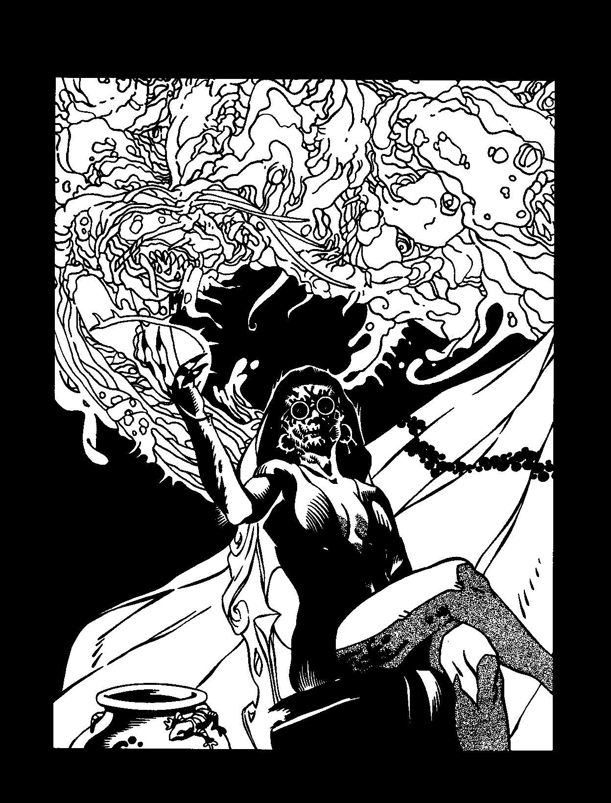

Blood magic has applications other than the Tremere's potent Thaumaturgy. Long before the secrets ofThaumaturgy had been codified, other magics served the Children of Caine, and continue to do so even in the modem nights.
A quick note on using these magics in your stories
- certain clans (notably the Assamites, Setites and Tzimisce) are described as having Thaumaturgy avail­ able to them in the core Vampire rulebook. These rules supersede those (which are intended as rough simula­ tions) - Assamite viziers learn the Assamite sorcery herein, Setites learn their special magic and T zimisce koldun learn koldunic sorcery. The costs they pay to increase their knowledge with experience are the same asif they learned Thaumaturgy-pathsat their current rating times four and the base Discipline (and its "free dot" in the primary path) at the current rating times
seven. Note also that they may be eligible to pay "in­ clan" costs for these Disciplines.
WESTERN NECROMANCY
Not long after prehistoric man first made the
distinction between life and death, he taught himself magic to contact ghosts of the departed. The ancient vampires who preyed on these early tribesmen took notice of this development, immediately devising ways to exploit it for their own ends. Few vampires feared or respected the petty deities of the kine -some evenhad
the temerity to count themselves among the ranks of the divine.They stood before the gods' blood-spattered altars, stealing the gifts meant for their worshippers. Early Kindred magicians reversed the boons of earth gods, stripping land, cattle and women of fertility. They stole luck from the gods of fortune, fire from the trick­ sters, strength from the deities of war. And from the
.gcds of death, they seized maps to the Underworld and the power to compel the obedience of ghosts. The death gods, like the others, are nowforgotten, but death magic retains its pale allure. Over the intervening millennia, magicians refined their death magic to exploit evolving cultural notions about gods, ghosts and the afterlife.
The history of necromancy begins, as does so much of Western thought and tradition, in the ancient world of Greece and Rome. Greek myths shaped Western conceptions of the afterlife, and of possible ways in which living magicians could draw upon its power and conjure the inhabitants of the underworld. The Greek poet Homer described agrim afterlife in which unhappy ghosts lingered, trapped inshadowy dreams of their past lives. By the time of Virgil, folk beliefs in the afterlife and the fate of dead souls had become much more elaborate. Virgil described in detail the geography of an underworld that operated as a justice machine. Souls were ferried to a court where three immortal judges praised the good and passed sentence on the wicked. The former spent eternity in the Elysian Fields, while the latter went to the fortress of Tartarus, where they eternally repeated an array of torments tailor-made to their specific misdeeds. For stealing the ambrosia of the

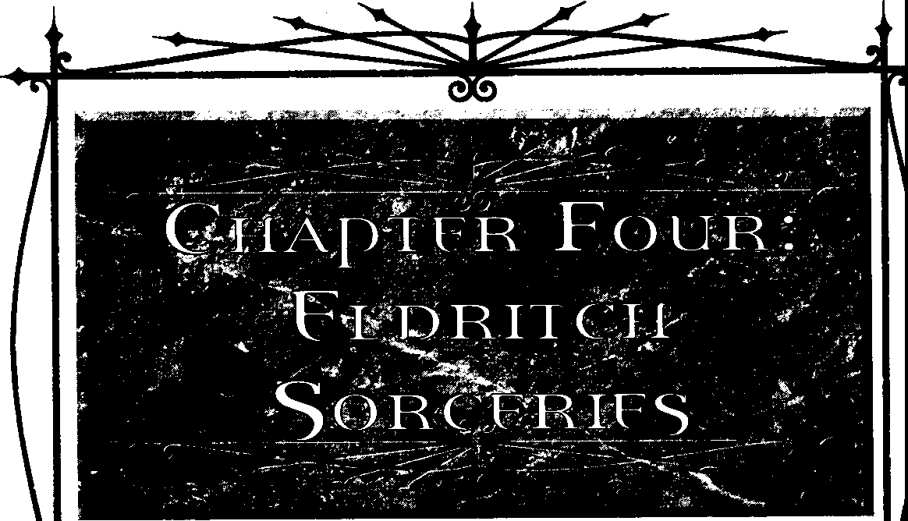
ELDRICH SoRCTRIES



gods, King Tantalus of Lydia suffered eternal hunger
and thirst-fruit dangled out of reach,evenmovingout of his hands, while the water that stood to his neck always flowed away when he tried to drink. The judges of the damned sentenced the founder of Corinth, Sisyphus, to roll a huge boulder up a hill, which would return to the bottom when he had reached the top. In this way he paid eternally for the restlessness that drove him to continually engage his neighbors in destructive and pointless warfare.
Magician-scientists of the Classical era treated in­ quiries into the nature of the afterlife and ways of interacting with its residents as an entirely legitimate aspect of their ongoing effort to expand human knowl­ edge.The firstcentury philosopher ApolloniusofTyana allegedly summoned the shade of Achilles and raised the dead, in addition to a range of other feats including clairvoyance and healing the insane. In the second century, Lucius Apuleius, now better known as the author of The Golden Ass, explored the control of shades, again as part of a wider portfolio of wonders ranging from dream interpretation to transformation into animal form. The third-century Neo-Platonists, who attempted to synthesize a holistic religion combin­ ing mysticism, Christian ideas, and the philosophies of Plato and Aristotle, studied the mechanisms by which ghosts operated and could be cajoled to bring about miracles.
Unfortunately, these figures attracted enemies who found it useful to accuse themofblack magic. Apollonius stood trial forsupposedly sacrificing a boy in order to use his entrails to read an augury. Authorities charged Apuleius with using magic to win the hand of a wealthy widow, and of plotting to poison her son. Necromancy was never considered one of their crimes; contact with the souls of the dead was not yet viewed as inherently evil. Magicians who restricted themselves to contact with the wraiths of the virtuous, and who used what they gained to good ends, were no more distrusted than other wonder workers.
This attitude changed with the conversion of the Roman Empire to Christianity, which began with Em­ peror Constantine Iin the thirdcentury. Many magicians used Christian mythology in a way true believers found blasphemous. Twisting a doctrine that frowned on the practice of magic, sorcerers began to call upon Jehovah and His angels to assist in the deliverance of magical effects. Some professed to be devout Christians and limited the subjects of their invocation. Vampiric sor­ cerers, knowing their souls were bound for no Christian Heaven, saw no reason to bother with the many annoy­ ing restrictions of the "pure" form of this sorcery.
However, they took sharp interest as other mortal sorcerers blithely added Jehovah and His angels to a hopper of deities, heroes, ghosts and demons from the many traditions of the Mediterranean basin. Likewise, necromancers - mortal and Cainite alike - mixed cosmologies and summoned damned souls from the Christian Hell while at the same time drawing power from the Classical underworld. Seeing the contradic­ tion in this didn't stop them from doing it, because, for whatever reason, it worked.
Magicians saw themselves as practical men repeat• ing whichever experiments they found successful. If God truly disapproved, He wouldn't let the magic work, would He? Although such rationalizations might have suited the magicians, they scandalized the emerging ecclesiastical class. Christianity forbade all sorcery, frowning especially on contact with the dead. As Christianity's sway grew, wise magicians hid their ac­ tivities. Church fathers took the story of Simon Magus of Samaria, mentioned in the New Testament as a sincere but misguided magician who seeks to purchase the wonder-working secrets of apostles Peter and John, and held him up as the first heretic. Anyone who
followed his path could expect eternal hellfire and earthly persecution. Many magicians themselves be­ came Christians, seeking to invoke the power of saints and angels; they forswore necromancy as not only
dangerous but evil. Magicians interested in necromancy therefore became double rebels, spitting in the face not only of religious orthodoxy but of their fellow sorcerers. In their rebellion, necromancers found power.These clandestine researchers, whose names are now lost to history, used a variation on Platonic logic to posit that the rules a society chose to live by sustained an inherent
mystical force. Those who best lived by those rules could draw on them to gain power. However, great energy could also be gained by deliberately breaking those rules. The Church's condemnation of necro­ mancy merely increased its potential for those few daring souls willing to flout Christian morality. Thus the principle of Taboo became central to necromantic practice. The greater and holier the rule, the more energy it contained. Ergo, the most powerful effects could be conjured by ceremonies that broke the most potent laws of society. One of the greatest taboos concerned the manipulation of human remains. Con­ tact with corpses and body parts thus became a central focus of necromantic ritual during the early Christian era, which it had not been during the more open and inquisitive Classical times. Present-night practitioners, who watch as once-unassailable taboos of Western society fall left and right, are grateful that contact with

Blooo MAoc SECR£ISOf THAUMArul!Ct



bodily remains has stayed as abhorrent as ever. This revulsion makes their magic work - or so the theory goes. This belief explains why the details of necroman­ tic paths and rituals cower above all others in sheer, visceral perversity.
The ocher principle of necromantic magic, Au­ thority, also arose during the third century, and grew in influence in the course of Europe's conversion from paganism to Christianity. The anti-Christian magician and philosopher Iamblichus proposed the doctrine of theurgy, which drew its powers from symbols and the law ofcorrespondence. lamblichus developed adetailed hierarchy that placed gods, heroes, ghosts, angels and demons into a single system, which the magician could call upon to escape from the bounds of necessity. Iamblichus did not design his system so that it could be exploited by necromancers, but exploit it they did. If these entities could be defined and placed on a grid in descending order of importance, the necromancers thought, it stood to reason that necromancers could approach the lesser-powered entities not as supplicants but as masters.
Biblical ideology, ironically enough, supplied the rest of the philosophical equation. Ever since the story of Adam and Eve, Christian myth repeatedly stressed that the world of nature was a gift from God to human­ ity, who could dispose of it as they wished. Man was meant to dominate nature. Necromancers extended this European way of thinking to the world beyond: Magicians should dominate the souls of the dead, be­ cause they can. Tonight's necromancers look upon the ghosts of the dead as little more than a resource to be exploited. They care no more for the welfare and desires of theshades they call upon than they would for a barrel of crude oil or a cart brimming with iron ore.
Although fullest expression of the Western credo of domination over nature occurred at the time of the Renaissance, during the era of exploration and coloni­ zation, necromantic theory had by chat point already been fixed into its present form, with the ascension of the Giovanni clan. As cutthroat arms merchants who made their fortunes during the Crusades, the principle of domination proved second nature to them. They were already accomplished necromancers when Augustus Giovanni tricked a decrepit Antediluvian into Embracing him, and then slew the vampire and his descendants in order to become the head of hisown new clan. Much of the magic of Necromancy as practiced tonight was refined in the few short but monstrously productive years between the clan's firstdabblings into the art and its Embrace.To their dismay, the Giovanni found that their talent for innovation had died with
them. For the last five centuries or so, despite their continual efforts, they've advanced the state of the art of Necromancy only by increments.
Although contemporary necromancers do not of­ ten believe in the literal existence of theGreek gods and heroes, many of their rites continue to draw on the names and imagery of the Classical mythology, espe­ cially as it related co the world beyond death. Even as mortals, the eldest members of the Giovanni family felt a greater sympathy for the grand pagan ethos of the Classical era than they ever did for Christian parables and iconography. Ever anxious to display their erudi­ tion, Giovanni necromancers delight in tormenting their foes with obscure classical references. Thus the ritual called Chair of Hades refers to the Chair of Forgetfulness Hades used to trapTheseus and Pirithoils. Instead of a mere magic circle, Giovanni magicians protect themselves from malign ghosts with a Circle of Cerberus, an allusion to the gigantic, dragon-tailed, three-headed dog that guards the gates of the under­ world and prevents the dead from escaping back into the land of the living.
PRACTICAL NECROMANCY
As his first lesson, any new student of Necromancy learns the importance of separating magical sendings based on Taboo from sendings based on Authority. Taboo-breaking sendings require the magician to wal­ low in thefilthof the grave. Authority sendingsdemand physical purity and cleanliness. (Spiritual purity is, conveniently, not required.) To realize both principles in the course of one working is to risk failure at best and destruction at worst. Any rite that allows the necro­ mancer to interact withotherworldly beings takes great pains to protect her from possible harm or influence.
The Greek originators of these rites considered purity and cleanliness a necessary component of this protection; wraiths, they discovered, could seize on impurities and imperfections and use them to circum­ vent the worker's protections, gaining freedom of action in the mortal world. Thus, in order to prepare for dealings with shades, the necromancer must purify herself through fasting, chastity and bathing. Long preparation times decrease the chances of an entity overcoming the necromancer's safeguards. Mortal nec­ romancers are often urged to meditate as well, to divest themselves ofemotional preoccupations.Vampires learn that their chronic inability to experience strong emo­ tion works in their favor in this situation. A summoned wraith capable of turning on his would-be dominator searches the magician's aura for his strongest passions, which can be used as a mystical lever to compel obedi-

[LORJO,SORCERIES



ence. A wraith summoned by a vampire searches in vain, sensing only a grayed-out aura of muted values.
When the necromancer has concluded her prepa­ ration, she dons a sec of robes, which must be spotlessly clean and perfectly maintained. The merest stain or dangling thread end may provide the wraith the lever­ age it needs to reverse the power relationship of the rite and command the necromancer. The robes must fit perfectly; an overlong sleeve or hem also counts as a dangerous imperfection.
The necromancer then draws a magic circle co act as a barrier between her and the wraith she intends to summon. It also keeps out unexpected interlopers; some opportunistic ghosts wait along the boundary between world and underworld, hoping to cross over on a rift between the two temporarily brought into being by a necromantic ceremony.
Having prepared herself in the formulaic manner, the necromancer then commences the specificgestures, incantations and prop manipulations of the particular sending she wishes to accomplish. The physical items used in the procedure must always include objects symbolizing the following concepts: one, the necromancer's mastery over the shade; two, the shade's imprisonment in the underworld; and three, the indi­ vidual identity of the wraith. The necromancer needn't bother with the last item if he doesn't care which ghost he summons up.
Classic symbols of mastery include crowns, tiaras, scepters, ermine collars, thrones, jeweled rings and medallions of office or rank. Modem variants might include Rolex or Cartier watches, money clips dis­ tended with high-denomination bills, mahogany office furniture or expensive designer clothing. The latter are frequently substituted for old-style robes, provided that they're perfectly maintained andconstructed; beware of the substandard tailoring of many top-name designer brands! Clever necromancers match their symbols of authority to the understanding of the wraiths they intend to summon. A parody papal miter works well against the ghost of a devout Roman Catholic (so long as it is superbly fashioned), whereas a general's uniform of the appropriate period and nationality establishes authority over a soldier's shade.
Symbols of imprisonment include chains, metal rods sawn from jail-cell bars, handcuffs, shackles, prison uniforms, gurneys with restraint straps, straightjackets and rubber gloves. Medievalist necromancers may pre­ fer torture implements such as red-hot pokers, racks, iron maidens or face-cages. Modernists might select electroshock machines, electronicankle bracelets, tasers or trays of sedatives. Although it helps if the wraith was
imprisoned during his life and faces the object that he most strongly identifies with that confinement, this is a bonus, not a necessity.
The best symbol of a wraith's identity is his Fetter, an object with which he has a pre-existing emotional relationship. One of the hallmark necromantic abilities allows the necromancer to acquire the Fetter of a wraith he plans to command on a regular basis. The Fetter isn't necessary, though; the necromancer need merely prove to the wraith that she knows enough about him to make him dance to her will. The symbol may be professional, as in the case of a doctor's stethoscope, a judge's gavel
or a lion-tamer's whip. It may be personal- a treasured
photograph, a high-school yearbook or a wedding ring. Or it might reflect a favorite interest or hobby - a camera to capture a photographer, a model bike to drive a motocross enthusiast, a hook to catch a fisherman.
It would be incongruous for the Taboo-breaking rites to follow a formulaic arrangement like that above. Each working is unique. However, certain common elements unite them all.
The most obvious common point is that all employ the remains of the dead (usually human remains) or other powerful symbols of death that arouse disgust and anxiety in the living. Grave dust, chunks of tombstone, maggots (especially those recently engaged in devour­ ingdead flesh), coffin nails, embalming equipment and autopsy tools all fit the latter category. Necromantic doctrine states that the symbols of death muse be relevant to the society in which the practitioner oper• ates. For example, traditional Chinese avoid the ancient funerary bronzes of their nation's archaeological past, because of their association with death; at the same time, Western collectors of Chinese art covet them as attractive antiquities and art objects. A funerary um would be no good to a necromancer of Western origin in a Western country, but might be useful if the necro­ mancer is either breaking a tradition of his own upbringing, or is working his magic in China.
Taboo-breaking rites seek to combine the remains and relics of death with actions society at large sees as wholly separate from death. Youth is seen as the oppo­ site of death, so necromancers involve children or symbols of childhood in their ceremonies. Fertility is the opposite of death, so necromancers commit plea­ sureless, sterile sexual or quasi-sexual acts to in the course of their sendings. Necrophilia represents the ultimate expression of this concept. Already experi­ enced necrophiliacs before introducing sorcery into the equation, the debased members of Clan Giovanni have explored countless exotic variations of this abhorrent act in an effort to keep their magic potent. A currently

8uxJo MAac:StemsorTHAUMATIJRGY



fashionable technique involves the surgical, post• mortem creation of new penises and vaginas from the flesh and bones of the dead. Giovanni surgeons install this new genital equipment on the corpse's back, belly, neck and thighs,so that as many asa dozen practitioners can simultaneously conjoin with the same dead sex partner, regardless of its original sex. This practice should retain its power for a few more decades; after that, the Giovanni will have to come up with some­ thing really perverse.

NECROMANTIC RITUALS
Thefollowing rituals enhance the necromancer's
powers and offer her protection from the dead.
System: The player rolls Intelligence + Occult against a difficulty of three plus the level of the ritual (maximum 9).
Certain ceremonial practices give necromancers bonuses when working their ritual magic. The difficulty of any effect targeted against a wraith decreases by one if the symbols of imprisonment (see page 104) used in the working happen to be those the individual wraith most strongly identifies with captivity or torture. For example, the wraith of a kidnapping victim remembers being gagged with duct tape; a necromancer wishing to work magic on her may subtract one from his difficulty by adding a roll of duct tape to his ritual gear.

LEVEL ONE RITUALS
CIRCLE OF CERBERUS
Thenecromancer bathes, fasts and abstainsfrom all physical comforts and pleasures, most especially sensual ones,for a night.Then she dons well-maintained, high­ quality robes orother clothing. She draws a circle on the floor in a place of safety. She may then proceed to use other necromantic powers, confident that her protec­ tion against ghosts and spirits has been enhanced.
Each success subtracts two from the difficulty of all rolls the player must make to resist anyattempted harm or influence on the part of a ghost, Spectre or spirit, so long as the necromancer remains inside the circle. Treat any botches scored while attempting to use nec­ romantic paths as failures instead.
RApE OFPERSEPHONE
A team of surgeons trained in the unpleasant ways of Necromancy performs an elaborate operation on a freshlydeadorwell-preservedcorpse. From the cadaver's
dead tissues, they create up to seven new penises, vaginas or other sexual apparatuses.
The necromancer engages in intercourse with the corpse's new genitalia. He may then subtract two from the difficulty of all necromantic magic- except those targeting ghosts, Spectres or spirits-for theremainder of the night.
If a number of necromancers perform the ritual together, they may freely trade Willpower points be­ tween one another for the rest of the night. During this time, one participant may experience the tactile sensa­ tions of another by concentrating for a few seconds and spending a point of Willpower, regardless of the dis­ tance separating them. No more than seven necromancers can perform the ritual together.
LEVEL TwoRITUAL
JUDGMENT OF RHAOAMANTHUS
The necromancer chooses a wraith she will later summon, using the Summon Soul power of the Sepul­ chre Path. In a cleansed bronze brazier, she bums several pages of a law book anda religious text matching the faith the wraith held in life. She mixes the ashes of the books with silver powder and uses the mixture to make her Circle of Cerberus (see above). When the wraith appears, the necromancer tells him that she has the power to send him to the real afterlife, the one he believed in when he was alive. If the ritual works, the wraith believes her. If the wraith fears judgment and hellfire, she can induce him to do what she wants by threatening to use her power. lfhe yearns for Heaven
and escape from the bizarre existence of the under­ world, she can secure his cooperation by promising to use it. Since she can't make good on this promise, Judgment of Rhadamanthus won't work twice on the same Heaven-seeking wraith.
Wraiths who were atheists while alive, or didn't believe in life after death, automatically resist this ritual.

LEVEL THREE RITUAL
DRINHOF5TYH 'SWATERS
Thenecromancer robs agrave andsteals the corpse's skull. He sawsoff the top of the skull; the sawn-off piece, flipped over, forms a cup-shaped piece of bone. He covers this piece with clay, making a bowl, which he proceeds to fire in a kiln. If any blood descendant of the corpse eats from the bowl during a meal with the
necromancer, any promises the subject makes to the necromancer gains otherworldly enforcement. If the subject fails to live up to them, he is visited byaSpectre,

llDi<H SOl<DJIS



which torments him relentlessly until he makes good on them or offers the necromancer acceptable comperu;ation.
In addition to the time it takes to rob the grave, the modeling and firing of the bowl takes at least four hours, depending on how fancy the necromancer wants it to look. It may be reused until destroyed.

LEVEL FOUR RITUAL
0RINH OFLETHE' SW ATERS
The necromancer acquires an object once owned by, or symbolic of, a particular wraith. The object must be able to be damaged by water; the necromancer destroys it by leaving it to soak in water. During the soaking, he periodically spits into the water. After the object has been destroyed, the necromancer conjures the wraith or otherwise arranges to be in her presence. The wraith loses all memory of her identity, becoming
highly susceptible to suggestion on the part of the necromancer. Obviously, this ritual is of no use if the necromancer want.s the summoned ghost to answer questions.
The wraith's memory loss continues for one night per success scored. It may not use Pathos points to counter any action on the necromancer's part. Its Will­ power drops by the number of successes scored; it may not replenish its Willpower pool while the effect lingers.

LEVEL FIVE RITUAL
CHAIR OF HADES
The necromancer acquires a corpse's femur and tibia bones-decreasing thedifficulty of the casting by one ifhe doesso by personally robbing agrave. He wraps the bones in coarse cloth and then encases them in wood or metal so chat their lengths match and they become capable of bearing weight. He then builds a chair; each encased bone forms one of its legs. If a blood descendant of the corpse sits in the chair, she loses all desire to do anything but sit in the chair. She leaves the chair only to quickly fulfill basic bodily needs.
Whenever a qualified victim sit.s in the chair, the necromancer's playerrolls Intelligence+ Occult against her Willpower. If successful, the effect lases until the chair is destroyed. Otherwise, even if the victim is forcibly moved from the chair, she does everything she can to sit in it once more. In addition to the time it takes to obtain the bones, the construction of the chair takes at least eight hours. The necromancer may spend addi­ tional time on the chair to make it look fancy or to mimic an existing piece of furniture.
VouoouN

NECROMANCY
Followers oft1oudoun, the religio-magical tradition of the people of Haiti, greatly fear the effects of ouangas, black magic intended to aggressively harm people. Bokkor, practitioners of ouangas, accept no categorical limitations on their bad magic. In addition to their powers over the dead, they claim to be able to curse people, control the weather, blight crops and generally perform the sorts of harmful acts blamed on sorcerers by folk traditions the world over. Despite the range of powers attributed to malign sorcerers, common people fear no form of black magic as they do the spells and rituals involving death and the souls of the dead.
Voudoun worshippers dread the attentions of hu­ man voudoun priests (houngans) gone bad, but in doing so they misdirect their anxieties. Jealous and fearful worshippers periodically subject even the most virtuous houngans to baseless rumors of involvement in sorcery and death magic. Some of the most vociferous accusers, when not beating the bushes for witches, hypocritically pressure their houngans to perform ouangas rites to curse their own enemies. The few houngans willing to admit to being sorcerers generally rely more on trickery and suggestion than on actual supernatural powers. For example, a human houngan makes people fear him by dressing outrageously and spreading rumors about his willingness to lay curses on others for the least provoca­ tion. He performs sleight-of-hand magic tricks and passes them off as magical sendings. He takes credit for sicknesses, natural disasters and eruptions of madness. A few vulnerable people come to fear him so much that they begin to exhibit psychosomatic health problems
- further enhancing his dread reputation.
Genuine outbreaks of t1oudoun death magic flow not from living houngans, but from Kindred who exploit a magically potent belief system to grant themselves useful powers. The Kindred didn't invent t10udoun, ouangas or even the tradition's death magic; an adven­ turous few of them simply moved in when rumors of zombies and a cooperative god of death began to filter out of Haiti.
The t1oudoun religion began to take shape not long after 1512, when Haiti's Spanish overlords brought the first African slave laborers to the island to work its mines. Voudoun flourished as a new amalgam of differ­ ent beliefs from the enslaved laborers' various tribes of origin. One or two Kindred made their havens in Haiti

Bt.oooMAGic: Sf.CREJS Of THAUMATURGY

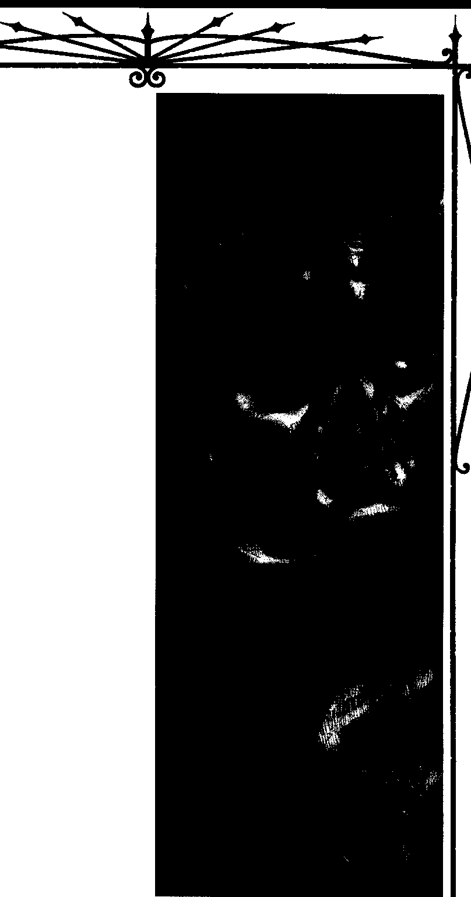

at this time, attracted by the opportunities for unre­ stricted feeding offered by the slave trade. They numbered among the many European pirates lured to the region by Spanish vessels laden with gold and ripe for plunder. When they arrived at Haiti, a few pirates settled down and established plantations, again run with African slave labor. Early Kindred colonists paid no more attention to their slaves' religious develop­ ment than the mortal pirates with whom they mingled.
If they had, perhaps current Kindred practitioners of
voudoun necromancy would understand even more of the metaphysics underlying the magic they now use.
In 1698, France signed a treaty with Spain, taking possession of the colony and bringing with it a few French Kindred. French became the language of Haiti, and Catholicism its state religion. The slave culture in tum adopted and adapted elements of Catholic iconog­ raphy into its pantheon of gods and spirits. One of the island's Cainites, a Lasombra with Giovanni connec­ tions named Gisele Hemmet, took notice of ouangas and the new possibilities it offered to the moribund traditions of Western necromancy. Inculcating herself into a cell of roving ouangas practitioners, she secretly underwent initiation as a houngan, and, as she had fervently hoped, was "mounted" by the loo (god-spirit) called Baron Samedi.
Samedi is the Lord of the Cemetery, the incarna­ tion of the threshold between life and death. Although he can be a dreadful and frightening figure, believers do not identify him as a pet.roloa,or malign spirit. Ordinary
worshippers propitiate him in hopes that he will guide their deceased family members to their proper final rest as loa acines, or ancestral spirits. He does so when pleased by graveside sacrifices of food, crosses and the ritually obligatory three centimes (pennies). Simulta­ neously imperious and impish, Baron Samedi mocks humankind for its lusts and passions. Images of his grinning, skull-like face gaze out from murals on the houmfor walls, reminding all who behold them of the folly of mortal concerns in the face of the eternity of death. (The houmfor is the central hut in a modest temple complex, where ceremonies are performed.)
Gisele Hemmet expected Baron Samedi to be pleased by the chance to make a Cainite his horse, and he was-but not in the wayshe'd hoped. She'd entered into the initiation ceremony assuming that this primi­ tive death spirit would be so shocked and delighted to learn of the existence of Cainites that he'd welcome his new houngan not just as a special servant of death, but as a child he'd never known. The naive, rustic deity would doubtless shower her with new mystic abilities she could use for her own purposes. Instead, as the

[I.DflX}I Som[S



Baron's presence entered her body and mind, she found herself overwhelmed byan ancient consciousness vastly more forceful than her own. Gisele shook as the amused disdain the Baron felt for her and her kind reverberated through her. The Baron did offer her power, which she greedily accepted, only half-understanding that the price she would pay would be her sense of confidence and entitlement. She had foolishly submitted to some­ thing much greater than herself. Something, as she would soon discover, which would never leave her side, no matter how much she might want it to.
The Baron came to her many times in the next years, always unbidden. Sometimes he offered her more magic, like a barman placing a free glass of rum under a drunkard's nose. More often he came only to turn her certainties into doubts, her assurance into dread. Vam­ pires, he whispered in herear, were even more ridiculous than mortals. (He insisted on using the vulgar term vampire, especially when he saw Hemmet bridle to hear it.) Theit plans were doomed. Their sense of immortal­ ity was false. They were trapped on the threshold between life and death, neither here nor there, yet had deluded themselves into thinking that they were mas­ ters of the world. He would give Hemmet power all right; he would give it to any of her kind who submitted to be ridden. Not because the powers would help them; quite the contrary, his help would only cement their folly. He would give his gifts because it amused him. Vampires were the rudest joke he'd heard in centuries.
Several Cainites flocked to Hemmet seeking the occult knowledge she'd gained. She brought others to the houmfor to be mounted. Still seeking Samedi's approval, she promised to bring him a legion of Cainite devotees who would become his houngans. At this news he laughed until acrid tears flowed down his cheeks. Sometimes she warned her eager recruits they were making a mistake. Few heeded her words of caution. Those who were as foolish as she was, Hemmet ruefully decided, deserved to share her discomfiture. A small coterie of Cainites, claiming various clan allegiances, came to see what she'd been warning them about; those most intrigued became the Baron's houngans.
In 1791, the island's slaves revolted against their masters and overthrew them; Haiti became the hemisphere's second republic. Hemmet wouldn't have dreamed of contributing tosuch ashocking upending of the social order, but helped the revolt along in a few subtle but important ways once it got going. She did so hoping to prove her worth to the Baron and escape his campaign of mockery. She told him she'd done it tohelp his people; he threw back his head and laughed as he always did. The slaves' new success was just another
illusion; in the face of death, there was no freedom. Haiti would always belong to him; even he lacked the freedom to change this.
THE BARON AND
H15 HOUNGANS
Themere intervention of 200 years has done little to change the humiliating relationship between the houngan and the mocking loa who gives them the magic they wish for, in hopes that they will use it to destroy themselves.
To become ahounganof the Baron, a cultist attends a ritual led by priests already initiated to hisservice. The houngans offer food and drink to the Baron to gain his attention. Accompanied by drums, officiates and aspir­ ing initiate join together inan ecstatic dance, employing fast, exhausting moves that induce an altered state of consciousness (the robust vampiric physiology demands that neophyte worshippers spend much more time dancing to attain the trance state than humans re­ quire). The ceremonies can require many nights of ritual activity before Baron Samedi deigns to mount his new charge. (Experienced houngans, like their human counterparts, learn over time to slip easily into the trance state.)
When mounting comes, the loa takes over the initiate's body, speaking in a different voice - some­ times a different tongue-and adoptinga body language all its own. It declares that it is Baron Samedi, and engages other participants in conversation. If mounting comes too soon, attending houngans suspiciously inter­ rogate the loa to ensure that it is Baron Samedi who has come and not some lesser petro loa mischievously hi­
jacking the ceremony for its ownamusement. If it is not
the Baron, the houngan employ a rite to drive out the interloping loa and then continue the ceremony until the Baron does appear.
When the Baron arrives, he declares that the ini­ tiate has finally submitted to the cosmic realities of death, even though it may take centuries for her to fully admit that she has done so. He asks the houngan which of his boons the initiate seeks.He announces that he has granted this boon, in hopes that it will lead this errant child to see the truth of her position. He then departs, leaving an exhausted supplicant to collapse on the dirt floor of the houmfor like a plaything suddenly dropped by its owner. When she recovers, she finds that she now possesses the powers she sought.
She also learns that she's forged a binding personal contract with the Baron that cannot be severed, even if she renounces the use of the boons he has granted her. The Baron can come at any time; he refuses to limit his


BLOODMAc.c: SocmsorlHAuMAruRGY

llll

surprise visits co moments when his houngans happen co have submitted to the trance state. A selection from Gisele Hemmer's journal, much-circulated in Kindred circles, describes one such incident in detail. Ac the time, Hemmet was preparing herself for a meeting at which she expected to be attacked by an Assamite contract killer. The Bacon first appeared to her in the shower, materializing from nowhere, startling her so badly that she fell backward andopened herscalpon the shower head. As she tended to hec minor but embarrass­ ing wound, he perched on her sink, swinging his legs and making pointedly pointless small talk about what various famous people might say just before they die. The Baron interspersed his annoying banter with a series of sly gibes and insults, pausing atone point to lick up a few stray spatters of blood chat had fallen into the sink from Gisele's head wound. He then made aface and performed a supposedly comical spit-take that didn't amuse Gisele one bit. She ordered him to leave; he responded witha cryptic statement about the disturbing numerological significance of this year's climactic sta• tistics, hinting that it meant disaster for Gisele and her plans. Unable to restrain herself, she launched for the hundredth time into a plea for more respect and toler­ ance for his humble servants. In the journal, Gisele recreates an ensuing hour of philosophical discussion, in which the insufferably smug Baron invited her to ask questions about his origins and motives, co which he pcovided inconsistent and evasive answers. He pro­ ceeded from there to poke holes in her plan co protect herself from the assassin, planting fresh doubts about allies she'd until then trusted completely. Before de­ parting, he Informed her that she was doomed, that her plans if completed would bring her more misery than sorrow itself, and that he would possess her completely one night -even though he had no particular desire to doso.
If an annoyed victim of a visitation tries to attack
the Baron, he vanishes, leaving behind echoing gales of victorious laughter. If he thinks his target hasn't been unsettled enough yet, he immediately rematerializes,
laughing, elsewhere in the room.
When appearing uninvited, Baron Samedi does not possess the houngan. It's too hard to hold a conver­ sation that way. He manifests himself as an apparition, altering his appearance at whim. He always appears as an impressive-lookingblack man. He usually chooses to look about six feet tall, but may on occasion show up as
a dwarf. The Baron may be bald or elaborately coiffed; his face may be shaven, bearded or decorated with a gigantic handlebar moustache. He always appears in
grand clothing. He may deck himself out as a 16th­ century pirate, sporting a black velvet topcoat, frilly cuffs, an array of looted medals and other military decorations, and a wide-brimmed hat with a 10-inch crown; an insinuatingly friendly, painted skull and crossbones appears on the front of the crown. As whim strikes him, he may adopt the face paint and loincloth of an African shaman or the dark suit of a 19th-century undertaker. Afterthevoodoo-themedJames Bond movie Live and Le.t Die came out in 1973, he often appeared in the form of actor Geoffery Holder, who memorably played him in the movie. He dropped this joke in the mid-'80s, when Holder appeared in a series of commer• cials for the soft drink 7-Up. These days, he most often materializes in a stylish outfit, each piece of which is an animal product of some kind: long leather jacket with ermine collar, white silk shirt with ivory buttons, sharkskin pants and snakeskin boots. When a houngan comes too close to the Baron, the snakes' heads on the boot toes widen their baleful eyes, open fanged mouths and hiss. In any of these guises, he may wander through the ranks of ritualises as they perform one of hisceremo• nies, pinching or kicking some, licking and kissing
others.
When the Bacon is not present, houngans maysuffer other unwanted visitations. Whenever they find them­ selves in the presence of petroloas or free-coaming souls of the dead, they hear the voices of theseentities in their heads. These beings lurk everywhere in Haiti. Their constant murmuring, gossiping and pointless chatter poses less of a threat to the listener's sense of well-being, however, than the Baron's impertinent interjections. Nonetheless, they can be annoying or - where con• centration is of the utmost- lethally distracting. Loas and similar spirits dwell in abundance wherever animis­
tic beliefs hold sway. In Brazil, where followers of the spirit religions candomble and macumba practice rites similar in broad structure, if not in detail, to ooudoun, spirits chatter in Portuguese patois instead of French. Local spirits prove just as bothersome in Africa, where the coots of voudoun lie,or in the totem-haunted depths of the Pacific Northwest forests, or on the howling expanses of the Arctic tundra. As practitioners of spirit magic urbanize, bothersome loas and their kin extend their range. Whether they were summoned by practi­ tioners of mojo in New Orleans or Santeria priestesses in immigrant New York, they wait to annoy the houngan. Don't think you can awid us, they whisper. The whole millenium thing is going our way. We're globalizing. The people are tired of the big gods who ignore them. The world belongs to l<S again.



ELDiKliS""""5




THE5AMEDI
Not long after the slave revolt, Hemmer's under­ lings brought an unpleasant surprise to her attention. They'd captured a gaunt, strange-looking Cainite lurk­ ing on the grounds of her estate. The creature, who appeared more like a walking rotting cmpse than a proper Cainite, identified himself only as Macoute. Under torture, the creature claimed to be a member of a bloodline called the Samedi. Hemmet accused it of having stolen thefavors of the Baron, assuming that he was creatinga new group of Cainites to mock her and to compete with her. Although terribly injured, Macoute just laughed at this suggestion. His rueful, half-mad manner reminded her utterly of the Baron's manner, convincing her that her theory was right. She engaged in a brief campaign against Macoute's fellow Samedi, stopping only when theshambling vampiresdiablerized several of her own comrades. Macoute has passed him­ self off as the Baron many times, and has even gone so far as to name one of his childer Brigitte, after the Baron's wife.
Tonight the Samedi (see Vampire Storytellers Companion, pages 12-13) and Hemmet's houngans steer clear of one another. The solitary, fringe-dwelling Samedi keep to themselves, or act as independent contractors in Cainite power struggles. The houngans treat the existence of the Samedi as another of the Baron's elaborate jokes at their expense. The Samedi consider Hemmet and company to be na'ive fools lead­ ing wretched unlives in a prison of their own making. They share the Baron's fatalistic worldview. He rarely needs to visit them to show them the futility of their existence; they feel it in their rotten bones. He appears to them only when they forget their impermanence and try to build things or carry out complex plans.
Cenain Samedi believe that their terrifying master isan Antediluvian Cainitewho has merely takenon the identity of the Haitian death spirit. Although their association with Haiti and its magic are comparatively recent, they claim that their bloodline is very old.
Like any bloodline, the Samedi add new members by Embracing mortals.To learn the magic of the Baron, they must undergo the same initiation rites as the houngans.

SERPENTS OF THELIGHT
The luckless island of Haiti veritably crawls with vampires. A small group of Setites called the Serpents of the Light make their havens here, too. They've adapted Set's mythology to voudoun belief; the serpent god of life, Damballah, replaces Osiris as the hate object
in their practices. Several Serpents of the Light can use Baron Samedi's magic, though their connection to Set seems to immunize them from his visitations. While pretending to be occupied with other matters, they're arming themselves for a battle to drive Hemmet's group of poseurs from the island. Exactly what resolution can come of Haiti's three-sided undead conflict remains to be seen.

THE AFTERLIFE
Voudoun worshippers believe that the souls of the freshlydeadgotoa waterywaystation.There theyspend an amount of time that varies with social status; promi­ nent individuals may leave early, while the less socially well-off endure longer stays. If the families of the dead perform the proper rites when the interval ends, their souls find their way back to the shores of Haiti, where­ upon they occupy special jars provided by the ritualists. The worshippers take the jars home, confident that theirancestors are now loa-racine whocan provide them with luck and guidance. If the ceremony of return is disrupted or neglected, the spirits tum sour and return to haunt people and wreak havoc. The magic of the houngan revolves in part around the diversion of these souls for nefarious ends.
Common people fear two forms of death magic most of all. They worry that the soulless bodies of their dead kinfolk might be turned into walking dead - the zombies of voodoo pop culture fame. Even more than that, they fear that they will be turned into zombies while still living, and forced to work the cane fields in a form of slavery that deprives them even of the ability to think. Adherents of local folk beliefs also dread a female vampire they call the lou-garou. (Despite the name, this is not a reference to the lycanthropes of Werewolf: The Apocalypse.) Evidently, Gisele Hemmer was a bit careless about maintaining the Mas­ querade during her early nights on the island....

RITUAL ITEMS
In accordance with his lessons on the imperma­ nence of all things but death, the Baron scorns the idea that ancient, historically resonant objects are more po etful than ordinary ones. In Baron Samedi's magic, obiects gain mystic resonance through their connec­ tion to their user, not their provenance. A houngan's rit al b.lade is more likely to be an old, rusted utility kmfe wtth a handle wrapped in dirty masking tape than a dagger of gleaming gold retrieved from some Roman ruins. The idea that holding a relic of the ancient past confers even a momentary sense of connection to

BLooo MAoc: SKREl5 orTHAUMAruRGY



anything that might be called immortality is sheer nonsense to Baron Samedi.
Neither does Baron Samedi show any respect for riches or any other indicator of success in the material world. People frantically accumulate jewels and gold and houses and works of art to try to proclaim their power in the face of death, but they're fooling them­ selves in the eyes of the Baron. He offers hisfollowers no special favors if they use especially valuable items in their rites. The poorest laborer enjoys just as great a chance of reaching him as the richest landowner up on the hill. They'll be united in death anyway. That's why the Baron's favorite monetary gift is just a few tarnished pennies - that's all anyone is really worth in the end.
As he will no doubt tell you the next time he pops in for a visit.

VOUDOUNIN

D1sc1pLINES
TheBaron's initiates use the same paths as Western necromancers, but perceive the underlying cosmology differently. The houngan doesn't meet spirits from the underworld of Western tradition. He finds loas in the temporary underwater resting place of the freshly dead, the mortal world, where restless spirits lurk or from the funereal jars where dwell the benign ancestral spirits called loa-racines. The spirits themselves believe they are in a storm or sea, sometimes calling their watery limbo a tempest. In some instances, houngans face different limitations or risks when using the paths. If a power goes unmentioned here, the houngan use it with­ out significant modification.
5EpULCHRE PATH
5uMMON50uL
Voudoun believers whose souls go to the under­ world, or are destroyed or lost, cannot be summoned. Loa-racines more easily resist summoning; add two to the difficulty of attempts against them.
HAUNTING
Again, increase the difficulty of using this power when a loa-racine is its subject.
BONE PATH
5ouL 5H'ALING
Hounganssometimes call this"Make Living Zombie."
DAEMONIC pos",ESSION
Houngans refer to this effect as "Make Zombie."
AsHPATH
EHNIHILO
Known by the houngans as "Visit the Dead," this power allows the necromancer to travel to the underwa­ ter holding area where the freshly dead wait to be called back to land as loa-racines. To reach this place, the practitioner must physically travel across a body of water and slip beneath the surface. The journey takes about six hours. Conveniently, vampires needn't worry about breathing.

VOUDOUNRITUALS
Baron Samedi's houngans use the following rituals to interact with dead spirits and the realm where they exist.
System: As with other necromantic rituals, the player rolls Intelligence + Occult against a difficulty of three + the level of the ritual (maximum 9).

LEVEL ONE RITUAL
HNOWING STONE
By use of his own blood and the proper rituals, a houngan can mark a person's spirit, allowing the vam­ pire to see where his subject is at any time, even after he has died. In this fashion many of the spirit-haunted vampires keep tabs on their close kinand theirenemies. The houngan bleeds herself, then uses the vitae to paint the name of the target on a consecrated stone. If the ritual is successful, she can afterward learn the target's current whereabouts by dancing around the
stone in trance state until the Baron or one of his petro Joas whispers the desired information into her ear. The stone loses its powers on the night of All Saints Day unless the houngan spends a blood point.
LEVEL Two RITUAL
Two CENTIMES
Thehoungan ceremonially "kills" a mortal, laying him out on a pallet in the middle of her houmfar and putting pennies on his eyes. The mortal's soul journeys to the underworld, which he perceives, initially at least, as the way-station where wudoun believers congregate after death. The mortal can interact with the souls of the dead and travel elsewhere in the underworld, while also retaining the power to speak to the houngan and describe what he's experiencing. While in the under­ world, however, the subject's soul cannot affect the environment. Although he may talk to other spirits, he may not physically interact with them or their sur­ roundings - he is a "ghost among ghosts," as it were.


ELDRICH SOORIE.5

Ill


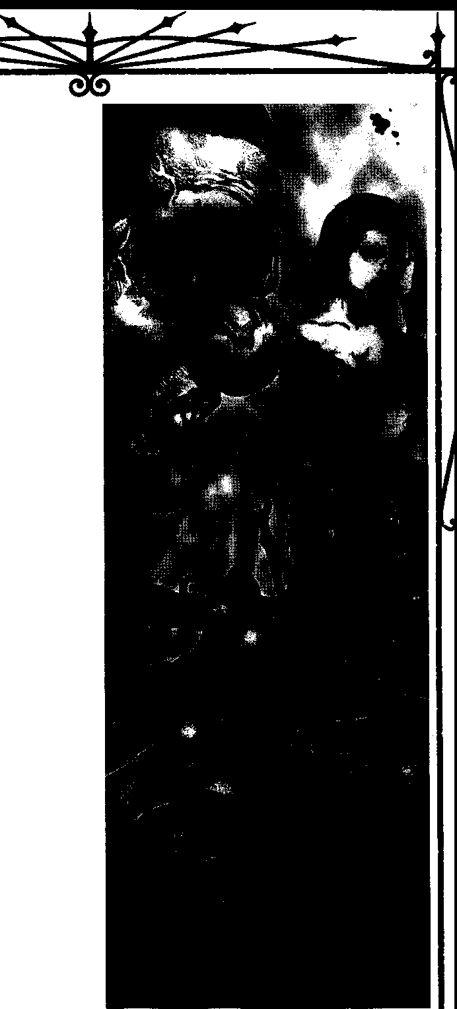

Minions may voluntarily undergo the ritual to assist houngans. Houngans may use Two Centimes to terrify unwilling victims.
LEVEL THREE RITUALS
NIGHTMARE DRUM',
Thehoungan using this ritual sends the dead to haunt the dreams of an enemy, using the wraiths to drive an opponent slowly insane. Once the ritual iscast, the houngan has no control over this power, save to stop it from continuing. The shape of the nightmares and the images that assault the target are not under the control of the houngan; they are under the control of the wraiths who actually do the haunting.
The houngan uses his own blood and a personal possession of the target's in this ritual. Once the item has been coated with blocxl, the houngan must burn the item, sending a ghostly icon of it to the Shadowlands both as an identifying badge and as a reward to the spirits who agree to haunt the target. While the item burns, the houngan (and assistants, if available) pound out a relentless beat on gigantic drums, headed in human skin. The drums are inaudible in this realm but thunderous in the underwater home of the dead. To
silence the deafening drums, the wraiths resignedly agree to negotiate with the houngan They promise to send nightmares to the victim for as long as the houngan demands, in return for a favor. Their request normally runs along the lines of passing a message to a living relative or exacting revenge against someone who
slighted them.
BLOOD DANCE'
TheBlood Dance allows a spirit to communicate with a living relative. They perform this ritual for people in exchange for money or favors.
The houngan must dance and chant for two hours, calling forth the right spirit and entreating all other ghosts to leave the area. (As usual, the power of chis ritual means nothing to Baron Samedi should he choose to manifest himself.) While dancing, the vampire pours colored sands and ocean salt on the ground in a precise pattern and then makes the link between the living person and the deceased associate. If successful, the wraith "appears" within the houngan'ssand-sigil and the living person can communicate with her for one hour. Failure means the spirit could not be contacted.
LEVEL FOUR RITUAL
BALEFUL DOLL
A baleful doll is a powerful figure that is linked directly to the spirit of the target. This doll must be

BLOOD MAQC: 5£.CRETS Of THAUMAlURGY

112

handcrafted, and is only finished when it has been painted with the vitae of the houngan and dressed in some article of clothing from the victim - which should be unwashed for a better connection. Once the doll has been cursed, the houngan can use it to cause physical damage to the target. If the doll is destroyed, the target suffers six dice of lethal damage. If the doll is injured (often with pins or other items), the victim takes six dice of bashing damage.
The houngan must craft the doll, using ritual chants throughout the process. This normally takes four to five hours. The player rollsStamina+ Crafts (difficulty 8) to succeed in this part of the ritual- a doll that does not resemble its victim is useless for the purposes of this ritual, though some houngans sell them as "authentic voodoo dolls" to tourists.

LEVEL FIVE RITUALS
DEADMAN'5HAND
Thehoungan takes a rag stained in the blood, sweat or tears of the intended victim. She takes a freshly severed human hand (which can come either from a corpse or a living "donor") and doses it around the rag. As the hand decomposes, so does the victim. His flesh bloats, turns gray and then green, then starts to slough off. The victim's brain remains fresh until the very end, so he can see the maggots writhe in the putrescent rack of meat that once was his healthy body.
The houngan makes the standard roll and spends two blood points for each point of Stamina possessed by the victim. The victim loses health levels according to the timetable below. Only the removal of the rag from the hand can stop the process. If this happens, health levels return, also according to the chart below.
Health Level Time Until Next Loss Bruised 12 hours
Hurt 12 hours
Injured Six hours
Wounded Three hours
Mauled One hour
Crippled 30 minutes
Incapacitated 12 hours
Mortal characters whosuffer more than 12 hours of incapacitation die, while Kindred who remain Inca­ pacitated for more than 12 hours succumb to torpor.

SETITE SORCERY
Followers of Set require no lengthyhistory lesson or abstruse discourse on theory to understand where their magic comes from. It comes from their god, Set. They
use magic to do asSet demands, addicting, seducing and degrading the world. Set made the rites for the use of his followers. What more needs to be asked?
Despite their professed disinterest in the origins and mechanics of their magic, Setites do derive from their deity a magical practice with a long and interest­ ing history. In practice, it seems like rudimentary Necromancy or rough Thaumaturgy, yet it is not quite either. Setite sorcery is distinct. To understand it, one must first look at Set and his role in Egyptian mythology.

THE MYTH OF SET ANDOSIRIS
Setappears in ancient Egyptian myth as the ulti­ mate violator of the Life Principle as incarnated by Osiris, king of gods and embodiment of the fertility of the Nile. The wealth and prosperity of Egyptian society depended on the natural irrigation provided by the annual floodings of the Nile's banks, making Osiris the central figure in the Egyptian pantheon. When an envious Set fell upon his brother Osiris and dismem­ bered him, the Nile ceased to flood, bringing famine to the people. Osiris' son, Horus, slew Set, allowing Isis, sister of both warring brothers and wife to Osiris, to find and piece together the scattered bits of her husband's corpse. Her action restored the fecundity of the land, even though Osiris himself now lacked the crucial component of a male fertility deity. His phallus, having been eaten by fish, could not be restored to his body. Unable to continue in hisold role, Osiris became god of the underworld. As overseer of the fabled Western Lands, the abundant afterlife of Egyptian belief, he presided over the souls of the dead. He gave a part of his essence to each of Egypt's kings, the pharaohs, who became divine and took over his fertility duties.
Osiris was not the only figure in the story whose death forced a change of roles. Set found himself in the darkness, where he vowed eternal revenge against Osiris. In disguise, he crept into Osiris' new kingdom, the Western lands, in search of information that would allow him to continue the war against his brother. He would wage this battle on two fronts, against Osiris'
former kingdom and his new one. He would people the land of the living with undead progeny, continuing his primal struggle against everything that was alive and vital. Also, he would teach his new followers to steal power from the dwellers in the Western lands, making a lie of Osiris' promises of eternal life.
A tiny minority of Setites immerse themselves in non-Egyptian mythologies, finding analogues to the story of Set and Osiris in the primal battles between rival gods featured in many origin stories. For example, a trio of Minnesota Setites who use neo Nazi pagan




llDRICHSomES



bikers as minions took Loki's slaying ofBaldur in the Norse legends as the basis for their adaptation of Setite magic.
RAIDING THE WESTERN LANDS
Themagic of the ancient Egyptians revolved to a great extent around preparations for the afterlife. Life in Egypt served asa mere prelude to an eternity of comfort and pleasure in the Western Lands, at least for those Egyptians with the wherewithal to ensure that their bodies would be properly mummified and entombed in accordance with the precise instructions provided in
the magical tome called The Book of Coming Forth by
Day. (Today it appears on the shelves of any well stocked bookstore under the title The Egyptian Book of the Dead.) Wealthy citizens, most especially pharaohs
and members of their couns, spent much of their time and resources securing suitably impressive tombs for themselves. They stocked their burial chambers with everything a soul would require for life in the Western Lands. They piled these rooms high with jewels, fumi
cure, perfumes, clothing andother luxury goods. In later eras, they filled them with usht:abis, miniature statues representing the servants who would serve them for eternity. AU of the appurtenances of the tombs now
seen in Egyptology departments of the world's muse urns, from gold sarcophagi to canopic jars containing the preserved viscera of the deceased, were essential to the successful journey to the Western Lands.
Set's sorcery operates by blasphemously subverting the magic handed down by Osiris. He wrote his own book of death magic, The Book of Going Farth b:, Nigh which teaches his followers to drain energy from souls residing in the Western Lands. In order to do so, they must seek out the tombs of freshly dead individuals
buried in accordance with the rites of The Book of
Coming Farthby Day.Theyexhume the corpses, stealing the canopic jars and as much of the other symbols of wealth and comfort found in the tombs as theycan carry back to their lairs. Set's followers then dissect the mummy, splaying it out and pinning it down according to Set's exacting specifications. They reposition the canopic jars, inverting the four cardinal directions in which they are supposed to be arranged.
The Book of Going Farthb:,Night claims that thesoul of the desecrated mummy, previously comfortable and resplendent in the mansions of the Western Land, suffers a seizure and withers away into a state of unceas ing torment. The afflicted soul writhes in pain and shrieks unintelligibly. Its condition strikes terror into the breasts of hiscompanions in the Western Land, and
reminds Osiris that the Lord of the Dead is indeed more powerful than himself.
For pleasing his god in this way, the sorcerer gains a material benefit. As long as his captured mummy remains in the mystical pattern of desecration, he draws mystical energy from it, which he can use to fuel his other magical sendings. Ancient Setites zealously guard the secret tombs containing their appropriated mum mies. Modem initiates face a challenge in securing victims of their own: The religion Set's magic bias phemes is no longer extant. Original mummies lie under glass in museums, where their absence would be too easily missed, or remain hidden under the Egyptian sands, eluding Setites and Egyptologists alike. Setite leaders maintain contacts in the Egyptian antiquities ministry in hopes of diverting ill-publicized finds to favored neonates, but demand nevertheless outstrips supply. The troublesome rarity ofsuitable original mum mies forces them to seek modem substitutes.
Most Setites believe that any mortal who sees to it that hisfinal resting place serves as a glorious reflection of his achievements in life ends up in the Westem Lands, never mind his intended post-deathdestination. Although not asefficacious asacorpse buried according
to the full specificationsof The Book ofComing Forth by
Day, the remains of these accidental travelers to the Western Lands can be used as Setite magical foci. Setitesscour obituary pagesof the richand celebrated in search of candidates for tomb robbing. They look for elaborate crypts, monuments, and the burial of items of wealth. A well-heeled, flamboyantTexanwhoarranged to be buried in her red Ferrari proved to be a rich source of energy for her Setite graverobber. The elements of an ostentatious self memorial needn't all be found at the gravesite: Individuals who endow schools, museums or libraries to commemorate their accomplishments and remind others of the wealth may also wind up in the Western Lands.
A recently incorporated business in California charges a handsome fee to bury the dead in a simulated Egyptian style. The deceased rests in a sarcophagus in a pyramidal tomb, adorned with asolid gold death mask, after having undergone a process combining ancient mummification rituals with freeze-drying technology. The company's marketing material targets both eccentric status-seekersand members of the New Age movement. Needless to say, the company's shareholders are all Setites, and the bodies don't stay in those pyramidal tombs for long.
Other modem attempts to elude the Grim Reaper also provide raw material for Setite sorcerers. About a sixth of the frozen corpses occupying the storage facili-


8i.ooo M.lcz, Su:ms o, THAIIM,\nJ<Y



ties of cryogenics labs belong to individuals unexpect•
edly spending eternity at Osiris' side. The rest of them are useless. In youngSetite jargon, a useful cyrogenically frozen corpse is referred to as a "cherry Popsicle."
Although the Setites believe in the literal reality of the Western Lands, other Kindred familiar with their practices think otherwise. Their magic might be pow­ ered by the intensity of their faith alone - even if that faith is utterly misplaced - or by some other force. A few bold Giovanni Necromancers reckon that Set's Western Lands are nothing more than some undistin­ guished backwater of the Underworld.

5ETITE 5ENDING5
Once the sorcerer has his focus in place, he's ready co work Set's magic. The serpent deity created his sorcerous sendings to subject all manifestations of the Life Principle to the forces of decay, degradation, disor­ ganization, entropy and chaos. Things that are strong, vital and puremust be weakened, drainedand adulterated. The means by which sorcerers evoke this magic stems from ancient Egyptian practice. Favored magical
processes include the writing ofhieroglyphs, the formu­ lation and application of perfumes and unguents, and the cursing of enemies with the aid of canopic jars.
Every society that learned to represent spoken language in written form at one time regarded that process as magic. Every magical tradition arising from such a society teaches that words contain inherent power. Set's sorcerers take this pronouncement one step further by claiming that the hieroglyphic language of the ancient Egyptians is more powerful than any other. They make this claim because hieroglyphs are pictographic - that is, the word for something is also a drawing of that thing. Thus the connection between the word and the thing that it represents is stronger in a pictographic script than in a phonetic one, in which letters represent sounds which are strung together to form words. Non-pictographic languages are abstract, but the ancient hieroglyphs are concrete, and therefore contain the essence of that which is represented. Many Setite paths and rituals include the transcription of formulae from The Book of Going Forth by Night in hieroglyphic form. The power of a sending increases with the complexity of the process and the permanence of the result. Faithfulness to original methods of writing also matters. Thus it is good to write a formula in wet clay with a stylus, because it will harden into a nearly indestructible tablet, but better still to chisel it into solid stone in imitation of the bas-relief seenon somany ancient Egyptian monuments and tomb walls. Pen and
ink technique on papyrus still provides some additional benefit, but hieroglyphs scrawled in ball-point on the back of a cocktail napkin at a Kindred fete lessen the sorcerer's chances of success.
Salves and perfumes serve as another medium for the delivery of magical effects. They gamer results in situations where the sorcerer expects co gain the oppor­ tunity to apply these potent substances to his target. Traditional Egyptian magicians used these substances to heal the body and mind. Setite sorcerers use them to corrode flesh and confuse the senses. They create a particularly mind-warping variant of the fashionable drug MDMA byadding an unguent derived from hyena bladders to the chemical recipe. They've also expanded the use of these substances to non-living targets; they may create unguents to bum away stone or corrode a computer's hard drive. One substance moves like a slug, slowly covering an object's surface. It then crawls away into a dark comer co form itself into a perfect, albeit hollow, replica of the object.
Canopic jarsprovide the third cornerstone of Setite sorcery. These are the clay vessels used in tombs to store the internal organs of the deceased. Set taught his followers how to expand their use to the living. Tradi­ tional practice employed four canopic jars, each corresponding to a direction, a deity and an organ or organs of the body. The south jar contained the deceased's stomach and large intestines, and drew asso­ ciation with the human-looking deity Amset. The north jar, dedicated to the baboon god Hapi, held the small intestines. Under the protection ofT uamutef the jackal, the east jar kept the heart and lungs. Khebsemuf the hawk watched over the west jar and its liver and gallbladder. When at all possible, Setite sorcerers secure tissue samples from these organs and place them in the appropriate jars, in order to gain power over the tissue donors. For this reason, some Setites work as lab tech­ nicians, orderlies or medical waste disposal specialists in hospitals; others simply bribe hospital personnel to provide them with the desired samples.

SETITE PATHS
Setite sorcery is unlike normal Thaumaturgy, in that its paths don't necessarily require inherent vitae expenditure or Willpower rolls. The power for these paths usually comes from the Western Lands, not from the sorcerer herself. In fact, these paths are more like closed-ended Disciplines than more traditional thaumaturgical paths, though they are finite and de pend on the larger theory of Setite sorcery.

I.tm:tt SOl([R]ES



THE SNAHE INSIDE
Setites love debasement of all kinds, but have developed a special taste for the self-destruction of others. Although the modem concept of addiction existsfarfrom the ancient Egyptian worldview, tonight's Setites confidently believe that their god would ap­ prove. Even ifhe doesn't care for their favorite pursuit, they're not about to stop. After all, it's habit-forming.
- FIRST TASTE
TheSetite uses this power while his target is con­ ductingsome minor, repetitive action.The power makes him unconsciously associate his action with pleasure, so he'll want to do it again. And again. And again. Cre­ ative-minded Setites can addict their victims to thoroughly bizarre substances or behaviors.
System: The player rolls Manipulation + Seduc­ tion against adifficulty equal to the subject's Willpower. The number of successes determines the strength of the induced compulsion. Whenever the target sees another chance to repeat the triggering behavior, he must make a Willpower roll (difficulty equals the Setite's Will­ power) to stop himself from doing so. The victim loses his compulsion entirely if he scores five successes while attempting to resist.
- • CROSS-ADDICTION
The Setite temporarily changes the focus of an addict or compulsive's dependency to a substance or behavior of her own choosing. For example, a cocaine addict could be made to crave the act of sex while on the rush, or a compulsive gambler may become a kleptoma­ niac as well.
System: While the Setite is in the victim's com• pany, the player rolls Manipulation + Seduction (difficulty equals the target's Willpower.) If successful, the target switches fixations for a number of scenes equal to the Setite's successes. By spending a blood point, the vampire can extend the period for the same number of scenes.
- • • THE_JONF'5
The Setite reinforces a victim's preexisting addic­ tion orcompulsion, so that he'll set aside all of his moral impulses and ethical beliefs to satisfy his craving.
System: While the Setite is in the presence of the target, the player rollsManipulation+ Seduction against adifficulty equal to the target's Willpower and spends a blood point. If successful, any qualms the victim might have about removing the barriers to the satisfaction of her cravings melt away - she may not even spend Willpower points to overcome the addiction, and she'll gladly leave heroffice during the middle of work to score
a hit. The effect lasts for one scene per blood point spent.
••••FATAL COMpULSION
TheSetite twists a victim's dependency, turning it into a literal hunger. If the subject doesn't satisfy his addiction, he starves to death.
System: The Setite mus be in the target's presence, and the player rolls Manipulation + Seduction against adifficulty equal to the target's Willpower and spends 3 blood points. Whenever she goes for three consecutive nights without indulging her addiction or compulsion, the subject suffers one health level of unsoakable lethal damage. The only way to regainhealth levels lost in this way is to satisfy the compulsion; the character recovers allof them immediately and the power's influence ends.

PATHOFTHEDRYNILE
When the son of Osiris killed Set, the snake god vowed that he would take his revenge by working to destroyeverything that his brother hadheld dear in life. Like the god they from which they take inspiration, practitioners of this path swear to destroy everything that makes a society work. Some accept this task as the price of the power Set grants them. Others revel in it, as they seek their own revenge against an uncaring uni­ verse. The Path of the Dry Nile serves as their greatest weapon in this crusade.
Unless otherwise stated, each power requires the Setite to place a faience (blue-glazed earthenware) amulet in the personal effects or dwelling of a target individual. The magic lasts until the individual destroys or otherwise gets rid of the amulet. However, it may do permanent harm while active. A husband who leaves his wife under the influence of Love Dies, for example, won't necessarily be able to win her forgiveness after he discards the amulet and comes to his senses.
- BEAUTY FADES
TheSetite causes a work of art, such as a painting, sculpture, novel, film or live performance, to be per­ ceived by its audience as repellent, ugly, badly executed and cruelly nihilistic. Using the power on a work of arc that already displays one or more of these qualities is redundant.
System: The Setite rolls Wits + Manipulation (difficulty 3-9, at Storyteller's discretion: a sitcom episode rates a3; the Mona Lisa, a 9.) The Setite must be in the presence of the work when he uses the power.If multiple copies of a work exist, only the one(s) in her presence is affected. For example, characters watching a televi­ sion broadcast with her see it as repulsive, while viewers in other households perceive it to be nothing out of the

111.00J SECmsOfTHAU'Mru



ordinary. The effect lasts for the length of time required to experience the work, or for one scene, whichever is greater. This power doesn't require the amulet de­ scribed above.
  - • TRU',T WITHER5
Thevictim begins to suspect that aspecified, trusted ally or associate intends to betray him. The victim's
The duration of this power varies by the number of successes the Setite acquired. It may be cured through therapy, drugs, etc., before this time period, however, should the victim seek help.
One success One night
Two successes One week Three successes One month

delusion escalatesfrom mild unease to wild-eyed paranoia.
System: The Setite'splayerrolls Wits+ Manipula­ tion against the target's Willpower and spends a blood
Four successes Five successes
One year Permanent

point.The full process takes nine weeks minus one week per success scored. The subject may resist on a successful Willpower roll if he suspects that something outside may be influencing him (Storytellers, use your best judgment) by accumulating more successes than weeks have passed in the character's decline.
••• LovEDIE5
TheSetite suppresses all feelings oflove felt by the victim toward a specified secondary target. The first victim feels nothing but emptiness and confusion when he sees or thinks about the second. Love Dies counters romantic, platonic and familial love.
System: The Setite must be in the presence of her subject to initiate this power. The player rolls Wits + Manipulation against the target's Willpower andspends two blood points. Thereafter, the subject's emotional attachment -which must have been love in origin - withers over the course of the next few nights. This power does not affect blood bonds. Love Dies ends after a number of months equal to the Setite's Willpower at the time it is used.
  - • • • Hope D1550L ve5
TheSetite's victim subject can't shake the absolute conviction that aspecified goal he meant toaccomplish can under no circumstances be achieved. He rapidly grows disheartened and indolent.
System: The Setite must be in the presence of the subject at the time he invokes this power. The player rolls Wits + Manipulation against the target's Will­ power and spends three blood points. If the roll is successful, the subject sinks into a deep depression over the course of one day or night, and becomes distinctly morose. While in this state, a character may only have a number of dice equal to her Self-Control Virtue available for dice pools. If she wishes to use her full dice pool, she must spend a Willpower point to undertake that action. Although this power is unlikely to drive a character to suicidal depression, a character already predisposed toward that end may find the urge more compelling.
- • • • • THRONE5 CRUMBLE
TheSetite selects an individual and causes him to reexamine his loyalty to an authority figure. No matter why the target followed his leader- admiration, ideo­ logical fervor, fear, greed or simple ambivalence -he now bitterly rejects his allegiance. Whether the victim actively works against the former object of his loyalty, or simply drops out of the picture, remains his choice.
System: The Serice must see his subject to initiate this power. The player rolls Wits+ Manipulation (dif, ficulty of the target's Willpower) and spends three blood points. If the roll is successful, the character acquires an active antipathy for some leadership figure who affects his life - a manager, a vicar, a king, a president, his father - and reacts in order with his
Nature against that figure. This will not always result in physical conflict; a Conformist may well "play along" grudgingly with the authority figure, but he might seek the company of others who oppose the leader, whereas aRoguemaymakeagrandshowofrebellionagainsttheleadcr.

SETITE RITUALS
Setite rituals usurp power from the Western Lands, or from its ruling deity, Osiris. They provide a focus the Setite sorcerer can draw upon to work the magic of his path, or to strengthen his hand in the performance of otherwise mundane tasks.
System: The player rolls Intelligence + Occult (difficulty is three + level of the ritual, maximum 9). Success brings the result given in the description of the ritual; a failure means that nothing happens. A botch cancels all currently active ritual or path effects, as disfavor in the Western Lands cuts off a sorcerer from their effects.

LEVEL ONE RITUALS
MILl<OF5ET
This entry is a catch-all for a range of rituals too numerous to mention, though many Setites have their own names for concoctions created in this fashion. In



each, the Setite creates a salve or unguent with magical properties. The exact details of the ritual and ingredi­ ents of the salve vary depending on the desired effect.
Each effect must be learned as a separate ritual. When he wants his character to gain a new ritual, the player specifies a desired effect; the Storyteller deter• mines its level, according to her judgment of the unguent's effectiveness as compared to other ritual effects. She should rule out any effect that too closely resembles an existing path or ritual from any tradition, unless the effect is a common one already available to a number of Disciplines. Effects must change their targets for the worse, or alter them so that they serve a new purpose. It takes one week per level to produce a single dose of salve or unguent. It stays potent for a number of weeks equal to the player's successes, and then becomes useless.
Here are some common manifestations of the Milk of Set.
LEVEL TwoRITUALS
OpENINGTHl: 0ATl:
This ritual prepares a corpse so that it becomes a focus for the Setite's magic. If the corpse is not already
mummified according to ancient Egyptian tradition, it must undergo the procedure before the ritual begins. This process alone can takeseveral nights, and is usually performed by a coven of Setite priests and sorcerers.
Once the body is prepared, the ritualise begins the ceremony by verbally recounting the victory of Set over Osiris, and informing the corpse of Set's subsequent penetration of the Western Lands and the powerless• ness of Osiris to stop his progress. He arranges the canopic jars in reversed order, placing the jar that's supposed to be positioned to the west of the body to its east, andsoon. The ritualise then saws open the corpse's chest cavity and breaks open the ribcage. He severs the corpse's spine and drills dozens of hooks into the corpse. Into the hooks he threads catgut strings, which he then attaches to a metal frame around the mummy. The sorcerer pulls the strings tight, forcing the body into a
tortured position. The ritual takes12 hours to complete.
The Storyteller assigns the corpse a rating from O co 5,showing the degree towhich itsfuneral arrangements satisfied the requirements of The Egyptian Book of the Dead. Zero represents no similarity whatsoever -which will most often be the case- and 5 signals the greatest adherence to those rituals possible in modem times. The Storyteller keeps his value secret until the ritual's

Effect
Add to gas tank of vehicle, so that itgoeswhereSetite wants, not where driver steers it

Alter a lock so that it con­ forms to a key the Setite owns
Bum through steel or concrete

Make drug more addictive

Make hollow replica of object coated in salve

Melt flesh on contact

Salve slithers along the ground in sluglike manner, following trail of specified individual

Seek out a computer and maliciously alter contents of its hard drive.
Level
3

1

2

1
Varies by object size

1 per two health levels of damage dealt

2

1
successful completion.
A successful Setite now possesses a means of si­ phoningenergy from the Western Lands. He may at any time increase his blood or Willpower pools bya number of points equal to the rating the Storyteller assigned the mummy. After the passage of a number of hours equal to his successes on the ritual, he loses the points. He may do this once per night.
If anyone destroys the corpse or unstrings it from the frame, the Setite loses asumof blood and Willpower points (distributed by the Storyteller) equal to twice his mummy's rating.

LEVEL THREE RITUAL
PRl:PARl: CANOpICjAR'3
TheSetite takes bodily tissues of a desired victim and places them in the four canopic jars used in ancient Egyptian funerary practice. He inverts the ritual de­ signed to ensure speedy passage co the Western Lands, gaining advantage over the chosen victim. The jarsand thek a.ssodared tissue types are described fully on page 115.
Samples of other tissues can be used, though they are not so potent. The Setite can still direct a working against a target even ifhe lacks the requisite bitsof flesh; he can use an object stolen from the victim that sym­ bolically resonates with thedesired organ.The remaining



81.0ooM.\Q:: S!om aJHA1NA100



bits of a meal half-eaten by the target work as substitute contents of south or north jars. Heart pills and asthma inhalers - even breath mints and syringes - make acceptable substitutes for the contents of the east jar. Drugs or alcohol once in the possession of the target can represent the liver and gall bladder in a jar of the west. The ritual cakes four hours co perform. Once com­ pleted, the Setite can at any time interfere with any
action performed by the victim, provided he is some­ how aware of the target's current activities. Examples of interference include making the victim miss a bus or plane, lose her wallet, become the subject of a random mugging, and any number of other significant yet indi­ rect effects. The Setite may interfere with a number of actions each night equal to the number of successes scored on the ritual roll. He may do this until the jars are moved or destroyed.
LEVEL FOUR RITUAL
DI5MFMBFRMENT OF O5IRl5
TheSetite ritually dismembers the captured leader of a group or organization, starting with the limbs and finishing with the penis. (The ritual works only on male victims.) At the conclusion of the ritual, the Setite drops the phallus into a tank full of fish. It only works if the fish devour the severed organ.
The organization headed by the victim suffers a serious calamity, as determined by the Storyteller. A corporation might lose half of its stock value overnight, a military unit could fall in battle, or a religious order might experience mass defections.
The ritual takes six hours to complete.
LEVEL FIVE RITUAL
DJ',Ml:MBERINGTHF Goo
TheSetite removes from a canopic jar a tissue sample taken from the chosen victim; the sample must have steeped in the urine of a jackal, hyena or other scavenging predator for at least 24 hours. She brews an unguent in which the tissue sample, vitae and papyrus are ingredients, then covers her genitals with this un­ guent. The Setite completes the ritual by coming into skin contact with the victim before the next sunrise.
The victim may resist the ritual on a Willpower roll (difficulty 9) ifhe accumulates more successes than the Setite had on the ritual roll. If the ritual succeeds, the victim loses both a number of Willpower points and a number of blood points equal to twice the caster's number of successes. Further, the victim can't refresh either pool for one night. Note that a significant blood loss (3 or more points) may very well kill a mortal, or at least require medical attention.
[LDP:lCH SORWJES



ASSAMITE SORCERY
Thedistant viziers of the Assamite clan survey the fresh carnage wrought by their juniors with intoxicated detachment. They have withdrawn to Mount Alamut to pursue the mystical revelations provoked by their exposure to kalif. Kali[derives from the leaves and resins of a plant grown through sorcerous means; its con­ sciousness-alteringproperties make it.s mundane cousin, the cannabis plant, seem tame by comparison. Because vampire blood doesn't circulate, the viziers must go to unusual lengths to enjoy the effects of their favored drug. They ply mortal minions with the smoke of the drug, and then drink their blood, flooding their circula­ tory systems with the desired intoxicants. Viziers find no shortage of willing minions eager to spend the rest of their lives puffing the all-powerful weed. The users don't care that prolonged use shortens their lives by decades. In fact, some Assamites have hinted that a few pre-Embrace apprenticeships to the clan involve serv• ing as vessels for the kalif-sorcerers.

ROOTS
Assamite sorcerers regard themselves asabove petty concerns of cultural loyalty or purity of tradition. As human creations, magical traditions warrant no more respect than any other potentially useful invention. They should and must be adapted to suit the viziers' goals. Still, their experience and scholarship remains largely limited to the ancient traditions of the Middle East.Their efforts to expand theirsyncretic approach to incorporate useful techniques from cultures further afield has mired itself in the usual slowness of thought that afflicts vampires when they attempt to innovate. Only three traditions trulyfeedAssamite practice in the modem nights.
HIGH ANDLow MAGICS OF MESOPOTAMIA
The high magic of Mesopotamia, wielded by Babylonian priests and priest-kings, concerned itself with the maintenance of agricultural fertility and a hierarchical social order. These two things were inter­ connected; the specialized roles of many members of Babylonian society wouldn't have been possible with­ out abundant crops. In the primal Mesopotamian myth, the god-king Marduk faces Tiamat, Dragon of Chaos, and is slain, but then achieves resurrection and defeats the dragon, returning order and fertility to the land. Mortal kings performed ceremonies to recount the deeds of Marduk and share his power. Each year, the holy king would accept a blow in the face from a priest; if the blow brought tears, fertility was assured. Further fertility rites followed, including an annual wedding to
a sacred priestess representing the goddess of female potency. Assamites now repeat the forms of these rituals to their ownends. The fearsome ritual of diablerie, Rite of Marduk Slain and Risen, parodies these ancient forms-here, thetearsshed by rhe stricken high priest are tears of blood, and they signal doom for the victim.
Lesser Mesopotamian magics included divination, which detennined auspicious and inauspicious days for action using a lunar calendar and an astrological ephem- eris predicting the cyclic fortunes of the subsequent 473,000 years. Magicians interpreted dreams, and per­ fanned haruspications, auguries read in the spilled entrails of slaughtered sheep. The common people suffered from the ever-present fear of ghosts and de­ mons; wizard-priests warded off such malign influence byconsulting exorcists and donning protective amulets and talismans. Amulets were ready-made magical ob­ jects designed to fend off common curses, whereas magicians constructed talismans asone-time aids in the
perfonnance of specific magical feats. Actions that upset the social order attracted not only bad luck, but the attention of malign supernatural creatures who dwelt in the desert, in graveyards and in comers. Black magicians harmed their victims through curses, which could be performed from a distance. Spittle, a bodily substance considered more potent than blood, powered their curses. They also laid curses by fashioning an image of the victim and then destroying it.
PERSIA: RITES OF MITHRA
In ancient Persia, early followers of the sun-god, Mithra, communed with their deity through rites of ritual intoxication. Priests called magi promulgated his worship, giving usthe root for the word "magic." Persian religion underwent a revolution in the seventh century B.C., when the prophet Zoroaster (sometimes referred to as Zarathrustra) revealed, in the sacred text Zend­ Avesr.a, that the world's many conflicts were but a manifestation of a cosmic struggle between the forces of good and evil. The supreme deity Ahura Mazda headed the armiesof good; the destructive god Ahriman led the minions of evil. Zoroaster revealed that Mithra was Ahura Mazda's son, and incorporated him into ceremo• nies in which ritualises achieved ecstatic communion with the divine by drinking the fermented juice of the
haoma plant. As Mithras, the sun god continued to
attract the worship of the magically minded, and in late Roman times enjoyed a resurgence of worship asa pagan alternative to Christ. Roman cultists, including many soldiers and the Emperor Julian, added bull sacrifice to the ecstatic ceremonies; the intended beneficiary of Mithras' favor sat in a trench and allowed the blood of the slaughtered bull to run down over his head and

lli.oooMloc, StoosOITHAll\lAru"11



shoulders. Several factions of vampires among the Ro­ man ruling class promoted his worship - Mithras' hunger for blood made him one sun god they could enthusiastically support. They also favored Mithras in the hope that his popularity might stem the growth of the troubling thing called faith; his worship was con­ ducted through experience, not belief. They lost the gamble, and Mithras was forgotten - except by the Assamites, whofound elements worthcopyingin hisrites.

FUSION OF TRADITIONS
TheAssamite viziers took the ecstatic Persian rites of haoma as the basis of their magic, replacing its fermented beverage with the stronger smokeofthekalif They spend months at a time in drug-assisted trance; if they went out hunting themselves, their entire program of inquiry could bestopped or even reversed. The viziers rely on their juniors to bring them the blood they still need to survive, and they understand that they must offersomething ofgreat value in returnfora service they so thoroughly depend on. Accordingly, they've stolen precious time from their pure mystical inquiries to develop magical means of aiding their clanmates with­ out leaving the confines of their mountain retreat. The viziers combine the Mesopotamian 473,000-year calen­ dar of augury and practice of entrails-reading with
Arabic kinanah to pick ideally auspicious moments for the staging of attacks. They use shir to cloak those who feed them with the concealment abilities of mighty
djinn. With blood-spittle, with broken effigies, and with the names of ghosts and demons, they curse the targets of a hunt. They draw on alchemy to invest their incantations in potions and amulets, so that they can be triggered when needed. In a parody of the highest rites of Mithras, they strengthen favored hunters through blood baptism. The viziers twist the fertility rites of old Babylon to infuse the entire clan with luck and power, a use of Mesopotamia's high magic which carries with it a useful side effect: it binds all who benefit from it into a social order, cementing the loyalty ofother Assamites to their viziers. For example, in a recent attempt to reestablish their influence over increasingly errant lessers, the viziers invited a cadre of the clan's most feared assassins to Mount Alamut to participate in the largely social ritual. While the long-term effects of the rite remain to be seen, it has enhanced cooperation between top assassins and viziers.
Although their ritesmay make reference to Marduk or Mithra and may draw upon the narratives of their myths as inspiration for the ritual actions, Assamites do not worship these entities; they do not revere gods - they seek to become them.

QUEST FOR GODHEAD
Drawing on traditions even further afield than the Middle Eastern ones to which they owe their magic, Assamite viziers believe they can one night transform themselves into entities of vast power, capable of re• making the world in their image. The secret of this transformative power can be found in a higher reality separated from the physical world by a barrier they call the veil. The viziers use kalif to pierce that veil.The kal,if plant must be watered in blood to reach its full halluci• natory potential; naturally, the blood of other vampires grows plants that achieve the greatest potency. The viziers therefore need quantities of blood tosustain their greenhouses in addition to the stocks they themselves feed on.
Each vizier's experience of the quest to pierce the veildiffers. They share their visions in hopes of agreeing on a base reality behind these varying perceptions. As they achieve consensus, their visions grow more similar. Many viziers now experience a vision as described below. Those who do not try to force their minds to perceive a vision that conforms to the accepted model.
The experience begins after ingesting large quanti­ ties ofkalifblood in the midst ofMithraic mystery rites. The individual first sees the false world's details-the tiles and columns of ritual chamber, the water pipes, the carpets and wall hangings- separate and dissolve into tiny pinpricks that eventually grow so small that noth­ ing is left to be seen. The celebrant sees nothing for a while. Then everything goes red. Finally a series of geometric forms, whirling spirals and bottomless cones that seem ready to swallow the visionary whole appears. The celebrant must walk into a spiral or fall into acone. Then he finds himself at the bottom of a staircase, leading upstairs to an archway. As he tries to ascend the stairway, he faces fierce opposition. Visions of his life assail him. First come negative visions: memories of secret shames, past wrongdoings and traumatic failures. He must dismiss these visions and focus only on the
stairway. If he succeeds, he can move up a step, then
another, and another. The task requires fierce concen­ tration. At some point, positive visions come: sensual experiences, recollections oflove and comfort, feelings of power and mastery.
For centuries, the viziers treated this condition of blissful hallucination as the whole point of the experi­ ence. They lingered in a palace of pleasure, cooled by soft breezes, breathing ambrosial air, able to indulge any whim without consequence. They tasted vitae so sub­ lime that it made them tremble with pleasure. With the stunningly beautiful, perpetually willingservants of this


ELI>KliSom!s

paradisiacal realm, they experienced dimensions of erotic pleasure far removed from the gruntings and pantings and biological imperatives of mortal sexuality. These couplings seemed to bring the participant.s into direct contact with the divine.
As they spent more and more time in the explora­ tion of this realm, the viziers' grip on Assamite affairs slipped. Their indifference to nightly business trans­ formed them from iron-willed, attentive advisors to withdrawn and distant figures of little relevance to the average clan member.
Finally the viziers concluded that in the state of bliss lay a spiritual trap. Constant pleasure, no matter how intense, could only serve as adead end on the quest for true understanding. It drained the soul of energy, stole one's individual sense of purpose, and dulled the sharpness of the mind. There had to be more to their magic than this. That's when the viziers realized that the Station of Ultimate Rapture, as they dubbed it, hid something even more desirable: the way to become blood-gods.
The Station of Ultimate Rapture continues to interpose it.self enticingly in the vizier's path each time he tries to ascend the stairs toward the ultimate truth. Each vizier must struggle to resist its blandishment.s every time he enters into the ritual. These temptations present themselves more tenaciously than the negative visions experienced earlier in the vision; no vizier can put them aside consistently. If the mystic succeeds in pushing them away, he again faces an arduous journey up the stairs, as the number of steps seems to increase infinitely. lfhe does reach the top of the stairs, he parts the veil and looks beyond it....

READING WHAT THESHY
15 THINHING
Manipulation of distance stands as the hallmark of Assamite sorcery; the sorcerer grants benefits to hunters he may never have met face-to-face. He seeks out targets from thousands of miles away, providing infor­ mation on their weaknesses. The viziers see the 20th century, the era in which globalcommunicationsshrunk the world into a single confused and fractious commu­ nity, as the long-prophesiedgolden era of their kind.To their surprise and initial dismay, they've discovered a puzzling link between their long-sought state of tran­ scendental consciousness and the ultra-modem miasma of radio waves, satellite transmissions and television broadcasts that now wreathes the world. As they traverse upward through the many stairways to ecstatic, kalif­ fuelled bliss, they can tune their minds into CNN or tap
into data from the Global Positioning Satellite system. They call this process "reading what the sky is think­ ing." When the sorcerer sends curses to plague clan enemies on other continents, he now bounces his malign magic off the upper atmosphere, or piggybacks it on radio waves. At least, this is how their drug-altered minds now visualize the working of their magic. The sorcerer can listen in on a victim's cellular phone call, substitute the words of his interlocutor with a mislead­ ing message of his own, open a permanent window into the target's soul, or dispatch a djinn to ride those signals to their source and vex the enemy. One vizier recently tracked an elusive Setite with a price on his head by following his purchases of Egyptian antiquities on an Internet auction site.
Although most of the viziers now enthusiastically explore their newfound connection between height­ ened consciousness and the global communications grid, a few fear that their colleagues may be throwing away centuries of inquiry on a seductive distraction. Others see distraction as the least of their worries. They fear the implications of a growing sensation that the communicationsgrid they're soblithe!y involving them­ selves with possesses a transcendent consciousness of its own, one that is coalescing, with their unwitting help, into something much mightier than themselves. One vizier now lies restrained and gibbering in an Assamite private hospice in Beirut, after monitoring satellite transmissions while in a trance state. He concluded from them that the satellites were talking to one an­ other, and that itwasthe global communicationssystem that started and stopped the recent war in Kosovo.
Are theyunwittingly giving it the powers ofgodhead they mean to seize for themselves? Unfortunately for them, recent events within their clan leave them little choice but to step further along this dangerous path. Apprentice Assamites no longer tithe blood to their sires as a matter of course; out in the world, it's every hashishayin for himself. Viziers must now offer good value for the blood they receive on every transaction. Their increasingly demanding lessers insist on guaran­ tees, and aren't shy about dictating terms. Once they show that they candosomething useful, the viziers must keep doing it, or starve.

A55AMITE PATHS
Assamite sorcery paths, like mainstream Thaumaturgy, require the expenditure of one blood point and a Willpower roll, in which the difficulty equals the power's level + three. Failure indicates that




BLOOo MAac:SOCRrJS OFTHAUMATURGY



the effect does not come to be, while a botch costs the character a permanent Willpower point.
THE HUNTER'<;WINDS
The Assamites are known as the assassins of the
Kindred world for a reason. Their viziers provide them with ways co avoid detection that go above and beyond the vampiric Discipline of Obfuscate. Assamite magic can do more than merely blind a person to their pres• ence or confuse a target's senses: Those benefiting from the Path of the Hunter's Winds have learned to do many of the things for which the Nosferatu are infa­ mous, but in a more physical sense. Viziers bestow these gifts on "field" Assamites, making contact in person or
through the ritual Reach the Earth or through the use
of a talismanic stone created through the ritual Pebble From the Mountain. The subject holds the activation of the power in abeyance until he needs to trigger it; at any one time he can maintain a number of dormant effects equal co his current Willpower. The recipient does not learn if the vizier's magic was successful until he tries to activate the effect.
- SCENT OF DECEPTION
When this power is employed the recipient can mask or completely alter her scent. The original pur­ pose for this ability was to avoid the hunting dogs of nobles and crusaders, but it proves just as effective at throwing off any Lupines, ghouls or Gangrel who might be following coo closely for comfort.
System:Success indicates the Assamite can change or simply negate herscent, making trackingher far more difficult. Failure means nothinghappens, whilea botched roll actually amplifies her scent or makes it noticeably offensive.
- • CHAMELEON'5 SHIN
Thesubject can change the colorofhis skinand the texture as well. If resting against a tree with rough bark, the skin and clothing alike of the Assamite take on the same coloration - including any variations - and changes to mimic the form.
System: If successful, this power makes the subject is virtually impossible to see (+4 difficulty on all Perception rolls) so long as he remains stationary. Slight movements might be mistaken for the wind, but any sudden change in position negate the effects. The player muse roll Perception + Stealth (difficulty 6, or 9 if anyone is actively looking for him) if the character tries to change his environment, such as moving from
the tree-camouflage to that of a brick wall. While the texture of the skin changes, it remains skin: No in­ creases or decreases in the character's Stamina occur as
are,ult<ithissoo:erouspower.Thisability last,forooescene.
- • • UNA55UMINO pose
The subject uses this power to blend into virtually any crowd, no matter what size. Anyone seeking the character simply fails to see her, automatically assuming that the Vampire belongs there.
System: If successful, people simply do not notice the Assamite, no matter how hard they might be look• ing.Observers using technological meansofsurveillance, like video cameras, can still see him, though. This power lasts for one scene.
- • • • WHIFF OF l<ALIF
TheAssamite distom the perceptions of those around him, so that they experience a distractingly powerful feeling of intoxication. They may enjoy a pleasant hallucination,or may just stand there blissing out, not caring what the Assamite is up to.
System: Any character looking directly at the Assamite as the effect is activated must roll Wits + Alertness (difficulty 7) or face intoxication. Any obvi­ ous threat to a character activates his subconscious defense mechanisms and snaps him out of the kalif dream. Otherwise, this power, once activated, lasts for one hour foreverysuccessgarnered on the activation roll.
••••• GHosTBoov
The Assamite triggering this power can move through solid objects, without being seen or heard. For all intents and purposes, the Assamite becomes intan­ gible. The side effect of this power is that the Assamite cannot affect anything material around her any more than it can affect her.
System: This power require thTee blood points instead of the usual one. Once in the Ghost Body the subject cannot be seen, heard or touched. Despite the name, this power does not actually place the character within the realms of the dead, and docs not allow interaction with the ghostsfrom the Underworld. Some Assamites have reported seeing very strange things while in this form, however, and most are very cautious about attaining the Ghost Body. Once the character decides to affect the physical world again, she is once again visible andsolid. No other Disciplines work while
the Assamite uses this power- shemay not Dominate anyone, activate Celerity oreven useAwpex, ifshe hasit.

WIIIJl5omEs


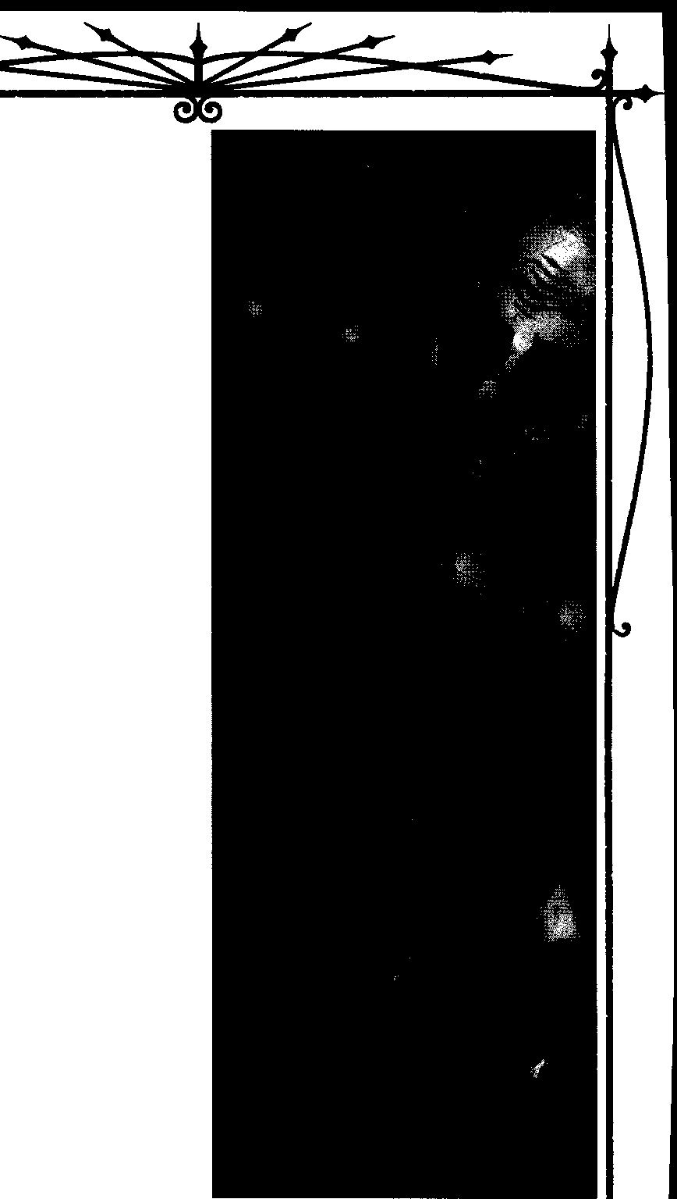
ASSAMITE RITUALS
Many Assamite rituals revolve around contact between the reclusive viziers and worldly assassins. The latter exchange vitae for magical services. Also, invok­ ing rituals requires one to ingest at least one point of vitae from a vessel under the influence of kalif, or to actively inhale large quantities of the smoke itself and consciously move it through one's body by forcing
blood to circulate.
System: The player rolls Intelligence + Occult (difficulty 3 + level of the ritual, maximum 9). Success brings the desired result; nothing happens in the event of failure.
Some effects last until the next inauspicious night, as set out by the 473,000-year Mesopotamian calendar. The Storyteller rolls a die for each night, as needed. Each time she rolls a 1, the night is inauspicious. Storytellers, keep track of these inauspicious nights on a scratch-paper calendar, to keep them consistent.

LEVEL ONE RITUALS
TOUCH THEeARTH
This ritual allows the vizier to contact another Assamite for the purpose of aiding him with further sorcerous effects.
Long in advance of the ritual, the vizier takes a stylus and writes, in ancient Mesopotamian script, on a small, still-wet, clay tablet, the name of a lesser-genera­ tion Assamite. Once hardened, the tablet is placed in an acid to weaken it again.
When he chooses to begin the ritual, the vizier uses chalk or paint to draw on the tiled floor of his ceremo­ nial chamber the stylized image of an eye, with white, pupil and iris. The eye must be bigenough so that a cat, dogor rodent can beplaced inside it. Using a mortar and pestle, the vizier reduces the tablet to powder. He mixes it into food, which he places in front of the animal.
When the animal has ingested the food, the vizier cuts its throat with a knife and waits until the pool of spilled blood has expanded in at least four places past the line denoting the white of the eye.
When the vizier speaks into the animal's ear, the Assamite whose name was written on the tablet hears his voice. When the vizier listens atthe animal's mouth, he can hear his target's voice.This works no matter how much distance separates vizier and target. The vizier may proceed to use any Assamite path or other ritual power to benefit the target. The vizier may also pass to the target any object small enough to fit in the palm of his hand.

BlooDMAac: SECmS OFTHAUMATURGY

PEBBLE FROM THEMOUNTAIN
Thevizier takes a stonefrom MountAlamut, places it in his mouth, and meditates for an hour. He soaks the stone in his own blood, then in the blood of another Assamite. He gives the stone to that Assamite while chanting an incantation naming himself and the sub­ ject as successors to Tiamat, Ahriman, and all the shaitaruofHelLTherirualtakesanhourandahalftoperfonn.
At any subsequent point, by placing the stone in her mouth and repeating the incantation, the other Assamite can initiate a mystical link between herself and the vizier identical to that created by Touch the Earth. She is not performing sorcery; the magic rests in the stone, which always works if the vizier's player made his initial roll.
LEVEL TwoRITUAL
1
GIFTOFMITHRA S 8ULL
Vizier and subject must beconnected by Touch the Earth or Pebble From the Mountain. The vizier places a small, sharp blade inside a wineskin or plasma bagand then withdraws it and passes it to the subject. The subject cuts an incision in her chest. Blood bubbles out of the incision but then vanishes, reappearing inside the vizier's waiting container. Through this method, the target may pay the vizier in vitae for his services.
The ritual takes one tum per blood point donated by the target.

LEVEL THREE RITUAL
AppROACH THEVEIL
Thevizier enters the transcendental state required to experience visions of the veil. He ingests kal:ifladen blood, bathes in the blood of a fresh-killed bull and meditates. He must first ward off a distracting cascade of unpleasant memories, then an even more tempting series of sensual pleasures. Then comes the opportunity for revelation.
The ritual takes eight hours. Although the vizier performs it for research purposes, seeking the secrets of apotheosis, a peek past the Veil of Truth does grant direct benefits. Subtract the number of successes on the roll to enact this ritual from the difficulty of the first path or ritual roll the Assamite's player makes after completion of the ritual. The vizier must take advan tage of the bonus before he loses his next blood point.

LEVEL FOUR RITUALS
RITE OF MAR DUHTRIUMPHANT
This ritual asserts the vizier's authority over a lesser clan member. The vizier ritually enacts the coronation
of Marduk, donning mask and robe. Other participants in the ritual, each of whom must be an Assamite of a higher generation than the vizier, take the role of various Mesopotamian deities; each kneels before the sorcerer and proclaims that his or her divinity is but an aspect of the 50 manifestations of Marduk. Everyone present opens a vein and bleeds into a bronze bowl. After the blood is mixed together, all drink from it.
The vizier may increase the difficulty of any action undertaken by an Assamite by the number of other participants in the ritual. He may apply this penalty only to actions that directly threaten his unlife or position (Storyteller'sdiscretion.) He may not increase difficulties above 9. The effect lasts until the next inauspicious night. The ritual requires one hour to complete, plus 20 minutes for each participant.
1
DIRECTING AHRIMAN S LANCE
Thevizier takes either an accurate image of a tatget individual, or a small object she once owned, and swallows it. He waits for an hour, then cuts (or has fellow viziers cut) the object out of his belly. Until the next inauspicious night, any Assamite in possession of the item or image improves her chances of killing the targeted individual.
The possessor of the ritualized item lowers the difficulties of all actions that bring her closer to killing the target individual (Storyteller's discretion) by the number of successes scored by the vizier. The ritual takes 2 hours to perform.

LEVEL FIVE RITUALS
RITE OF MARDUH SLAIN ANDRISEN
Thevizier makes contact with another Assamite. The beneficiary names a victim she intends to diablerize. The sorcerer then takes part in a group ceremony with at least three other participants who know the ritual. Donning robe and mask, he ritually enacts the myth of Marduk, taking the part of that god. The other partici­ pants alternately take the parts of Marduk's mother, Ea; his consort, Sarpanitu, and the chaos dragon, Tiamat. Tiamat "kills" Marduk, but Marduk "resurrects" himself and "slays" her, symbolically making her into the body of the world. Once this has been enacted, the primary ritualist must unflinchingly suffer a hard blow to the face from each of the other participants. The appear, ance of blood-tears in the ritualist's eyes signals the ritual's success.
If the beneficiary succeeds in diablerizing herspeci, fied target before the next sunrise, the victim's sire, all the sire's childer, all of the target's childer, and any vampire in blood bond with the victim share his final




EumiSotm!s



sensations as he perishes. Each of them loses one blood
point and three Willpower points, which goto the killer (though the character may not exceed her Trait maxi­ mums). If the killer's blood pool is full, the remainder goes to the vizier. Furthermore, all of these collateral targets suffer an effect chat lasts until the passing of 13 inauspicious nights: they lose one Willpower for every 10 minutes theyspend in the presence of the beneficiary or the vizier, as they suffer flashbacks to the original victim's demise.
1
5FEING WITH THE5HY 5 EYE5
Thevizier enters a trance state and concentrates on a subject individual. He must have on his person an accurate image of the target, or an object she once owned. He then sees a vision of the target, and in so doing learns her precise, current location, no matter where on earth she is. Viziers typically use this ritual at the behest of younger Assamites, locating victims for them in exchange for vitae.
LEVEL 5rx RITUAL
I
FROM MARDUH S THROAT
Thevizier creates an alchemical substitute for vampiric blood, allowing the drinker of sufficient quan­ tities to decrease her generation. The process converts mercury, molcen gold, a range of plant and animal proteins, and other exotic ingredients into vitae.
Each ritual, which takes eight hours, produces one fourth of a blood point. To decrease her generation, an Assamite must consume a number of points of this alchemical blood equal to the maximum blood point value of a vampire of the desired generation. (See the chart on Vampire: The Masquerade p. 139.) The consumer of the blood need not be the vizier who prepared the concoction. All of the blood for a given change in generation must be made by the same vizier, in the same laboratory. No more than one week may pass between one use of this ritual and the next for a single drop in generation, or all of the existing vitae­ elixir spoils.
When the full amount of blood is at hand, the Assamite tries to assimilate the blood into her body. (This is not part of a ritual.) She makes an extended Stamina roll (Difficulty 9), seeking a number of suc­ cesses equal to the blood points consumed. Failures don't stop the process, but they do deal 6 points oflethal damage apiece. Assimilation is so painful and distract­ ing that any attacks made against her during this time face a difficulty of only 2.

HOLDUNIC50RCERY
Long before the blood magics of the Tremere ap­ peared, the Tzimisce wielded the mystical artofKoldunic Sorcery. Unlike the arcane paths of Thaumaturgy, Koldunic Sorcery is a spiritual magic that manipulates the elements in nature. From the magically rich and diseased soil of their ancestral demesnes, the Tzimisce drew demonic power. Now, through the proper rites of
contrition and binding, a koldun can summon forth the
elemental correspondences that shape natural forces.
The specific ways of this spiritual magic were often taught to novice koldun based on their regional settings. For example, though the Ways of Spirit and Fire were universal, the Way of Wind was known only among koldun residing in the Carpathian Mountains. The Way of Water was predominantly practiced by koldun who made their havens near bodies of water like the Black Sea, the Plain Lakes and rivers of the Danube, Somes and Arges. The Way of Earth was common among koldun residing in the flatlands and plateaus of Eastern Europe.
During the time of Clan Tremere's birth, Koldunic Sorcery was at its height in practice. With the threat of the T remere and their blood magic, thissorcery became the weapon of choice for the koldun fighting to protect their lands. Bloody feuds between these two camps of sorcerers stained the Danube crimson and powerful magic defiled the land. As the Dark Ages passed, Koldunic Sorceryfaded as well, unpracticed andspoken of only in passing and half-truths.
In tonight's world, only afew, veryancient Tzimisce practice Koldunic Sorcery. These surviving koldun are extremely territorial, rarely surfacing long enough to make their presence known, and prefer to keep to themselves, surrounded by ruins of once-mighty castles and manses. With the mysterious disappearance of the Tremere antitribu, knowledge and philosophy of Koldunism is more frequently shared with anyone will­ ing to learn of its existence, and has begun to spread among the ranks of the Sabbat's youth. Some suspect
that enterprising Fiends have leaked a bit of their wisdom to the sect in order to keep the old ways in practice. More cynical Sabbat, though, believe that a clever Cainite or pack managed to steal a few secrets from a lax Tzimisce and passed them on to whoever wanted to learn.
System: Koldunic Sorcery consists of five elemen­ tal ways and several rituals, and is learned in a system similar to Thaumaturgy. A character's base Koldunic

BwooMAGIC: Su:Rrn Cf THAUMAlURCiY



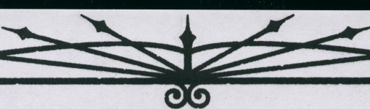
Sorcery Trait dictates how well he may learn the ways of the magic, and eachdot earned in the Discipline also earnsthe characteranotherdot in the wayof her choice. Obviously, this bonus dot may not beallocated to a way that would be rated higher than the character's knowl­ edge of Koldunic Sorcery. Kindred intent on learning Koldunic Sorcery must also study the unique Knowl­ edgeofKoldunism. Fora character to invoke the powers of Koldunic Sorcery, a player must spend a Willpower point, then make an appropriate Attribute (governed by the way in question) + Koldunism roll (difficulty 4 + the level of the power). These five types of Attribute rollsareCharisma for the WayofSpirit,Stamina for the WayofEarth, Perceptionfor the WayofWind, Witsfor the Way of Water and Manipulation for the Way of Fire.UnlikeThaumaturgy, there isno primary path that must be learned; any of Koldunic Sorcery's ways are accessible at the standard cost of paths, provided the koldun can find a teacher or suitable text.
Storytellers are advised that this is a rare form of spiritual magic, and thatcharacters are unlikely to have access to it unless they are a part of the Sabbat or otherwise have reason to research Koldunism. Players must keep in mind that Koldunic Sorcery has only just begun to circulate within the Sabbat; it is a certainty that a member of the Camarilla or of the independents isn't going to be searching out this art, if she is aware of it at all.
THEWAYOFEARTH
Ancient koldunhospodar rulersonceclaimed sover­ eignty over the lands of Eastern Europe, manipulating the magically rich chemozem - "black earth" - to invoke their power and instill fear in their boyars and peasants. Now, the young koldun of the Sabbat beckon the spirits of the Westernsoiland derive their powers of the Way of Earth from natural surroundings. When a koldun employs a power of this way, his eyes change color to walnut brown and his skin ripples with small patches of stone.
- SoIL SILHOUETTE
A koldun invoking this power has the ability to command dirt to rise up from the ground and crawl up the legs of an individual. The soil rises up very quickly and, as it passes above a victim's knees, renders him immobile.
System: Success on the activation roll causes the dirt anywhere withina 100-foot radius of the invoker to roil and crawl up a victim's legs; the dirt ends its ascent about halfway between the knees and hips. Unless the subjectcanscorefivesuccessesonaStrength + Survival roll (difficulty 6), he remains trapped in place by the

New HNOWLEDGE
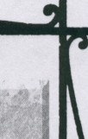
HOLOUNISM
This new Knowledge measures a Kindred's familiarity with the philosophies of Eastern Euro­ pean animism. A koldun's player rolls this Ability withone offive possible Attributes wheninvoking the power of the magic. Each level also bestows a more in-depthunderstanding of thisspiritual magic and the manipulation of the natural elements.
- Student: Knowledge of major spir its and placations.
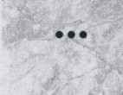

- • College: You know much of the old ways and are recognized as a koldun.

••••
Masters:Yourankamongthe most powerful of the present-night koldun.
Doctorate:The spiritsquakewhen you are angry.
- • • • • Scholar: A potent and eldritch master of the spirits of the land.
Possessed by: A few young Sabbat; Tzimisce (and old ones at that)
Specialties: Philosophy, Ritual, Lore, Rela­ tions with Spirits

Soil Silhouette for a number of turns equal to twice the successes the player scored on the activation roll.
- • UNEARTHLY5TAMINA
A koldun invoking this power temporarily borrows the earth's resilience, lending him stamina. Some elder T remereof EasternEurope reminisce on the frightening capacity for pain their rival koldun could withstand when invoking Unearthly Stamina. Sabbat koldun of­ ten use thispower to prove their mettle during the ritae. System: After spending a Willpower point and making a successful Stamina + Koldunism roll (diffi­ culty 6), the player may add two temporary Stamina dice when soaking damage. These can be included in soaking aggravated damage. This effect lasts for one
scene.
- • • SoILoFDEATH
By invoking Soil of Death, a koldun commands roots to risefrom the ground and draga target below the soil, incapacitatinghim. Once buried up to his neck, a victim finds it increasingly difficult to breathe as he feels the weight of the earth crushing his chest.

ELOROiSoRcwr.s



System: Roots issue forth from the ground and wrap themselves around the legs, ankles and waist of a
- success
- successes
One structure
Five structures

victim, pulling him underneath the earth. For every success a player scores on a Stamina + Koldunism roll (difficulty 7), the victim remains trapped underground for one cum. Mortals and ghouls will have a very difficult time breathing due to the prolonged pressure from compact earth, and must make a Stamina roll (difficulty 7) or suffer one level of lethal damage for every tum they spend entombed in the earth.
  - • • • ROOTOFVITALITY
Many healers believed that burying a person in the ground would allow the rich soil to purge him of his ailments. This power allows the koldun to draw any person into the ground up to the neck co heal grievous wounds.
System: With the expenditure of a Willpower point, the koldun commands the soil co pull a person down into the ground in order to heal her wounds. A character must remain underground for one tum per health level he heals. All damage a character suffers can heal in chismanner includingaggravatedwounds, though the injured party must spend a blood point per aggra­ vated wound level that hedesires co heal (assuming the wounded character may do so). During chis time of healing, the subject is helpless and unable to perform any ocher actions.
1
- successes A residential street
- successes Half a city block
- successes A full city block
THEWAYOFWIND
Asecond avenue ofKoldunic Sorcery, the Way of Wind was once manipulated by T zimisce lords to pro­ tect their Eastern European lands. Invoking these powers granted them the ability to control the element of crivat to suit theirwhims and master the air they once breathed in their mortal days. People of Eastern Europe, espe• cially in Romania, name these types of unnatural winds the koldun manipulate - people of the west call the windsAustru, or the Black Winds, while residents of the south name them the Great Winds or the baltaret. When a koldun invokes a power of this way, his eyes change color co sky blue and gusts of wind breeze all about him.
- WINDSOFGurr.,T
Ancient koldun hospodars invoked Winds of Guile as a means of ensuring loyalty in their boyars without the need of a blood bond. This power caused a wind to gust around these boyars that sounded co chem like whispering voices, telling of the horrors chat would befall them and their families should they betray their
wioode. These voices would slowly warp the minds of

••••• DRACULA SRESTLE5S50UL

Peasants whisper silent prayers to protect them­ selves from the unusual tremors that sometimes shake the Carpathian Mountains, which they believe co be the spirit of Dracula waking from centuries of slumber. In truth, this odd seismic activity is the result ofkoldun calling upon the dormant wrath of the blighted land. When invoking chis power, a koldun creates a large earth tremor capable of shaking the foundations of a city block.
System: With the expenditure of a Willpower point and a successful Stamina+ Koldunism roll (diffi­ culty 9), a player enables her character to cause the earth co shake violently. Each success she scores in• creases the radius of the quake; victims within the area of effect suffer 10 dice of lethal damage. Cars, RVs and small houses suffer substantial damage and, at the
these men, and only when this sorcery waned would they regain their coherence. Afterward, the boyars were so afraid of the consequences of betrayal that their loyalty to their master was unswerving. Ko/dun of the Sabbat enjoy invoking this power during ritae before feeding, reveling in the mixture of adrenaline in the blood of a vessel stricken with terror.
System: Witha successful Perception+ Koldunism roll (difficulty 5), a koldun invokes mystical winds that plague a victim. The target is convinced chat he hears voices whispering of his most evil deeds (Storytellers are encouraged co improvise on the content the whispers a victim hears). When in the presence of the koldun, targets lose two dots of Courage (ro a minimum of one). Each success the koldun's player scores increases the duration of this power.

Storyteller's discretion, may be destroyed altogether. Buildings three stories and higher, such as apartment complexes and office buildings may sustain some struc­ tural damage, but thissupernatural tremor is not strong enough to cause chem co crumble and fall. This tremor lases for one tum.
One success Two successes Three successes Four successes Five successes
One scene One night One week Two weeks One month

Bt..oooMAGr: SE.am OF THAUMA1URGY



  - • BITING W lNDS
The koldun creators of this power attempted to invoke a wind as chill as the air atop the Carpathian Fagrash Mountains. They noted the pain their victims endured as their bodies' temperatures dropped until the very blood froze in their veins. A koldun invoking this power had a much easier time of ridding his land of undesirables by plaguing them with bone,chillinggusts. Modem Sabbat koldun invoking this wind sometimes refer to its effect on victims as the "meat locker." A koldun invoking Biting Winds causes a very cold breeze to swirl around in an area of his choosing. As the wind increases in speed, the wind chill factor drops the temperature until anyone within the affected area find it too uncomfortable to remain.
System: After the player spends a Willpower point and rolls Perception + Koldunism (difficulty 6), the character summons forth a freezing cold wind. When Biting Winds first takes effect, a cool breeze blows in a 100,yard radius. Little by little, the winds gust faster and much colder. This continues until the wind blasts a stabbing chill difficult for anyone to tolerate. Those affected lose two dice from Dexterity dice pools and are reduced to half movement. Anyone attempting to enter this area must first spend a Willpower point and suffer a (soakable) level of bashing damage from the extreme cold.
•••WlND',OFLETHARGY
Although these winds do not induce immediate sleep in a victim, prolonged exposure to this supernatu­ ral gale causes extreme exhaustion and fatigued movement.Targets caught in Winds of Lethargy smell a bittersweet smoke in the air. Individuals also claim that the wind feels like many intangible hands persis­ tently rubbing their muscles to relaxation.
System: The player rolls Perception + Koldunism (difficulty 7) and spends a point of Willpower. If the roll is successful, the koldun creates a wind that induces extreme lethargy within a 200,foot radius, remaining for two turns per success he scores on the invocation roll. People caught in this gust of air must make a Stamina+ Survival roll (difficulty 8) or are reduced to halving all dice pools chat involve physical actions (actions such as breathing and blinking are innate and, therefore unaffected, though the Storyteller should emphasize their laboriousness). Additionally, this fa, tigue reduces the movement rate of its victims by half for one full scene.
    - • • • TRA VE'LlNG THEW INDS
Akoldun employing this power moves at incredible speeds by riding along the winds. The wivodes of nights
past often appeared in each of their boyars' homes and to the villages of their lands, instilling fear in the peasants and terrorizing them to fealty. Koldun under, taking these outings could travel to most, if not all of their boyars and villages in a single night's time. During the Dark Ages, peasants under the rule of akoldun rarely rebelled against their master, fearing a personal appear­ ance and, as a result, his swift punishing wrath. A koldun' s body becomes almost ethereal while he moves along the wind, disappearing into a blurry outline of his physical self and re-materializing in a similar fashion.
System: Akoldun journeys along the currents of the wind after the player spends a Willpower point and successfully rolls Perception+ Koldunism (difficulty 8). With a successful invocation of this power, a koldun's body blurs in a gust of wind, moving through the air at 250 mph, though not directly affecting how fast the wind blows. This effect must be invoked outdoors; though he can avoid all obstacles outside, the koldun lacks the control to maneuver through a building of any kind and risks slamming into walls, doors and people at this high speed. This power lasts for one scene, after which the koldun re-materializesat hisdestination from his blurry shape back to his normal physical self.
••••• BoovoFZEpHYR
Akoldundissolvinginto Body of Zephyr blends into the air, maneuvering through the smallest of cracks. The koldun' s body retains its basic shape, though it is too ephemeral and transparent for onlookers to make out any physical details.
System: It takes a full tum for a koldun to invoke this transformation, after a successful Perception + Koldunism roll (difficulty 9) and the expenditure of a point of Willpower. In Body of Zephyr, a koldun moves at double his movement, though he cannot take any physical actions. Other powers of the Way of Wind may be used inconjunction with Body of Zephyr byspending an additional Willpower point at their activation; no other Discipline powers may be manipulated while in this form. A koldun may remain in this transformed state indefinitely, though he can return to his original form after one full tum of concentration.

THEW AYOFWATER
This way was practiced primarily among koldun with havens near some sort of water source, from the Plain Lakes to the Black Sea. With their powers, these koldun confounded many Turkish invasion attempts along the Danube River, sinking their ships and drown, ing them under mystical riptides. When employing the powers of this way, a koldun' seyes change color to vivid, almost glowing aquamarine.



ELIIOJCHSam!S

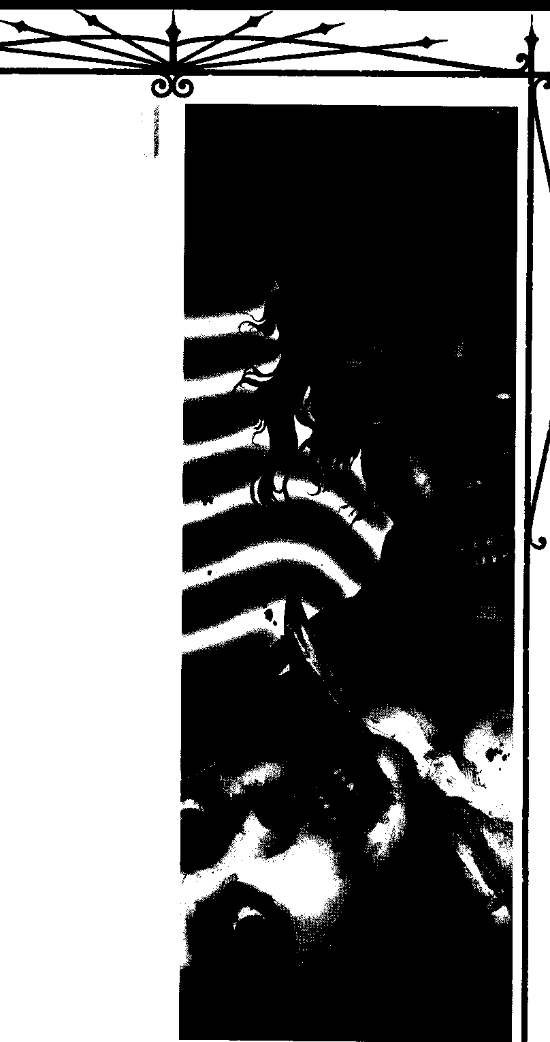

F ABLE'5 OF THE DEAD WATER
In koldunic folklore,.1. ales are told of thr powerful ancient sorcerer,.s practicing the Way of Water. These elders were thpught to have ere- I ated all the rivers, lakes and seas of Eastern
Europe, and wielded the power toJlood the land 1•
to the top of the Alps. While"figl:i 4:tg.to·pt t i their holdings in what is know;qt(lday as Brii>V ! these three koldun were ovemin bv·._·pa,ck of j
Kindred or Lupines and ;tom to·pieces. _·Their··1· blood supposedly spilled in ..all o£tit, !,odies of water theycreated, andfor ahund yearsno life j could survive within their depths. Peasints in
Transylvania referred to this liquid 8.$"dead wa- i
I
ter," for its inability to sustain aquatic life.
It was only a fe\V decades before the appear- ance of Clan Tremere When an elder koldun created a ritual, Remembran 'of Dead Water
(see "Rituals"), in honor of the koldun .of this "' fable. Some of the present--night Sabbat un participate in this ritual to connect with their 1
I
spiritual ancestors. I

    - pooL',OFILLUSION
Travelers have told tales of receiving warnings of future events, cries for help and even divine interven­ tion from spirits that manifested themselves from a water source. Water spirits have been recounted the world over, from river cannibals to the lovely mermaids and lorelei that beckoned men to watery deaths. Even King Arthur received his prized sword Excalibur from such a spirit of water, known as the Lady of the Lake. At this beginning level of the Way of Water, a
koldun has the ability to create a three-dimensional illusion along the surface of a water source. Ko/dun during the modem nightssometimes invoke this power of illusion to prey on the superstitions of the mortal world.
System: The player makes a Wits+ Koldunismroll (difficulty 5) in order to create an illusion of her choosing. The illusion can speak and walk, but it is intangible and cannot leave the boundaries of water. This phantom image lasts for several seconds, after which it will slowly dissipate.
e e WATERY 50LACE
Should a koldun desperately need shelter, from enemies or the risingsun, she may opt tosink below the cool, dark, protective waters. fu the vampire walks into a source of water, she sinks below its surface, protected by the magic of the liquid.Though akoldun can immerse

Bt.ooo MAac:SECRETS () THAUMATIJRGY



herself into nearly all water sources, she cannot move around within it; water currents mystically avoid the koldun's dead body at her original interring point.
System: Unlike most powers ofKoldunic Sorcery, this power does not require the expenditure of a Will­ power point; the player must accumulate two successes on her Wits + Koldunism roll (difficulty 6) to success­ fully submerge the character in the water. The amount of water must be at least a foot in depth and as large as her body for a koldun to rest there. This power acts like the Protean Discipline power of Earth Meld; after invoking Watery Solace, a vampire is completely con­ cealed from the rays of the sun. Those looking straight down into the water where a koldun melds may make a Perception+ Alertness roll (difficulty 8). On a success­ ful roll, they catch a glimpse of the slumbering koldun
and can attempt to attack or rouse her.
•••WATER WALI<
Nolonger bound by the laws of physics, akoldun has the ability to walk along the fluid surface of water. So long as she invokes this power, the vampire may walk the water's surface as if it is as solid as earth.
System: The ko!dun may walk across the surface of water for a number of scenes equal to the number of successes the player scores on a Wits+ Koldunism roll (difficulty 7). This does not prevent the creatures of the seas or lakes (or any body of water the koldun traverses) from interacting with her. The Storyteller may find it appropriate to have dolphins torment her, or a hungry
shark could surprise the vampire and take a bite at her from beneath. It is also possible that the koldun will be spotted by individuals in boats, fishermen or even people swimming in her general vicinity.
•••• WATE'RYMINION5
Theko!dun of the Middles Ages often invoked these minions from the moats surrounding their castles to deter the marauding Turks. These servants are com­ prised completely of water, ascending from a watery source. Once primed by this power, the minions follow only very simple instructions from the koldun, though
they do so without hesitation. Some of the Turks surviving raids on a koldun's keep told stories of weirds, dragons and dire wolves roaming around the armalisti castles.
System: The player spends a point of Willpower. For every success he scores on a Wits+ Koldunism roll (difficulty 8), one Watery Minion rises from its source and forms into anyshape thekoldun desires. The Story­ teller determines appropriate Traits aswellas the number of health levels for these minions if they have the ability to attack and defend. As they are composed of water,
bashing damage does not slow the minions, though fire­ related attacks gain an extra two dice to damage. All of these Watery Minions last for one night.
•••••oooMTmE's
Many Turkish ships lie below the Black Sea, de­ stroyed by mighty whirlpools invoked bykoldun. Victims fight to keep themselves afloat or else find themselves sucked into whirling tides, suffocating until they can swim free from this vortex. Some of tonight's ko!dun entertain themselves by creating swirling riptides in
pools to surprise late-night swimmers.
System: The player spends a Willpower point and rolls Wits+ Koldunism (difficulty 9) to create a whirl­ pool. For every success she scores, the width of this maelstrom increases by l0feet. Doom Tides have a base Strength15; this Strength increases by increments of five for each success the koldun scores beyond the activation roll. Victims must make a Strength + Sur­ vival roll (difficulty 8; Potence adds successes) in order to pull free from the riptide. This effect remains for one
scene.

THEWAYOFFIRE
Ancient koldun created the Way of Fire by first manipulating the molten magma that exploded from volcanoes found throughout Eastern Europe. Then they evolved their control over the fiery liquid earth to the point of invoking their own unique effects that would not necessarily occur during volcanic activity. Koldun who possess the powers of the Way ofFire in the modem
nights are feared simply for their capacity to destroy so much in a short amount of time, just as a volcano can eliminate life on entire islands within a day. When invoking any of the powers of this way, a koldun's eyes glow a feverish orange.
Note: At the Storyteller's discretion, Kindred ob­ serving these powers in use may be overtaken by R0tschreck (with the exception of thekoldun, ofcourse).
- 5HATTER
In a small demonstration of power that is inherent of the Way, a koldun invokes the air about an object to increase in temperature until the object combusts.
System: The player makes a Manipulation + Koldunism roll (difficulty 5) and spends a Willpower point. The koldun must have a target object in his line of sight before he can cause it to Shatter. Once this power is invoked, the heat around the target object intensifies until the object spontaneously combusts. The Storyteller may make a soak roll for the object to see if it does in fact Shatter (determined by the size or quality of an object: three dice for a small or shoddy

[LDIICH mRl!S

object, five for an average-sized object and seven dice for a large or well-crafted object. Anything the size of a car cannot Shatter, as it is much too large). The object must accumulate five successes over three soak rolls (difficulty 5), or it will shatter. This power cannot be used on living beings or Kindred.
•• ROU5ETHEMOLTENROCH
Thekolduncan now cause magma to bubble upfrom the earth's core and slowly ooze its way along the ground. Although there is not a substantial amount of lava present, the magma burns through nearly every­ thing it comes in contact with. The molten fires slowly work their way along tree trunks, spread from bottom to topfloorofa house andmayeveneat througha metal door.
System: Onlyenough magma to fill a bathtub boils up through the ground, though it causes a victim to suffer three health levels of aggravated damage. Each success the player scores on the Manipulation + Koldunism roll (difficulty 6) keeps the lava superheated for one tum. It oozes along the ground in any direction the koldun desires, but at a slow-as-molassesrate. When the duration of this power expires, the magma instantly cools, creating a small slab of solid rock.
•••GATES OFMAGMA
Thekoldun invokes molten rock to bubble up from the ground in a circular ring, 10 feet high. The flow of lava is constant, creating a makeshift wall of super­ heated rock around the koldun. So long as this power remains in effect, it is nearly impossible for individuals to traverse the Gates of Magma without causing them­ selves severe bodily harm. It takes mighty resolve for a person toeven approach the wall, as it gives off heat that causes grievous bums.
System: For every success the player scores on the Manipulation+ Koldunism roll (difficulty 7), the seeth­ inghot lava will continue tosurround his person for two turns. Individuals who attempt to penetrate the Gates of Magma must first make a Courage roll (difficulty 8). If successful, they can continue to approach the heated barrier but suffer one health level oflethal damage - or aggravated damage if they are Kindred. Failure to suc­ ceed on this Courage roll translates into the mind succumbing to its instinctual defense of self-preserva­ tion; a second attempt to penetrate through the barrier requires the additional expenditure of a Willpower point. Anyone physically touching the Gates of Magma suffers three health levels (not dice) of aggravated damage.
••••HEATWAVE
Thekoldun acts as a conduit for steam geysers and evokes a blast of dehydrating air, withering and desic­ cating an opponent.
System: The player spends a Willpower point and rolls Manipulation + Koldunism (difficulty 8). The vampire calls up hydrogen sulfide from the Earth's mantle and blasts a target. Mortal victims suffer five health levels oflethal damage as their bodies dehydrate. Vampires react similarly and also suffer five health levels of lethal damage, which they may soak. Kindred also lose five blood points that evaporate from the body (regardless of their soak roll), resulting from the ex­ treme heat of this gas. Note that this may send some Kindred into frenzy or torpor.
- •••• VOLCANIC8LA'3T
At this mastery level of the Way of Fire, a koldun commands lava to explode from the ground in a huge stream. The molten rock sprays in a large arc, then moves in small rivers in every direction, burning, melt­ ing and destroying most everything in its path. Cars melt in these rivers, trees catch fire and bum to the ground, and houses erupt into flaming infernos in the wake of devastation.
System: This power is not subtle. Lava erupts 20 feet into the airfrom underground with the expenditure of a Willpower point and a successful Manipulation + Koldunism roll (difficulty 9). For every success the player scores, the lava continues to explode from under­ ground and move in rivers in all directions for one tum. Anything coming in contact with this molten rock suffers three levels of aggravated damage per tum (soak.able onlywith Fortitude). Storytellers must decide how long objects remain intact after coming in contact with the lava before they ignite or dissolve. Once this power expires, the lava will cease its eruption and all of the magma will quickly cool, trapping objects remain­ ing within the river stream in a thin sheet of rock.
THEWAYOFTHE5pIRIT
There resides a single force, an essence, that en­ compasses all things in nature. The ancient koldun manipulating this way mystically tapped into this es­ sence and, as a result, they gained insight and minor control over their surroundings. Oftentimes, the koldun wielded this way in conjunction with other powers of Koldunic Sorcery. Many also protected themselves by invoking this way before entering their havens, to pre-





BLOODMAc.c: SOCRrJSorTHAI.IMAruRGY

empt attempts on their unlives. Tonight'skolduninvok­ ing the Way of the Spirit procure a similar outcome as their ancient predecessors, creating a bond between themselves and the spirit of the land.
System: The player spends one Willpower point, then rolls her Charisma+ Koldunism (difficulty4 + the level of the desired effect; see below) to activate the powers of this way. These powers last for one scene per success the player scores. The chart below describes how far away from her person a koldun can "feel" out intruders or hostile spirits according to her power level.
A koldun can invoke other powers of Koldunic Sorcery that she knows in conjunction with the Way of the Spirit, though only at a lesser or equal power level at which she knows the Way of the Spirit. For example, a koldun may invoke Level One through Three powers ofWayofWater inconjunction with the powersof Way of theSpirit if she knows theWay of the Spirit at Level Three.
This power also confounds use of the Disci­ pline of Obfuscate.
R( EAWAHENIN0THEDEADWATER LEVEL ONE RITUAL)
With the destruction of the T remere antitribu and as Koldunic Sorcery was rediscovered, new koldun searched for a means to spiritually reconnect them­ selves to their ancient predecessors. In accords with the fables of "dead water," many of these new koldun begin their nights by performing this ritual, cast by dripping some of their blood into a lake, river or ocean and then ingesting the liquid.
System: A koldun must drip one point ofblood into the water source from which she intends to drink, then ingest an equivalent of one blood point's worth of in water. This liquid mystically evaporates through the vampire's bodysoon after being ingested. After success­ fully performing this ritual, akoldun regains one point of temporary Willpower. This can only replace spent Willpower points andcannot exceed the koldun's maxi­ mum Willpower pool. Reawakening the Dead Water can be performed only once per night.

•
••
•••
••••
•••••
"See"everythingwithina 50-footradius "See" everything within 100 yards "See"everything within aquarter-mile "See" everything within a mile "See" everything within five miles
TIES THAT BIND (LEVEL FOUR RITUAL)
Before an ancient koldun could learn a new way, he performed thisritualand removed oneof hisribs (through Vicissitude or other means). A mystical symbol repre­ senting the particular way the koldun intended to learn was inscribed onto the bone, then implanted back into

HOLDUNIC RITUALS
Like Thaumaturgy, Koldunic Sorcery grants its caster access to rituals. Though magical, these rituals are not Hermetic and are incompatible with any form of T remere or Giovanni magic. Most rituals require a blood sacrifice on top of any other specific components. Only a few rituals are presented here - Storytellers
and players of koldun are encouraged to create their
own, to reflect the unique bond between the T zimisce sorcerers and their home soil.
System: The player must make a successful Intelli­ gence + Koldunism roll (difficulty 4 + the level of the ritual) and shed blood in order to cast any ritual. Whether the blood belongs to the koldun or not is unimportant; one blood point must spill per ritual level to cast this spiritual magic.
the body. Ko/dun cast this ritual to symbolically lend part of themselves to the essence of the land. In return, they were granted the ability to practice the spiritual magic that is Koldunic Sorcery. In the present night, Sabbat koldun revised this ritual to serve a more practi­ cal purpose with less torturous requirements. Performed asoften as weekly, this ritual reconnects thekoldun with the eldritch magic of the Old World.
System: After spilling four points of blood onto a patch of dirt then ingesting this soil, a koldun may lower the difficulty of any Koldunic Sorcery rolls he makes over the next three nights by one. Multiple uses of Ties That Bind have no effect- thekoldun gains no greater benefit if he uses this ritual more than once in three nights.




EtDRICH SOP£ERIES

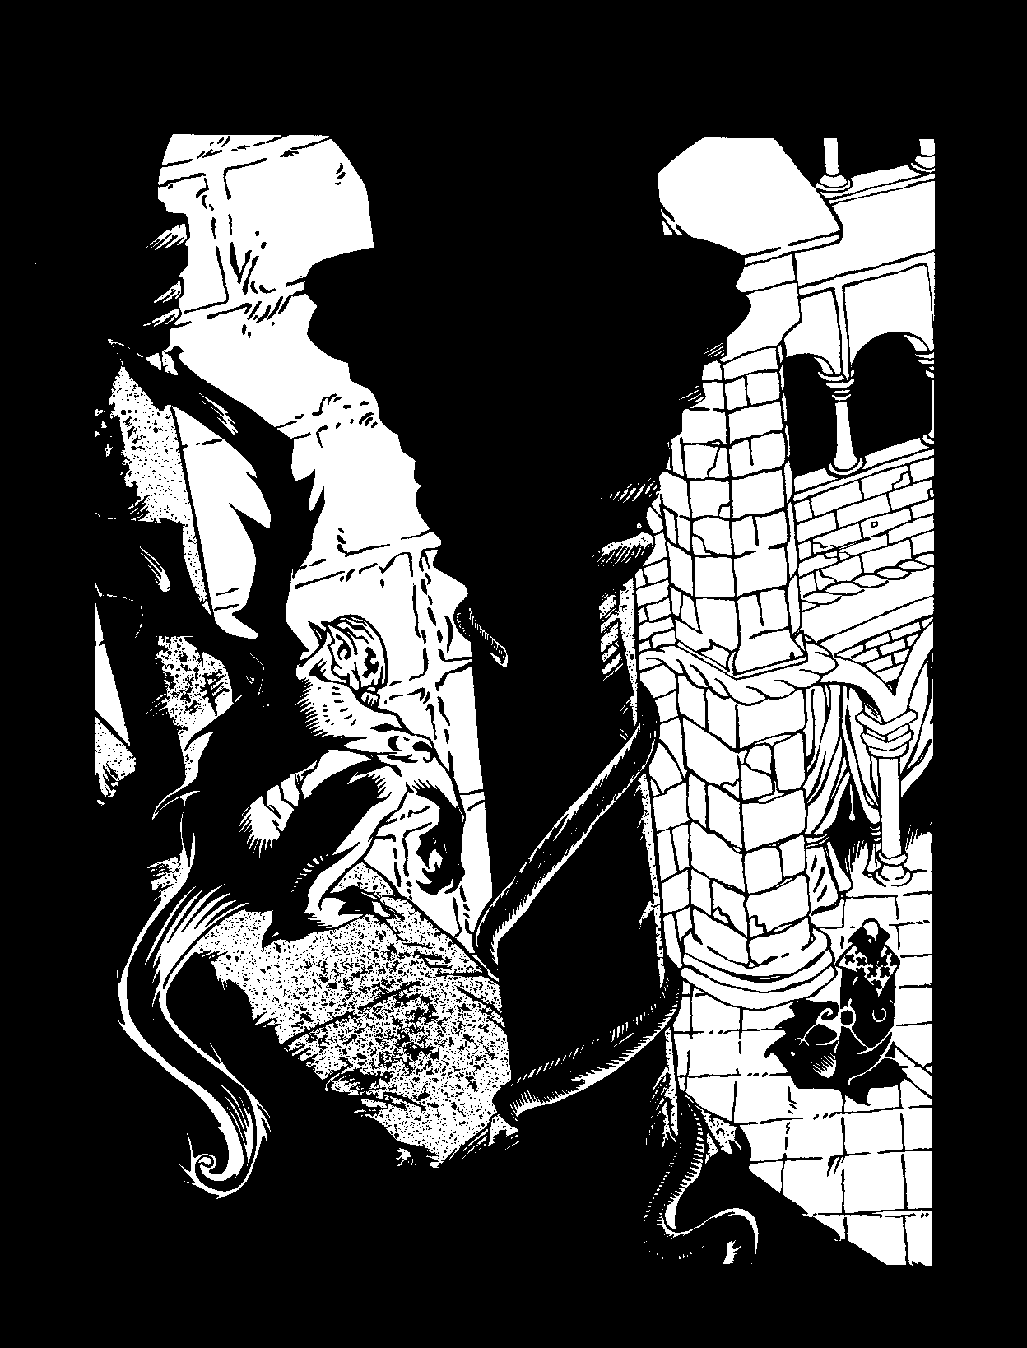

This appendix contains rules, systems and sugges­ tion for creatures of thaumaturgical origin. As one might suspect, these creatures are quite rare, even in the shuddersome domains of the most potent thaumaturges. The Warlocks know that a preponderance of these creatures would only draw attention to them - who believes in gargoyles in these modem nights? - and so they use them sparingly or in the utmost secrecy. Still, many of these magical beasts had their origins in nights long past, and old habits die hard with the static Kindred. The hidden domains and havens of venerable T remere may well house several of these mystical min­ ions, or they may simply be leftovers, creatures whose masters have died but who still remain animated by deathless magic.
BLOOD BROTHl?R
Blood Brothers are a brood of vampires created by a unique combination of Thaumaturgy and Koldunic Sorcery. Generally created in circles of three to seven vampires, the Blood Brothers all resemble on another superficially, as the ritual Embrace warps them toward a common purpose. They are most often seen as gangs of lookalike thugs, skinheads and other rough types.
Blood Brothers share a mystical connection that not only allows them the benefits of a psychic "hive mind," but also gives them the ability to heal each other
from a distance, "share" limbs and even form an enor­ mous coagulated monstrosity with their own bodies.
The ritual to create a Blood Brother is Level Five Koldunic Sorcery. It requires all Blood Brothers of the circle to be present at the same time, thus forming their unwholesome bond. Unlike other Kindred, Blood Broth­ ers cannot create new Blood Brothers- they may only be created.

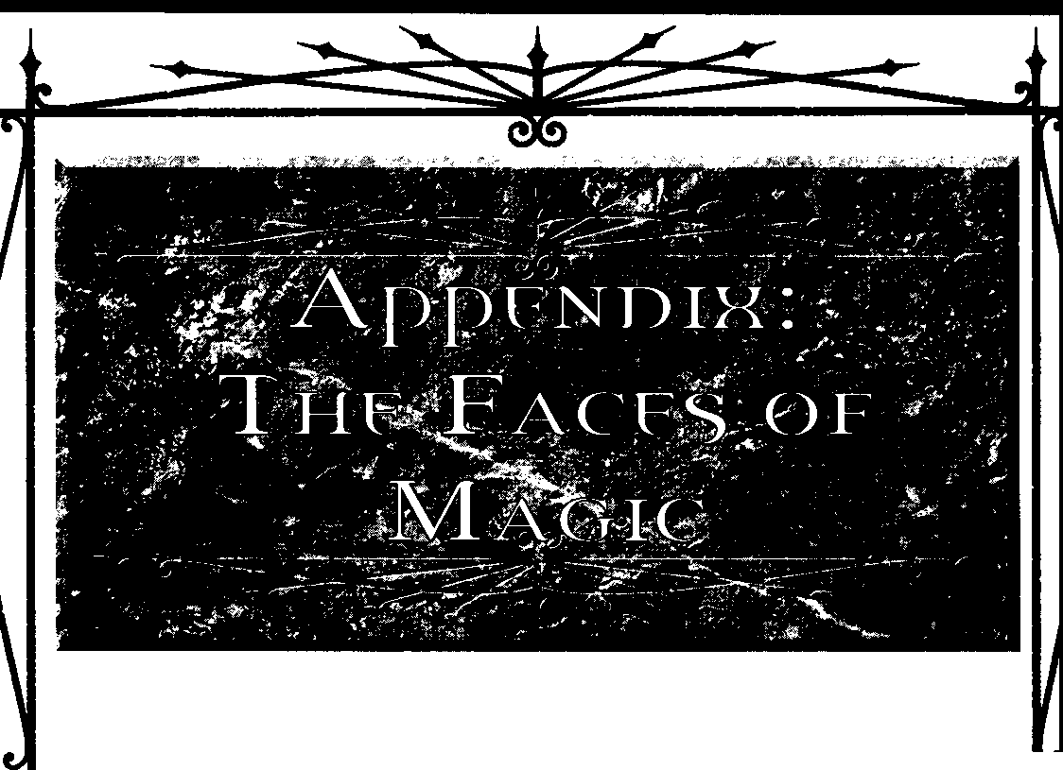

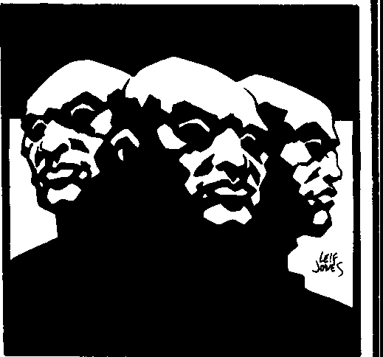
Am.Notx: THE FACES Of MAac



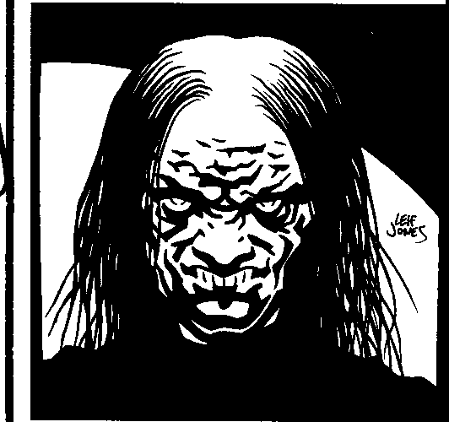
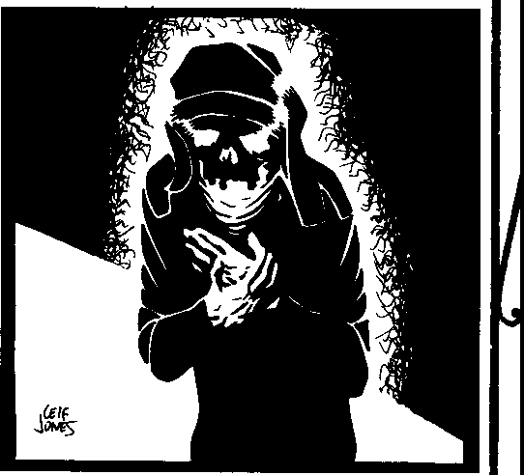
For more information on Blood Brothers, see the Guide to the Sabhat.

The bodies of demon-bound exude a fiendish heat, and their eyes radiate an orange-red energy. They are seemingly somewhat intelligent, but they lack the abil­ ity to speak in languages comprehensible to mortals and Kindred alike.
The ritual to create a demon-bound is Level Four, and they are very rare in the modem nights. If a demon­ bound hasn't been destroyed by the seventh night it spends on Earth, it collapses of its own accord, ruining the body as the demon burns itself out and returns to its own realm.
Strength 3, Dexterity 3, Stamina 4
Charisma 1, Manipulation 2, Appearance 2
Perception 2, Intelligence 2, Wits 4
Willpower: 3, Health Levels: OK, -1, -1, ,2, -2, -5
Abilities: Alertness 1, Brawl 2, Dodge 2, Intimida-
tion 3, Streetwise 2, Crafts 1, Melee 3, Stealth 1,
Survival 2, Investigation 2, Occult 1
Disciplines: Fortitude 1, Potence 2
Blood Pool: 10
CORp'5E MINION
Acorpse minion is an animated corpse, driven by the soul of its previous (and now dead) occupant.

For more information on corpse minions, seep. 46.
Strength, Dexterity , and Stamina all as they were in life, less one (but not below 0)
Willpower: 1, Health Levels: OK, , 1, -1, -2, -2, -5
Abilities: Brawl 2, Intimidation 2
Blood Pool: 0 (though some have what amounts to one very foul point of blood, depending on how long they're been dead and due to what circumstances)
DEMON-BOUND
Thedemon-bound are malignant spirits forced to inhabit the bodiesofdead mortals. Their unholy strength makes them quite powerful, but because they are now wholly creatures of this world, their existence is tempo­ rary at best outside of whatever hell from which they have been conjured forth.
For more information on demon-bound, see page 46. Strength 5, Dexterity 2, Stamina 5
Willpower: 2, Health Levels: OK, OK, OK, -1, -1,
-2, -2, -5
Abilities: Brawl 3, Intimidation 3, Melee l Blood Pool, 0
GARGOYLE'
Gargoyles are Kindred created by sorcery and the blood of Old World vampires. As their name alludes, they resemble the stony guardians of medieval build­ ings, complete with wings that allow them flights and power over the element of stone.
The ritual to create a Gargoyle is Level Five. It requires a significant quantity of blood from two vam­ pires of Clans Gangrel, Tzimisce or Nosferatu and a mortal subject who will become the new Gargoyle.

BwooMAac: StCR£ISmTHAUMAruRGY

Creating a homunculus is a Level Two ritual and requires the thaumaturge to add a bit of her own flesh to a mixture of blood and viscous herbal compounds. The flesh-often afingertip- is specially created when the ritual is performed, insuring that the excised meat doesn't grow back (or there would be nothing from which to create the creature). Additionally, a homun­ culus drinks one blood point from its master at the new moon of every month. This last is often done through a nipple or hidden puncture.

For more information on Gargoyles, see the Guide to the Camarilla.
Strength 4, Dexterity 2, Stamina 3
Charisma 1, Manipulation 2, Appearance 0
Perception 3, Intelligence 2, Wits 3
Willpower: 3, Health Levels: OK, -1, -1, -2, -2, -5
Abilities: Alertness 1, Brawl 3, Dodge 2, Expression
1, Intimidation 3, Animal Ken 1, Crafts 2, Melee 1,
Security 1, Survival 3
Disciplines: Fortitude 2, Potence 1, Flight 1

Blood Pool, 10
Note: Gargoyles are actually full-fledged vampires whose Traits are far more individual than this. Still, if the Storyteller needs a Gargoyle for the sole purpose of guarding something or waylaying the players' charac­ ters, these Traits should serve the purpose.
HOMUNCULU5
A homunculus is a tiny replica of the sorcerer who creates it. Generally, homunculi have their own spe­ cialized features that their "parent" doesn't have - some possess leathery wings, others have no arms and a pair of powerful hopping legs. Some are sluglike and crawl where their master asks. Homunculi tend to be a foot or less in length, and weigh less than 30 pounds.
A sorcerer's homunculus follows her directions more or less, often acting as a spy or lesser servant for its master.They have basic intelligences, along the lines of a cat (and they are often equally as mischievous), and they speak in keening warbles understood only by their masters.

For more information on homunculi, see page 46. Strength 1, Dexterity 3, Stamina 2
Willpower: 3, Health Levels: OK, OK, -2, -5
Abilities: Alertness 2, Stealth 2

Blood Pool, 1/2
Note: Homunculi may have any special abilities the Storyteller decides to give chem. These may be Disciplines, "natural" powers or anything that suits their concept. Players wishing for their characters to create homunculi should discuss the specifics with their Storyteller.
RAZOR BAT
Arazor bat is an animal gargoyle, made from magi­ cally endowing a bat with the resiliency of stone. Their wings are sharp and their fangs are like tiny stalactites. The Tremere originally crafted razor bats to serve dual purposes. As spies and alarms, they could keep the warlocks aware of intruders and the like. As assailants, aflock of them couldswoop from their aerie and tear an enemy to ribbons before he knew what hit him. Razor

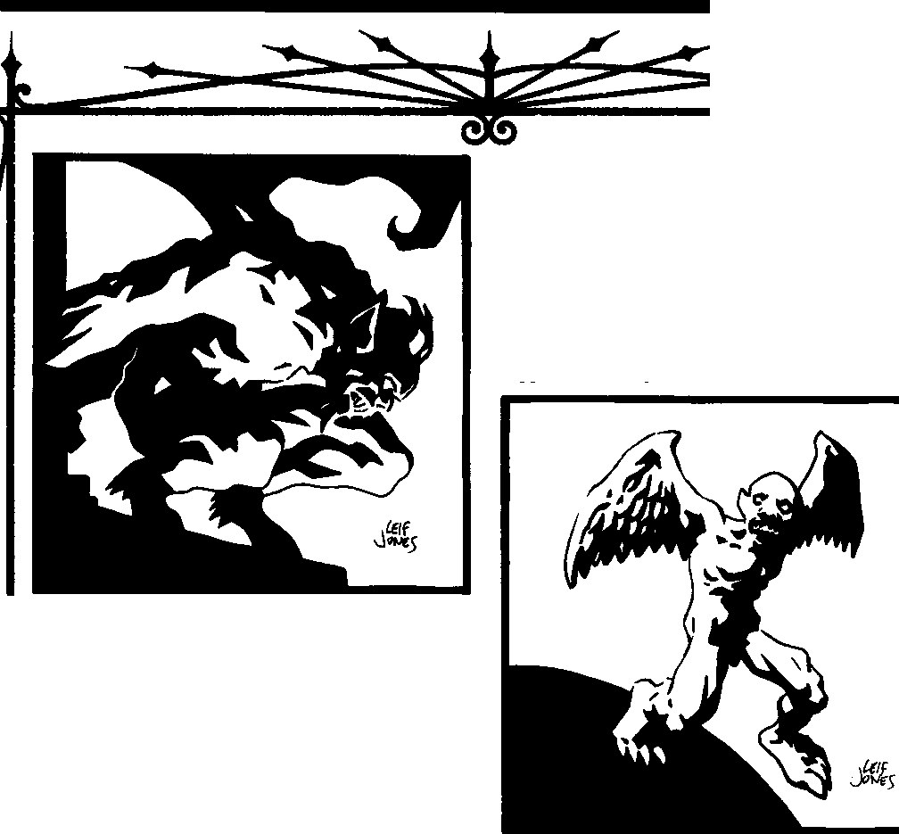

Am.NDIX: THE F.-.as mMAac:



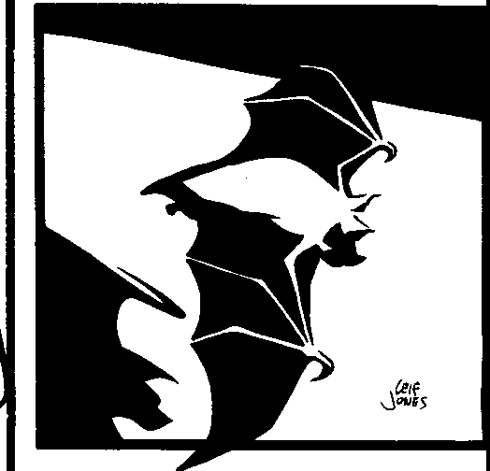
bats are often trained to squeal whenever someone unknown to them enters a certain area. Although their eyesight leaves much to be desired, their sense of smell has developed quite well and they have the same echolocation abilities as normal, living bats. Razor bats can also fly at greater than normal speeds - up to 25 miles per hour.

Strength 1, Dexterity 3, Stamina 2
Willpower: 2, Health Levels: OK, OK, -1, -3
Abilities: Alertness 3, Dodge 3, Stealth 2
Blood Pool: 1
Note: Damage done by razor bats (one die) is considered aggravated, given the Thaumaturgical changes the Tremere have wrought upon their bodies.
5TONFHOUND
Ina process similar to that which creates the tarot bats, the Tremere have been able to thuamturgically augment hounds into Gargoyle creatures as well. Gen­ erally drawn from stock like mastiffs and Rottweilers, stone hounds are ill-tempered, monstrous beasts known
for their fanatical loyalty to their owners and latent hostility toward practically everyone else. Of all "Gargoyle minions," the stone hounds are the most numerous. Stone hounds have glowing red eyes that allow them to see in darkness (as per Protean Level One), and some few of their number actually have craggy wings and the ability to fly, similar to Gargoyles. These winged hounds are quite rare in the modem nights, though their use hasbeendocumented in Vienna,

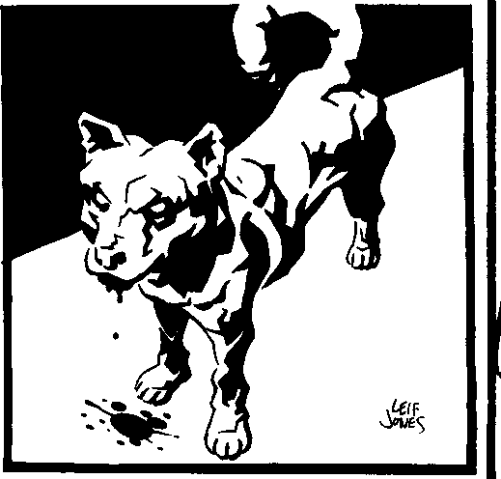
northern Italy, London and even a few New World cities.
Strength 4, Dexterity 3, Stamina 4
Willpower: 3, Health Levels: OK, -1, -1, -2, -2, -3, -5
Abilities: Alertness 3, Athletics 3, Brawl 3, Dodge
3, Intimidation 3, Stealth 2

Blood Pool, 3
Note: Stone hounds may bite for five dice of damage or claw for four, and this is considered aggra­ vated.Stone hounds alsohave one level eachof Potence and Fortitude. Additionally, stone hounds crafted from less hardy stock have lower Traits - the characteristics here represent a large breed of dog.

Bwoo MAoc:Smtm Cf THAUMAlURGY

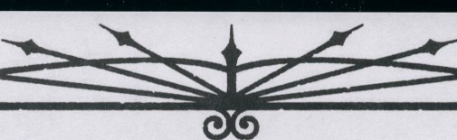

REVENANT5
Revenants are much like ghouls, though their exposure to Kindred vitae (as wellascenturies of interbreeding and ocher lessdefinable details) has made them somewhat self-sufficient with regards to vampire blood.They exist in an unholy half-state between undeath and life,aware and part of the world of Kindred, yet isolated from it as much as they are shunned by the mortal world.
More details on revenants may be found in the Guide to the Sabbat and Ghouls: Fatal Addiction.
0UCHE5HI
What little the Ducheski allow others to know about chem indi­ catesa history of treachery. Like most of the other revenant bloodlines, the Ducheski claim to have onceserved the hoary T zimisce of the Old World. Since those nights, however, something caused them to turn their backson theirerstwhile masters and throw their fates in with the Tremere.Needless tosay,thishasnotearned themanyfavorwith theFiends.
Ducheski revenants are rare, indeed, and some say the line is dying out after severing its connections with the Tzimisce who bred them so long ago. Rumors attribute a few crumbling manses to the

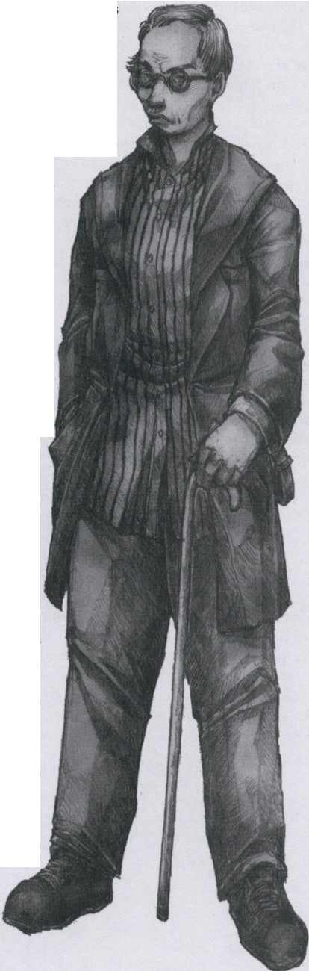


family's holdings, mostly spread through Europe. It is here that they serve their new masters, the Tremere. Although a few Ducheski sometimes receive the Embrace intotheclan, the Tremere generally prefer to keep them in roles of subservience. A few prominent Warlocks maintain Ducheski ghouls in their libraries, sanctums and thaumaturgical laboratories, but by and large the family re­ mains a well-guarded secret even among the ranks of the Tremere.
The true genius of the Ducheski manifests in their talent with machines and contraptions. They are masters of mechanical de­ vices,sometimes devising worksof twisted da Vincian brilliance­ though the purposes to which these machines are turned are almost alwaysgrim.To thoseelders who knowof them,a Ducheski torture device or system of alembics is a sign of status, much like owning a pieceoforiginal artwork. To the Ducheski, it is the price for which
they have sold their souls to escape the talons of the T zimisce - a burden they silently bear.
Disciplines: Auspex, Dominate, Thaumaturgy
Weakness: Asa result ofcenturiesspent under the thumbof the Tremere, the Ducheski have grown quite farfrom the human side of their beings. This insularity has also led to a penchant for inbreed­ ing- the Ducheski relate only to other Ducheski, it seems. This inbreeding has caused an aberration in the minds, bodies and personalities of the Ducheskis, who betray the birth defects and skittish personalities of those too far removed from outside human contact. No Ducheski may ever have a Social Trait above 2.
Quote:Whatever the master says, sosays me,and you, too,if
you know what's what and best.

Am.NolX: THE FACES OFMAoc


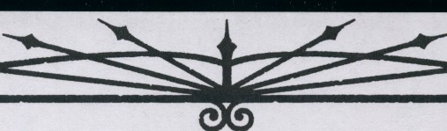



RAFASTIO
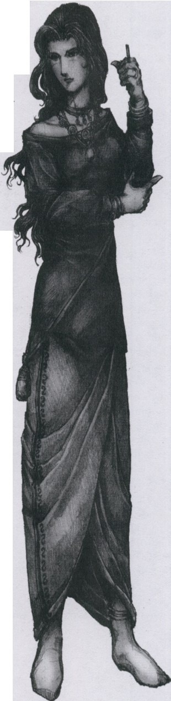
Members of the rareRafastio bloodline arewitches in the truest senseof the word. They have practiced various magics since the first nights of their once­ patron sect, the Black Hand, which has since fallen and left them isolated from the rest of the world.Originally part of the Po River Valleycivilization, the modern nights still find the few remaining Rafastio families in those areas of southern Europe, though a few have fled to the New World within the last century.
The Rafastio are masters of the lesser, "hedge" magics from which early Thauamturgy derived many of its practices. They excel at conjuringspirits, invoking lesser curses, tainting marks with "the evil eye" and divination, and had parlayed this supernatural prowess into an arrangement with the inscrutable Kindred of the Black Hand. That sect's near-annihila­ tion has left the Rafastio floundering, revenants without masters and opposed by hostile Kindred. Although they are not often heard of outside certain circles, the few Cainites who do know of them often perceive them as threats: the agentsofa fallensect whoare best destroyed rather than allowed to fester and continue the work of their masters.
To the Rafastio, life is one challenge after another. Hunted by powerful (if rare) enemies and isolated by a legacy of Kindred dominance and forbidden magical practices, a Rafastio must be tough or accomplished to survive. In light of the Black Hand's destruction, the Rafastio have claimed no new masters and chosen to remain the masters of their own destinies. Despite this, a few Rafastio have made deals with individual vampires, no small number of which have been among the Tremere, T zimisce and Assamite clans. The fate of their dwindling numbers would seem to be resigned to a few success stories among individuals, while the rest of the line either vanishes or dies in anonymity.
Disciplines: Animalism, Auspex, Thaumaturgy
Weakness: A curse delivered upon the Rafastio in nights long past has tied them inextricably to the moon. On nights with a new moon in the sky, all attempts to use Disciplines by Rafastio characters suffer +2 difficulties. On nights with waxing or waning moons, such difficulties increase byone. On nightsof the full moon, however, Discipline difficul­ ties drop by one. Additionally, Rafastio blood rejects the Curse of Caine
- any attempt to Embrace a Rafastio isdoomed to failure, and obviously likely to kill the character.
Quote: The blood holds great power- let us look and see what secrets we may pry from it, shall we? Hold still- I need only a slight bit more from you.

Bt.ooo MAGIC:SECRETS orTHAUMATURGY

